Comment–Topic Correlation Report
Model: llama3

Summary
Topics processed: 3
Comments available for this video: 104
Comments with correlated=True: 1 (1.0%)
Comments with score >= 60: 1 (1.0%)
Total candidate pairs checked: 312
----------------------------------------

Topic T1: Altium 365 and Component Comparison
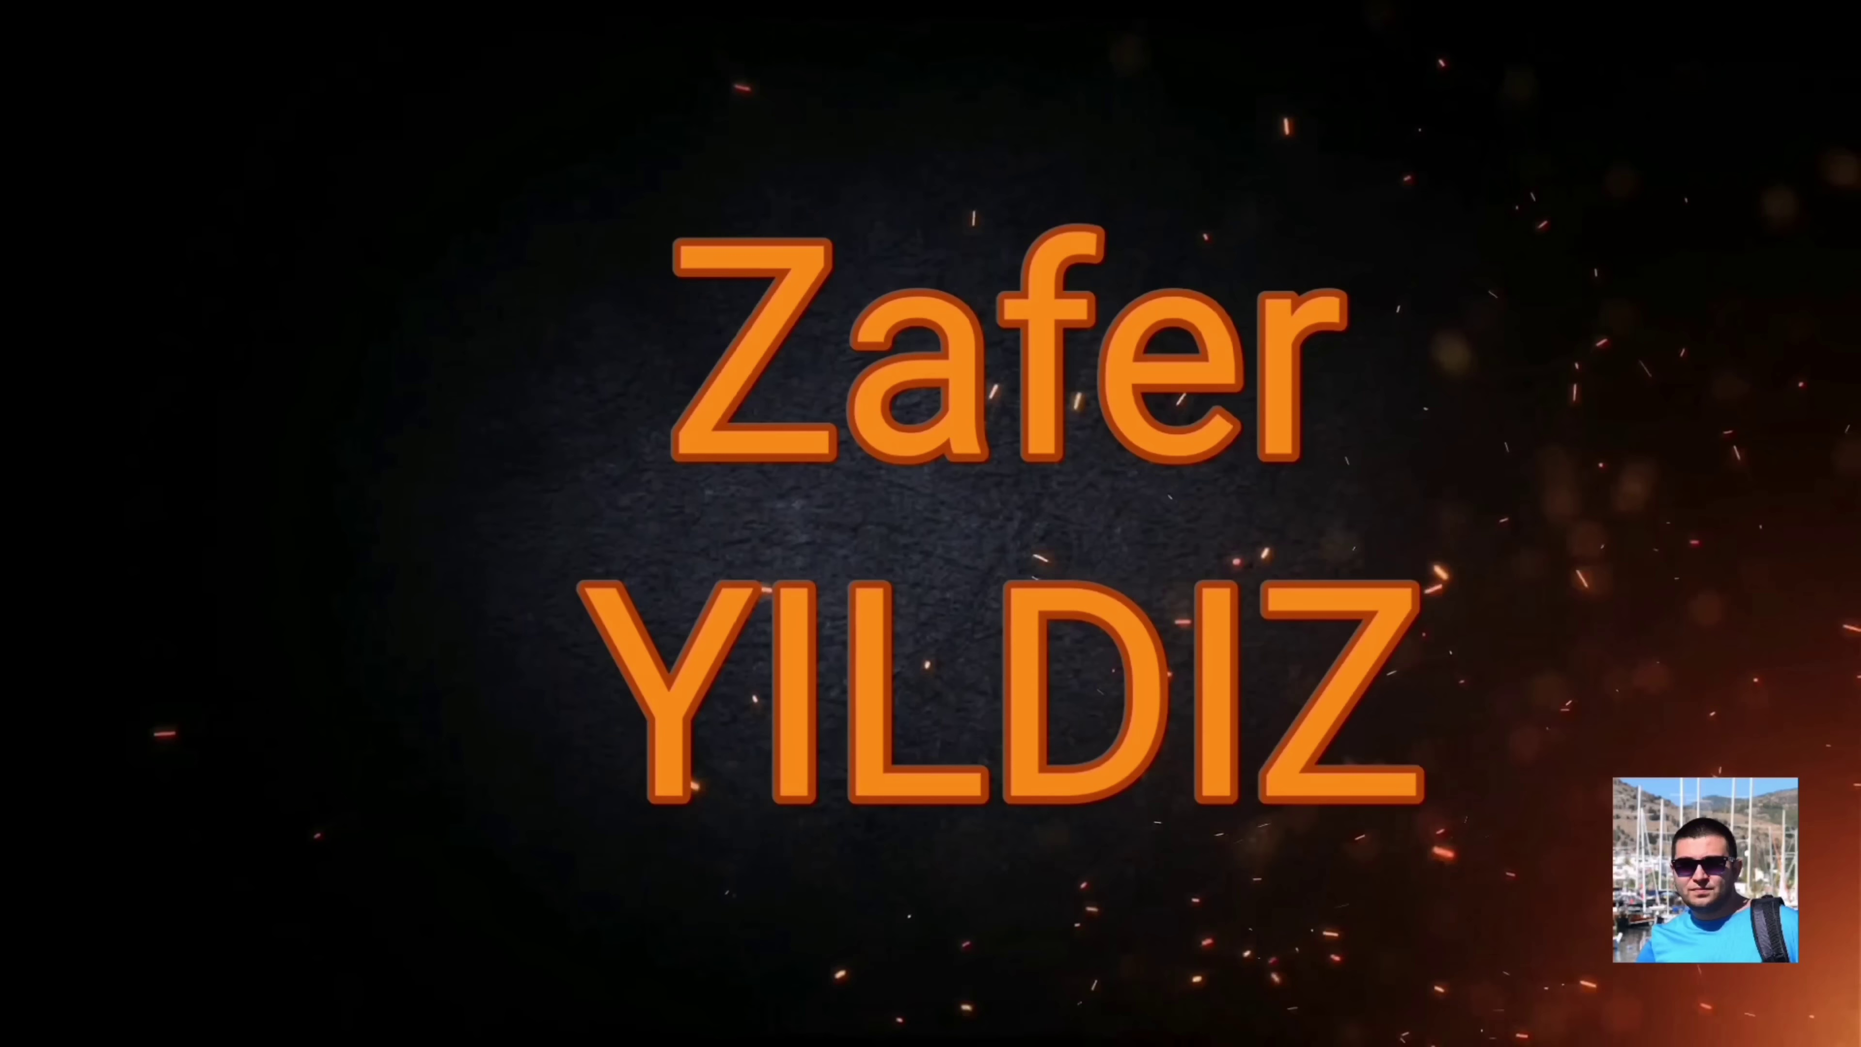 | 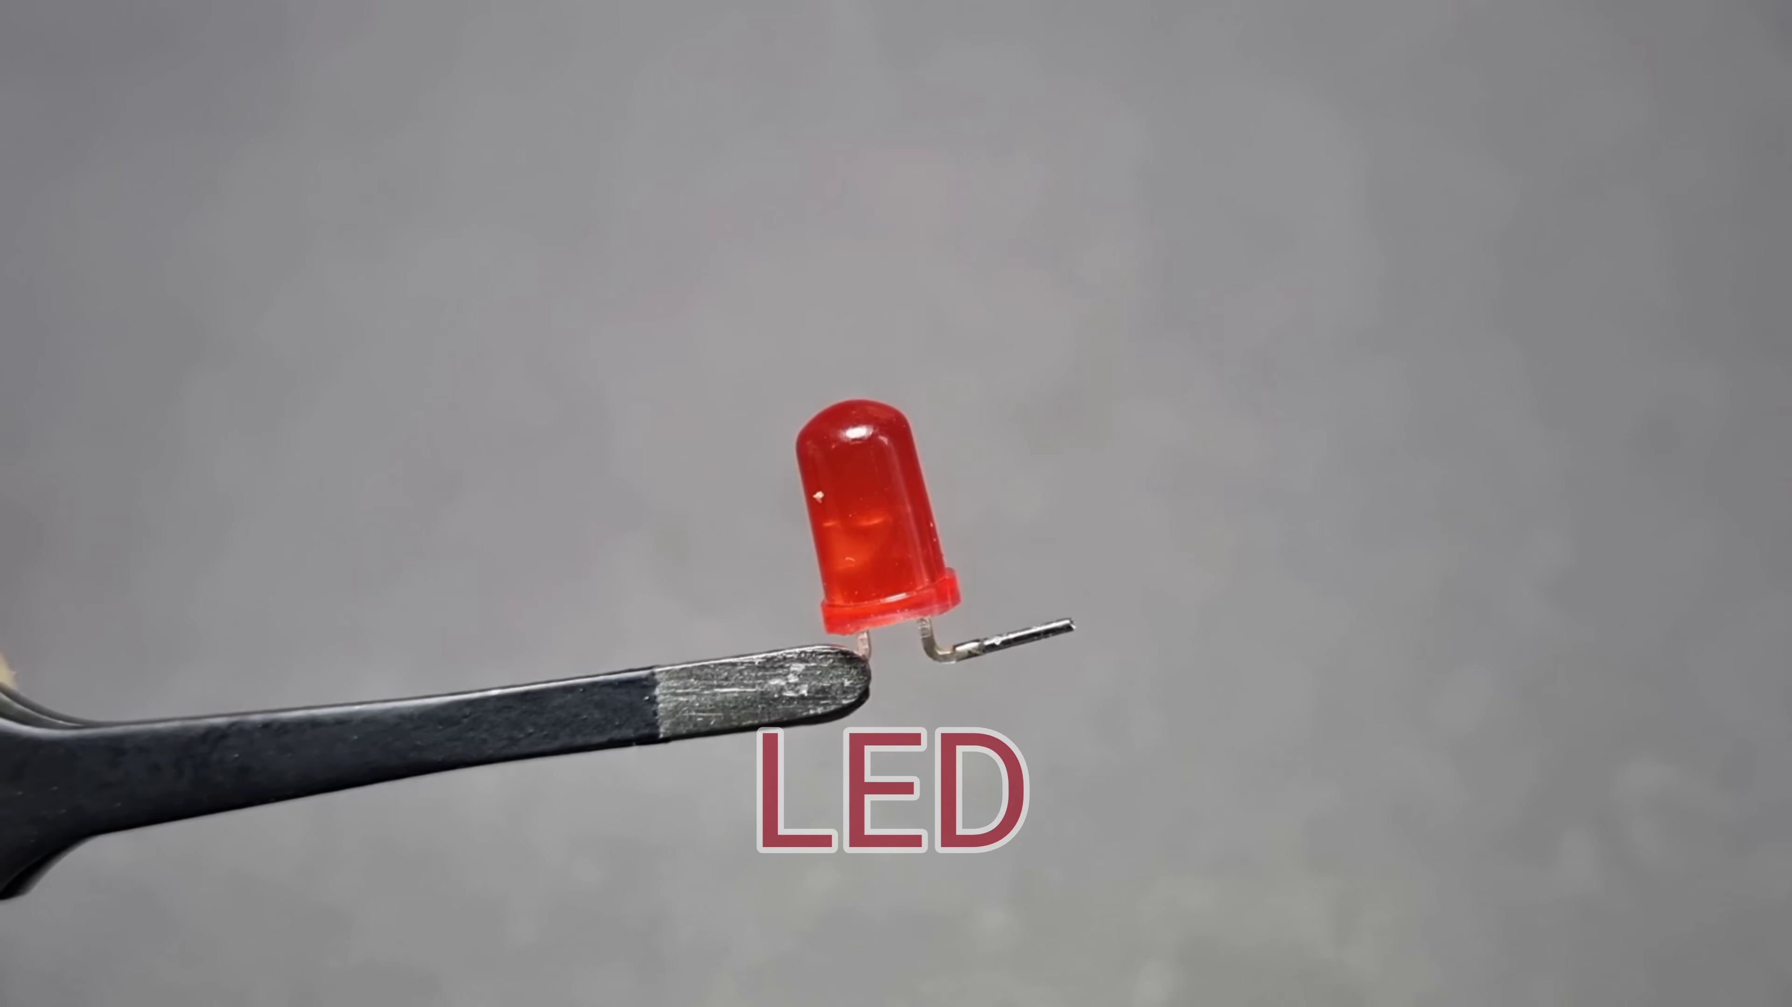 | 
Description: The speaker suggests comparing electronic components across hundreds of suppliers using Altium 365.
Correlated (true): 1 (1.0%)
Score >= 60: 1 (1.0%)
Average Score (of valid matches): 75.00

Top 1 Correlated Comments:
Score: 75
Comment: https://drive.google.com/file/d/19bqJpv99YLko-8xJhnbKY-aQM_NvPqla/view
Reason: The comment discusses the same topic of component comparison using Altium 365, specifically mentioning a Google Drive link. Although it's not a direct quote from the topic description, the mention of suppliers and Altium 365 suggests a strong connection between the two.
Source: https://www.youtube.com/watch?v=GbdF6th5PZk

Topic T3: Videoma Sponsorship
 |  | 
Description: The speaker thanks Videoma for sponsoring.
Correlated (true): 0 (0.0%)
Score >= 60: 0 (0.0%)
Average Score (of valid matches): 0.00
No strongly correlated comments found.

Topic T2: Altium Designer Integration
 |  | 
Description: The speaker explains that customers or team members can view and comment on work directly from the internet.
Correlated (true): 0 (0.0%)
Score >= 60: 0 (0.0%)
Average Score (of valid matches): 0.00
No strongly correlated comments found.

