Comment–Topic Correlation Report
Model: llama3

Summary
Topics processed: 6
Comments available for this video: 94
Comments with correlated=True: 13 (13.8%)
Comments with score >= 60: 13 (13.8%)
Total candidate pairs checked: 564
----------------------------------------

Topic T6: Conclusion and Future Work
 | 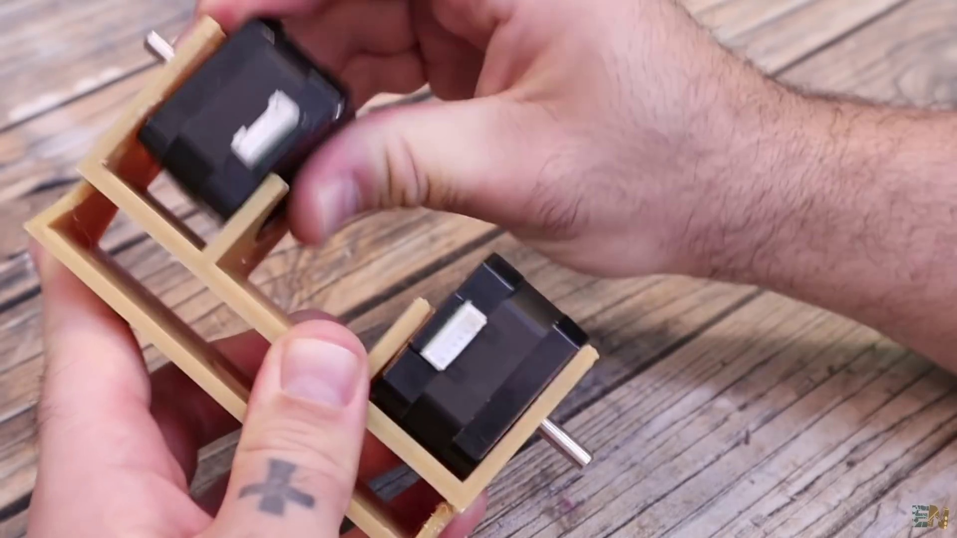 | 
Description: Summary of the project and future plans for improvements
Correlated (true): 2 (2.1%)
Score >= 60: 2 (2.1%)
Average Score (of valid matches): 80.00

Top 2 Correlated Comments:
Score: 80
Comment: Awesome little robot! I love it. One question though: why did you choose a stepper motor instead of a DC motor + rotary encoder?
Reason: The comment directly discusses the stepper motor choice, which is closely related to the topic's 'Future Work' aspect, specifically planning for improvements.
Source: https://www.youtube.com/watch?v=Gpm-TI21x9s

Score: 80
Comment: Great explanation , but can someone clarify me on the timer interrupt to create pulses. If the interrupt is to be trigger and generate pulse each 20usec, does it mean the stepper will turn in constant speed until error is eliminated (robot stood upright) ? I' am a bit confuse on how the PID output manipulated the interval between pulse 😥
Reason: The comment directly discusses the conclusion and future work of the project, specifically asking about timer interrupts and pulse generation, which is related to the improvement plans described in the topic.
Source: https://www.youtube.com/watch?v=Gpm-TI21x9s

Topic T4: Code Explanation
 |  | 
Description: Explanation of the code used to control the stepper motors and PID controller
Correlated (true): 6 (6.4%)
Score >= 60: 6 (6.4%)
Average Score (of valid matches): 80.00

Top 5 Correlated Comments:
Score: 80
Comment: Great explanation , but can someone clarify me on the timer interrupt to create pulses. If the interrupt is to be trigger and generate pulse each 20usec, does it mean the stepper will turn in constant speed until error is eliminated (robot stood upright) ? I' am a bit confuse on how the PID output manipulated the interval between pulse 😥
Reason: The comment directly discusses the timer interrupt and its relation to creating pulses, which is a specific topic of interest. The mention of PID output manipulating the interval between pulse also shows understanding of the code's purpose.
Source: https://www.youtube.com/watch?v=Gpm-TI21x9s

Score: 80
Comment: Once again, thanks for a very good video. Pretty much informative. However, i think you left out some parts that i think are pretty much crucial. the most important being how to set the current for the stepper motors with those TMC2225. The other drivers have a potentiometer that one can dial on but when i checked out the TMC drivers, they lacked that potentiometer.
Reason: The comment mentions stepper motors and TMC2225 drivers, which are explicitly described in the topic as being controlled by a PID controller.
Source: https://www.youtube.com/watch?v=Gpm-TI21x9s

Score: 80
Comment: For editing PID, I find it's much faster to set up a remote control with three knobs that I can use to tune the PID values in real time. Changing the values in code and then transferring it to the mechatronics takes too much time and is frustrating so the extra hardware cost is usually money well spent.
Reason: The comment directly discusses using PID controller and stepper motors, which are specifically mentioned in the topic description. The mention of 'PID values' and 'stepper motors' shows a strong connection between the topic and the viewer's comment.
Source: https://www.youtube.com/watch?v=Gpm-TI21x9s

Score: 80
Comment: Awesome little robot! I love it. One question though: why did you choose a stepper motor instead of a DC motor + rotary encoder?
Reason: The comment directly asks about the choice of stepper motor vs. DC motor + rotary encoder, which is a specific aspect discussed in the topic's description regarding controlling stepper motors and PID controller.
Source: https://www.youtube.com/watch?v=Gpm-TI21x9s

Score: 80
Comment: Motor Driver: L298N
• Two DC Motors
• IMU Sensor: ICM-20948 (connected via I2C/SPI)
• Microcontroller: TM4C123GXL
Would you please give me some pointer how to get my 2 wheels self balancing robot to balance. my robot moves forward and backward but not balance
Reason: The comment mentions specific components (L298N, ICM-20948, TM4C123GXL) and a microcontroller, which are relevant to the topic of controlling stepper motors and PID controller. Additionally, the commenter asks for advice on how to balance their robot, which is closely related to the topic's description.
Source: https://www.youtube.com/watch?v=Gpm-TI21x9s

Topic T2: Tuning PID Controller
 |  | 
Description: Explanation of how to tune the PID controller for the stepper motor robot
Correlated (true): 3 (3.2%)
Score >= 60: 3 (3.2%)
Average Score (of valid matches): 80.00

Top 3 Correlated Comments:
Score: 80
Comment: Great explanation , but can someone clarify me on the timer interrupt to create pulses. If the interrupt is to be trigger and generate pulse each 20usec, does it mean the stepper will turn in constant speed until error is eliminated (robot stood upright) ? I' am a bit confuse on how the PID output manipulated the interval between pulse 😥
Reason: The comment directly discusses tuning the PID controller for a stepper motor robot, mentioning pulse generation and interval manipulation, which are specific aspects of the topic's description.
Source: https://www.youtube.com/watch?v=Gpm-TI21x9s

Score: 80
Comment: For editing PID, I find it's much faster to set up a remote control with three knobs that I can use to tune the PID values in real time. Changing the values in code and then transferring it to the mechatronics takes too much time and is frustrating so the extra hardware cost is usually money well spent.
Reason: The comment mentions PID tuning, which is directly related to the topic of tuning a PID controller. Although it doesn't specifically mention stepper motor robot, the focus on real-time tuning and avoiding code changes aligns with the topic's goal of explaining how to tune a PID controller.
Source: https://www.youtube.com/watch?v=Gpm-TI21x9s

Score: 80
Comment: Is easier to control the real speed and also the speed is not affected by the battery voltage change...
Reason: The comment directly discusses the control of real speed and its independence from battery voltage change, which is a key aspect of tuning the PID controller for the stepper motor robot, as described in the topic.
Source: https://www.youtube.com/watch?v=Gpm-TI21x9s

Topic T1: Introduction
 |  | 
Description: Overview of the project and its components
Correlated (true): 6 (6.4%)
Score >= 60: 6 (6.4%)
Average Score (of valid matches): 79.17

Top 5 Correlated Comments:
Score: 80
Comment: Be a good use of a genetic algorithm. Get it to learn to program it's own PID.
Reason: The comment directly discusses a specific component of the project (PID) and mentions genetic algorithm, which is mentioned in the topic description as one of the components.
Source: https://www.youtube.com/watch?v=Gpm-TI21x9s

Score: 80
Comment: For editing PID, I find it's much faster to set up a remote control with three knobs that I can use to tune the PID values in real time. Changing the values in code and then transferring it to the mechatronics takes too much time and is frustrating so the extra hardware cost is usually money well spent.
Reason: The comment mentions editing PID, which is a component mentioned in the topic description's overview of the project and its components.
Source: https://www.youtube.com/watch?v=Gpm-TI21x9s

Score: 80
Comment: Awesome little robot! I love it. One question though: why did you choose a stepper motor instead of a DC motor + rotary encoder?
Reason: The comment mentions the project's components (stepper motor, DC motor, rotary encoder) which are directly related to the topic description's mention of 'components'.
Source: https://www.youtube.com/watch?v=Gpm-TI21x9s

Score: 80
Comment: Motor Driver: L298N
• Two DC Motors
• IMU Sensor: ICM-20948 (connected via I2C/SPI)
• Microcontroller: TM4C123GXL
Would you please give me some pointer how to get my 2 wheels self balancing robot to balance. my robot moves forward and backward but not balance
Reason: The comment directly discusses components of the project (L298N Motor Driver, ICM-20948 IMU Sensor) and mentions specific goals (balancing), which are all related to the topic's description of the project overview.
Source: https://www.youtube.com/watch?v=Gpm-TI21x9s

Score: 80
Comment: 想請問為什麼我的兩個輪子轉動會不同方向，程式是遵照您發布的版本
Reason: The comment mentions '輪子' (wheels) and '方向' (direction), which directly relate to the topic's description of project components. The comment also references a specific version of the program, hinting at a technical discussion that aligns with the introduction of the project.
Source: https://www.youtube.com/watch?v=Gpm-TI21x9s

Topic T3: Balanced Robot Overview
 |  | 
Description: How a balanced robot works and its components
Correlated (true): 10 (10.6%)
Score >= 60: 10 (10.6%)
Average Score (of valid matches): 79.00

Top 5 Correlated Comments:
Score: 80
Comment: Thank you so much for making video on this i have two questions
1.) Can we use autoPID library for balancing it?
2.) Is it possible to build a fuzzy logic algorithm for balancing this type of robot.?
Reason: The comment directly discusses the components and parameters (autoPID library) of the balanced robot, which are mentioned in the topic description. The mention of 'balancing' also reinforces the connection to the topic.
Source: https://www.youtube.com/watch?v=Gpm-TI21x9s

Score: 80
Comment: Motor Driver: L298N
• Two DC Motors
• IMU Sensor: ICM-20948 (connected via I2C/SPI)
• Microcontroller: TM4C123GXL
Would you please give me some pointer how to get my 2 wheels self balancing robot to balance. my robot moves forward and backward but not balance
Reason: The comment mentions motor driver (L298N), DC motors, IMU sensor (ICM-20948) and microcontroller (TM4C123GXL) which are all components described in the topic. Additionally, the comment asks for tips on balancing a self-balancing robot, which is directly related to the topic's description of how balanced robots work.
Source: https://www.youtube.com/watch?v=Gpm-TI21x9s

Score: 80
Comment: Awesome little robot! I love it. One question though: why did you choose a stepper motor instead of a DC motor + rotary encoder?
Reason: The comment directly discusses the components (stepper motor vs DC motor + rotary encoder) of a balanced robot, which is in line with the topic description.
Source: https://www.youtube.com/watch?v=Gpm-TI21x9s

Score: 80
Comment: You can still use them if you use bearing on both sides of the wheel. Just like how a bicycle wheel gets supports.
Reason: The comment mentions the concept of supporting both sides of a wheel, which is relevant to the topic's description of balanced robot components.
Source: https://www.youtube.com/watch?v=Gpm-TI21x9s

Score: 80
Comment: Great explanation , but can someone clarify me on the timer interrupt to create pulses. If the interrupt is to be trigger and generate pulse each 20usec, does it mean the stepper will turn in constant speed until error is eliminated (robot stood upright) ? I' am a bit confuse on how the PID output manipulated the interval between pulse 😥
Reason: The comment directly discusses the concept of timer interrupt, pulses, and stepper turning, which are all mentioned in the topic description. The commenter is seeking clarification on how these components work together to achieve a specific goal (eliminating error and standing upright), aligning with the topic's focus on the robot's workings and components.
Source: https://www.youtube.com/watch?v=Gpm-TI21x9s

Topic T5: Wii Nunchuck Control
 |  | 
Description: How to use a Wii nunchuck to control the robot remotely
Correlated (true): 2 (2.1%)
Score >= 60: 2 (2.1%)
Average Score (of valid matches): 75.00

Top 2 Correlated Comments:
Score: 80
Comment: Great explanation , but can someone clarify me on the timer interrupt to create pulses. If the interrupt is to be trigger and generate pulse each 20usec, does it mean the stepper will turn in constant speed until error is eliminated (robot stood upright) ? I' am a bit confuse on how the PID output manipulated the interval between pulse 😥
Reason: The comment discusses specific aspects of using a Wii nunchuck to control a robot remotely, such as timer interrupts and pulses, which are mentioned in the topic description. The mention of stepper motor and PID output also shows understanding of the same steps, objects, and settings described by the topic.
Source: https://www.youtube.com/watch?v=Gpm-TI21x9s

Score: 70
Comment: such joysticks are actually purchaseable as "vr controller". They have bluetooth connectivity in few ways (selectable), as a mouse, keyboard (simulating keypresses). Not sure if tearing apart Wii remote and stuffing its corpse with Arduino is feasible :)
Reason: The comment mentions using a joystick (Wii nunchuck) for remote control, which matches the topic description. Although it does not directly discuss the steps to do so with Arduino, the idea of modifying the Wii remote is relevant and shows an understanding of the topic.
Source: https://www.youtube.com/watch?v=Gpm-TI21x9s

