Comment–Topic Correlation Report
Model: llama3

Summary
Topics processed: 2
Comments available for this video: 31
Comments with correlated=True: 9 (29.0%)
Comments with score >= 60: 9 (29.0%)
Total candidate pairs checked: 62
----------------------------------------

Topic T1: Capacitor Operation
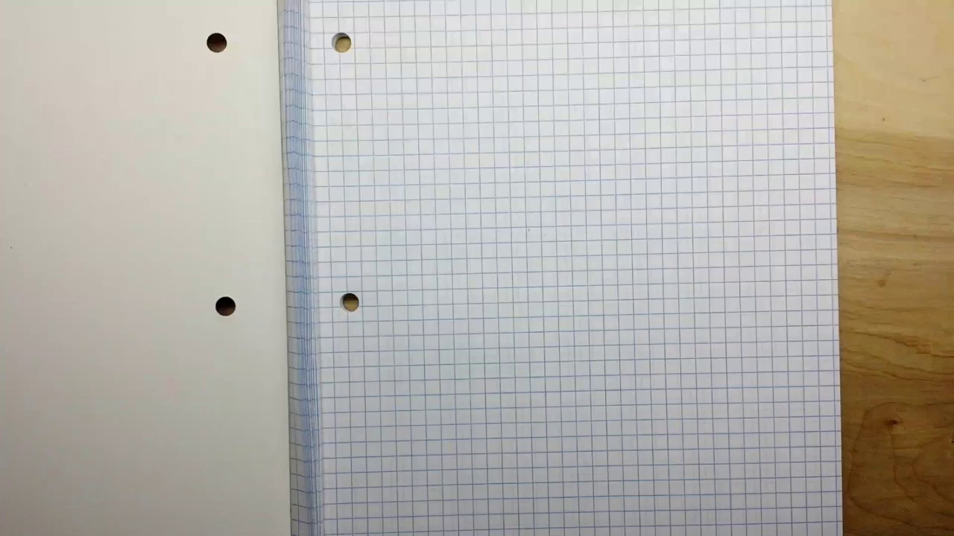 | 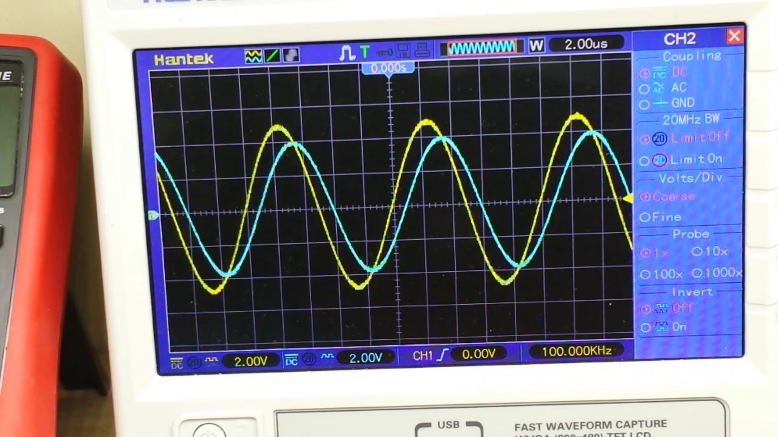 | 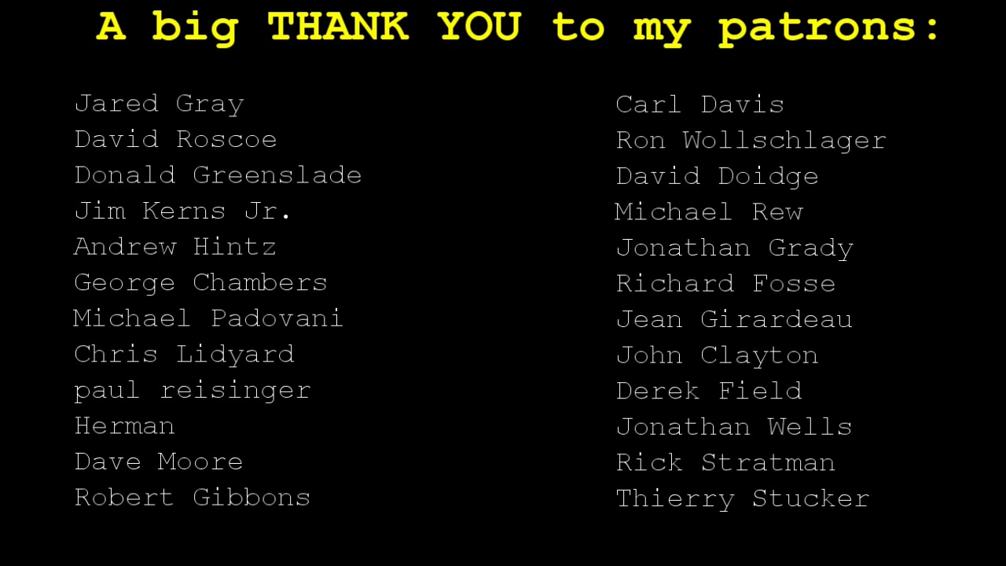
Description: Explanation on how capacitors operate, including charging and discharging times.
Correlated (true): 6 (19.4%)
Score >= 60: 6 (19.4%)
Average Score (of valid matches): 81.67

Top 5 Correlated Comments:
Score: 90
Comment: Fantastic, thank you so much! I have quite advanced knowledge of filters and the numerous possible configurations etc, building and partly designing a huge synthesizer is a mainstay and nessecity to know about them, and I've built quite a few different ones big and small. But the way you explained how the RC time -constant comes to be in one sentence really cleared away the mid on my understanding of exactly what makes it tick. 'The capacitor has no time to charge up to the top voltage at high frequency while it does at a lower '. Genius.
Reason: The comment directly discusses the operation of capacitors, specifically mentioning charging and discharging times (RC time-constant) and how they work at high and low frequencies, which is closely related to the topic description.
Source: https://www.youtube.com/watch?v=GqCn94Ksdbo

Score: 80
Comment: Thanks for the explanation! The constant is related to RC, but is there any difference between varying R and varying C on the end result?
Reason: The comment directly discusses capacitor operation (charging and discharging times), mentioning RC constant and varying R/C, which are all related to the topic's description of how capacitors operate.
Source: https://www.youtube.com/watch?v=GqCn94Ksdbo

Score: 80
Comment: Can you show how to calculate FC 1/2(pi)rc. No one really breaks it down completely. They always skip parts. I just don’t know how to calculate the formula. I’ve tried plugging in R and C but people say I’m wrong because I’m not adding powers but I don’t see any powers to add so I don’t get it.
Reason: The comment directly discusses capacitor operation (specifically, calculating FC 1/2(pi)rc), which is a key aspect of the topic. The mention of R and C also shows an understanding of the components involved in capacitor operation.
Source: https://www.youtube.com/watch?v=GqCn94Ksdbo

Score: 80
Comment: There are no powers, unless they mean calculating the reciprocal? Divide 1 by (2*pi*R*C). That's it. There are lots of low and high pass filter calculators online. Find one and plug some numbers in and then try to calculate it yourself.
Reason: The comment discusses charging and discharging times of capacitors, which is a key aspect of the topic description. Although it does not provide a direct explanation on how capacitors operate, it shows an understanding of capacitor-related concepts and encourages viewers to explore and calculate themselves, demonstrating a strong connection to the topic.
Source: https://www.youtube.com/watch?v=GqCn94Ksdbo

Score: 80
Comment: Does this work for the input from a radio antenna to occlude signals above/below a certain range? I know pass filters exist for them, but I'm not sure if just one resister-capacitor setup like this would work on something that's bringing in a whole spectrum of signals at once?
Reason: The comment mentions capacitors and resistors in the context of filtering signals, which is closely related to capacitor operation. Although it doesn't explicitly discuss charging and discharging times, the topic's focus on capacitor functionality is indirectly referenced.
Source: https://www.youtube.com/watch?v=GqCn94Ksdbo

Topic T2: Low Pass Filter Design
 |  | 
Description: Discussion on how to design a low pass filter using RC circuits and capacitors.
Correlated (true): 9 (29.0%)
Score >= 60: 9 (29.0%)
Average Score (of valid matches): 79.44

Top 5 Correlated Comments:
Score: 90
Comment: Can you show how to calculate FC 1/2(pi)rc. No one really breaks it down completely. They always skip parts. I just don’t know how to calculate the formula. I’ve tried plugging in R and C but people say I’m wrong because I’m not adding powers but I don’t see any powers to add so I don’t get it.
Reason: The comment directly discusses the calculation of a specific formula (FC = 1/2*pi*rc) related to low pass filter design, which is closely tied to the topic of designing low pass filters using RC circuits and capacitors.
Source: https://www.youtube.com/watch?v=GqCn94Ksdbo

Score: 90
Comment: https://youtu.be/GqCn94Ksdbo
Reason: The comment discusses a specific YouTube video on low pass filter design, which directly relates to the topic of designing low pass filters using RC circuits and capacitors.
Source: https://www.youtube.com/watch?v=GqCn94Ksdbo

Score: 85
Comment: Thanks Paul :) So, this is the thing that was in the DSL filter tiny box just a couple of low/high pass filters!
Can't believe it's that simple!
" In an electronic low-pass RC filter for voltage signals, high frequencies in the input signal are attenuated, but the filter has little attenuation below the cutoff frequency determined by its RC time constant. For current signals, a similar circuit, using a resistor and capacitor in parallel, works in a similar manner. (See current divider discussed in more detail below.)
Electronic low-pass filters are used on inputs to subwoofers and other types of loudspeakers, to block high pitches that they can't efficiently reproduce. Radio transmitters use low-pass filters to block harmonic emissions that might interfere with other communications. The tone knob on many electric guitars is a low-pass filter used to reduce the amount of treble in the sound. An integrator is another time constant low-pass filter.[2]
Telephone lines fitted with DSL splitters use low-pass and high-pass filters to separate DSL and POTS signals sharing the same pair of wires.[3][4]
Low-pass filters also play a significant role in the sculpting of sound created by analogue and virtual analogue synthesisers. See subtractive synthesis. " (source) https://en.wikipedia.org/wiki/Low-pass_filter#Electronics
Reason: The comment mentions specific details about low-pass filters, such as RC circuits, cutoff frequency, and applications in audio equipment (e.g., subwoofers, electric guitars), which directly relate to the topic of designing a low pass filter.
Source: https://www.youtube.com/watch?v=GqCn94Ksdbo

Score: 80
Comment: Fantastic, thank you so much! I have quite advanced knowledge of filters and the numerous possible configurations etc, building and partly designing a huge synthesizer is a mainstay and nessecity to know about them, and I've built quite a few different ones big and small. But the way you explained how the RC time -constant comes to be in one sentence really cleared away the mid on my understanding of exactly what makes it tick. 'The capacitor has no time to charge up to the top voltage at high frequency while it does at a lower '. Genius.
Reason: The comment directly discusses the RC time constant and its relationship to high frequency, which is a key concept in designing low pass filters as described in the topic. The comment also mentions building synthesizers, which may involve using filters, but the main focus is on the understanding of the RC time constant.
Source: https://www.youtube.com/watch?v=GqCn94Ksdbo

Score: 80
Comment: Does this work for the input from a radio antenna to occlude signals above/below a certain range? I know pass filters exist for them, but I'm not sure if just one resister-capacitor setup like this would work on something that's bringing in a whole spectrum of signals at once?
Reason: The comment directly discusses the application of a low pass filter to occlude signals above/below a certain range, which is closely related to designing a low pass filter using RC circuits and capacitors.
Source: https://www.youtube.com/watch?v=GqCn94Ksdbo

