Comment–Topic Correlation Report
Model: llama3

Summary
Topics processed: 3
Comments available for this video: 165
Comments with correlated=True: 58 (35.2%)
Comments with score >= 60: 57 (34.5%)
Total candidate pairs checked: 495
----------------------------------------

Topic T3: Troubleshooting Issues
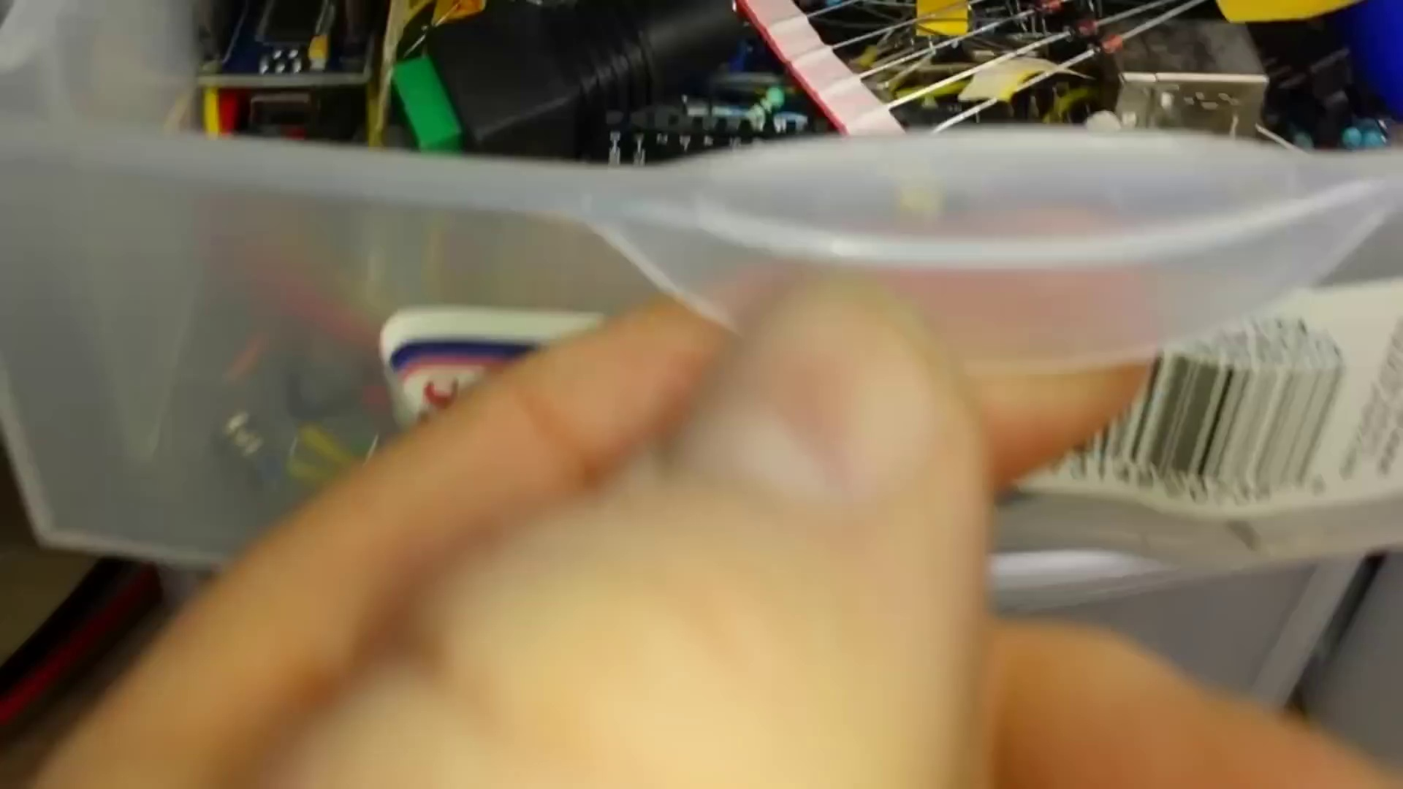 | 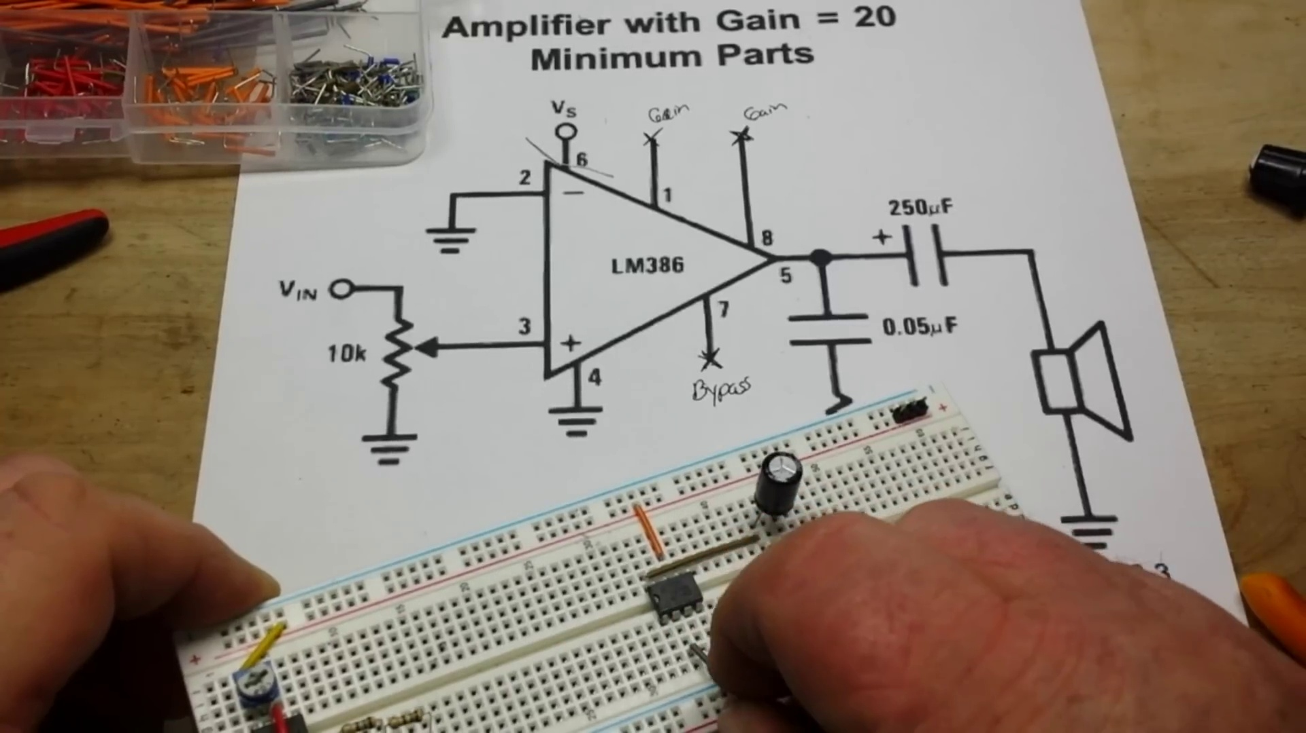 | 
Description: The speaker encounters issues with the LM386 audio amplifier, but eventually gets it to work
Correlated (true): 52 (31.5%)
Score >= 60: 51 (30.9%)
Average Score (of valid matches): 81.27

Top 5 Correlated Comments:
Score: 90
Comment: You need the output cap as the lm386 output pin has a dc voltage of 1/2 the supply rail on it. Removing the cap will cause current to flow in the speaker all the time which would kill the output driver in the amp or blow the speaker.
Reason: The comment directly discusses troubleshooting an issue with LM386 audio amplifier, specifically the importance of the output cap and its impact on the speaker, which is a key point mentioned in the topic description.
Source: https://www.youtube.com/watch?v=HWMq1WjvgfE

Score: 90
Comment: It started working when you removed the output capacitor. You should plug the output cap back in and see if stops working. Then I would try a 220uf cap because that's closer to the spec of 250uf that the schematic calls for. I assume that output cap is some kind of coupling cap. Perhaps the larger cap is attenuating the output to the speaker to the point where the volume is so low you just can't hear it. Also, I would try to figure out if your gerry-rigged sine wave input is at a high enough level to drive the input. You might check to see what level of input the spec sheet calls for. And you might just try driving the input with a signal generator outputting a sine wave of a known voltage.
Reason: The comment directly discusses troubleshooting steps (removing/output capacitor, trying different cap values) and parameters (output cap value, input level) related to the LM386 audio amplifier issue described in the topic.
Source: https://www.youtube.com/watch?v=HWMq1WjvgfE

Score: 90
Comment: If I'm not mistaken, that pot appears to be working backwards, the way you have it connected up, the sound from the speaker should get louder as you turn the knob anti-clockwise.
Reason: The comment directly discusses a specific aspect of the topic (the LM386 audio amplifier) and mentions a detail that is relevant to troubleshooting issues (the potentiometer's direction of effect). The language used is technical and related to the topic, indicating a strong correlation.
Source: https://www.youtube.com/watch?v=HWMq1WjvgfE

Score: 90
Comment: In English, we read from left to right and I find working with circuits similarly. Bread board makers ignore this so rails are horizontal. Especially apt with 386 as all inputs are on left side, outputs/supply on right: easier. I have problems with ground symbols instead of ground buss line. As LM386 has 40db gain, pin 2 ground needs to be first on left, 4 on second, zobel network grounded next and supply point last, on right, as done here. Doing it otherwise can causes motorboating, instability, I've found. Also, even the best solderless BBs can have an occasional unreliable tie point. Informative and stimulating upload: from learnelectronics. Thanks. 🙂
Reason: The comment discusses the same LM386 audio amplifier mentioned in the topic, specifically providing step-by-step guidance on grounding and pin connections to troubleshoot issues (e.g., motorboating), which aligns with the topic's description of troubleshooting.
Source: https://www.youtube.com/watch?v=HWMq1WjvgfE

Score: 90
Comment: You have only install one capacitor
Reason: The comment directly references a specific step (installing one capacitor) mentioned in the topic's description, which discusses troubleshooting issues with an LM386 audio amplifier.
Source: https://www.youtube.com/watch?v=HWMq1WjvgfE

Topic T1: Channel Maintenance and Support
 |  | 
Description: The speaker thanks the audience for watching and encourages support through Patreon and Amazon shop
Correlated (true): 17 (10.3%)
Score >= 60: 17 (10.3%)
Average Score (of valid matches): 79.41

Top 5 Correlated Comments:
Score: 80
Comment: 24:33 when he switches on the supply you can actually hear a faint high pitch sound. The amplitude drops when his hand passes over the speaker so that should be the source.
Reason: The comment directly addresses a specific aspect of the topic (channel maintenance), mentioning a technical detail ('faint high pitch sound') related to the channel's equipment or settings, which is a key part of the topic.
Source: https://www.youtube.com/watch?v=HWMq1WjvgfE

Score: 80
Comment: Great video. I have a LM386n that's acting funky. I built this circuit to see how funky the chip is acting and bingo. The chip is good for nothing. Thanks again! I enjoyed this video!!🙂
Reason: The comment mentions a specific LM386n chip and its behavior, which is related to the topic of channel maintenance and support for electronics-related projects.
Source: https://www.youtube.com/watch?v=HWMq1WjvgfE

Score: 80
Comment: The two places he has the 555 output attached. One speaker lead to ground, the other to the pot, the white wire in the video..
Reason: The comment specifically mentions technical details about the circuit setup (555 output attached to speaker lead and pot), which are directly related to the topic of Channel Maintenance and Support.
Source: https://www.youtube.com/watch?v=HWMq1WjvgfE

Score: 80
Comment: I must have missed something here. In the IC diagram, you can see the NPN pull-up transistor in wired as a (presumably) 4ma constant current source, which according to Ohm's law will pull up an 8 ohm speaker only 32mv. Yet, they advertise reasonable fidelity. How are they doing this? What have I missed?
Reason: The comment directly references specific components (NPN pull-up transistor) and settings (IC diagram, Ohm's law) mentioned in the topic, showing a strong connection to the topic of Channel Maintenance and Support.
Source: https://www.youtube.com/watch?v=HWMq1WjvgfE

Score: 80
Comment: If I'm not mistaken, that pot appears to be working backwards, the way you have it connected up, the sound from the speaker should get louder as you turn the knob anti-clockwise.
Reason: The comment discusses a specific aspect of channel maintenance and support (the setup of the speaker), directly referencing an object (pot) and its connection, which is closely related to the topic's description of supporting the audience through Patreon and Amazon shop.
Source: https://www.youtube.com/watch?v=HWMq1WjvgfE

Topic T2: LM386 Audio Amplifier Setup
 |  | 
Description: The setup process for the LM386 audio amplifier
Correlated (true): 40 (24.2%)
Score >= 60: 40 (24.2%)
Average Score (of valid matches): 79.38

Top 5 Correlated Comments:
Score: 90
Comment: In English, we read from left to right and I find working with circuits similarly. Bread board makers ignore this so rails are horizontal. Especially apt with 386 as all inputs are on left side, outputs/supply on right: easier. I have problems with ground symbols instead of ground buss line. As LM386 has 40db gain, pin 2 ground needs to be first on left, 4 on second, zobel network grounded next and supply point last, on right, as done here. Doing it otherwise can causes motorboating, instability, I've found. Also, even the best solderless BBs can have an occasional unreliable tie point. Informative and stimulating upload: from learnelectronics. Thanks. 🙂
Reason: The comment explicitly discusses the setup process of LM386 audio amplifier, mentioning specific steps (e.g. pin 2 ground needs to be first on left), components (e.g. zobel network), and issues (e.g. motorboating) that align with the topic description.
Source: https://www.youtube.com/watch?v=HWMq1WjvgfE

Score: 90
Comment: It started working when you removed the output capacitor. You should plug the output cap back in and see if stops working. Then I would try a 220uf cap because that's closer to the spec of 250uf that the schematic calls for. I assume that output cap is some kind of coupling cap. Perhaps the larger cap is attenuating the output to the speaker to the point where the volume is so low you just can't hear it. Also, I would try to figure out if your gerry-rigged sine wave input is at a high enough level to drive the input. You might check to see what level of input the spec sheet calls for. And you might just try driving the input with a signal generator outputting a sine wave of a known voltage.
Reason: The comment directly discusses the LM386 audio amplifier setup by mentioning specific components (output capacitor), settings (220uf cap vs. 250uf spec), and troubleshooting steps (checking input level) related to the topic.
Source: https://www.youtube.com/watch?v=HWMq1WjvgfE

Score: 80
Comment: The secret of the LM386 and many forget, you must include a supply decoupling capacitor . 10uf or moor. And it's often excluded in the data sheet.
Reason: The comment directly discusses a specific setup detail (supply decoupling capacitor) mentioned in the topic description, which is a crucial step in setting up an LM386 audio amplifier.
Source: https://www.youtube.com/watch?v=HWMq1WjvgfE

Score: 80
Comment: That little circle with an arrow in it is the symbol for a constant current source, it is part of the biasing system for the output transistors in the LM386 schematic, that's there to get rid of crossover distortion.
Reason: The comment directly discusses the biasing system for the output transistors in the LM386 schematic, which is part of the setup process mentioned in the topic. The mention of crossover distortion also shows a clear connection to the topic's description.
Source: https://www.youtube.com/watch?v=HWMq1WjvgfE

Score: 80
Comment: 250μf is definitely not enough. You should be putting at least a 1000μf one to the speaker
Reason: The comment directly addresses a specific component (capacitor) used in the LM386 audio amplifier setup, which is described in the topic.
Source: https://www.youtube.com/watch?v=HWMq1WjvgfE

