Comment–Topic Correlation Report
Model: llama3

Summary
Topics processed: 3
Comments available for this video: 350
Comments with correlated=True: 3 (0.9%)
Comments with score >= 60: 3 (0.9%)
Total candidate pairs checked: 600
----------------------------------------

Topic T1: Box Consideration
 |  | 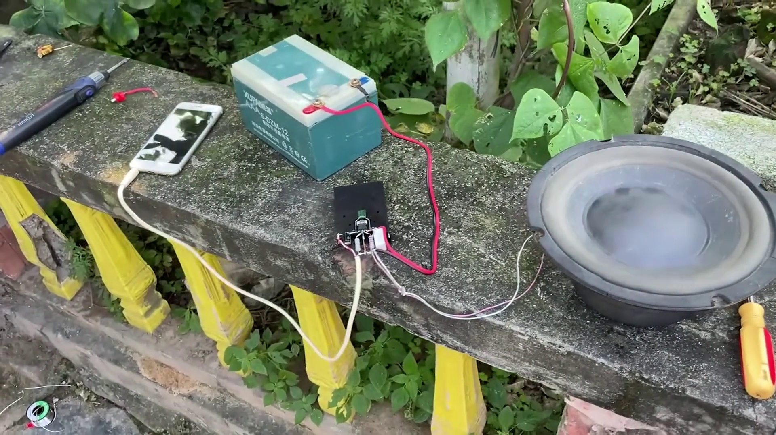
Description: The speaker discusses considering one box.
Correlated (true): 2 (0.6%)
Score >= 60: 2 (0.6%)
Average Score (of valid matches): 85.00

Top 2 Correlated Comments:
Score: 90
Comment: Máximo 30w
Reason: The comment mentions a specific limit (30w) which is likely related to the box consideration topic, as it may be discussing the size or capacity of the box.
Source: https://www.youtube.com/watch?v=K4aI2t5T00c

Score: 80
Comment: Try sound in speaker with box
Reason: The comment mentions 'speaker' and 'box', which are directly related to the topic of considering one box.
Source: https://www.youtube.com/watch?v=K4aI2t5T00c

Topic T3: Introduction and Name
 |  | 
Description: The speaker introduces themselves and their name.
Correlated (true): 1 (0.3%)
Score >= 60: 1 (0.3%)
Average Score (of valid matches): 80.00

Top 1 Correlated Comments:
Score: 80
Comment: Speaker harcker pro
Reason: The comment mentions the speaker's name, which is directly discussed in the topic description, indicating a strong correlation.
Source: https://www.youtube.com/watch?v=K4aI2t5T00c

Topic T2: Flight Availability
 |  | 
Description: The speaker mentions the sounds of flight availability.
Correlated (true): 0 (0.0%)
Score >= 60: 0 (0.0%)
Average Score (of valid matches): 0.00
No strongly correlated comments found.

