Comment–Topic Correlation Report
Model: llama3

Summary
Topics processed: 7
Comments available for this video: 20
Comments with correlated=True: 3 (15.0%)
Comments with score >= 60: 3 (15.0%)
Total candidate pairs checked: 140
----------------------------------------

Topic T5: LE One Setup
 | 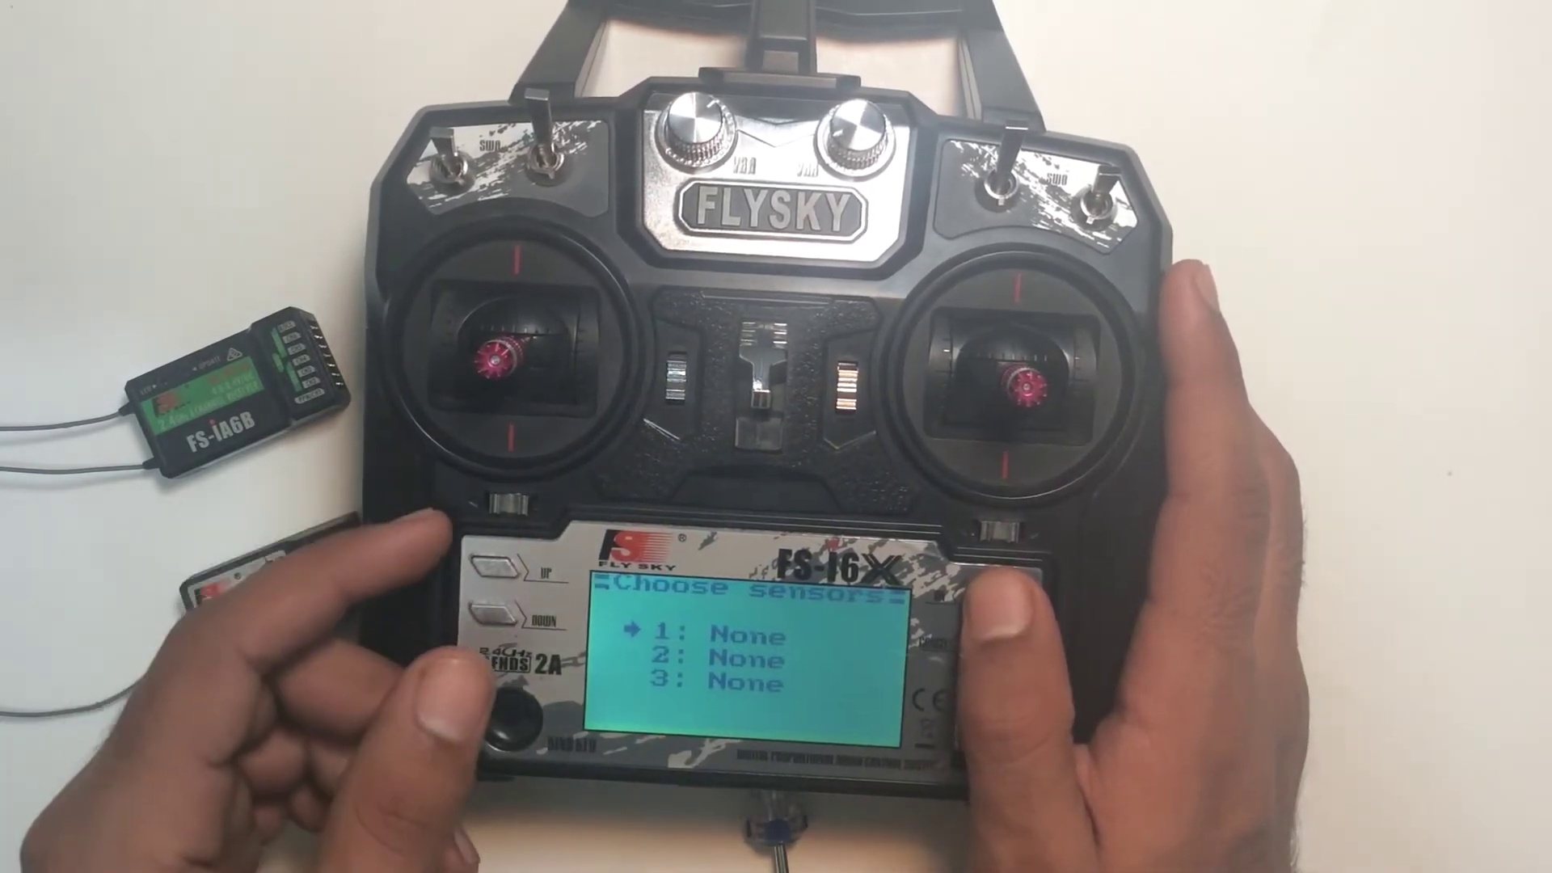 | 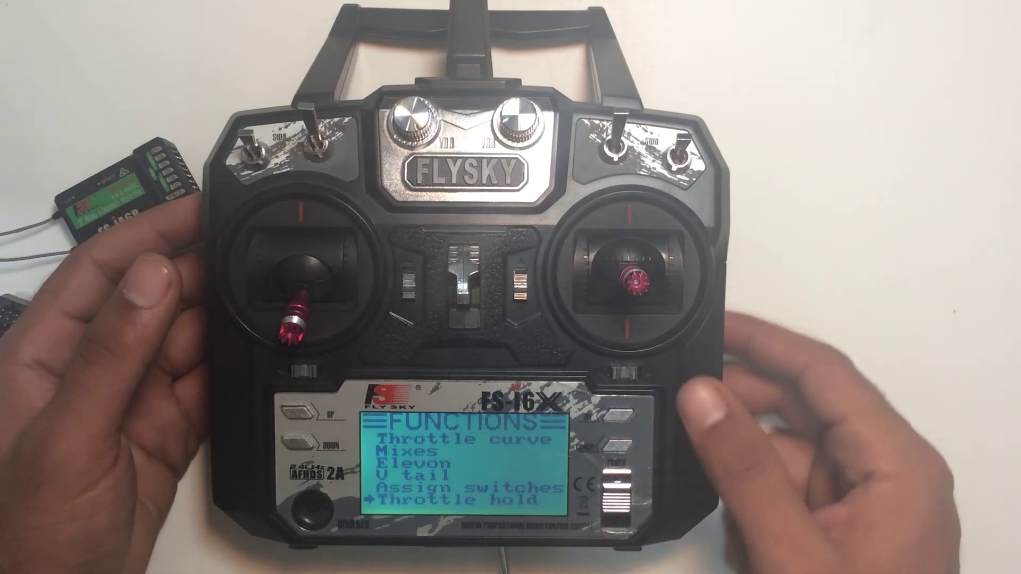
Description: Aircraft setup options
Correlated (true): 2 (10.0%)
Score >= 60: 2 (10.0%)
Average Score (of valid matches): 85.00

Top 2 Correlated Comments:
Score: 90
Comment: How to make the alieron and elevator mix ? For example when I turn left and right with the alieron I want the elavtor to move up aswell . instead when I turn to one side the elevator goes down and when I turn to the other side it goes up . how to make the elevator stay up when I turn both sides?
Reason: The comment directly discusses the alieron and elevator mix setup options described in the topic, which is a specific parameter mentioned in the description.
Source: https://www.youtube.com/watch?v=LYJDlz5w77Y

Score: 80
Comment: would it not be better to use for type select, use helicopter variable pitch for quads that are flying acro? or is the airplane/glider options still better or the same
Reason: The comment discusses a specific setup option (helicopter variable pitch for quads flying acro) and compares it to the airplane/glider options mentioned in the topic description, showing a strong connection between the topic and the viewer's comment.
Source: https://www.youtube.com/watch?v=LYJDlz5w77Y

Topic T4: Mixer Setup
 |  | 
Description: Master and slave channels for aircraft control
Correlated (true): 3 (15.0%)
Score >= 60: 3 (15.0%)
Average Score (of valid matches): 83.33

Top 3 Correlated Comments:
Score: 90
Comment: How to make the alieron and elevator mix ? For example when I turn left and right with the alieron I want the elavtor to move up aswell . instead when I turn to one side the elevator goes down and when I turn to the other side it goes up . how to make the elevator stay up when I turn both sides?
Reason: The comment directly discusses the mixing of aileron and elevator controls, which is closely related to the topic of 'Mixer Setup' for aircraft control.
Source: https://www.youtube.com/watch?v=LYJDlz5w77Y

Score: 80
Comment: BS! Of course you can!
Just adjust 1 of the POS or NEG values in the Mix to a - value and the other to a + value. Select to get the right response depending on whether you have your channels reversed.
Reason: The comment directly discusses adjusting values in the Mixer (POS or NEG) to achieve a specific response, which is related to the topic's description of master and slave channels for aircraft control.
Source: https://www.youtube.com/watch?v=LYJDlz5w77Y

Score: 80
Comment: would it not be better to use for type select, use helicopter variable pitch for quads that are flying acro? or is the airplane/glider options still better or the same
Reason: The comment mentions specific settings and parameters related to aircraft control (helicopter variable pitch for quads, airplane/glider options), which are directly discussed in the topic description about mixer setup for master and slave channels.
Source: https://www.youtube.com/watch?v=LYJDlz5w77Y

Topic T6: Assigned Switches
 |  | 
Description: Customizing switch functionality
Correlated (true): 1 (5.0%)
Score >= 60: 1 (5.0%)
Average Score (of valid matches): 80.00

Top 1 Correlated Comments:
Score: 80
Comment: BS! Of course you can!
Just adjust 1 of the POS or NEG values in the Mix to a - value and the other to a + value. Select to get the right response depending on whether you have your channels reversed.
Reason: The comment specifically mentions adjusting POS or NEG values in the Mix to customize switch functionality, which directly relates to the topic's description of customizing switch functionality.
Source: https://www.youtube.com/watch?v=LYJDlz5w77Y

Topic T1: Subtrim Settings
 |  | 
Description: Aligning control surfaces and tuning aircraft
Correlated (true): 1 (5.0%)
Score >= 60: 1 (5.0%)
Average Score (of valid matches): 80.00

Top 1 Correlated Comments:
Score: 80
Comment: How to make the alieron and elevator mix ? For example when I turn left and right with the alieron I want the elavtor to move up aswell . instead when I turn to one side the elevator goes down and when I turn to the other side it goes up . how to make the elevator stay up when I turn both sides?
Reason: The comment directly discusses the alignment of control surfaces (ailerons and elevator), which is a key aspect of 'Aligning control surfaces and tuning aircraft' as described in the topic.
Source: https://www.youtube.com/watch?v=LYJDlz5w77Y

Topic T7: Throttle Hold
 |  | 
Description: Automatically holding throttle at a set position
Correlated (true): 0 (0.0%)
Score >= 60: 0 (0.0%)
Average Score (of valid matches): 0.00
No strongly correlated comments found.

Topic T3: Throttle Curve
 |  | 
Description: How throttle increases upon movement
Correlated (true): 0 (0.0%)
Score >= 60: 0 (0.0%)
Average Score (of valid matches): 0.00
No strongly correlated comments found.

Topic T2: Dual Rate and Exponential Settings
 |  | 
Description: Sensitivity of controls
Correlated (true): 0 (0.0%)
Score >= 60: 0 (0.0%)
Average Score (of valid matches): 0.00
No strongly correlated comments found.

