Comment–Topic Correlation Report
Model: llama3

Summary
Topics processed: 6
Comments available for this video: 116
Comments with correlated=True: 38 (32.8%)
Comments with score >= 60: 38 (32.8%)
Total candidate pairs checked: 696
----------------------------------------

Topic T2: Master Multiplier Limitations
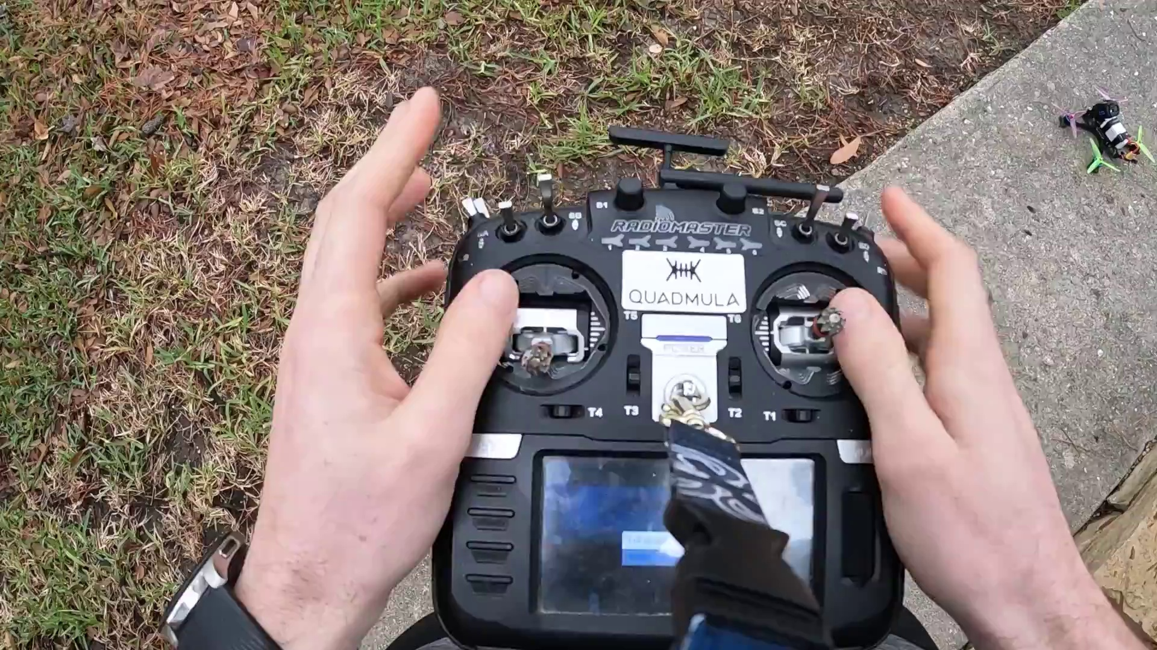 | 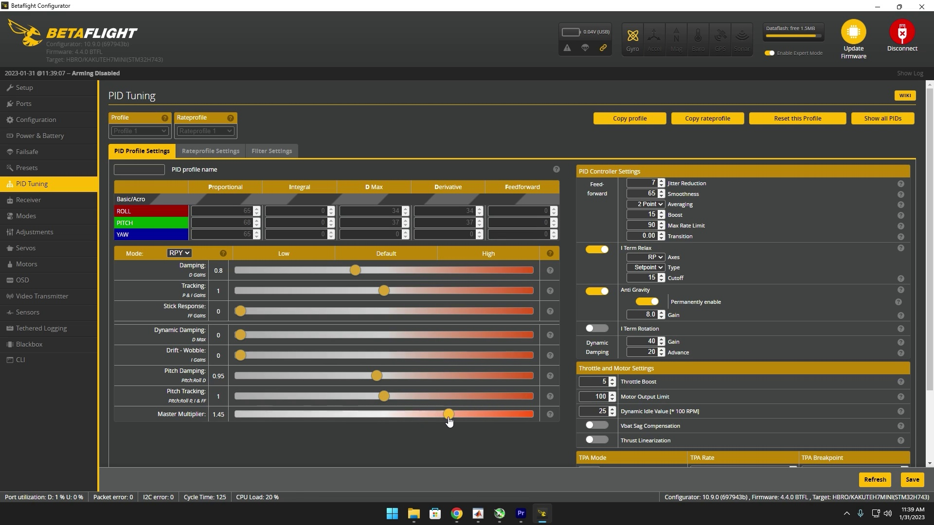 | 
Description: Determining the limit for master multiplier adjustments
Correlated (true): 12 (10.3%)
Score >= 60: 12 (10.3%)
Average Score (of valid matches): 80.83

Top 5 Correlated Comments:
Score: 90
Comment: i just found out that if you start noticing more and more oscilations as you push up the master multiplier, try lowering i term relax to middigate the oscilations coming from p term especially when anti gtavity kicks in. my master multiplier is at about 1.4, when id punch out it would go berserk with oscilations, the blackbox log showed p and d oscilatin in phase while i term was inverted, which means the quad was struggling to meet that setpoint, the antigravity feature was placing on it. so i lowered the iterm relax from 25 to 5 and that practically eliminated the issue! also antigrav gain is on 1.5 since my iterm is already crazy high, i might lower it
Reason: The comment directly discusses the limitations of master multiplier adjustments (specifically oscillations) and provides a solution to mitigate them by lowering iTerm relax. The topic title 'Master Multiplier Limitations' is explicitly addressed in the comment, making it strongly correlated.
Source: https://www.youtube.com/watch?v=N5DbiWFjbh8

Score: 80
Comment: Wouldn´t it make more sense for dynamic damping to decrease the D Gains rather than decreasing the master multiplier?
Reason: The comment mentions 'master multiplier', which is directly discussed in the topic title and description. The commenter's suggestion to adjust D Gains instead of the master multiplier also shows an understanding of the limitations being referred to.
Source: https://www.youtube.com/watch?v=N5DbiWFjbh8

Score: 80
Comment: nice tutorial! quick tip re Master multiplier. the ripple is oscillation (you'll see it in the dterm traces). Notice that it lower on pitch because there's more weight along that axis and it requires higher relative gains than roll, and you can see this in the latency difference between the two (pitch has higher/slower latency). what you wanna do in that case is bring roll only down until that ripple looks about the same as on pitch and their latency is approximately matched. then you know you have equal responsiveness on both axes. you'd do this by dropping the MM until roll only shows a small ripple then boost pitch PI and D to where it was before dropping the MM.
Reason: The comment directly discusses the limitations of Master Multiplier adjustments and how to determine its limits by matching latency and ripple patterns on pitch and roll axes.
Source: https://www.youtube.com/watch?v=N5DbiWFjbh8

Score: 80
Comment: That’s what I was thinking… as increasing the dynamic dampening would change the P:D balance that you found at the beginning.
Reason: The comment mentions 'dynamic dampening', which is likely related to the 'master multiplier' topic. The mention of 'P:D balance' and adjusting it also shows a strong connection to the topic description's focus on determining the limit for master multiplier adjustments.
Source: https://www.youtube.com/watch?v=N5DbiWFjbh8

Score: 80
Comment: Curious why you didn’t bother balancing the latency & ratios between axes prior to running mm test? I have a slightly different approach when I tune (always learning!), with an emphasis on balancing the latency between axes, prior to running up mm for latency reduction. Brain pointed out recently that what a lot of us have come to recognize as an over damped situation (rises to 1, then quickly undershoots and recovers) is actually the beginnings of an oscillation on that axis, relative to the pids on the other axis (typically roll relative to pitch, if I understood correctly).
Reason: The comment directly discusses the same topic of master multiplier adjustments and limitations, specifically mentioning latency reduction and balancing between axes, which are key concepts described in the topic. The mention of 'mm test' and 'pid's on other axis' also shows a strong connection to the topic.
Source: https://www.youtube.com/watch?v=N5DbiWFjbh8

Topic T6: Using PID toolbox for analysis
 |  | 
Description: The use of the PID toolbox software for analyzing and fine-tuning the PID settings for a quadcopter.
Correlated (true): 20 (17.2%)
Score >= 60: 20 (17.2%)
Average Score (of valid matches): 80.50

Top 5 Correlated Comments:
Score: 90
Comment: One important step is missing bro, you have to enable 100% pid controller for angle mode, stock value is 50%… if you fly angle for recording logs this step is essential…
Reason: The comment mentions PID settings and angle mode, which are directly discussed in the topic description. The mention of enabling a specific percentage for PID controller also shows strong overlap with the topic.
Source: https://www.youtube.com/watch?v=N5DbiWFjbh8

Score: 85
Comment: nice tutorial! quick tip re Master multiplier. the ripple is oscillation (you'll see it in the dterm traces). Notice that it lower on pitch because there's more weight along that axis and it requires higher relative gains than roll, and you can see this in the latency difference between the two (pitch has higher/slower latency). what you wanna do in that case is bring roll only down until that ripple looks about the same as on pitch and their latency is approximately matched. then you know you have equal responsiveness on both axes. you'd do this by dropping the MM until roll only shows a small ripple then boost pitch PI and D to where it was before dropping the MM.
Reason: The comment directly discusses PID settings, specifically Master multiplier and its impact on pitch and roll, which are the same steps described in the topic. The mention of 'dterm traces' and adjusting gains to match latency also demonstrates a strong relationship with the topic.
Source: https://www.youtube.com/watch?v=N5DbiWFjbh8

Score: 85
Comment: your graphs look the same with the I setting because I is not running during step-response thanks to i-therm relax
Reason: The comment directly discusses PID settings and their relation to I setting, which is a specific parameter mentioned in the topic description. The mention of step-response also overlaps with the topic's focus on analysis.
Source: https://www.youtube.com/watch?v=N5DbiWFjbh8

Score: 80
Comment: @JevinW if you move the drone with the pid controller at 50% pidtoolbox will read wrong values
Reason: The comment specifically mentions the PID controller and PID toolbox software, which are directly related to the topic's description of using the PID toolbox for analysis. The mention of moving the drone at 50% PID also highlights a specific setting mentioned in the topic.
Source: https://www.youtube.com/watch?v=N5DbiWFjbh8

Score: 80
Comment: Little late to this sorry, but make sure to launch PID Toolbox from where you installed it and not using a shortcut.
Reason: The comment directly addresses the usage of PID Toolbox, which is a critical step in the topic description's goal of analyzing and fine-tuning PID settings for a quadcopter. The only reason it's not a perfect match is that the comment focuses on technical details (launching the software from the correct location) rather than the actual analysis or tuning process.
Source: https://www.youtube.com/watch?v=N5DbiWFjbh8

Topic T4: Pitch Dampening
 |  | 
Description: Adjusting pitch dampening for under-damped response
Correlated (true): 11 (9.5%)
Score >= 60: 11 (9.5%)
Average Score (of valid matches): 80.45

Top 5 Correlated Comments:
Score: 90
Comment: i just found out that if you start noticing more and more oscilations as you push up the master multiplier, try lowering i term relax to middigate the oscilations coming from p term especially when anti gtavity kicks in. my master multiplier is at about 1.4, when id punch out it would go berserk with oscilations, the blackbox log showed p and d oscilatin in phase while i term was inverted, which means the quad was struggling to meet that setpoint, the antigravity feature was placing on it. so i lowered the iterm relax from 25 to 5 and that practically eliminated the issue! also antigrav gain is on 1.5 since my iterm is already crazy high, i might lower it
Reason: The comment discusses adjusting pitch dampening by lowering 'i term relax' to mitigate oscillations in the same context as the topic description, which mentions under-damped response and adjusting pitch dampening.
Source: https://www.youtube.com/watch?v=N5DbiWFjbh8

Score: 80
Comment: Curious why you didn’t bother balancing the latency & ratios between axes prior to running mm test? I have a slightly different approach when I tune (always learning!), with an emphasis on balancing the latency between axes, prior to running up mm for latency reduction. Brain pointed out recently that what a lot of us have come to recognize as an over damped situation (rises to 1, then quickly undershoots and recovers) is actually the beginnings of an oscillation on that axis, relative to the pids on the other axis (typically roll relative to pitch, if I understood correctly).
Reason: The comment mentions 'pitch dampening' and 'under-damped response', which are directly related to the topic's description about adjusting pitch dampening for under-damped response. The commenter also discusses balancing latency between axes, which is indirectly relevant to the topic of pitch dampening.
Source: https://www.youtube.com/watch?v=N5DbiWFjbh8

Score: 80
Comment: That’s what I was thinking… as increasing the dynamic dampening would change the P:D balance that you found at the beginning.
Reason: The comment specifically mentions increasing dynamic dampening and P:D balance, which is directly related to the topic of adjusting pitch dampening for under-damped response.
Source: https://www.youtube.com/watch?v=N5DbiWFjbh8

Score: 80
Comment: nice tutorial! quick tip re Master multiplier. the ripple is oscillation (you'll see it in the dterm traces). Notice that it lower on pitch because there's more weight along that axis and it requires higher relative gains than roll, and you can see this in the latency difference between the two (pitch has higher/slower latency). what you wanna do in that case is bring roll only down until that ripple looks about the same as on pitch and their latency is approximately matched. then you know you have equal responsiveness on both axes. you'd do this by dropping the MM until roll only shows a small ripple then boost pitch PI and D to where it was before dropping the MM.
Reason: The comment directly discusses pitch dampening and its relation to under-damped response, specifically mentioning the importance of matching latency and ripple on both axes. The mention of Master multiplier, PI, and D also shows a strong connection to the topic.
Source: https://www.youtube.com/watch?v=N5DbiWFjbh8

Score: 80
Comment: Wouldn´t it make more sense for dynamic damping to decrease the D Gains rather than decreasing the master multiplier?
Reason: The comment directly addresses a specific aspect of pitch dampening (dynamic damping), which is mentioned in the topic description. Although it doesn't exactly repeat the topic title and description, it's related to the concept of adjusting pitch dampening for an under-damped response.
Source: https://www.youtube.com/watch?v=N5DbiWFjbh8

Topic T3: Master Multiplier Settings
 |  | 
Description: Adjusting master multiplier for fast control links
Correlated (true): 15 (12.9%)
Score >= 60: 15 (12.9%)
Average Score (of valid matches): 80.33

Top 5 Correlated Comments:
Score: 90
Comment: nice tutorial! quick tip re Master multiplier. the ripple is oscillation (you'll see it in the dterm traces). Notice that it lower on pitch because there's more weight along that axis and it requires higher relative gains than roll, and you can see this in the latency difference between the two (pitch has higher/slower latency). what you wanna do in that case is bring roll only down until that ripple looks about the same as on pitch and their latency is approximately matched. then you know you have equal responsiveness on both axes. you'd do this by dropping the MM until roll only shows a small ripple then boost pitch PI and D to where it was before dropping the MM.
Reason: The comment directly discusses the master multiplier settings and how to adjust them for equal responsiveness on both axes, which is in line with the topic description about adjusting master multiplier for fast control links.
Source: https://www.youtube.com/watch?v=N5DbiWFjbh8

Score: 90
Comment: Curious why you didn’t bother balancing the latency & ratios between axes prior to running mm test? I have a slightly different approach when I tune (always learning!), with an emphasis on balancing the latency between axes, prior to running up mm for latency reduction. Brain pointed out recently that what a lot of us have come to recognize as an over damped situation (rises to 1, then quickly undershoots and recovers) is actually the beginnings of an oscillation on that axis, relative to the pids on the other axis (typically roll relative to pitch, if I understood correctly).
Reason: The comment directly discusses the same topic of master multiplier settings and tuning, mentioning specific concepts like latency, ratios, axes, and PIDs. The commenter also references the topic's goal of fast control links.
Source: https://www.youtube.com/watch?v=N5DbiWFjbh8

Score: 85
Comment: your graphs look the same with the I setting because I is not running during step-response thanks to i-therm relax
Reason: The comment directly discusses the master multiplier setting (I setting) and its relation to step-response, which is a key concept in the topic's description. The mention of 'i-therm relax' also shows an understanding of specific settings mentioned in the topic.
Source: https://www.youtube.com/watch?v=N5DbiWFjbh8

Score: 80
Comment: Wouldn´t it make more sense for dynamic damping to decrease the D Gains rather than decreasing the master multiplier?
Reason: The comment directly discusses the setting of 'master multiplier' and its relation to 'D Gains', which is a key concept in the topic's description about adjusting master multipliers for fast control links.
Source: https://www.youtube.com/watch?v=N5DbiWFjbh8

Score: 80
Comment: i just found out that if you start noticing more and more oscilations as you push up the master multiplier, try lowering i term relax to middigate the oscilations coming from p term especially when anti gtavity kicks in. my master multiplier is at about 1.4, when id punch out it would go berserk with oscilations, the blackbox log showed p and d oscilatin in phase while i term was inverted, which means the quad was struggling to meet that setpoint, the antigravity feature was placing on it. so i lowered the iterm relax from 25 to 5 and that practically eliminated the issue! also antigrav gain is on 1.5 since my iterm is already crazy high, i might lower it
Reason: The comment discusses the same settings (master multiplier) and mentions a specific issue with oscillations that is directly related to the topic's description of adjusting master multiplier for fast control links.
Source: https://www.youtube.com/watch?v=N5DbiWFjbh8

Topic T1: Flight testing
 |  | 
Description: The process of flying the quadcopter and testing its stability and performance.
Correlated (true): 29 (25.0%)
Score >= 60: 29 (25.0%)
Average Score (of valid matches): 80.17

Top 5 Correlated Comments:
Score: 90
Comment: i just found out that if you start noticing more and more oscilations as you push up the master multiplier, try lowering i term relax to middigate the oscilations coming from p term especially when anti gtavity kicks in. my master multiplier is at about 1.4, when id punch out it would go berserk with oscilations, the blackbox log showed p and d oscilatin in phase while i term was inverted, which means the quad was struggling to meet that setpoint, the antigravity feature was placing on it. so i lowered the iterm relax from 25 to 5 and that practically eliminated the issue! also antigrav gain is on 1.5 since my iterm is already crazy high, i might lower it
Reason: The comment directly discusses the stability and performance of a quadcopter in flight testing, mentioning specific parameters (master multiplier, i-term relax, anti-gravity gain) and their effects on oscillations, which is closely related to the topic's description.
Source: https://www.youtube.com/watch?v=N5DbiWFjbh8

Score: 80
Comment: I really appreciate you bringing value to the FPV community in an easy-to-understand way. I’m still wondering one thing: Do you test the quad in acro mode or angle mode?
Reason: The comment directly discusses flight testing (specifically, testing in acro mode or angle mode) which is strongly related to the topic description about flying and testing the quadcopter's stability and performance.
Source: https://www.youtube.com/watch?v=N5DbiWFjbh8

Score: 80
Comment: One important step is missing bro, you have to enable 100% pid controller for angle mode, stock value is 50%… if you fly angle for recording logs this step is essential…
Reason: The comment discusses the process of flight testing (enabling PID controller for angle mode), which is directly related to the topic's description of flying the quadcopter and testing its stability.
Source: https://www.youtube.com/watch?v=N5DbiWFjbh8

Score: 80
Comment: To adjust the PIDs, do you fly in acro or air?
Reason: The comment mentions 'flying', which is directly related to the topic of flight testing. Additionally, it specifically asks about adjusting PIDs, which is a crucial aspect of quadcopter performance testing mentioned in the topic description.
Source: https://www.youtube.com/watch?v=N5DbiWFjbh8

Score: 80
Comment: First of all, thank you a lot for your tutorial. Your quad is clean, why do you need so much filtering (I think you have defaults)? Do you use RPM filtering? Did you try to disable Gyro LPF and Yaw LPF? What values do you see in PIDToolbox -> Spectral Analyzer -> filter delay?
Reason: The comment directly discusses the same steps (flight testing) and parameters (RPM filtering, Gyro LPF, Yaw LPF) described by the topic.
Source: https://www.youtube.com/watch?v=N5DbiWFjbh8

Topic T5: Tuning PID for quadcopter
 |  | 
Description: The process of fine-tuning the PID (proportional-integral-derivative) settings for a quadcopter to achieve stable flight.
Correlated (true): 30 (25.9%)
Score >= 60: 30 (25.9%)
Average Score (of valid matches): 80.17

Top 5 Correlated Comments:
Score: 90
Comment: To adjust the PIDs, do you fly in acro or air?
Reason: The comment directly references tuning PIDs, which is the main topic of discussion. The mention of flying in acro or air mode to adjust PIDs indicates a specific scenario and setting, showing strong correlation with the topic.
Source: https://www.youtube.com/watch?v=N5DbiWFjbh8

Score: 90
Comment: nice tutorial! quick tip re Master multiplier. the ripple is oscillation (you'll see it in the dterm traces). Notice that it lower on pitch because there's more weight along that axis and it requires higher relative gains than roll, and you can see this in the latency difference between the two (pitch has higher/slower latency). what you wanna do in that case is bring roll only down until that ripple looks about the same as on pitch and their latency is approximately matched. then you know you have equal responsiveness on both axes. you'd do this by dropping the MM until roll only shows a small ripple then boost pitch PI and D to where it was before dropping the MM.
Reason: The comment directly discusses PID settings for a quadcopter, mentioning specific aspects like Master multiplier, dterm traces, pitch and roll axes, and latency differences. It provides actionable advice on how to fine-tune the settings for stable flight, matching the topic's description of tuning PID settings.
Source: https://www.youtube.com/watch?v=N5DbiWFjbh8

Score: 90
Comment: any idea how to lower the latency on pitch axes? what should i add? the difference is quite significat.. around 25/30%
Reason: The comment directly asks about tuning PID settings for a quadcopter's pitch axis, which is strongly related to the topic of fine-tuning PID settings for stable flight.
Source: https://www.youtube.com/watch?v=N5DbiWFjbh8

Score: 85
Comment: you can see some drift in the horizon on the throttle blips, maybe it need some more D term on the Roll axis.
Reason: The comment specifically mentions tuning PID settings for a quadcopter, referencing the 'D term on the Roll axis', which is directly related to the topic's description of fine-tuning PID settings.
Source: https://www.youtube.com/watch?v=N5DbiWFjbh8

Score: 80
Comment: @JevinW if you move the drone with the pid controller at 50% pidtoolbox will read wrong values
Reason: The comment mentions PID controller and PID toolbox, which are directly related to the topic of tuning PID for a quadcopter. The mention of reading wrong values at 50% also implies a specific setting or parameter being discussed, which is consistent with the topic's focus on fine-tuning PID settings.
Source: https://www.youtube.com/watch?v=N5DbiWFjbh8

