Comment–Topic Correlation Report
Model: llama3

Summary
Topics processed: 3
Comments available for this video: 26
Comments with correlated=True: 15 (57.7%)
Comments with score >= 60: 15 (57.7%)
Total candidate pairs checked: 78
----------------------------------------

Topic T2: Improved H-Bridge Motor Control
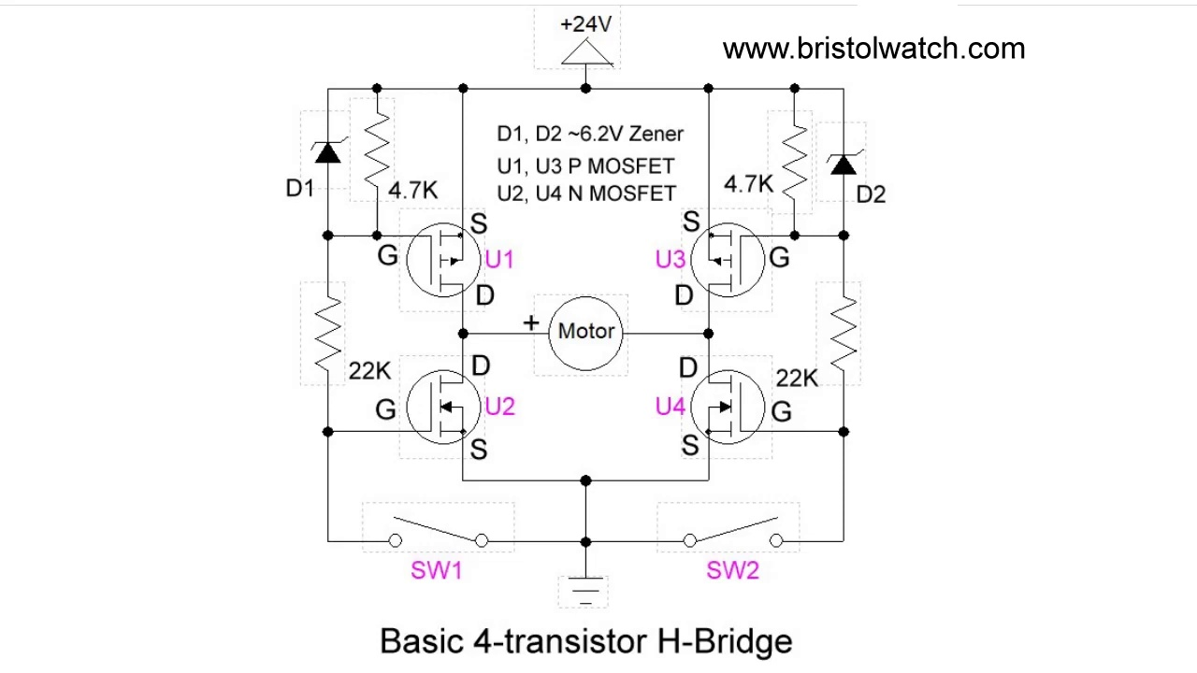 | 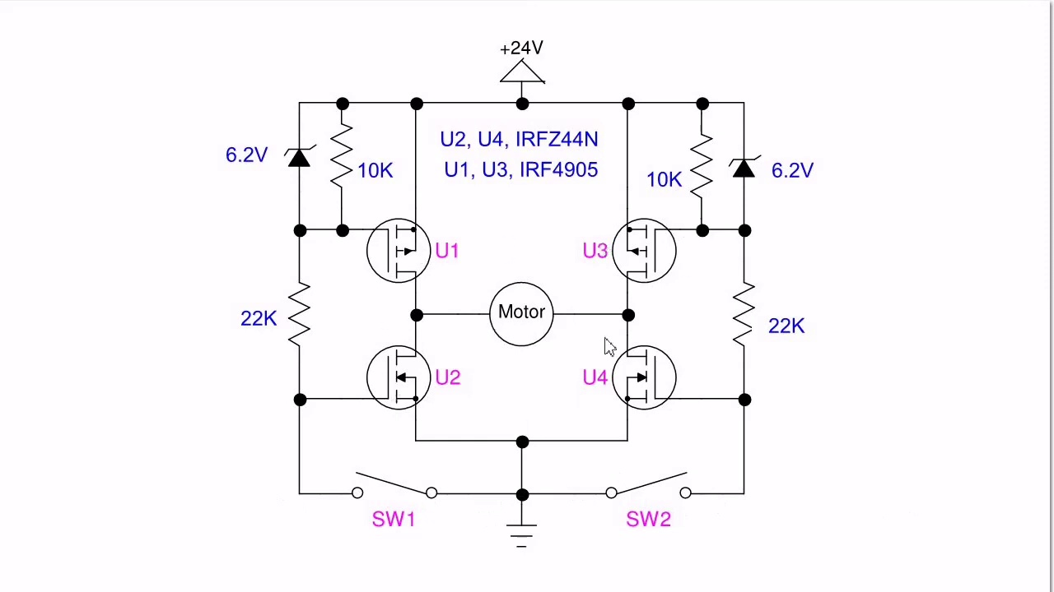 | 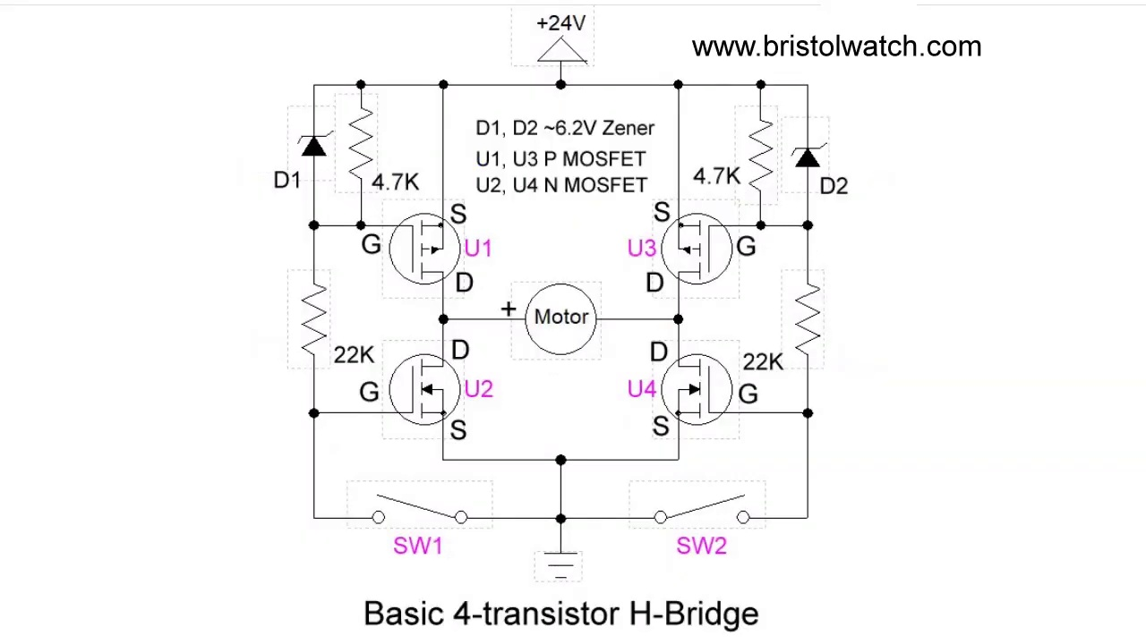
Description: The speaker presents an improved version of a previously published H-Bridge motor control circuit, highlighting its enhancements.
Correlated (true): 11 (42.3%)
Score >= 60: 11 (42.3%)
Average Score (of valid matches): 80.45

Top 5 Correlated Comments:
Score: 85
Comment: such as you think plausible candidates...they will be operating in the linear region..i.e. their voltage output varies linearly with intensity..
A Mosfet gate will " switch" its output efficiently provided its gate is above a certain threshold..below that it may exhibit a sluggish response and will be operating in it's Ohmic region...yet not considering the current drive capability of the photo voltaic device..
Also unknown is the impedance the g-s sees when the drive voltage is too low or below operating threshold.....
If it's impedance is too high or open circuited the gate will charge up due to the drain-gate capacitance& turn the device on unintentionally..that can lead to it's destruction.
Reason: The comment directly discusses the characteristics and limitations of H-Bridge motor control, specifically mentioning the Mosfet gate's response in different regions (linear, Ohmic) and its impedance, which is strongly related to the topic of improved H-Bridge motor control.
Source: https://www.youtube.com/watch?v=NQvVeLHzfSs

Score: 80
Comment: Your older H-bridge designs is what brought me to your channel.
My current project is improving the speed control on a milling machine power feed. These use universal motors, and are just SCR half wave controlled. Reversing is done with micro switches the reverse the connection of the field coils. Once I figured out that a H-bridge will not reverse the motor (I thought universal motors worked the same as PM motors), now I'm back to an improved PWM design that is much faster then 60Hz.
The problem with all these power feed after market units, the sweet spot on the speed potentiometer is so very small, from not rotating to too fast. I'm going to use an encoder so there will be feedback in the system. This will also let me have electronic limit switch end points.
So I can use a DPDT relay to switch the field coil, or figure out a solid state one. The direction change would only occur when the current is zero, so arching of relay contacts will not be an issue. I just think solid state is the way to do this. And that is effectively an H-bridge. And would be the design you have in this video.
I'm a retired EE, 10 years now.
Reason: The comment discusses the same concept of H-Bridge motor control, specifically highlighting its limitations and improvements over previous designs. The mention of universal motors and PWM design aligns with the topic's focus on H-Bridge motor control.
Source: https://www.youtube.com/watch?v=NQvVeLHzfSs

Score: 80
Comment: Does it have PWM control? Can a 40 amp motor be driven in this circuit?
Reason: The comment directly references specific components (PWM control) and parameters (40 amp motor) mentioned in the topic description, indicating a strong connection to the topic.
Source: https://www.youtube.com/watch?v=NQvVeLHzfSs

Score: 80
Comment: @LewisLoflin bts7960 b
Can I use it instead of this circuit? I use rpwm and lpwm terminals. Do you think the engine will switch right and left momentarily? Can it handle the circuit? Thank you.
Reason: The comment directly asks about using the improved H-Bridge motor control circuit (mentioned in the topic) and its capabilities to handle specific terminals (rpwm and lpwm), which shows a strong connection to the topic's description.
Source: https://www.youtube.com/watch?v=NQvVeLHzfSs

Score: 80
Comment: Yes PWM can work. Yes a 40-amp motor will work if the MOSFETs can handle it and the voltage is no higher than 20V.
Reason: The comment mentions specific details related to the topic, such as PWM and MOSFETs, which are crucial components of H-Bridge motor control. The mention of voltage (20V) and current (40-amp) also shows a direct connection to the topic's description of an improved motor control circuit.
Source: https://www.youtube.com/watch?v=NQvVeLHzfSs

Topic T3: MOSFET Selection
 |  | 
Description: The speaker discusses the selection of MOSFETs used in the H-Bridge circuit, highlighting their specific characteristics.
Correlated (true): 12 (46.2%)
Score >= 60: 12 (46.2%)
Average Score (of valid matches): 80.00

Top 5 Correlated Comments:
Score: 80
Comment: Hello Sir, I would like to ask a question about MOSFETs.... I'm trying to add a remote on and off switching to a 12vdc lamp. I'm trying to use a tsop1730 receiver which will drive a pnp transistor that connect to the 12v in order to power the lamp.I found that the light just flicker rapidly but doesn't stay on. So thinking and looking for a solution, I thought replacing the transistor with a pnp mosfet will do the job. I just not sure if will be possible, perhaps there is a simpler better solution to accomplish the on and off switching. Any help or advice will be appreciated very much. Thank you
Reason: The comment directly discusses MOSFETs in the context of an H-Bridge circuit, specifically considering their use as a replacement for a transistor to control a lamp's power. The topic's description of selecting MOSFETs for this application is closely related to the commenter's concerns and potential solutions.
Source: https://www.youtube.com/watch?v=NQvVeLHzfSs

Score: 80
Comment: such as you think plausible candidates...they will be operating in the linear region..i.e. their voltage output varies linearly with intensity..
A Mosfet gate will " switch" its output efficiently provided its gate is above a certain threshold..below that it may exhibit a sluggish response and will be operating in it's Ohmic region...yet not considering the current drive capability of the photo voltaic device..
Also unknown is the impedance the g-s sees when the drive voltage is too low or below operating threshold.....
If it's impedance is too high or open circuited the gate will charge up due to the drain-gate capacitance& turn the device on unintentionally..that can lead to it's destruction.
Reason: The comment directly discusses the selection of MOSFETs, mentioning their operating regions (linear and Ohmic), gate characteristics, and potential issues like impedance mismatch, which are all specific topics covered in the topic description about H-Bridge circuit MOSFET selection.
Source: https://www.youtube.com/watch?v=NQvVeLHzfSs

Score: 80
Comment: Yes. When both switches are off the MOSFETs switch to ground.
Reason: The comment directly discusses the switching behavior of MOSFETs in an H-Bridge circuit, which is a key aspect of selecting MOSFETs for this application. The mention of both switches being off and the MOSFETs switching to ground shows strong overlap with the topic description's focus on specific characteristics.
Source: https://www.youtube.com/watch?v=NQvVeLHzfSs

Score: 80
Comment: @LewisLoflin bts7960 b
Can I use it instead of this circuit? I use rpwm and lpwm terminals. Do you think the engine will switch right and left momentarily? Can it handle the circuit? Thank you.
Reason: The comment mentions specific MOSFET characteristics (e.g. 'bts7960') and discusses its use in a circuit ('H-Bridge'), showing strong relevance to the topic of MOSFET selection for an H-Bridge circuit.
Source: https://www.youtube.com/watch?v=NQvVeLHzfSs

Score: 80
Comment: What a bliss to have found your channel. Subscribed when I came across the photovoltaic optocoupler video of yours, we are lucky to have such good content online! This here is the standard CMOS implementation, MOSFETS requiring a P on top and an N at the bottom, naturally forming a NOT gate, with field effect transistors. I love you have extended it to allow for higher voltages that the MOSFET gates natively tolerate, in the standard CMOS implementation, you don't even have those as your rail is always within the region, and the silicon goes as fast as it can. One could ofcouse manufacture a p and a n mosfet with a thicker gate insulator to allow for 30 volts of input, and in that configuration nothing else is needed except the transistors and how you lay them to do any logic. I have three videos on the complete design starting with the CMOS not gate and then the AND and the OR on my channel, if you have a look you will see we have no mercy on the transistors, all gates are either connected to the up or the down rail directly. Best regards, happy to see so nicely made videos :)
Reason: The comment directly discusses the selection of MOSFETs in H-Bridge circuit and their characteristics, mentioning specific details like P-N layers and voltage tolerance, which strongly relates to the topic.
Source: https://www.youtube.com/watch?v=NQvVeLHzfSs

Topic T1: H-Bridge Circuit Schematic
 |  | 
Description: The speaker shares the schematic for the H-Bridge circuit, showing its components and layout.
Correlated (true): 13 (50.0%)
Score >= 60: 13 (50.0%)
Average Score (of valid matches): 80.00

Top 5 Correlated Comments:
Score: 80
Comment: Your older H-bridge designs is what brought me to your channel.
My current project is improving the speed control on a milling machine power feed. These use universal motors, and are just SCR half wave controlled. Reversing is done with micro switches the reverse the connection of the field coils. Once I figured out that a H-bridge will not reverse the motor (I thought universal motors worked the same as PM motors), now I'm back to an improved PWM design that is much faster then 60Hz.
The problem with all these power feed after market units, the sweet spot on the speed potentiometer is so very small, from not rotating to too fast. I'm going to use an encoder so there will be feedback in the system. This will also let me have electronic limit switch end points.
So I can use a DPDT relay to switch the field coil, or figure out a solid state one. The direction change would only occur when the current is zero, so arching of relay contacts will not be an issue. I just think solid state is the way to do this. And that is effectively an H-bridge. And would be the design you have in this video.
I'm a retired EE, 10 years now.
Reason: The commenter explicitly mentions the H-Bridge circuit and its application in their project to improve speed control on a milling machine power feed, which directly overlaps with the topic's description of the H-Bridge schematic.
Source: https://www.youtube.com/watch?v=NQvVeLHzfSs

Score: 80
Comment: @LewisLoflin bts7960 b
Can I use it instead of this circuit? I use rpwm and lpwm terminals. Do you think the engine will switch right and left momentarily? Can it handle the circuit? Thank you.
Reason: The comment directly discusses a specific aspect of the H-Bridge circuit (using rpwm and lpwm terminals) and asks about its feasibility for switching the engine's direction. The topic description mentions the circuit's components and layout, which are relevant to the commenter's inquiry.
Source: https://www.youtube.com/watch?v=NQvVeLHzfSs

Score: 80
Comment: @LewisLoflin thats good.. something I overlooked..so it's in
" brake" mode when OFF 👍
Reason: The comment directly discusses the H-Bridge circuit schematic, mentioning its mode ('brake' mode when OFF) which aligns with the topic's description of the layout and components.
Source: https://www.youtube.com/watch?v=NQvVeLHzfSs

Score: 80
Comment: Yes. When both switches are off the MOSFETs switch to ground.
Reason: The comment directly discusses a specific aspect of the H-Bridge circuit schematic, mentioning the behavior of MOSFETs when both switches are off. This shows strong correlation with the topic.
Source: https://www.youtube.com/watch?v=NQvVeLHzfSs

Score: 80
Comment: Thanks.
Maybe use photovoltaic optocouplers to allow use of identical n-channels on both low and high side.
Reason: The comment mentions the H-Bridge circuit, specifically discussing its design and possible optimization (using photovoltaic optocouplers), which strongly relates to the topic description of sharing a schematic for the same circuit.
Source: https://www.youtube.com/watch?v=NQvVeLHzfSs

