Comment–Topic Correlation Report
Model: llama3

Summary
Topics processed: 3
Comments available for this video: 335
Comments with correlated=True: 88 (26.3%)
Comments with score >= 60: 88 (26.3%)
Total candidate pairs checked: 600
----------------------------------------

Topic T1: Amplifier Performance
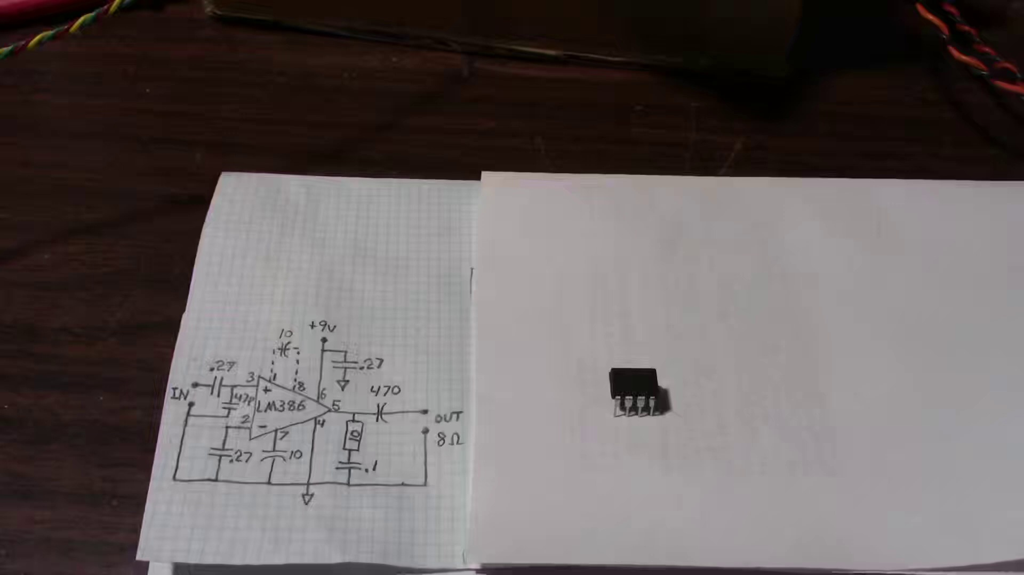 | 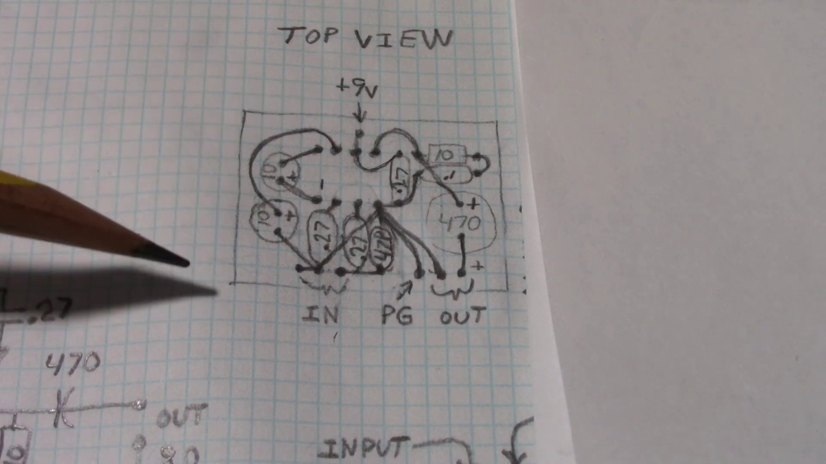 | 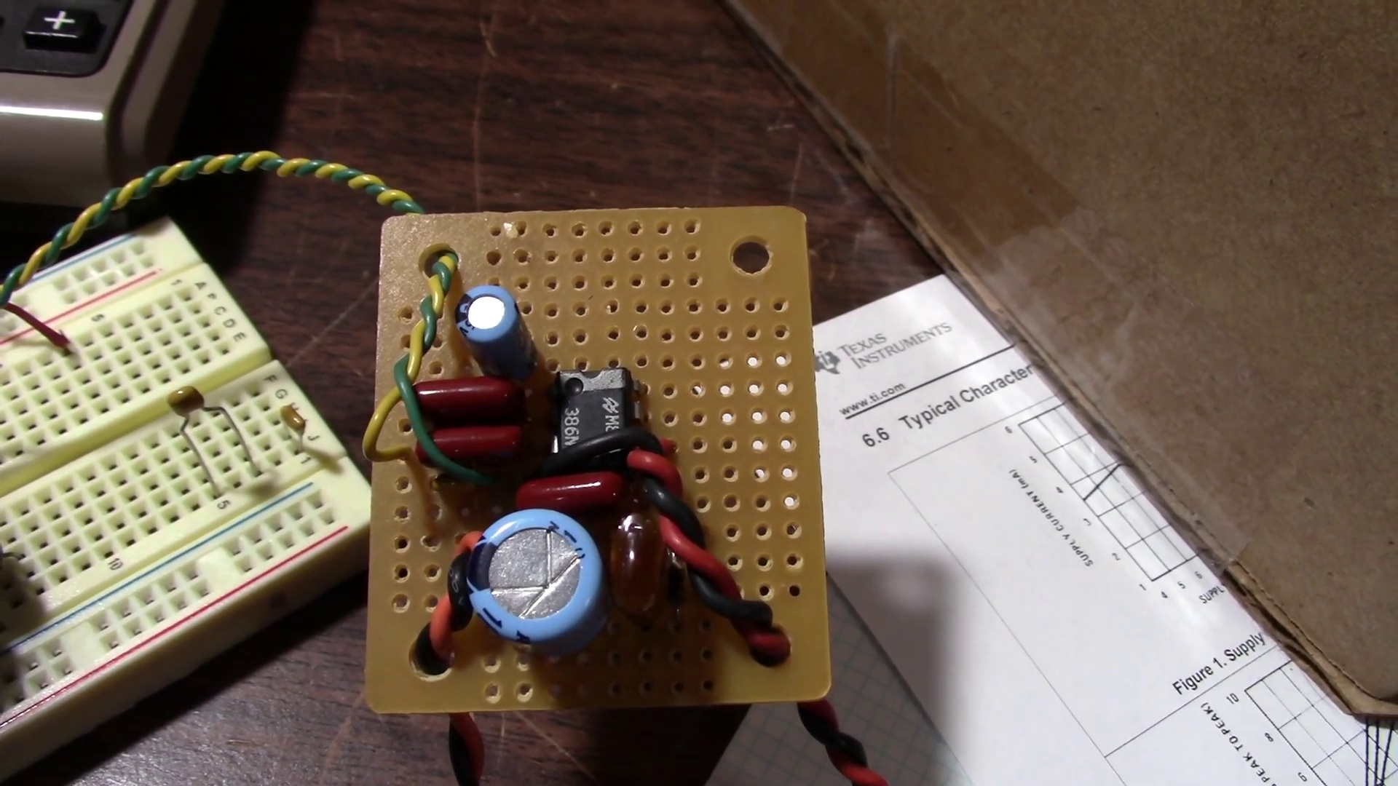
Description: The analyst tests the amplifier's performance, discussing its output power and distortion.
Correlated (true): 65 (19.4%)
Score >= 60: 65 (19.4%)
Average Score (of valid matches): 80.38

Top 5 Correlated Comments:
Score: 90
Comment: I used to make these as headphone booster amps for Walkmans. But I found the bass response was better if i used 2200uf decoupling capacitors on the output. Got bloody loud with some JVC over the ear headphones. They were rated nearly a watt of input power !
Reason: The comment directly mentions the amplifier's performance and output power, referencing specific details such as distortion, bass response, and decoupling capacitors. The mention of headphone booster amps and Walkmans also shows a connection to the topic of amplifier testing.
Source: https://www.youtube.com/watch?v=P4GsoMTv-SY

Score: 90
Comment: Because of internal current limit, the amplifier would actually produce more power into a 16Ω load, than 8Ω with a 12 volt supply. I consider that to be an absolute maximum voltage, and would not use that much in an amplifier design. At 9 volts supply, it really is best at 8 Ohms. According to the graph, the amplifier output seems to current limit at 375 milliamps. If the amp would maintain this current limit with a 4 volt power supply, it would fully drive the 4Ω load.
Reason: The comment directly discusses amplifier performance, mentioning output power, distortion, and current limiting, which are all relevant concepts in the topic description.
Source: https://www.youtube.com/watch?v=P4GsoMTv-SY

Score: 90
Comment: The frequency sweep shows a hint of crossover distortion appearing above about 10kHz, a combination of inadequate bias on the output (to give low quiescent current) and starting to run out of open loop gain. As you mentioned, configuring these little amps for high gain makes performance worse in pretty much every respect and should be avoided for any application were reasonable audio quality is desired.
Reason: The comment directly discusses the performance of an amplifier, mentioning specific parameters like output power and distortion, as well as settings like bias and open loop gain. The mention of 'crossover distortion' also aligns with the topic's description.
Source: https://www.youtube.com/watch?v=P4GsoMTv-SY

Score: 90
Comment: A perfect one needs an input op amp and a common negative feedback loop. Then you'll see 0.001% THD instead of 1.4%
Reason: The comment directly discusses amplifier performance (output power and distortion) mentioned in the topic description. The mention of THD (total harmonic distortion) and negative feedback loop are specific overlaps that strongly relate to the topic.
Source: https://www.youtube.com/watch?v=P4GsoMTv-SY

Score: 85
Comment: Nope, at least not when loaded with 8 Ohms. As explained in the video @8:00 the amp can hardly provide any more current. The increased load would lead to a significant voltage drop at each output stage, only causing more distortion.
Reason: The comment discusses the amplifier's performance, specifically mentioning output power and distortion, which are topics directly addressed in the description. The mention of load, voltage drop, and current also aligns with the analysis described in the topic.
Source: https://www.youtube.com/watch?v=P4GsoMTv-SY

Topic T3: Capacitor Effect
 |  | 
Description: The analyst shows how using the capacitor from the inverting input to ground affects the amplifier's output and reduces clipping.
Correlated (true): 46 (13.7%)
Score >= 60: 46 (13.7%)
Average Score (of valid matches): 80.11

Top 5 Correlated Comments:
Score: 90
Comment: @JohnAudioTech At many very high frequencies that might cause oscillations, the 0.27uF capacitor will be past resonance and may have a higher impedance than the 47pf capacitor... But I concede this is a minor detail. Thanks for the great video!
Reason: The comment directly mentions specific details about the capacitor (0.27uF and 47pf) and its effects on amplifier output, aligning with the topic's description of reducing clipping.
Source: https://www.youtube.com/watch?v=P4GsoMTv-SY

Score: 90
Comment: Doing that would block the DC current. The cap must be connected between Vcc and ground.
Reason: The comment directly addresses the impact of capacitor connection on DC current (mentioned in the topic), and provides specific correction to the original idea ('from inverting input to ground') with its own insight ('must be connected between Vcc and ground').
Source: https://www.youtube.com/watch?v=P4GsoMTv-SY

Score: 85
Comment: I'd want you to analyze and try one thing as well. I found this site:
https://hackaday.com/2016/12/07/you-can-have-my-lm386s-when-you-pry-them-from-my-cold-dead-hands/
That says to use the inverting input for the audio input instead of the non-inverting, saying "We’ve also noticed, and we’re not alone, that the inverting input seems to be less noisy than the non-inverting. See how the datasheet applications ground the inverting input (pin 2) and put the signal into pin 3? Do exactly the opposite and you’ll reduce your noise floor even further."
Would and could you then also connect the non-inverting input to the ground with the capacitor as you did in your video and would it improve anything then?
And maybe try out bridging the LM386 as well. I've found couple of schematics that promise 2W in bridge configuration.
https://www.eleccircuit.com/lm386-amplifier-stereo-2-watts/
Looking forward for your response as I am currently in the middle of building a lm386 stereo amp as my main computer speaker system.
I chose to do this because it makes it simpler for me, not to always click and setup everything on my music centre.
The Sanyo music centre tends to be quite muddy sounding compared to lm386 that sounds the best to my ears compared to all my cheap factory amps
I have actual computer speakers from 90's that are great but clumsy shaped and sound muddy and have a huge wall wart PSU
I have a pioneer car stereo that sounds great but doesn't remember the settings with the 12V PSU removed and is too digital and bothersome to set up every time
I will learn a bunch from building my own simple amp and I can always tinker with it
It's so cheap :D 5 chips from aliexpress for under a dollar.
Reason: The comment discusses the use of the inverting input and the effect of grounding it on noise reduction, which is directly related to the topic 'Capacitor Effect' that describes how using the capacitor from the inverting input to ground affects the amplifier's output.
Source: https://www.youtube.com/watch?v=P4GsoMTv-SY

Score: 85
Comment: At 6:30 you discuss an output coupling capacitor of 470 “ohms”. Expecting to see something like 470 uf. Is that correct?
Reason: The comment specifically references a concept described in the topic (output coupling capacitor) and asks about its value, which is directly related to the topic's discussion of capacitors affecting amplifier output.
Source: https://www.youtube.com/watch?v=P4GsoMTv-SY

Score: 80
Comment: Hi John - Thank you for this helpful video. I am puzzled by one thing. You added a .27 cap from the inverting input to ground to balance the circuit. However you then add the 47p cap from the non-inverting input to ground. Doesn’t this unbalance things? - Jim
Reason: The comment directly discusses the same circuit modification (adding a capacitor) and its potential impact on balancing/unbalancing, which is a key aspect of the topic 'Capacitor Effect'. Although it's a question rather than a statement, it shows strong understanding of the topic.
Source: https://www.youtube.com/watch?v=P4GsoMTv-SY

Topic T2: Board Quality
 |  | 
Description: The analyst discusses how soldering a board directly instead of using a socket board improves the amplifier's performance.
Correlated (true): 28 (8.4%)
Score >= 60: 28 (8.4%)
Average Score (of valid matches): 78.57

Top 5 Correlated Comments:
Score: 85
Comment: Nice to see someone make a decent circuit on a prototyping pc board with the LM-386. So many knock this chip because they have no idea how to properly build the circuit in the schematic. They think they can build a high gain circuit on a plug in proto bread board (what you call socket board) using hook up wire and have no clue about mutual induction between wires and stray inductance and capacitive coupling between all the busses on a "socket board". LS Short, don't let any of the output signal get back into the input.
To do that effectively you have to use twisted pair at the least, like you have here on the input and output and keep all leads as short as possible and to get the most performance out of the chip, use SHIELDED audio cable on the input and output with the center lead as short as possible and connected to good ground. Build the circuit on a etched double sided PC board with the input and output separated by a large ground plane as the chip was intended to be put on by the designer of the chip, International Semiconductor.
Electronics Engineers like myself and knowledgeable techs like you can get away with a good circuit mounted on a proto board like we've both done with a few tricks.
I have a two way intercom between my living room and outside privacy fence gate using the LM 386N-4 driven by a TL-082 OpAmp fed to a Radio Shack Mic that has been working since 2008. I love this combo and I can pick up sounds from blocks away.
I've thought about making a vid on how to properly build an audio amp with this chip for a long time. It's amazing how loud and clean this little device will drive an 8 Ohm speaker and will fill a whole room with sound.
Reason: The comment discusses the importance of building a circuit on a etched double-sided PC board instead of using a socket board, which is directly related to the topic's description about improving amplifier performance by soldering a board.
Source: https://www.youtube.com/watch?v=P4GsoMTv-SY

Score: 85
Comment: I'd want you to analyze and try one thing as well. I found this site:
https://hackaday.com/2016/12/07/you-can-have-my-lm386s-when-you-pry-them-from-my-cold-dead-hands/
That says to use the inverting input for the audio input instead of the non-inverting, saying "We’ve also noticed, and we’re not alone, that the inverting input seems to be less noisy than the non-inverting. See how the datasheet applications ground the inverting input (pin 2) and put the signal into pin 3? Do exactly the opposite and you’ll reduce your noise floor even further."
Would and could you then also connect the non-inverting input to the ground with the capacitor as you did in your video and would it improve anything then?
And maybe try out bridging the LM386 as well. I've found couple of schematics that promise 2W in bridge configuration.
https://www.eleccircuit.com/lm386-amplifier-stereo-2-watts/
Looking forward for your response as I am currently in the middle of building a lm386 stereo amp as my main computer speaker system.
I chose to do this because it makes it simpler for me, not to always click and setup everything on my music centre.
The Sanyo music centre tends to be quite muddy sounding compared to lm386 that sounds the best to my ears compared to all my cheap factory amps
I have actual computer speakers from 90's that are great but clumsy shaped and sound muddy and have a huge wall wart PSU
I have a pioneer car stereo that sounds great but doesn't remember the settings with the 12V PSU removed and is too digital and bothersome to set up every time
I will learn a bunch from building my own simple amp and I can always tinker with it
It's so cheap :D 5 chips from aliexpress for under a dollar.
Reason: The comment directly discusses board quality by mentioning specific steps and settings related to the LM386 amplifier, such as using the inverting input for audio input and bridging the LM386 for stereo operation.
Source: https://www.youtube.com/watch?v=P4GsoMTv-SY

Score: 80
Comment: Breadboard done and sounds FANTASTIC !!! I wound up connecting the 47pF ceramic between pins 3 and 4. Now I'm going to build two circuits side-by-side for stereo. I'm sure it'll sound even better built (if that's possible). Volume is perfect for my use as is, no need for any volume control other than my source, the headphone jack on an old Sandisk Sansa I had laying in a drawer. I'm powering it with a couple of 18650's and it's only drawing around 35 mA with the music I'm playing, Joni Mitchell. This is my first amplifier, but now I'm hooked, and I'm sure it won't be my last. THANK YOU, John !!
Reason: The comment directly discusses the same topic of building an amplifier and improving its performance by soldering a board, mentioning specific components (47pF ceramic) and settings (pins 3 and 4). Although it's not a direct discussion of 'board quality', the connection is strong due to the shared context and technical details.
Source: https://www.youtube.com/watch?v=P4GsoMTv-SY

Score: 80
Comment: I have an LM386 amplifier board, actually two of them. What mods can I make without desoldering the boards: 8 Ohm speakers, power supply capacitor, reduce gain, what else?
Reason: The comment mentions amplifier board and soldering, which are directly related to the topic's discussion on improving amplifier performance by soldering a board.
Source: https://www.youtube.com/watch?v=P4GsoMTv-SY

Score: 80
Comment: if you want more power or ability to use other loads you would have to graduate from the LM series to the TDA branded chips especially if you want a few watts in stereo unless you want to pile on LM chips on a PCB..
Reason: The comment mentions building a PCB (Printed Circuit Board), which is related to the topic of board quality, as discussed in the description.
Source: https://www.youtube.com/watch?v=P4GsoMTv-SY

