Comment–Topic Correlation Report
Model: llama3

Summary
Topics processed: 5
Comments available for this video: 35
Comments with correlated=True: 19 (54.3%)
Comments with score >= 60: 19 (54.3%)
Total candidate pairs checked: 175
----------------------------------------

Topic T2: Step 1: Verify Motor Spins
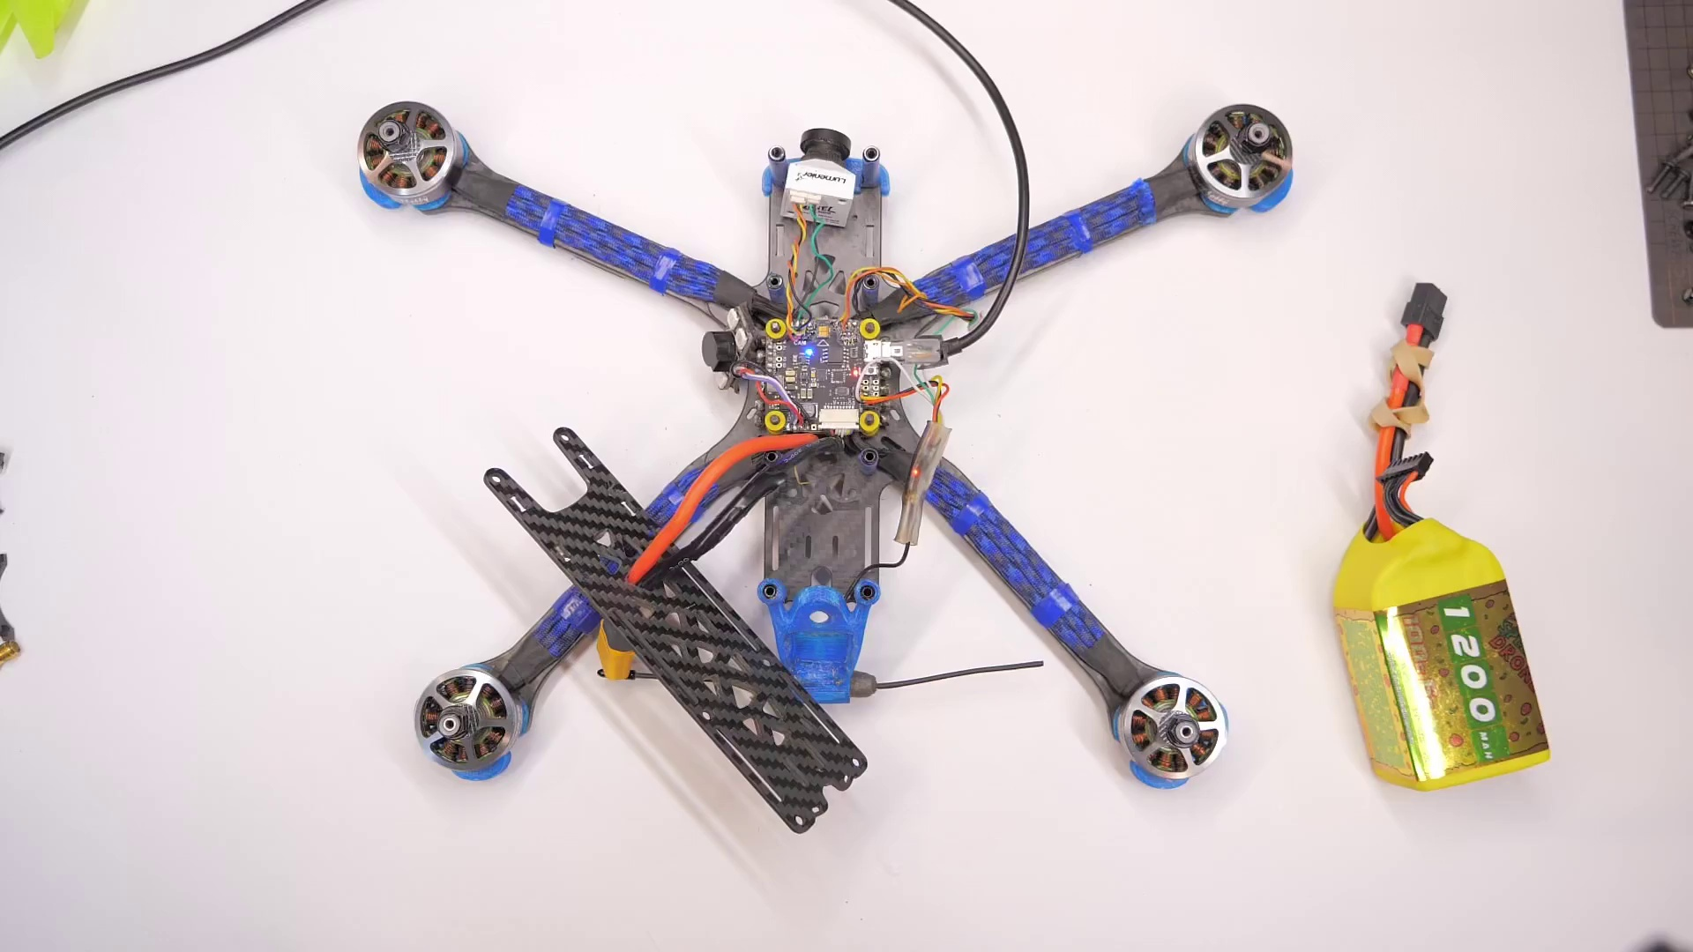 | 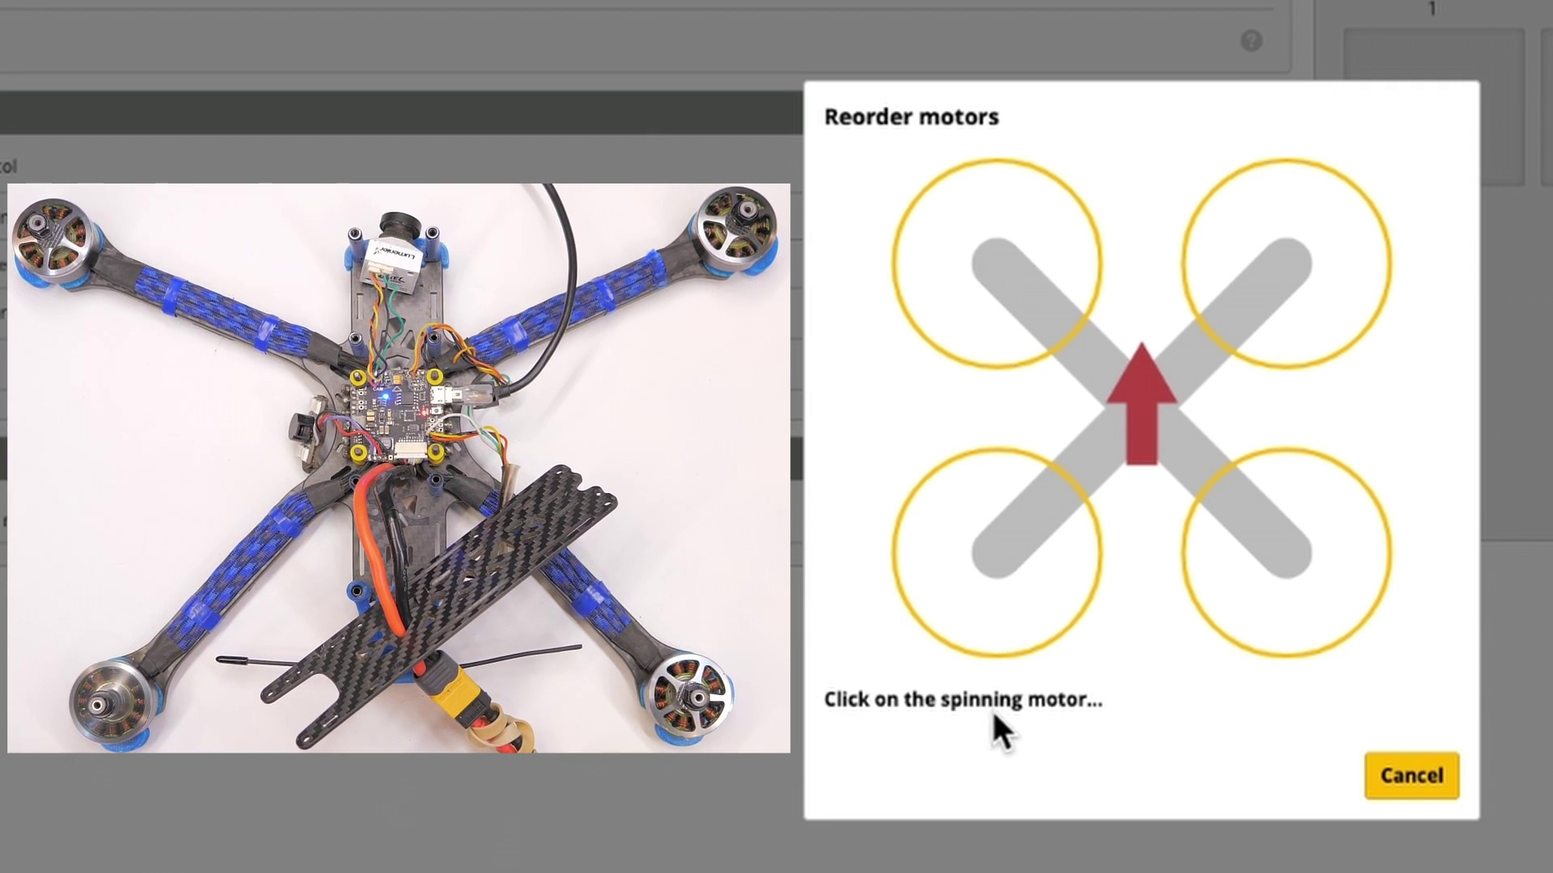 | 
Description: Check if the motors are spinning in the correct direction.
Correlated (true): 16 (45.7%)
Score >= 60: 16 (45.7%)
Average Score (of valid matches): 81.25

Top 5 Correlated Comments:
Score: 90
Comment: Hey! You can wrap a little piece of tape around the motor shaft to make it easier to see which way it's spinning.
Reason: The comment directly mentions a specific step ('wrap a little piece of tape') to make it easier to see which way the motor is spinning, which aligns with the topic's description of verifying motor spins.
Source: https://www.youtube.com/watch?v=PWyqVEkZGWk

Score: 90
Comment: Hi Adam qhen i hook up to Betaflight and go to the motors tab to change tbe Motor Direction none of the motors turn when i press 1,2, 3 or 4.Also they dont turn when I am in the 4 large circles that changes from yellow to green. My motors are all turning in the wring directionand i wanted to use tgeabove method instead of Blheli chrome App which again i dont know how to use. Im a newbie these methods so yoyr help would be greatly appreciated.
Reason: The comment directly discusses the same steps and settings (motors tab, motor direction) described by the topic, showing a strong correlation.
Source: https://www.youtube.com/watch?v=PWyqVEkZGWk

Score: 80
Comment: my 1 and 4 motor is not changing directions
Reason: The comment mentions specific motors (1 and 4) and their spinning directions, which aligns with the topic's description of verifying motor spins in the correct direction.
Source: https://www.youtube.com/watch?v=PWyqVEkZGWk

Score: 80
Comment: Thanks for the instructions! Please help, I have two motors that spin in the wrong direction, I tried changing the direction in the section Spin Direction, but they do not change direction and always spin in the same direction. What could be the reason? Thanks in advance!
Reason: The comment directly addresses the topic of motor spins and mentions specific steps (changing spin direction) mentioned in the topic description.
Source: https://www.youtube.com/watch?v=PWyqVEkZGWk

Score: 80
Comment: Hi Richard im having this problem with motors 1 and 2 turning in the wrong direction but my bf 10.9.0 does not show "Reorder motors". I can only change the direction up top of the quad motor diagram. I know nothing about CLI. And my firmware is 4.2.3 Eachine Lal3 4s quad. Can you help me?
Reason: The comment directly addresses the same issue described in the topic ('motors turning in the wrong direction') and mentions specific details related to the motors (1 and 2), which matches the topic's description.
Source: https://www.youtube.com/watch?v=PWyqVEkZGWk

Topic T3: Step 2: Change Motor Spin Direction
 |  | 
Description: Change the spin direction of each motor to match your desired setup.
Correlated (true): 14 (40.0%)
Score >= 60: 14 (40.0%)
Average Score (of valid matches): 80.71

Top 5 Correlated Comments:
Score: 90
Comment: How to control motor direction with arduino esc?
Reason: The comment directly asks how to control motor direction, which is a crucial step in changing the spin direction of each motor as described in the topic.
Source: https://www.youtube.com/watch?v=PWyqVEkZGWk

Score: 80
Comment: Thanks for the instructions! Please help, I have two motors that spin in the wrong direction, I tried changing the direction in the section Spin Direction, but they do not change direction and always spin in the same direction. What could be the reason? Thanks in advance!
Reason: The comment directly addresses a specific aspect of the topic (changing motor spin direction) and asks for help to resolve an issue related to this step, indicating strong correlation with the topic.
Source: https://www.youtube.com/watch?v=PWyqVEkZGWk

Score: 80
Comment: my 1 and 4 motor is not changing directions
Reason: The comment specifically mentions the issue with certain motors (1 and 4) not changing directions, which aligns with the topic's focus on changing motor spin direction.
Source: https://www.youtube.com/watch?v=PWyqVEkZGWk

Score: 80
Comment: Hi Richard im having this problem with motors 1 and 2 turning in the wrong direction but my bf 10.9.0 does not show "Reorder motors". I can only change the direction up top of the quad motor diagram. I know nothing about CLI. And my firmware is 4.2.3 Eachine Lal3 4s quad. Can you help me?
Reason: The comment specifically mentions changing the direction of motors (1 and 2), which matches the topic's goal of 'changing motor spin direction' and provides details on how it can be done in the quad motor diagram.
Source: https://www.youtube.com/watch?v=PWyqVEkZGWk

Score: 80
Comment: Great video, thanks for sharing!
I have a question on setting up the motor. Should the FC be facing towards us to get the correct configuration? For example, if I have a tinywhoop, let's say the Pavo Pico, where the FC is facing to the ground compared to you example where the fc is facing to the air . Should we view the FC from the drone's underside and then orient ourselves from there to establish the motor's order and orientation?
Looking forward to your insights!
Reason: The comment discusses the setup of the motor's spin direction, which matches the topic description's goal to 'match your desired setup'. The mention of the flight controller (FC) and its orientation also ties in with the topic's emphasis on changing the motor spin direction.
Source: https://www.youtube.com/watch?v=PWyqVEkZGWk

Topic T1: Introduction
 |  | 
Description: Initial setup and background information.
Correlated (true): 10 (28.6%)
Score >= 60: 10 (28.6%)
Average Score (of valid matches): 80.50

Top 5 Correlated Comments:
Score: 85
Comment: I clicked on motor direction on bf, it told me in a warning box that i need to update my firmware to 4.3.Do i simply click on the yellow button that says "Update Firmware"? And will that show me the circles i see on your video? Also can i damage my flight controller by clicking on update firmware?
Thank you for your time im banging my head on the wall with this one!😢
Reason: The comment discusses updating firmware (step described in the topic), which is a specific action related to the initial setup and background information mentioned in the topic description.
Source: https://www.youtube.com/watch?v=PWyqVEkZGWk

Score: 80
Comment: Great video, thanks for sharing!
I have a question on setting up the motor. Should the FC be facing towards us to get the correct configuration? For example, if I have a tinywhoop, let's say the Pavo Pico, where the FC is facing to the ground compared to you example where the fc is facing to the air . Should we view the FC from the drone's underside and then orient ourselves from there to establish the motor's order and orientation?
Looking forward to your insights!
Reason: The comment directly discusses the setup of the motor, which is part of the initial setup and background information described in the topic. The mention of FC (flight controller) orientation and motor order and orientation also overlap with the topic's description of setting up the motor.
Source: https://www.youtube.com/watch?v=PWyqVEkZGWk

Score: 80
Comment: Great video, really helped me to configure the motors on my first build! Thanks!
Reason: The comment mentions configuring motors, which is directly related to the topic's description of initial setup and background information.
Source: https://www.youtube.com/watch?v=PWyqVEkZGWk

Score: 80
Comment: My elrs receiver shows a solid light, indicating it’s bound but motors don’t spin up Beta flight shows stick motion
What am I missing?
Reason: The comment mentions a specific system (ELRS receiver) and its behavior (solid light), which is related to the topic of introduction and setup. The mention of 'Beta flight' also shows an attempt to apply or test the setup, further connecting it to the topic.
Source: https://www.youtube.com/watch?v=PWyqVEkZGWk

Score: 80
Comment: Hello, I have a problem with the moment I give gas with the console, the engines automatically go faster and when I suddenly give gas, the two rear engines push harder.
Reason: The comment discusses the same concept of giving gas and its effect on engine speed, which is directly related to the topic's description about initial setup and background information.
Source: https://www.youtube.com/watch?v=PWyqVEkZGWk

Topic T5: Conclusion and Next Steps
 |  | 
Description: Wrap-up of the video, with next steps for quadcopter setup and configuration.
Correlated (true): 10 (28.6%)
Score >= 60: 10 (28.6%)
Average Score (of valid matches): 80.00

Top 5 Correlated Comments:
Score: 90
Comment: I clicked on motor direction on bf, it told me in a warning box that i need to update my firmware to 4.3.Do i simply click on the yellow button that says "Update Firmware"? And will that show me the circles i see on your video? Also can i damage my flight controller by clicking on update firmware?
Thank you for your time im banging my head on the wall with this one!😢
Reason: The comment directly discusses next steps for quadcopter setup and configuration (updating firmware), which matches the topic description. The mention of a specific setting ('motor direction on bf') also overlaps with the topic's focus on quadcopter configuration.
Source: https://www.youtube.com/watch?v=PWyqVEkZGWk

Score: 80
Comment: Great video, thanks for sharing!
I have a question on setting up the motor. Should the FC be facing towards us to get the correct configuration? For example, if I have a tinywhoop, let's say the Pavo Pico, where the FC is facing to the ground compared to you example where the fc is facing to the air . Should we view the FC from the drone's underside and then orient ourselves from there to establish the motor's order and orientation?
Looking forward to your insights!
Reason: The comment discusses the setup and configuration of the quadcopter's motor, which is directly related to the topic's description about 'next steps for quadcopter setup and configuration'. The specific example given about the FC orientation (facing towards us or from the drone's underside) shows a strong understanding of the topic.
Source: https://www.youtube.com/watch?v=PWyqVEkZGWk

Score: 80
Comment: I am new to the whole fpv world but I've been in drones for a while I ended up buying up somebody's collection for a good deal can I have four 225 mm friends without flight controllers they all have motors on them has four ESC on each motor and I just got the Speedy beef at 4:05 stack in the mail to build it. Do I eliminate the escs? Don't the Speedy bee have its built-in esc's? Thanks
Reason: The comment discusses quadcopter setup and configuration, specifically mentioning the Speedy Bee, which is directly related to the topic's description of next steps for setup and configuration.
Source: https://www.youtube.com/watch?v=PWyqVEkZGWk

Score: 80
Comment: I fly motors out, after flashing bluejay and setting my motors in the right direction, i did not click motors reversed in betaflight. My quad would jump in the air and cutoff and land flat. After checking my quad against one of my old builds i seen motors reveresed wasnt selected. I had to save it and tried again and my new boo flew great.
Reason: The comment directly discusses setting up and configuring a quadcopter, specifically mentioning flashing BlueJay and selecting motor direction, which is closely related to the topic's description of 'next steps for quadcopter setup and configuration'.
Source: https://www.youtube.com/watch?v=PWyqVEkZGWk

Score: 80
Comment: Even by touching I cannot figure out which direction my motors are turning. Its on a 2s copter, so they are pretty small. Atm my drone does not go up if I hit throttle, so motor directions might still be off. Any hints?
Reason: The comment directly discusses the setup and configuration of a quadcopter, specifically mentioning motor directions and throttle, which are key aspects addressed in the topic's description.
Source: https://www.youtube.com/watch?v=PWyqVEkZGWk

Topic T4: Step 3: Verify Motor Spins Again
 |  | 
Description: Verify that all motors are spinning in the correct direction after changes.
Correlated (true): 16 (45.7%)
Score >= 60: 16 (45.7%)
Average Score (of valid matches): 79.69

Top 5 Correlated Comments:
Score: 85
Comment: Hi Adam qhen i hook up to Betaflight and go to the motors tab to change tbe Motor Direction none of the motors turn when i press 1,2, 3 or 4.Also they dont turn when I am in the 4 large circles that changes from yellow to green. My motors are all turning in the wring directionand i wanted to use tgeabove method instead of Blheli chrome App which again i dont know how to use. Im a newbie these methods so yoyr help would be greatly appreciated.
Reason: The comment directly discusses the same step of verifying motor spins, specifically mentioning the motors tab in Betaflight and changing the motor direction. The description also overlaps with the topic's mention of 'correct direction'.
Source: https://www.youtube.com/watch?v=PWyqVEkZGWk

Score: 80
Comment: my 1 and 4 motor is not changing directions
Reason: The comment mentions specific motors (1 and 4) not changing direction, which is directly related to the topic's description of verifying motor spins after changes. The topic specifically talks about motor directions, making the comment strongly correlated.
Source: https://www.youtube.com/watch?v=PWyqVEkZGWk

Score: 80
Comment: Thanks for the instructions! Please help, I have two motors that spin in the wrong direction, I tried changing the direction in the section Spin Direction, but they do not change direction and always spin in the same direction. What could be the reason? Thanks in advance!
Reason: The comment directly discusses the same problem (motors spinning in wrong direction) and solution (changing spin direction), which is strongly related to the topic 'Verify Motor Spins Again'.
Source: https://www.youtube.com/watch?v=PWyqVEkZGWk

Score: 80
Comment: Hi Richard im having this problem with motors 1 and 2 turning in the wrong direction but my bf 10.9.0 does not show "Reorder motors". I can only change the direction up top of the quad motor diagram. I know nothing about CLI. And my firmware is 4.2.3 Eachine Lal3 4s quad. Can you help me?
Reason: The comment mentions motor direction and the specific steps to change it, which aligns with the topic's description of verifying motor spins.
Source: https://www.youtube.com/watch?v=PWyqVEkZGWk

Score: 80
Comment: Hey! You can wrap a little piece of tape around the motor shaft to make it easier to see which way it's spinning.
Reason: The comment suggests a specific step (wrapping tape around the motor shaft) to verify motor spins, which aligns with the topic's description of verifying motor direction.
Source: https://www.youtube.com/watch?v=PWyqVEkZGWk

