Comment–Topic Correlation Report
Model: llama3

Summary
Topics processed: 1
Comments available for this video: 15
Comments with correlated=True: 1 (6.7%)
Comments with score >= 60: 1 (6.7%)
Total candidate pairs checked: 15
----------------------------------------

Topic T1: Repetitive Statements
 | 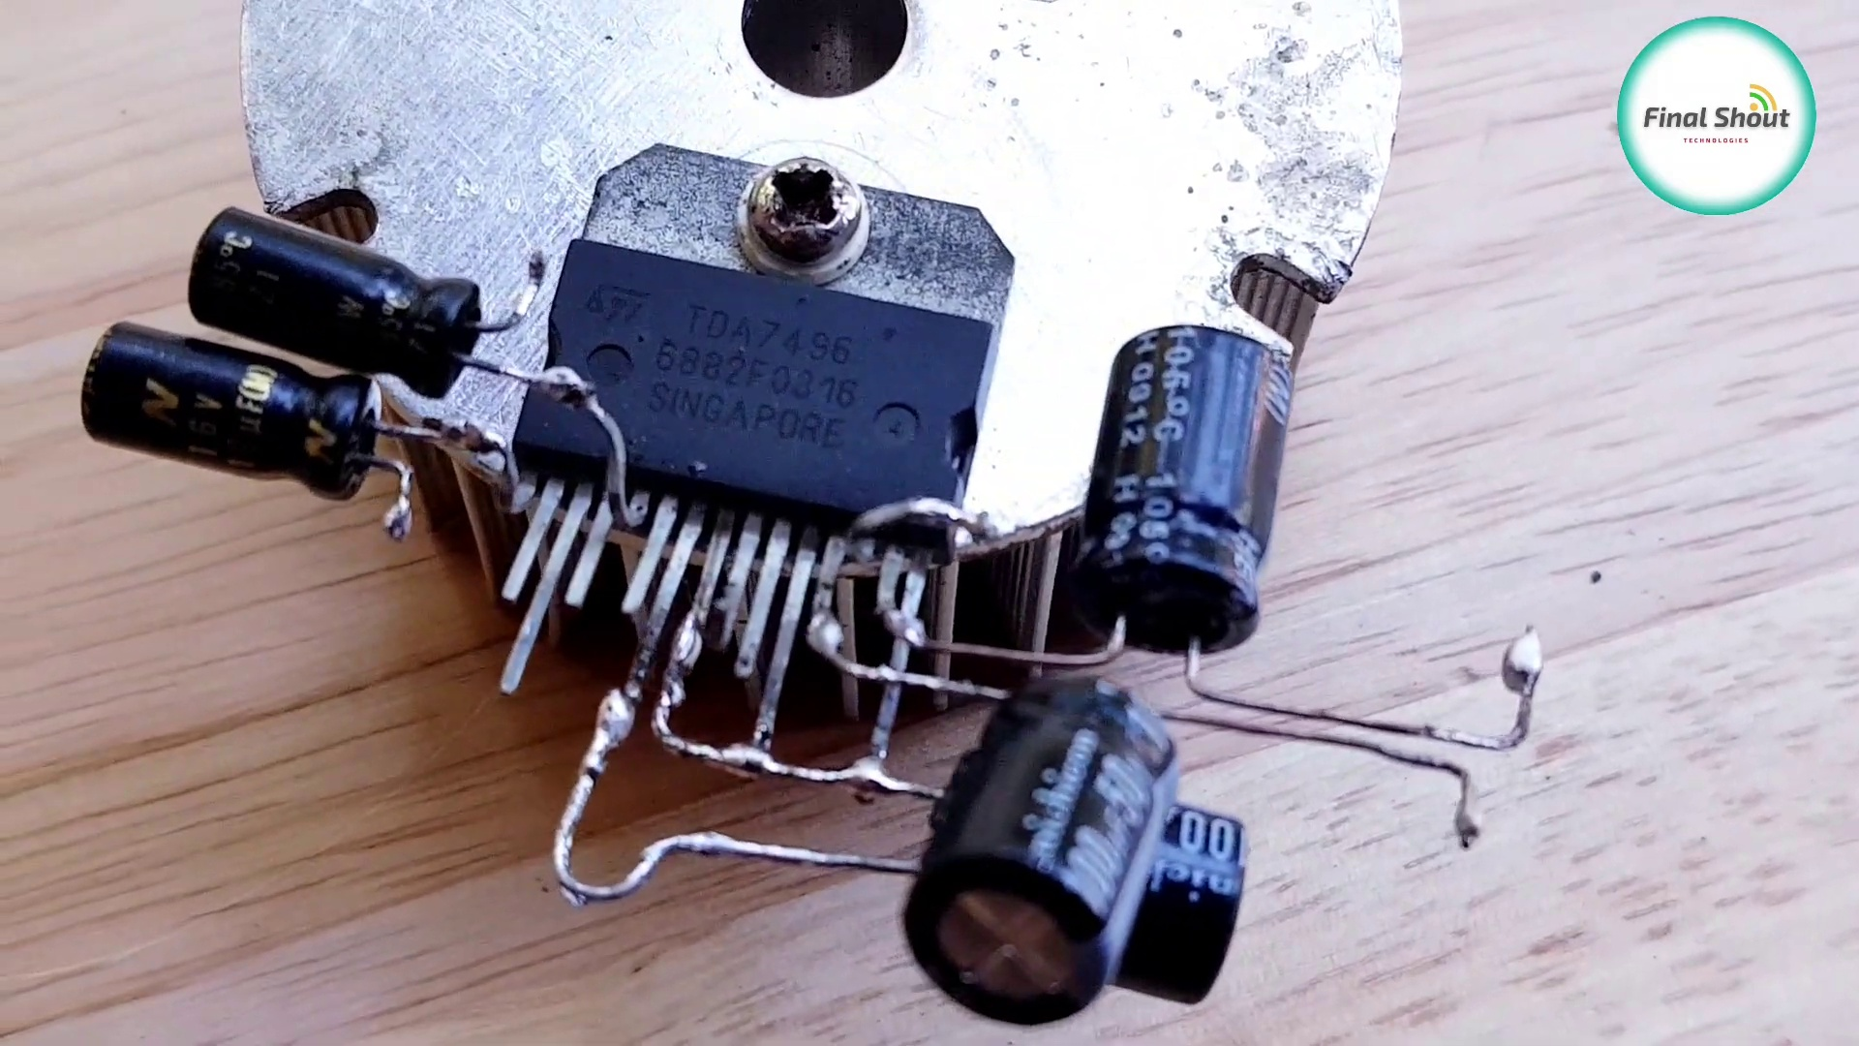 | 
Description: The speaker repeatedly says thank you without any clear purpose or context.
Correlated (true): 1 (6.7%)
Score >= 60: 1 (6.7%)
Average Score (of valid matches): 80.00

Top 1 Correlated Comments:
Score: 80
Comment: @suleymankerimkurt1110 calisti
Reason: The comment directly references the repetitive statements mentioned in the topic description, specifically mentioning repeated 'thank you's without clear purpose or context.
Source: https://www.youtube.com/watch?v=PfFkm0Kgkn0

