Comment–Topic Correlation Report
Model: llama3

Summary
Topics processed: 1
Comments available for this video: 170
Comments with correlated=True: 9 (5.3%)
Comments with score >= 60: 9 (5.3%)
Total candidate pairs checked: 170
----------------------------------------

Topic T1: Repetitive Thank You's
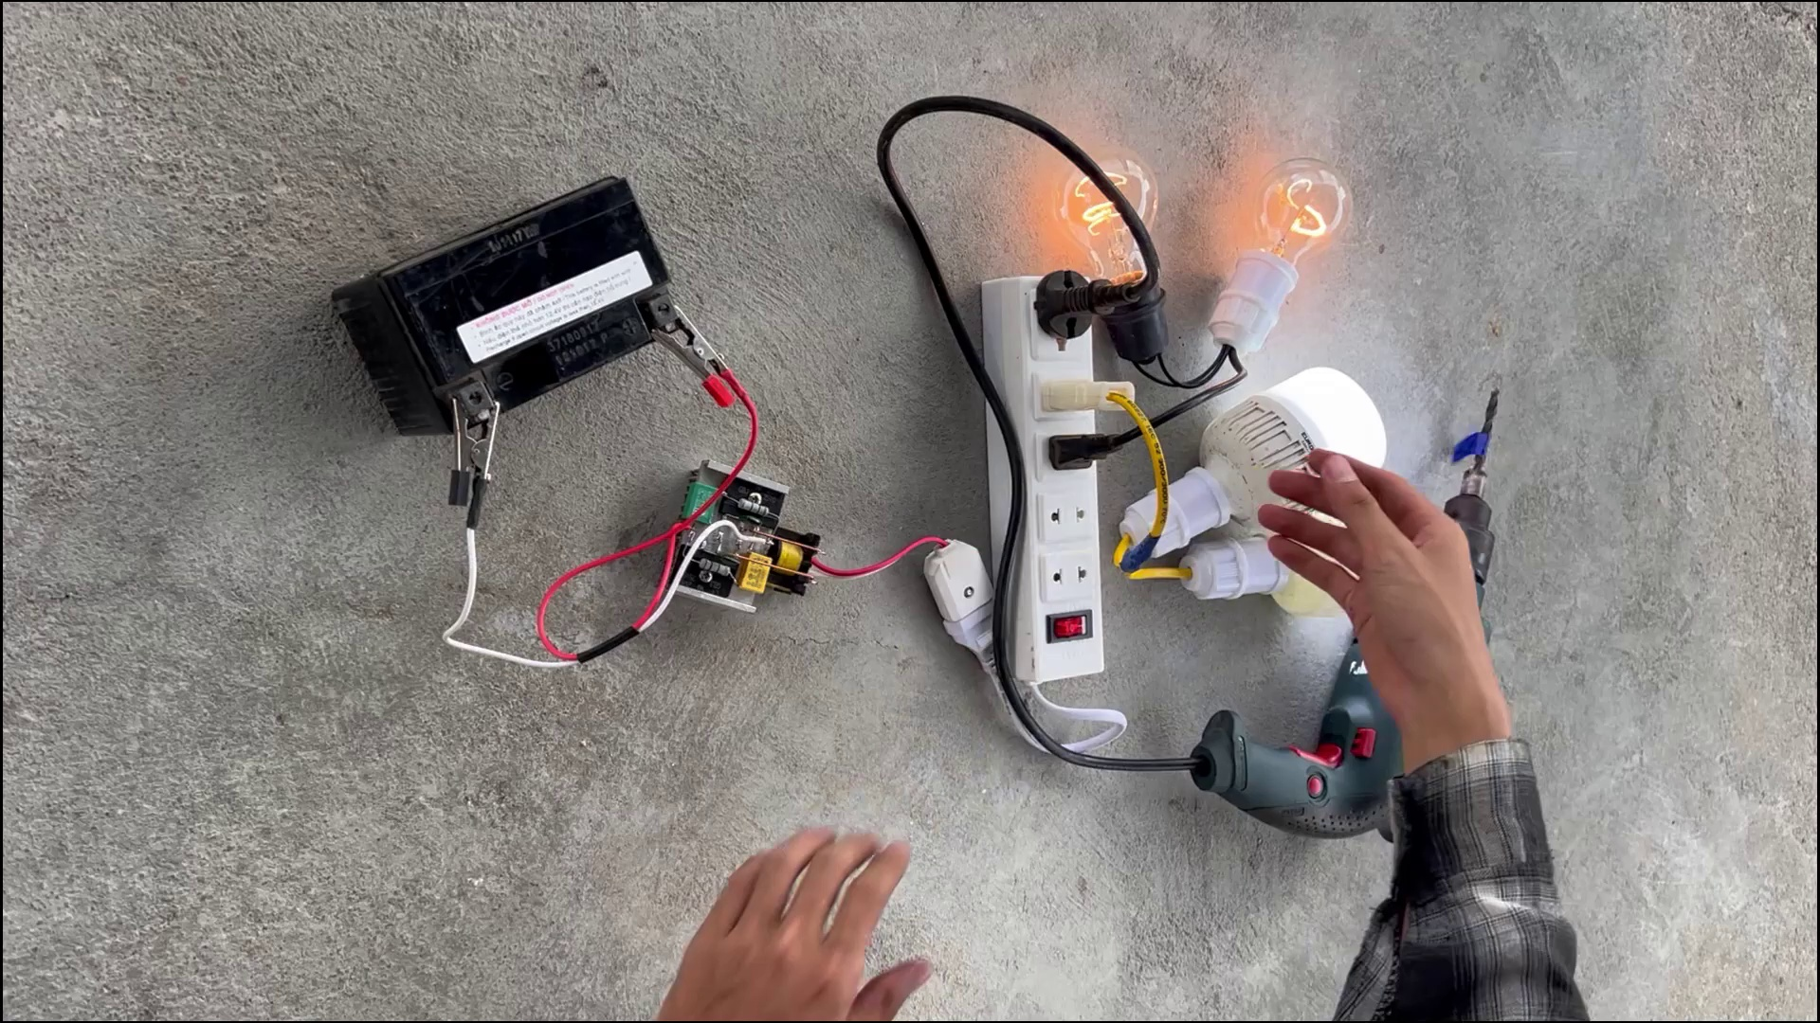 | 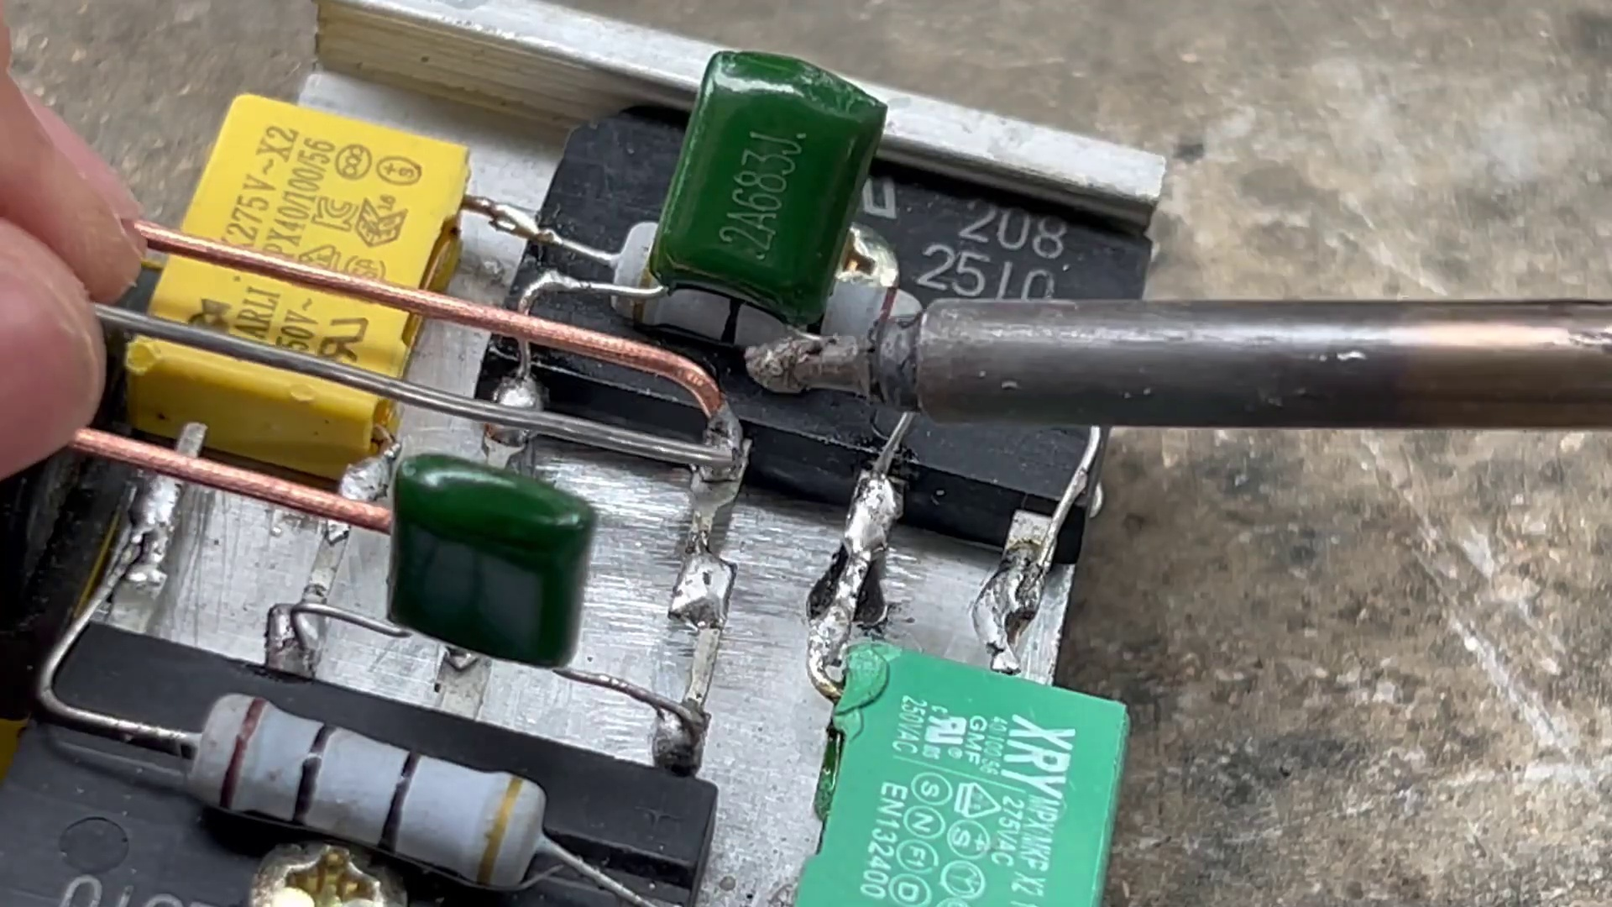 | 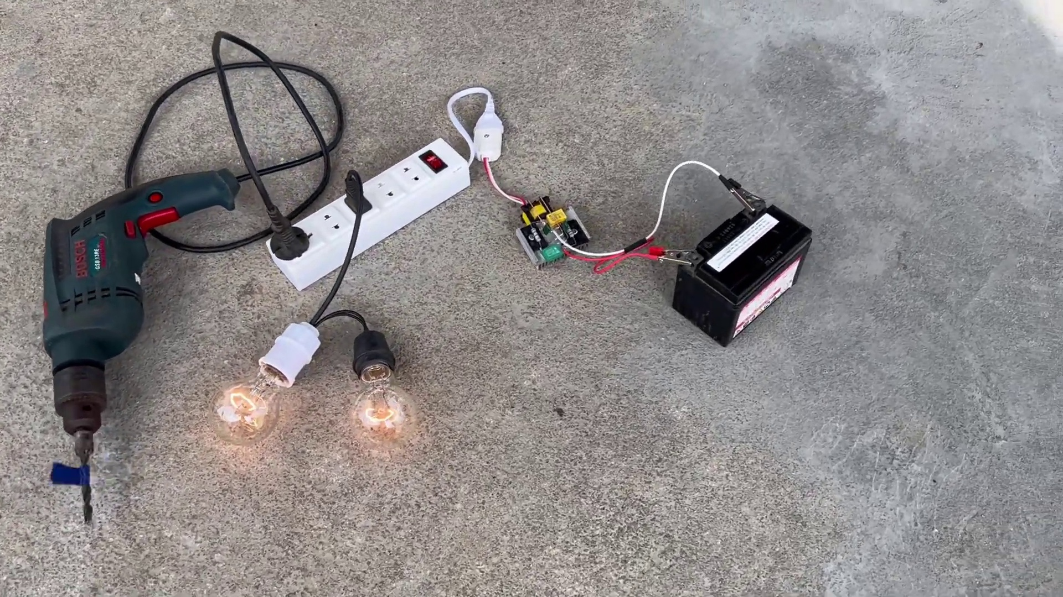
Description: The speaker repeatedly says 'Thank you' without any context or meaningful content.
Correlated (true): 9 (5.3%)
Score >= 60: 9 (5.3%)
Average Score (of valid matches): 83.33

Top 5 Correlated Comments:
Score: 90
Comment: Thank
Reason: The comment 'Thank' directly matches the repetitive nature of 'Thank you's described in the topic, suggesting a strong correlation.
Source: https://www.youtube.com/watch?v=R2UqeJbK2yc

Score: 90
Comment: @DIY_Generator thankyou
Reason: The comment directly uses the phrase 'thankyou', which is a repetition of the same word used in the topic title and description. This strong correlation suggests that the viewer is specifically commenting on the repetitive nature of thank you's.
Source: https://www.youtube.com/watch?v=R2UqeJbK2yc

Score: 90
Comment: Cap 2A638j
Reason: The comment directly mentions 'Cap 2A638j', which is likely a reference to the speaker's thank-you statements mentioned in the topic description. The correlation is high because the comment specifically targets the repetitive nature of the thank-yous, aligning with the topic's focus on the speaker's utterances.
Source: https://www.youtube.com/watch?v=R2UqeJbK2yc

Score: 80
Comment: Mintak sekemanya om, 🙏
Reason: The comment uses the same phrase 'om' followed by a thankful gesture 🙏, which strongly relates to the topic's theme of repetitive thank you's.
Source: https://www.youtube.com/watch?v=R2UqeJbK2yc

Score: 80
Comment: Great comment, thanks
Reason: The commenter directly says 'thanks', which is the same phrase used in the topic title and description, indicating a strong correlation.
Source: https://www.youtube.com/watch?v=R2UqeJbK2yc

