Comment–Topic Correlation Report
Model: llama3

Summary
Topics processed: 5
Comments available for this video: 1121
Comments with correlated=True: 198 (17.7%)
Comments with score >= 60: 198 (17.7%)
Total candidate pairs checked: 1000
----------------------------------------

Topic T5: Conclusion
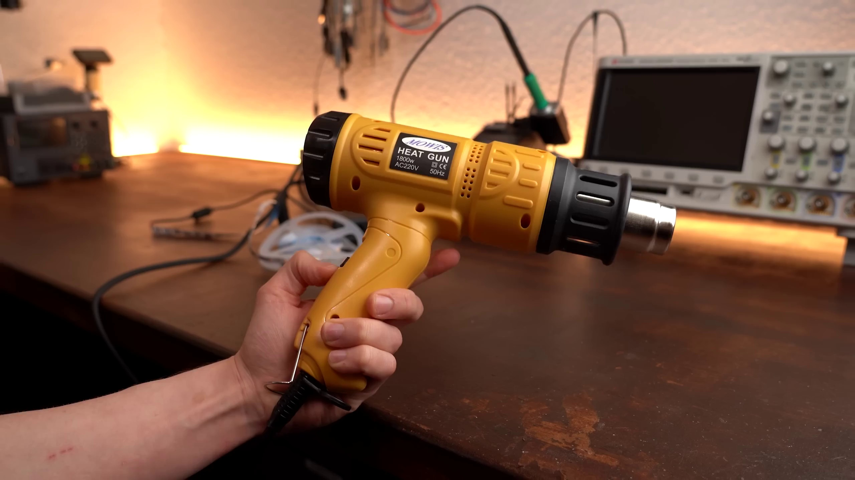 | 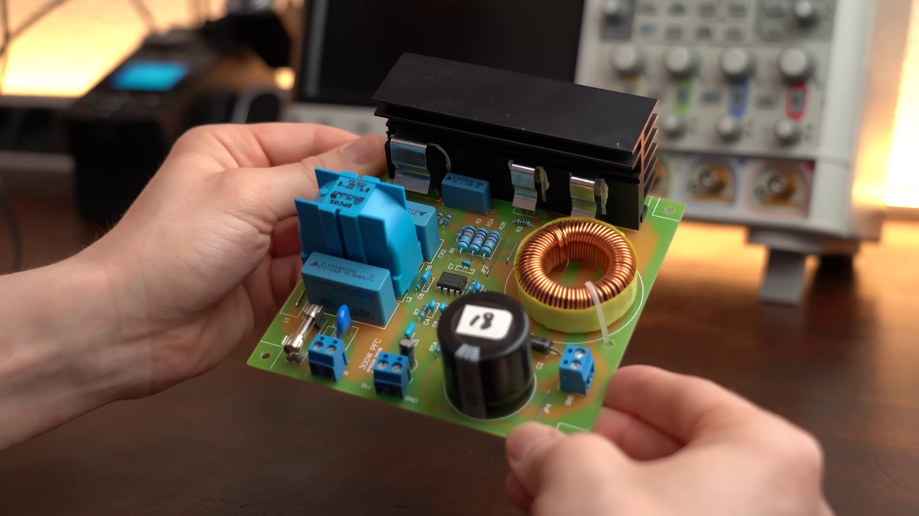 | 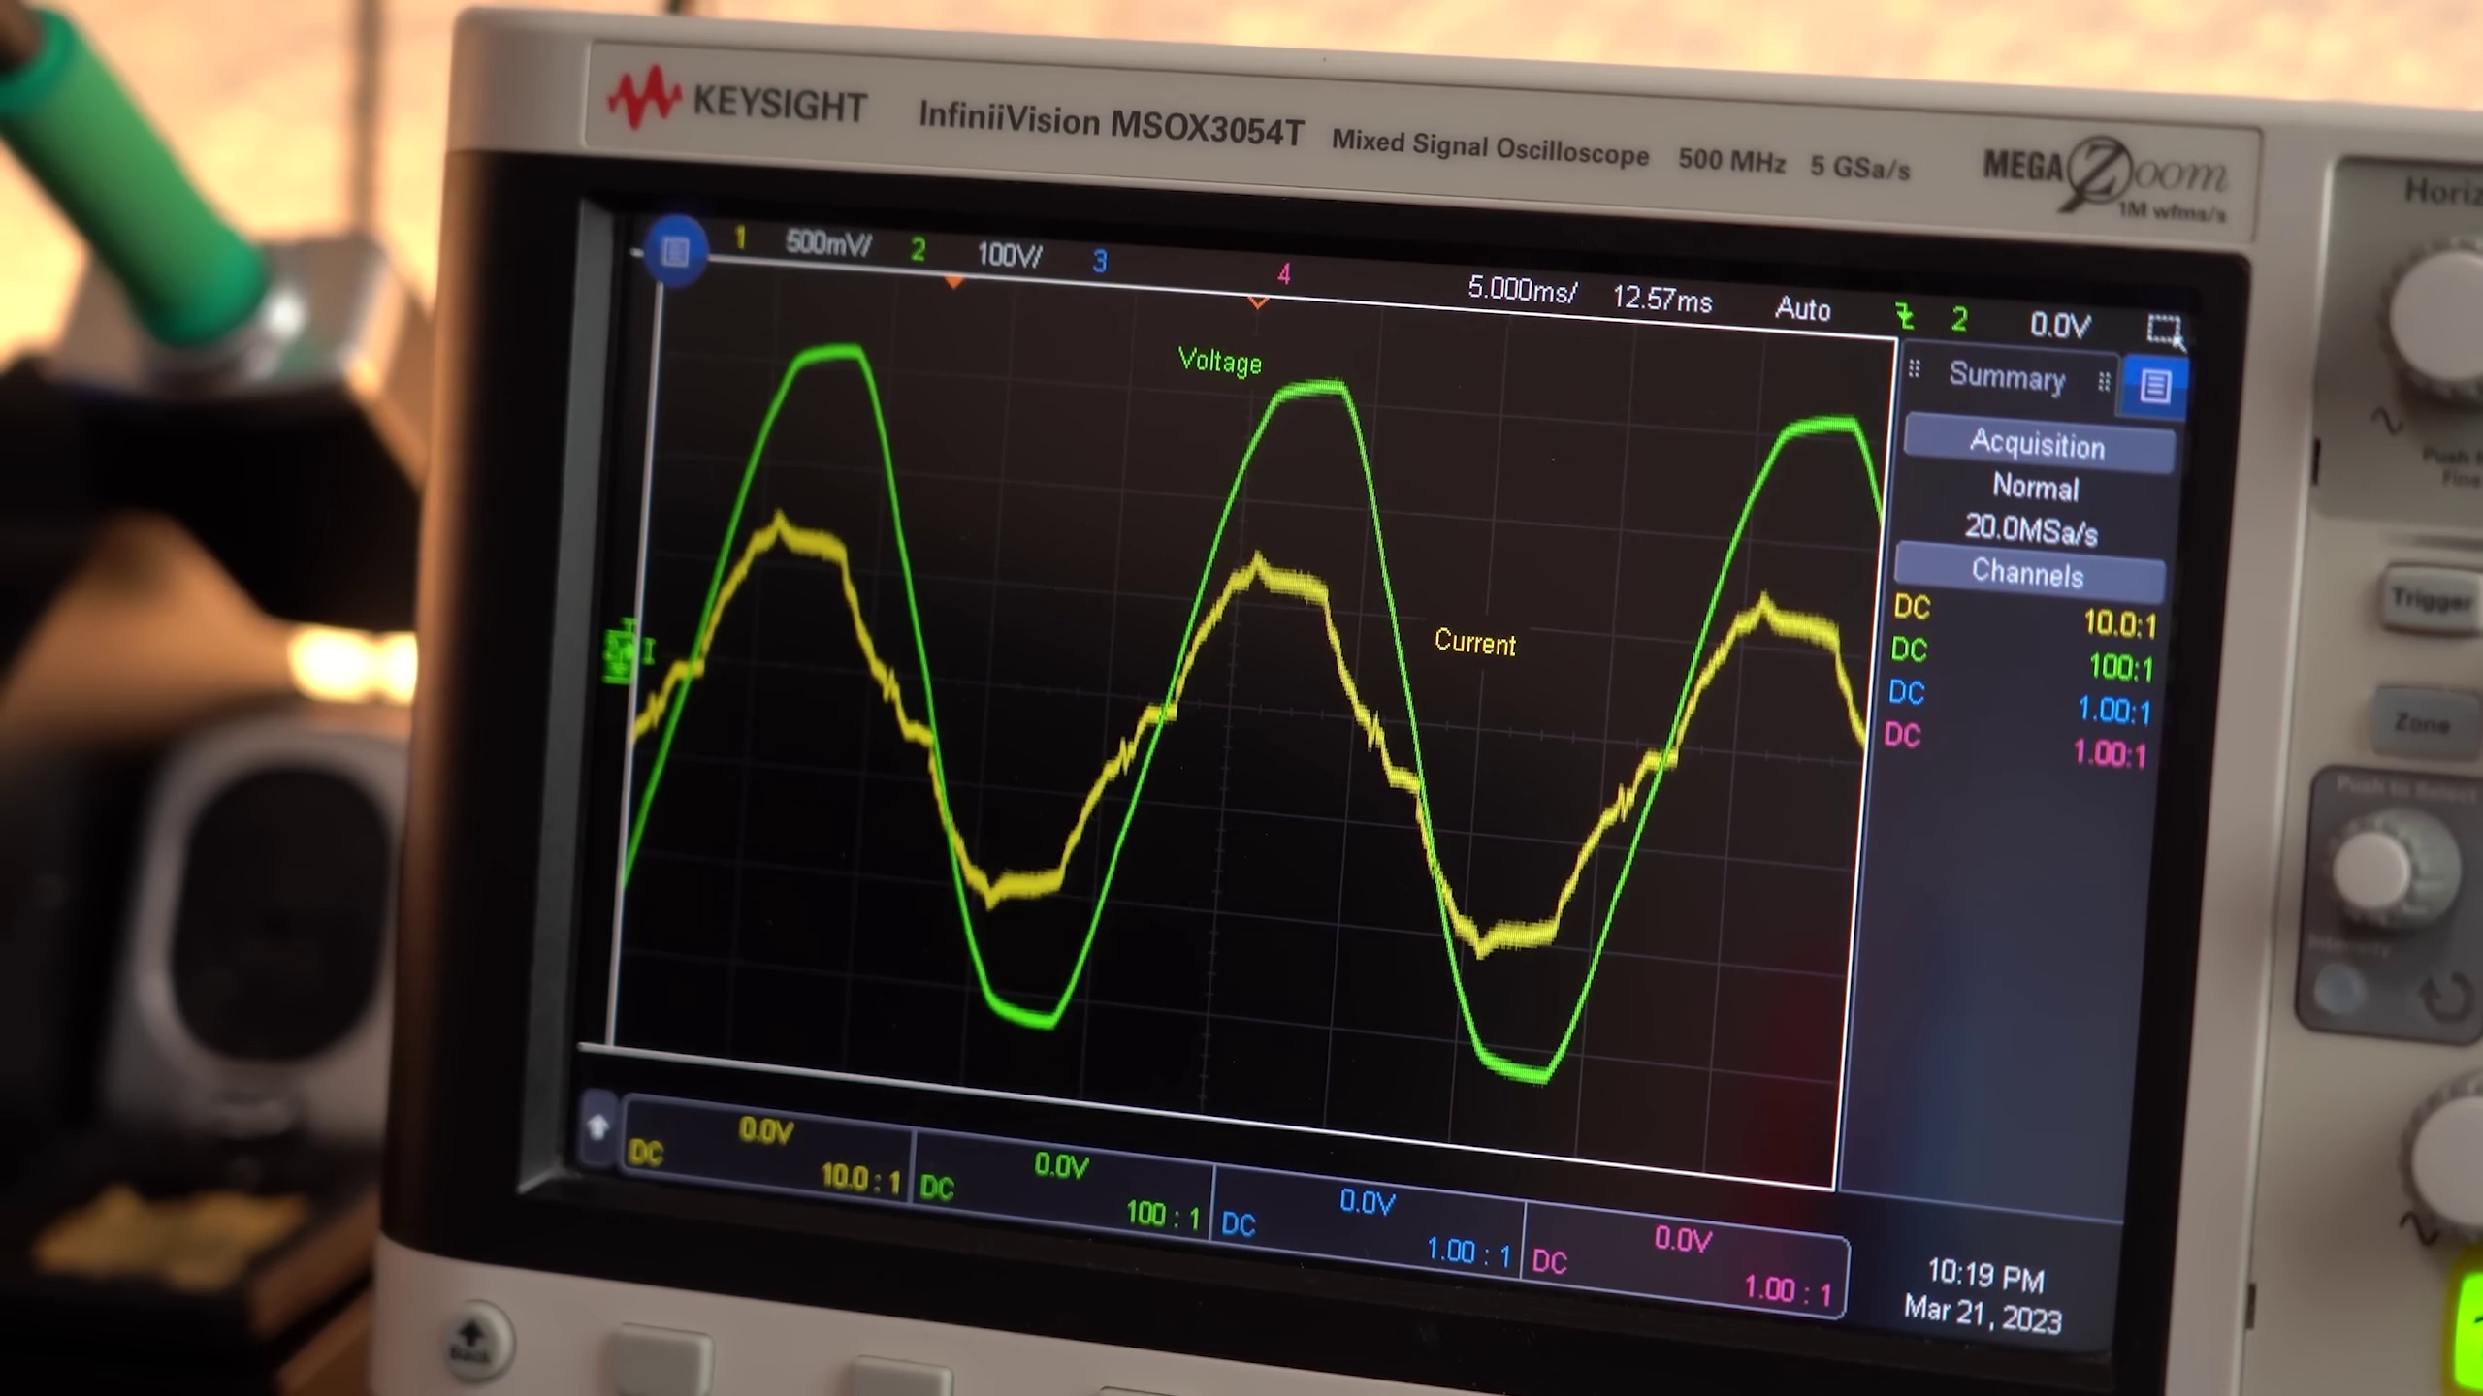
Description: Summary and final thoughts on the topic of power factor correction.
Correlated (true): 120 (10.7%)
Score >= 60: 120 (10.7%)
Average Score (of valid matches): 80.79

Top 5 Correlated Comments:
Score: 95
Comment: @greatscottlab the addition of PFC circuits was especially important for large data centers. In the early days of Google our servers didn't have PFC circuits which was fine when you didn't have many. We quickly learned the importance of PFC when we started building clusters with 1000+ servers. Without PFC we would run out of power capacity. PF on average was close to 0.6. Later server designs required a minimum PF of 0.9. Now a days most servers have a PF of 0.96 to 1.0. PFC circuits have become extremely important and have come a long way.
Reason: The comment directly discusses the importance of power factor correction (PFC) circuits in large data centers and servers, specifically mentioning PF values and the impact on power capacity. This aligns with the topic description about power factor correction.
Source: https://www.youtube.com/watch?v=U5cqrrhq9TA

Score: 90
Comment: Me before the video starts:
Power Factor Correction
Reason: The comment directly mentions 'Power Factor Correction', which is the main topic discussed in the description. The mention of 'before the video starts' is not relevant to the correlation.
Source: https://www.youtube.com/watch?v=U5cqrrhq9TA

Score: 90
Comment: Power factor IMPROVEMENT. The cost for power factor correction is exponential. Power factor IMPROVEMENT will also depend on leading or lagging voltage/current phase.
Reason: The comment directly discusses power factor correction, mentioning improvement and exponential cost, which is strongly related to the topic's description of power factor correction. The mention of leading or lagging voltage/current phase also overlaps with the topic's focus on the same topic.
Source: https://www.youtube.com/watch?v=U5cqrrhq9TA

Score: 90
Comment: How come the meter is showing a negative power factor, but a positive VA reading (@ 11:09). What have I missed here about power factors that makes that reading -ve?
Reason: The comment directly discusses the same topic of power factor correction, specifically addressing a negative reading and asking what's been missed about power factors. The title 'Conclusion' is also related to summarizing and final thoughts, which is consistent with the comment's inquiry.
Source: https://www.youtube.com/watch?v=U5cqrrhq9TA

Score: 90
Comment: Are there power supplies which attempt to correct the "power factor" of the grid, if it is distorted? Instead of having dedicated power factor correction units, large loads would act as such as needed.
Reason: The comment directly discusses the concept of power factor correction and its application to large loads in the grid, matching the topic's description.
Source: https://www.youtube.com/watch?v=U5cqrrhq9TA

Topic T2: Passive PFC vs. Active PFC
 |  | 
Description: Explanation of passive and active PFCs and their differences.
Correlated (true): 101 (9.0%)
Score >= 60: 101 (9.0%)
Average Score (of valid matches): 80.30

Top 5 Correlated Comments:
Score: 90
Comment: I get this is better for the grid but i missed power consumption of the pfc itself. Does it have more or less conversion losses compared to passive pfc options?
Reason: The comment directly discusses the same topic (PFC types) and specifically asks about power consumption and conversion losses, which are mentioned in the topic description. The only difference is that the comment focuses on a specific aspect (conversion losses) not explicitly stated in the topic title.
Source: https://www.youtube.com/watch?v=U5cqrrhq9TA

Score: 90
Comment: "Active PFC is basically a glorified boost converter"
Reason: The comment directly compares and contrasts Active PFC with Passive PFC, which is a key aspect of the topic's description. The phrase 'glorified boost converter' also highlights specific technical aspects of Active PFC, as mentioned in the topic.
Source: https://www.youtube.com/watch?v=U5cqrrhq9TA

Score: 90
Comment: I noticed at 09:48 the scope appears to show the current leading the voltage by a small amount, is this the best performance active PFC can provide or would a more complex design take us closer to perfection? I enjoy your content, thank you.
Reason: The comment directly discusses the performance of active PFC, specifically mentioning a scope measurement and comparing it to perfection. This is closely related to the topic's description of differences between passive and active PFCs.
Source: https://www.youtube.com/watch?v=U5cqrrhq9TA

Score: 90
Comment: The PFC circuit is pointless. A sinusoidal voltage and a sinusoidal current create a (1-(cos (2*Pi*f*t))²) power function which is of course not constant. How to achieve constant power (ie voltage) at the output, if the input power has a pulsating form?
This means that the PFC circuit cannot be a DC voltage pre-regulator as is often used. When it is a pre-regulator, it would have to draw constant power at constant consumption. And this would tend to create a current function of the form: I(t)=P/(A*sin(2*Pi*f*t)) which would draw a large current at low voltage points to maintain constant power. Such a current function increases the effective current through the conductors and creates additional transmission losses.
The best point of consumption for the smallest current through the conductors is at the top of the sinusoidal function. And the best PFC corrector is an LC filter after the diode rectifier, which suppresses the high harmonics of impulse current disturbances, i.e. reduces the current peak and extends the duration.
PFC only makes sense on machines that have sinusoidal current consumption that is out of phase with the voltage. And these circuits are called reactive power compensators.
There is also no conclusion from the measurement that the installation of the PFC circuit increased the effective input current by more than 10%. Because of this, losses in electricity transmission increase by more than 20%.
Reason: The comment directly discusses the differences and limitations of PFC circuits (passive vs active), highlighting their inefficiencies and optimal uses, which aligns with the topic's focus on explaining passive and active PFCs.
Source: https://www.youtube.com/watch?v=U5cqrrhq9TA

Score: 90
Comment: Yep. That is a kind of passive PFC. Measuring the phase shift and then adding caps accordingly.
Reason: The comment directly discusses passive PFC, which is the same topic mentioned in the description. The commenter also uses specific terms like 'phase shift' and 'caps', which are related to the differences described in the topic.
Source: https://www.youtube.com/watch?v=U5cqrrhq9TA

Topic T1: Introduction
 |  | 
Description: Overview of the topic and goals of the video.
Correlated (true): 6 (0.5%)
Score >= 60: 6 (0.5%)
Average Score (of valid matches): 80.00

Top 5 Correlated Comments:
Score: 80
Comment: Congratulation for your video, extremely interesting, as I saw from your diagram, the last blue dot, seems at 64 VA for 50 watts, that is pretty close to 82% efficiency which is the theoretical efficiency for converting AC to DC. Can you give us the exact numbers.Have you made any video regarding the efficiency of the power chargers of the electric cars to show us how much energy is wasted on the charger during a car charging;
Reason: The comment directly references specific details from the topic, such as 'diagram' and '64 VA for 50 watts', which are mentioned in the topic's description. The commenter also asks about related topics, like efficiency of power chargers for electric cars, showing a strong connection to the topic.
Source: https://www.youtube.com/watch?v=U5cqrrhq9TA

Score: 80
Comment: Exactly.
Reason: The comment directly responds to the topic description by affirming its accuracy ('Exactly'), indicating a strong connection between the topic and the viewer's understanding.
Source: https://www.youtube.com/watch?v=U5cqrrhq9TA

Score: 80
Comment: Great video Scott!
I have a dummy question. When you show us the shapes of the voltage and current on the scope, you say that peaks are not matching (not same amplitude). But these are two different physical asset. How you compare the amplitudes of these two?
Reason: The comment references specific visual elements (shapes on the scope) and concepts (peaks not matching amplitude) mentioned in the topic description, showing a strong connection to the topic.
Source: https://www.youtube.com/watch?v=U5cqrrhq9TA

Score: 80
Comment: Actually I would like to turn this one the 180deg. Imagine how much electronics that we could avoid if the power grid would be designed to handle the bad PF. Just in my house ther is probably 10 products with active pfc smsp.
Unfortunately that is not reality, maybe make a video that could look in to solution that would alow many “PF sinners” connect to the grid.
Br
Reason: The comment directly discusses the topic's goal of exploring a solution to allow devices with active PFC (power factor correction) to connect to the grid, which is a key aspect of the video's introduction.
Source: https://www.youtube.com/watch?v=U5cqrrhq9TA

Score: 80
Comment: Excellent video! One of the most apparent circumstances where a poor power factor can be an issue is when using backup inverters. Your 1500VA backup inverter is only going to reach 1500W if you've got a perfect load on it. If you've got a poor power factor, you'll have to derate the power rating!
Reason: The comment directly discusses a specific circumstance where poor power factor can be an issue, which is mentioned in the topic description (goals of the video), and also references a backup inverter, which is likely related to the introduction topic.
Source: https://www.youtube.com/watch?v=U5cqrrhq9TA

Topic T4: Practical Example: Using an Active PFC IC
 |  | 
Description: Demonstration of how to use an active PFC IC with a few external components.
Correlated (true): 56 (5.0%)
Score >= 60: 55 (4.9%)
Average Score (of valid matches): 79.91

Top 5 Correlated Comments:
Score: 90
Comment: ​ @seedney If a laptop PSU has power factor correction designed in and the PF is 0.48, the PFC is shit.
Reason: The comment directly discusses power factor correction (PFC) and its performance, using a specific example of a laptop PSU with PF 0.48, which is closely related to the topic's focus on using an active PFC IC.
Source: https://www.youtube.com/watch?v=U5cqrrhq9TA

Score: 90
Comment: A decent active PFC stage 20 years ago would run at around 95% efficiency, depending on the input voltage. When a large boost, such as from 85 volts AC input (the usual lower limit for a "universal input" PFC stage) is required, efficiency drops a few percent. With newer FETs and high-voltage ultrafast recovery rectifiers some improvement could be expected. If cost is no object, some additional improvement can come from using very high performance core material (e.g. molybdenum permalloy powder) for the boost inductor and winding with Litz wire instead of ordinary magnet wire.
Reason: The comment discusses the efficiency and performance of an active PFC stage, which is directly related to the topic's description of using an active PFC IC with external components. The mention of specific parameters (e.g. input voltage, boost inductor material) also shows strong correlation.
Source: https://www.youtube.com/watch?v=U5cqrrhq9TA

Score: 85
Comment: Active PFC circuits can be very difficult in terms of managing conducted EMI/RFI. You are basically chopping the rectified AC input at a frequency that could be anywhere from a few tens of kHz to a few hundred kHz. In the interest of efficiency the rise and fall times are very short, so there is lots of high frequency content. Some PFC controllers operate at fixed frequency, others at variable frequency. I used to do designs using a controller that I ran at 100 kHz, which at the time was a reasonable compromise when FETs, rectifiers, inductor cores and inductor windings were considered (I often say that in switchers everything is in conflict with everything else).
Filtering ahead of the rectifier will certainly require a reasonbly "large" common mode inductor and some normal mode inductance might be necessary, too. I've seen designs using two common mode inductors.
Radiated EMI/RFI is always a concern in any switecher. Circuit layout needs to be carefully considered.
I noted that at some point in the video there was a huge amount of "fur" on the waveform shown on the oscilloscope.
Reason: The comment discusses specific aspects of active PFC IC usage, such as managing conducted EMI/RFI, frequency selection (e.g., 100 kHz), and common mode inductance requirements, which directly relates to the topic's description of using an active PFC IC with external components.
Source: https://www.youtube.com/watch?v=U5cqrrhq9TA

Score: 85
Comment: @zyeborm I was watching this video and learned a lot but I had concerns or confustion:
i'll use numbers just for clarity not to suggest I am other than learning here. Can anybody help me out.
1. If I use electricity from the grid, they charge me unfortunately, for apparent power, here in the US at least, so PFCs would seem to someteimes be good investment especially for big loads, say for my refrigerator and heat pump and the big washer dryer etc appliance motors and air conditioner (if u have) and hvac motors and rectifiers SMPS? => So those would seem l lke worth cleaning up powerfactor. and obviously industrial customers are surely more motivated.
2. I guess I cant tell what my watt hour meter does what it calculates.. with regards to harmonics. I think it is supposed to sample V*I and average that over one cycle, say 20 ms for 50 Hz, if it were calc'ing actual power. I think it calculates Vrms over one or more integer number of 20ms periods, and I_rms over that many 20 ms periods, and and multiplies those scalars together, and charges us for that amount of apparent power for that number of periods, and accumulates that to get apparent watt hours? so what happens to harmonics then, since some will increase the rms current or rms voltage or their product others not, with different effect on the actual power deliverd?
3. I liked this video great tips and scope work and explanation, but I couldn't tell if the PFC actually say saved me money, I'll rewatch but it must be using extra power to run the boost converter and the magnetics and diodes& power transistor(s) and stuff? did i miss that?
so isnt there a tradeoff like get the PF up above say 0.5 or 0.707 to fix the worst of it but then diminishing cost returns?
4. Also, doesn't the grid have an (Thevenin?) impedance, if small, that needs to be considered, when doing the matching circuit? And does a load like the LEDs actually change impedance as say the LED brightness is turned up, or my washing machine is working hard, or unbalanced, or heavily loaded, so you need to pick an operatng point to match at, presumably the biggest win is to match the impedance where the equipment say the LEDs are drawing the most?
5. in the video, I couldn,t tell if the PFC+LEDs ended up drawing more apparent power from the grid, given the need to run the flyback, the scope view didn't really look like it actually was at PF=1, looked more like phase shifted so only 0.8, and fuzzy with high frequency switching noise? Is that HF switching more of an issuse? and I guess if we get PF better than 0.8 or so, probably have most of the financial value..
Thanks for any input I'm sorry if I mis understood.. but it seems like there are tradeoffs on how much to spend invest; and harmonics are confusing.
6. Finally it seems like the home power say solare+wind+biogas+ battery systems of the future will free us from utility crap and pollution, and we can kiss National Grid goodbye or maybe just to charge my sugarcane ethanol PHEV .. If my battery sourced nano grid is AC, say 50Hz it will will be less stiff and need a lot of PFC like thisnd filtering, and also will need to be able to start those big motor loads... will we then need good soft start or hard-starts? is that similar to PFC technology, but switched in? Or will home power (nano) grids say be DC, say run from battery pack at 300V or 600V from a tesla pack that I pulled from a used EV or EV truck? will I then use DC to run some loads, using EV sourced motors, and then invert to run legacy appliances? Or have a VFD or muxed VFD to run those? Or could nano-grids run at 400 Hz like aircraft, to reduce matching component size i.e.400 Hz = 1/sqrt(LC)?
Thank you. Sorry if this has a lot of ignorance.. still learning, trying to escape the grid and its methane and CO2 and mercury in our rivers and lakes etc...
Reason: The comment directly discusses the topic's concepts, such as active PFC ICs, power factor correction, and harmonics. The commenter also mentions specific components like boost converters, magnetics, diodes, and power transistors, which are described in the topic's description.
Source: https://www.youtube.com/watch?v=U5cqrrhq9TA

Score: 80
Comment: Great video! Also, it only remains to add, that some power supplies use passive PFC in form of a huge coil on an iron core. The coil opposes the fast current rises of the capacitor without drawing too much real power.
Reason: The comment mentions using an Active PFC IC, which is directly discussed in the topic. Additionally, it provides specific details on how passive PFC works, which is related to the topic's description of using an active PFC IC.
Source: https://www.youtube.com/watch?v=U5cqrrhq9TA

Topic T3: Why Do We Need a PFC?
 |  | 
Description: Discussion on the importance of power factor correction in AC-DC power supplies.
Correlated (true): 135 (12.0%)
Score >= 60: 135 (12.0%)
Average Score (of valid matches): 79.59

Top 5 Correlated Comments:
Score: 90
Comment: PFCs are mandatory already! If your device is CE marked, it should have been tested to IEC 61000-3-2/-3-12. Exclusions for Harmonics are <5W for lighting and <75W for everything else.
Reason: The comment directly discusses the importance of power factor correction (PFC) in AC-DC power supplies, referencing specific standards IEC 61000-3-2/-3-12, which aligns with the topic's description.
Source: https://www.youtube.com/watch?v=U5cqrrhq9TA

Score: 90
Comment: @jim4556 in industries..it is a must to install P.F.C. based reactive banks to maintain the minimum allowable deviation of power factor. going below that , a penalty is imposed which is all part of the Utility Rules that industries have to adhere to.
Reason: The comment directly mentions PFC (power factor correction) and reactive banks, which are key concepts in the topic's description about the importance of power factor correction in AC-DC power supplies. The mention of industry-specific regulations and penalties also aligns with the topic's focus on the practical application of PFC.
Source: https://www.youtube.com/watch?v=U5cqrrhq9TA

Score: 90
Comment: There was a pfc circuit based on the cuk converter that achieves a 0.99 power factor and I would suspect that the properties of the cuk converter radically lower the noise.
Of course, the cuk converter is transformer voodoo and a bit wonky to design.
Reason: The comment directly discusses the CUK converter and its properties, which are related to power factor correction (PFC) as described in the topic. The mention of achieving a 0.99 power factor also demonstrates a strong connection between the topic and the viewer's comment.
Source: https://www.youtube.com/watch?v=U5cqrrhq9TA

Score: 90
Comment: Me before the video starts:
Power Factor Correction
Reason: The comment explicitly mentions 'Power Factor Correction' which is a central topic of the video's description.
Source: https://www.youtube.com/watch?v=U5cqrrhq9TA

Score: 85
Comment: A power factor correction is only needed if your loads are inductive and most importantly if in large amount like large motors. Small devices such as LED lights consume the least amount of power. Then most of these device are fed with lower voltage thus making it more efficient. And the power supply of these LED devices are a switch mode type which play a big role in power consumption. a switch mode supplies nowadays have an efficiency greater than 95 percent. And looking at the oscilloscope display where the led devices are used, the trace almost correspond to almost unity power factor meaning that the load is resistive like your heat gun( neglecting the motor blower inside the heatgun). Another thing is, Refrigerators and air conditioning equipment today have inverters or variable frequency drives built-in to minimize the consumption of the equipment. Variable speed drives will have almost unity power factor since the line side of the device as seen from the power source is resistive. So installing such power factor correction is useless when your total load is low and only LED lights to consider.
Reason: The comment directly discusses the importance of power factor correction in specific contexts (inductive loads, large motors, LED lights, switch mode supplies) and mentions the benefits of having a low power factor (unity or near-unity) for certain devices (refrigerators, air conditioning equipment), which aligns with the topic's focus on power factor correction.
Source: https://www.youtube.com/watch?v=U5cqrrhq9TA

