Comment–Topic Correlation Report
Model: llama3

Summary
Topics processed: 6
Comments available for this video: 10
Comments with correlated=True: 0 (0.0%)
Comments with score >= 60: 0 (0.0%)
Total candidate pairs checked: 60
----------------------------------------

Topic T6: Conclusion and Next Steps
 | 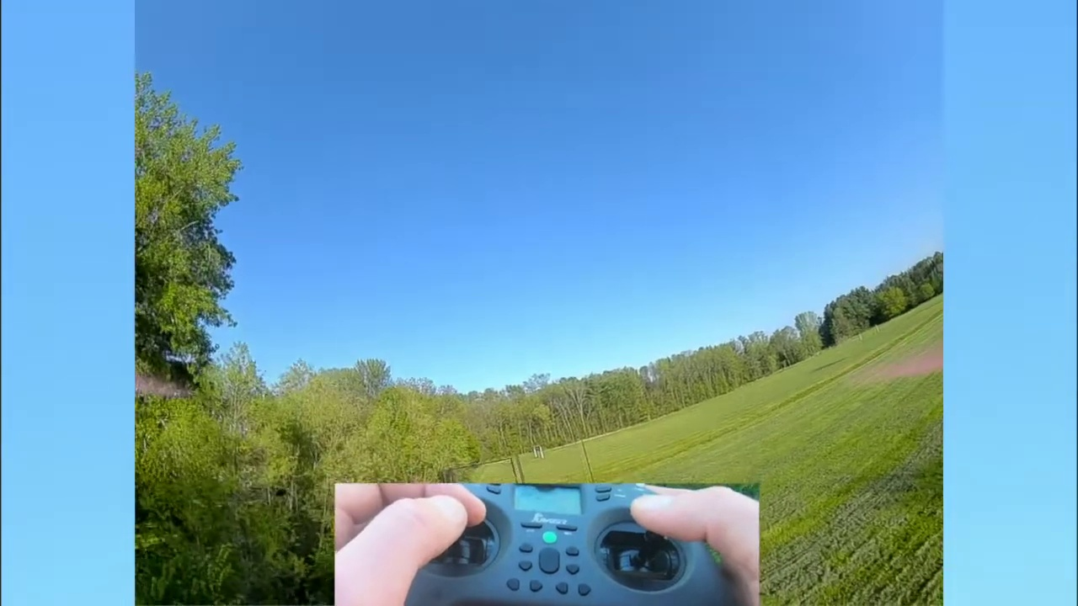 | 
Description: Summary of the tutorial and suggestions for further learning
Correlated (true): 0 (0.0%)
Score >= 60: 0 (0.0%)
Average Score (of valid matches): 0.00
No strongly correlated comments found.

Topic T5: Flying in Acro Mode
 |  | 
Description: How to fly in acro mode and perform flips and turns
Correlated (true): 0 (0.0%)
Score >= 60: 0 (0.0%)
Average Score (of valid matches): 0.00
No strongly correlated comments found.

Topic T4: Using FPV in Angle Mode
 |  | 
Description: Tips and tricks for flying in angle mode
Correlated (true): 0 (0.0%)
Score >= 60: 0 (0.0%)
Average Score (of valid matches): 0.00
No strongly correlated comments found.

Topic T3: FPV Modes: Acro Mode
 |  | 
Description: Explaining acro mode and how to use it
Correlated (true): 0 (0.0%)
Score >= 60: 0 (0.0%)
Average Score (of valid matches): 0.00
No strongly correlated comments found.

Topic T2: FPV Modes: Angle Mode
 |  | 
Description: Explaining angle mode and how to use it
Correlated (true): 0 (0.0%)
Score >= 60: 0 (0.0%)
Average Score (of valid matches): 0.00
No strongly correlated comments found.

Topic T1: Introduction to FPV
 |  | 
Description: Overview of FPV and its modes
Correlated (true): 0 (0.0%)
Score >= 60: 0 (0.0%)
Average Score (of valid matches): 0.00
No strongly correlated comments found.

