Comment–Topic Correlation Report
Model: llama3

Summary
Topics processed: 8
Comments available for this video: 20
Comments with correlated=True: 7 (35.0%)
Comments with score >= 60: 7 (35.0%)
Total candidate pairs checked: 160
----------------------------------------

Topic T8: Conclusion and Next Steps
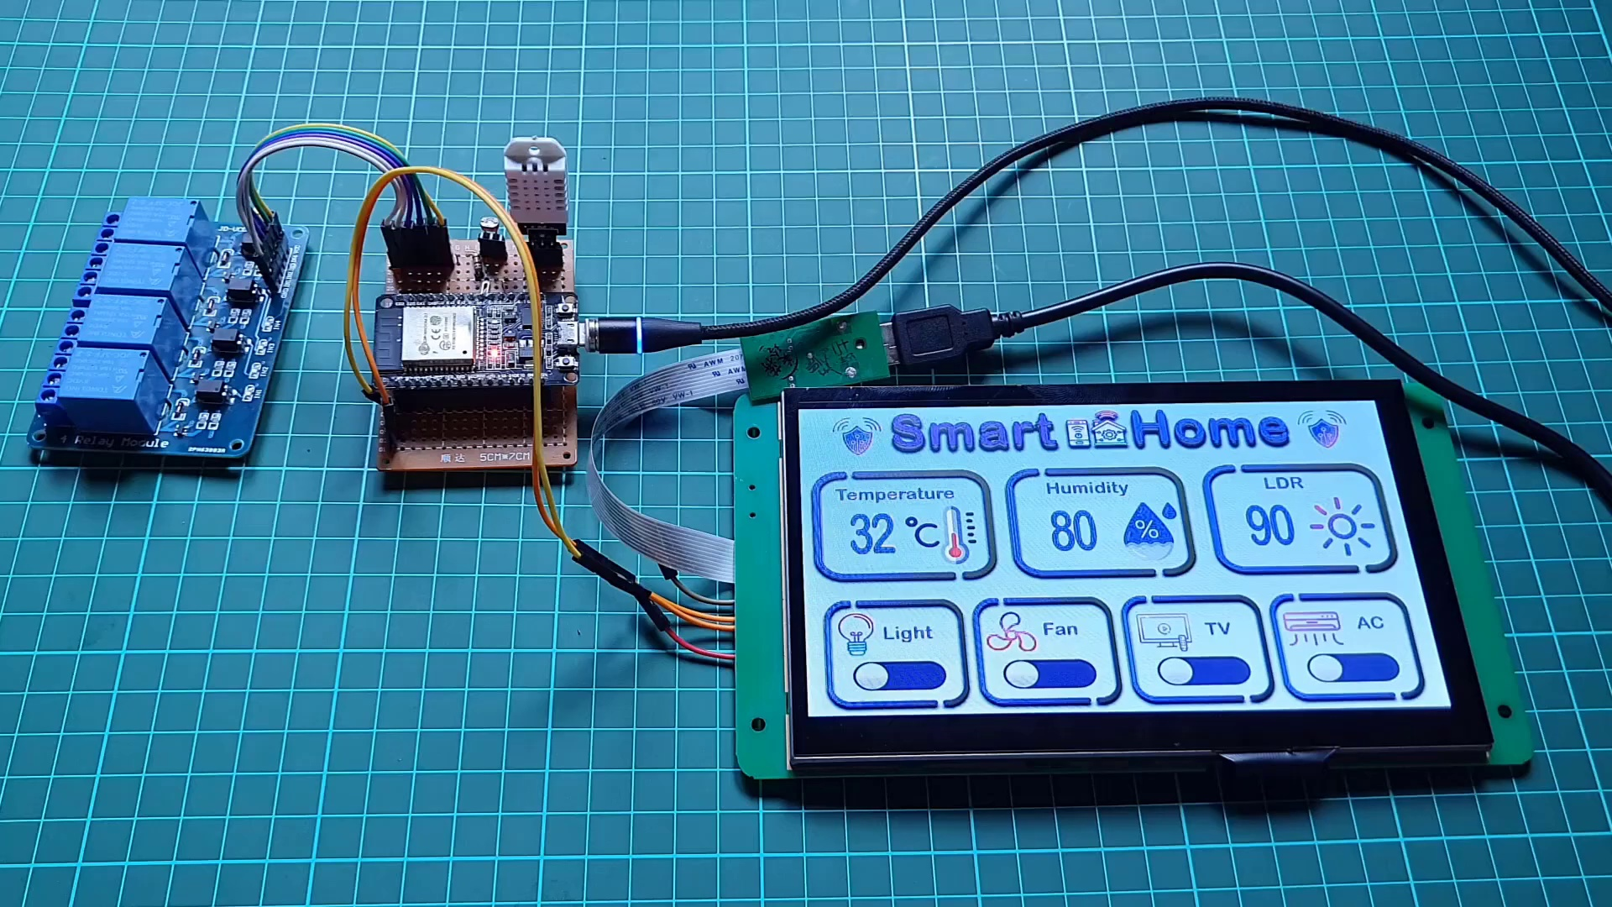 | 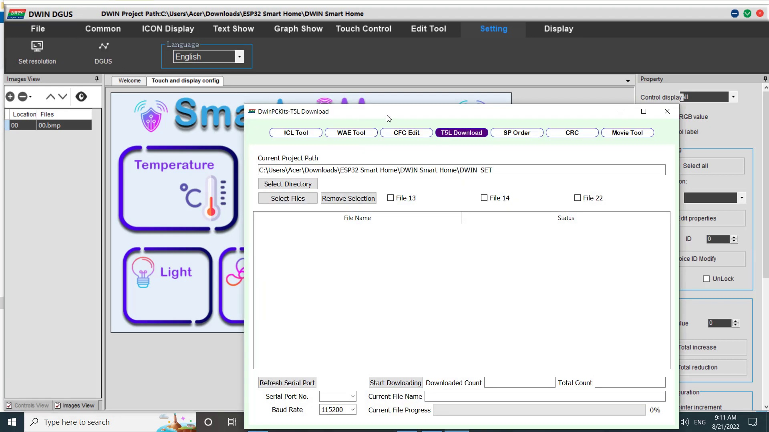 | 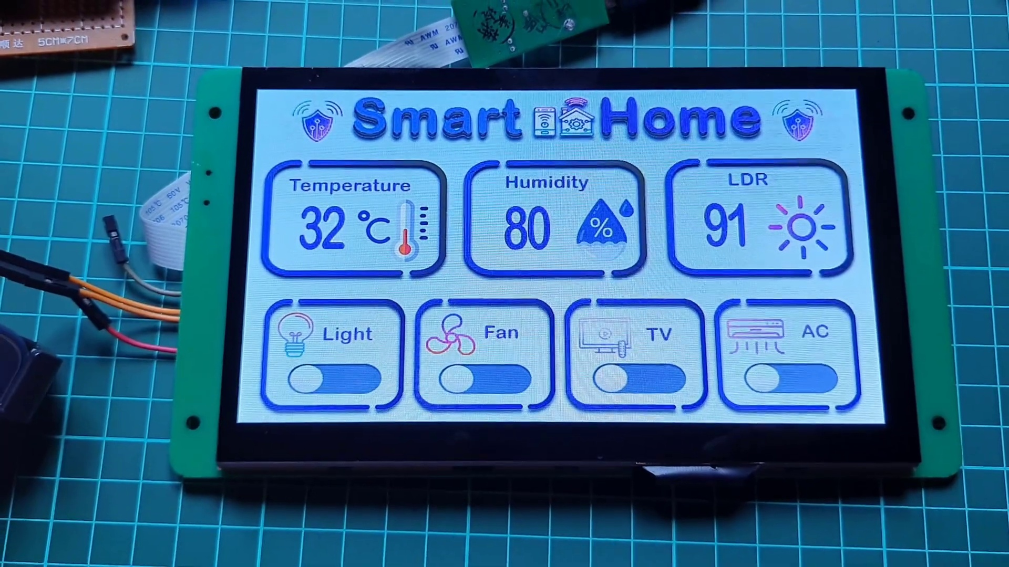
Description: Summarizing the smart home controller project and encouraging viewers to like and subscribe.
Correlated (true): 2 (10.0%)
Score >= 60: 2 (10.0%)
Average Score (of valid matches): 80.00

Top 2 Correlated Comments:
Score: 80
Comment: Sir I want connected esp8266 my router lan network......you can see this tutorial only esp ap mode connect....my requirement is esp board conceted my router then router WiFi acces then control....is possible?plz reply
Reason: The comment mentions connecting ESP8266 to a router's LAN network, which is directly related to the topic of setting up and controlling a smart home controller. The mention of AP mode and WiFi access also overlaps with the topic.
Source: https://www.youtube.com/watch?v=WpE4mQegNLgESP32

Score: 80
Comment: Will it provide feedback on tft as we use webserver as input for relay.. i.e., if relay one is switched on from webserver/ mobile will the status of lcd screen for relay one change to on
Reason: The comment specifically asks about the status of LCD screen for relay one changing to 'on' after switching it on from a webserver/mobile, which directly relates to the topic's focus on conclusion and next steps, and mentions specific technical details like TFT and relay.
Source: https://www.youtube.com/watch?v=WpE4mQegNLgESP32

Topic T7: Sending and Receiving Data
 |  | 
Description: Explaining how data is sent from the ESP32 web server to the Dwin HMI display and received back.
Correlated (true): 2 (10.0%)
Score >= 60: 2 (10.0%)
Average Score (of valid matches): 80.00

Top 2 Correlated Comments:
Score: 80
Comment: How we can make two way connection likee when you turn on the light from the web server also change the state of button in the dwin display?????
Reason: The comment directly discusses sending and receiving data between the ESP32 web server and Dwin HMI display, specifically mentioning a two-way connection and changing the state of a button on the display, which is strongly related to the topic.
Source: https://www.youtube.com/watch?v=WpE4mQegNLgESP32

Score: 80
Comment: Will it provide feedback on tft as we use webserver as input for relay.. i.e., if relay one is switched on from webserver/ mobile will the status of lcd screen for relay one change to on
Reason: The comment directly discusses the same concept of data transmission (from webserver to mobile) and reception (displaying relay status on LCD screen), showing strong correlation with the topic 'Sending and Receiving Data'.
Source: https://www.youtube.com/watch?v=WpE4mQegNLgESP32

Topic T3: Adding Modules
 |  | 
Description: Creating modules for sensors and appliances using var icon module and increment adjustment module.
Correlated (true): 1 (5.0%)
Score >= 60: 1 (5.0%)
Average Score (of valid matches): 80.00

Top 1 Correlated Comments:
Score: 80
Comment: Will it provide feedback on tft as we use webserver as input for relay.. i.e., if relay one is switched on from webserver/ mobile will the status of lcd screen for relay one change to on
Reason: The comment discusses the use of a webserver and mobile app to control relays and receive feedback on TFT (LCD) screens, which is closely related to the topic of adding modules for sensors and appliances.
Source: https://www.youtube.com/watch?v=WpE4mQegNLgESP32

Topic T2: Configuring the Project
 |  | 
Description: Explaining the necessary steps to create a smart home UI with Dwin HMI display and ESP32.
Correlated (true): 6 (30.0%)
Score >= 60: 6 (30.0%)
Average Score (of valid matches): 80.00

Top 5 Correlated Comments:
Score: 80
Comment: Bro how can we connect esp32 to mobile and controll from both display and mobile pls help
Reason: The comment mentions the ESP32, which is directly related to the topic's description of using it with a Dwin HMI display. The mention of controlling from both the display and mobile also shows some connection to the topic's goal of creating a smart home UI.
Source: https://www.youtube.com/watch?v=WpE4mQegNLgESP32

Score: 80
Comment: Bro how can we connect esp32 to mobile and controll from both display and mobile pls help
Reason: The comment mentions the ESP32 microcontroller, which is a key component in configuring the smart home UI project, as described in the topic. The request to control from both display and mobile also aligns with the goal of creating a user interface that can be controlled remotely.
Source: https://www.youtube.com/watch?v=WpE4mQegNLgESP32

Score: 80
Comment: How we can make two way connection likee when you turn on the light from the web server also change the state of button in the dwin display?????
Reason: The comment directly discusses a specific aspect of the project (two-way connection) and mentions a device (Dwin display) mentioned in the topic description, indicating a strong correlation.
Source: https://www.youtube.com/watch?v=WpE4mQegNLgESP32

Score: 80
Comment: Sir I want connected esp8266 my router lan network......you can see this tutorial only esp ap mode connect....my requirement is esp board conceted my router then router WiFi acces then control....is possible?plz reply
Reason: The comment mentions ESP32 and connecting it to a router's LAN network, which are directly related to the topic of configuring a project with Dwin HMI display and ESP32, as described in the topic description.
Source: https://www.youtube.com/watch?v=WpE4mQegNLgESP32

Score: 80
Comment: Will it provide feedback on tft as we use webserver as input for relay.. i.e., if relay one is switched on from webserver/ mobile will the status of lcd screen for relay one change to on
Reason: The comment directly discusses the configuration of a smart home UI using Dwin HMI display and ESP32, specifically asking about feedback on TFT LCD screen status changing based on relay switching from a webserver/mobile app input. This shows strong correlation with the topic's focus on configuring the project.
Source: https://www.youtube.com/watch?v=WpE4mQegNLgESP32

Topic T1: Introduction
 |  | 
Description: Getting started with Dwin HMI display and ESP32 project tutorial.
Correlated (true): 8 (40.0%)
Score >= 60: 8 (40.0%)
Average Score (of valid matches): 80.00

Top 5 Correlated Comments:
Score: 80
Comment: Bro how can we connect esp32 to mobile and controll from both display and mobile pls help
Reason: The comment mentions ESP32, which is the main topic of the tutorial. It also asks about controlling from both display and mobile, which aligns with the goal of setting up an HMI display.
Source: https://www.youtube.com/watch?v=WpE4mQegNLgESP32

Score: 80
Comment: Bro how can we connect esp32 to mobile and controll from both display and mobile pls help
Reason: The comment mentions ESP32, which is also mentioned in the topic description. Additionally, the request to control from both display and mobile aligns with the goals of the tutorial, making a strong connection between the topic and the comment.
Source: https://www.youtube.com/watch?v=WpE4mQegNLgESP32

Score: 80
Comment: Hi I have the EVAL EKT040B. Why didn't you put a level shifter on the TX of the display for the ESP-32? is the TX output of this display 5V?
Reason: The comment directly addresses the ESP32 project tutorial mentioned in the topic description, specifically questioning a design choice and referencing the display hardware (EKT040B) which is related to the topic of setting up the Dwin HMI display.
Source: https://www.youtube.com/watch?v=WpE4mQegNLgESP32

Score: 80
Comment: please have someone made the water level indicator project on this dwin display or can anyone guide me how to do that please 🙏 i ll appreciate it 😢
Reason: The comment mentions the Dwin HMI display, which is the main topic of the tutorial, and asks for guidance on a specific project (water level indicator), which is likely related to the ESP32 project mentioned in the topic description.
Source: https://www.youtube.com/watch?v=WpE4mQegNLgESP32

Score: 80
Comment: How we can make two way connection likee when you turn on the light from the web server also change the state of button in the dwin display?????
Reason: The comment directly discusses making a two-way connection between the web server and Dwin HMI display, which aligns with the topic's goal of introducing an ESP32 project tutorial featuring Dwin HMI. The use of specific terms like 'Dwin display' and 'ESP32' also reinforces the correlation.
Source: https://www.youtube.com/watch?v=WpE4mQegNLgESP32

Topic T5: Previewing the UI
 |  | 
Description: Showing the preview of the smart home UI on the Dwin HMI display.
Correlated (true): 3 (15.0%)
Score >= 60: 3 (15.0%)
Average Score (of valid matches): 78.33

Top 3 Correlated Comments:
Score: 80
Comment: Will it provide feedback on tft as we use webserver as input for relay.. i.e., if relay one is switched on from webserver/ mobile will the status of lcd screen for relay one change to on
Reason: The comment discusses the UI preview and its relationship with the relay status on the LCD screen, which is directly related to the topic's description of showing the smart home UI on the Dwin HMI display.
Source: https://www.youtube.com/watch?v=WpE4mQegNLgESP32

Score: 80
Comment: Can u tell me how to write float value on dwin display
Reason: The comment mentions the Dwin HMI display, which is directly related to the topic's description of showing the preview on the Dwin HMI display. Although it does not explicitly mention 'previewing the UI', the focus on the Dwin display suggests a connection.
Source: https://www.youtube.com/watch?v=WpE4mQegNLgESP32

Score: 75
Comment: please have someone made the water level indicator project on this dwin display or can anyone guide me how to do that please 🙏 i ll appreciate it 😢
Reason: The comment mentions the Dwin HMI display, which is explicitly mentioned in the topic description as the device to show the smart home UI preview. Although the specific project of water level indicator is not discussed in the topic, the mention of the Dwin display establishes a connection between the topic and the comment.
Source: https://www.youtube.com/watch?v=WpE4mQegNLgESP32

Topic T6: Uploading the Project to the Display
 |  | 
Description: Explaining how to upload the project file to the Dwin HMI display using HD card and T5L download tool.
Correlated (true): 0 (0.0%)
Score >= 60: 0 (0.0%)
Average Score (of valid matches): 0.00
No strongly correlated comments found.

Topic T4: Generating Files
 |  | 
Description: Saving the project as touch file, show file, and config bin files.
Correlated (true): 0 (0.0%)
Score >= 60: 0 (0.0%)
Average Score (of valid matches): 0.00
No strongly correlated comments found.

