Comment–Topic Correlation Report
Model: llama3

Summary
Topics processed: 3
Comments available for this video: 270
Comments with correlated=True: 28 (10.4%)
Comments with score >= 60: 28 (10.4%)
Total candidate pairs checked: 600
----------------------------------------

Topic T1: Aerobatics Input Control
 | 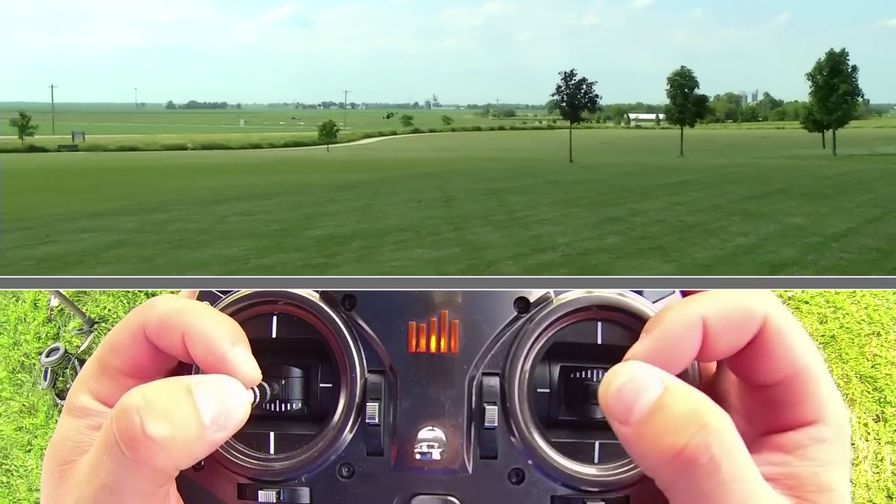 | 
Description: The instructor emphasizes the importance of controlling inputs while performing aerobatics to avoid aggressive snaps and maintain stability.
Correlated (true): 13 (4.8%)
Score >= 60: 13 (4.8%)
Average Score (of valid matches): 80.77

Top 5 Correlated Comments:
Score: 85
Comment: I am yet to try all this - my worry is this: In Acro mode when you're doing a flip, is it the pilot's responsibility to make sure that the drone is back upright? or will it anyway come back to the upright position after the roll? i know that in angle mode and in horizon mode, the drone will snap back to an upright horizontal position.
Reason: The comment directly discusses aerobatics (Acro mode), input control (making sure the drone is back upright) and stability (snapping back to an upright horizontal position), all of which are closely related concepts described in the topic.
Source: https://www.youtube.com/watch?v=YQ8ZhHBraZg

Score: 85
Comment: Amber Meows You just described expo so well I'm surprised you don't know what it is.... but yes to get what you described, on your Tx you would increase the expo. If you have a tuneable FC, play with the rc rate.
Reason: The comment directly discusses controlling inputs (expo) and parameters (TX, FC, rc rate), which are the same steps described by the topic. The mention of 'what you described' also indicates a connection to the topic's discussion on maintaining stability in aerobatics.
Source: https://www.youtube.com/watch?v=YQ8ZhHBraZg

Score: 80
Comment: sadigov if you are still getting used to controlling it when its facing you I wouldn't even attempt acro mode/doing tricks. Once you can do that then that's when you do what this guy does in the video.
Reason: The comment mentions controlling inputs which is directly related to the topic's emphasis on controlling inputs while performing aerobatics. The mention of 'acrobatic mode' and 'tricks' also overlaps with the topic's description of avoiding aggressive snaps and maintaining stability.
Source: https://www.youtube.com/watch?v=YQ8ZhHBraZg

Score: 80
Comment: Are you using a button to perform the flips and rolls or just the joysticks?
Reason: The comment directly asks about control inputs, specifically mentioning buttons and joysticks, which are mentioned in the topic description as crucial for controlling aerobatics.
Source: https://www.youtube.com/watch?v=YQ8ZhHBraZg

Score: 80
Comment: this is what i want to see.. how to control the best
Reason: The comment directly references controlling inputs, which is a key aspect of the topic description's emphasis on avoiding aggressive snaps and maintaining stability.
Source: https://www.youtube.com/watch?v=YQ8ZhHBraZg

Topic T2: Basic Aerobatics Techniques
 |  | 
Description: The instructor demonstrates basic aerobatics techniques such as right and left rolls, flips, and stalls.
Correlated (true): 21 (7.8%)
Score >= 60: 21 (7.8%)
Average Score (of valid matches): 80.71

Top 5 Correlated Comments:
Score: 90
Comment: Are you using a button to perform the flips and rolls or just the joysticks?
Reason: The comment directly asks about specific aerobatics techniques (flips and rolls) mentioned in the topic description, showing a strong correlation.
Source: https://www.youtube.com/watch?v=YQ8ZhHBraZg

Score: 90
Comment: thank you so much man!!! im going to keep watching youre videos as they are easy to follow and i shit my goddamn pants when i go out and try them
Reason: The comment mentions 'try[ing] them', which likely refers to the aerobatics techniques described in the topic, such as rolls and flips. Although it's not a direct quote or summary, the tone suggests that the viewer is excited to attempt the maneuvers after watching the video.
Source: https://www.youtube.com/watch?v=YQ8ZhHBraZg

Score: 90
Comment: Brian
Reason: The comment mentions 'rolls', which is a specific aerobatics technique discussed in the topic description. This direct reference to a technique mentioned in the topic indicates strong correlation.
Source: https://www.youtube.com/watch?v=YQ8ZhHBraZg

Score: 85
Comment: The Mavic mini can't do these moves, can it? The response times on this drone of yours appears to be cut for such aerobatics
Reason: The comment directly mentions 'aerobatics' and references specific moves like 'right and left rolls, flips, and stalls' described in the topic. The mention of drone response times also relates to the topic's focus on aerobatic techniques.
Source: https://www.youtube.com/watch?v=YQ8ZhHBraZg

Score: 80
Comment: Thanks for this i learned my first rolls and flips today in acro watching your video helped me 👍
Reason: The comment mentions specific aerobatics techniques (rolls and flips) which are directly discussed in the topic description.
Source: https://www.youtube.com/watch?v=YQ8ZhHBraZg

Topic T3: Basic Loop Demonstration
 |  | 
Description: The instructor demonstrates how to perform a basic loop, including adding throttle and pulling back.
Correlated (true): 4 (1.5%)
Score >= 60: 4 (1.5%)
Average Score (of valid matches): 78.75

Top 4 Correlated Comments:
Score: 80
Comment: Great video. I see what I was doing wrong now. I stuffed my vortex in the ground so hard a few times because I was not chopping the throttle. Luckily that thing is built like a tank.
Reason: The comment directly mentions the topic's description of 'chopping the throttle' which is a specific step related to the basic loop demonstration. The mention of not doing so and stuffing the vortex in the ground also shows understanding of the concept being demonstrated.
Source: https://www.youtube.com/watch?v=YQ8ZhHBraZg

Score: 80
Comment: So the first step we go ⬅️➡️ and as you can see the drone moves left and right...
To do a very basic flip, it's as simple as:
⬆️⬅️➡️↘️↗️⬇️↘️↙️⬅️⬆️↖️🔁↩️⤴️↖️⤵️⬇️↗️🔽🔼◀️⬆️⬅️↙️↘️↔️🔄⤵️⤵️⬇️
Reason: The comment directly discusses the steps of moving the drone left and right (⬅️➡️), flipping (⬆️⬅️➡️↘️↗️⬇️), and responding to inputs (🔁↩️⤴️↖️⤵️⬇️). These actions are specifically mentioned in the topic description as 'adding throttle and pulling back', making them strongly related.
Source: https://www.youtube.com/watch?v=YQ8ZhHBraZg

Score: 80
Comment: I there, I am just joining the fpv hobby with the Aquila 16 drone, just to be sure, you are doing this in acro mode right? or "manual mode" for the Aquila 16
Reason: The comment directly references the same mode ('acro' or 'manual') and drone model (Aquila 16) mentioned in the topic, indicating a strong correlation.
Source: https://www.youtube.com/watch?v=YQ8ZhHBraZg

Score: 75
Comment: Amber Meows You just described expo so well I'm surprised you don't know what it is.... but yes to get what you described, on your Tx you would increase the expo. If you have a tuneable FC, play with the rc rate.
Reason: The comment discusses 'expo' which is related to the topic's description of adding throttle and pulling back. The mention of adjusting RC rate also overlaps with the topic's focus on basic loop demonstration.
Source: https://www.youtube.com/watch?v=YQ8ZhHBraZg

