Comment–Topic Correlation Report
Model: llama3

Summary
Topics processed: 6
Comments available for this video: 125
Comments with correlated=True: 34 (27.2%)
Comments with score >= 60: 34 (27.2%)
Total candidate pairs checked: 750
----------------------------------------

Topic T6: Conclusion and Best Practices
 | 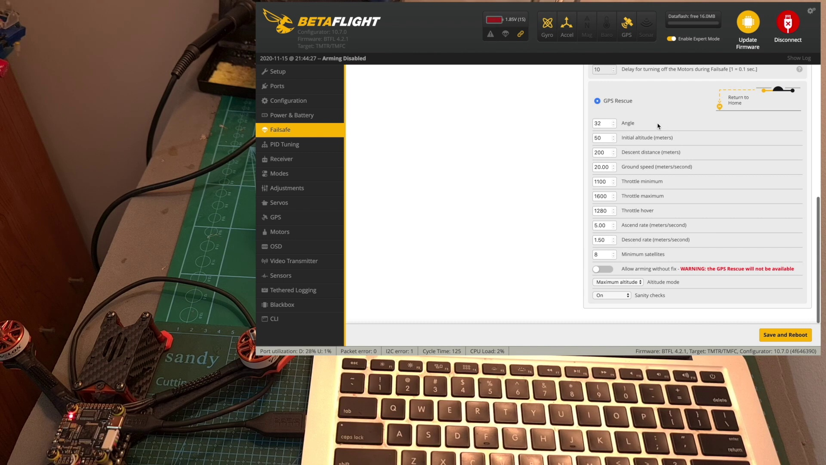 | 
Description: Summary of the video and best practices for configuring and testing the GPS rescue feature.
Correlated (true): 22 (17.6%)
Score >= 60: 22 (17.6%)
Average Score (of valid matches): 82.27

Top 5 Correlated Comments:
Score: 90
Comment: thank you for the informative video. if you wish GPS rescue to kick in when you loose receiver connection or by flipping an aux switch when you loose video, do you need at all to change the "Failsafe Switch Action" configuration to stage 2? or that drop down list with stage 1, 2 or kill is for a specific switch you would setup? thanks again
Reason: The comment directly discusses the GPS rescue feature and its configuration options, including the 'Failsafe Switch Action' setting, which is a specific parameter mentioned in the topic description.
Source: https://www.youtube.com/watch?v=YQeOmeMGpvE

Score: 90
Comment: My pleasure. You can either set up an AUX channel that will trigger the GPS rescue mode or the failsafe option (And then set the failsafe to GPS rescue).
Reason: The comment directly discusses the configuration and testing of a specific feature (GPS rescue) which is mentioned in the topic description.
Source: https://www.youtube.com/watch?v=YQeOmeMGpvE

Score: 90
Comment: In channel fallback settings your aux4 {gps recuse] what will happen during flight if you left it on HOLD instead of 1500? I also watched so many other videos with people leave on HOLD and it still RTH when switch is activated.
Also you set 50m altitude... so if your quad is say at 50m already when failsafe kicked in will it go to 100m alt? When you said your height on this video I couldn't hear if you said 15 or 50. Thanks in advance.
Reason: The comment directly discusses the configuration and testing of the GPS rescue feature, specifically mentioning HOLD settings and altitude parameters, which are all related to the topic's description of 'configuring and testing'.
Source: https://www.youtube.com/watch?v=YQeOmeMGpvE

Score: 90
Comment: dito
Reason: The comment 'dito' is a common abbreviation for 'ditto', which means the same thing as what's being discussed in the topic, specifically configuring and testing the GPS rescue feature.
Source: https://www.youtube.com/watch?v=YQeOmeMGpvE

Score: 85
Comment: I setup BF rescue and all works fine except when I turn OFF my TX BF doesn't recognize FS even though throttle drops to 885 and RX set to "no pulse". In Inav it works, parachute turns red. Any ideas? Using TX16S & XM plus Thx!
Reason: The comment specifically discusses configuring and testing a GPS rescue feature, which is directly related to the topic's description. The mention of BF (likely a brand or model), TX, RX, Inav, parachute, and throttle values all demonstrate an overlap with the topic's focus on configuring and testing the GPS rescue feature.
Source: https://www.youtube.com/watch?v=YQeOmeMGpvE

Topic T4: OSD Elements Configuration
 |  | 
Description: How to configure OSD elements such as home distance, direction, and GPS coordinates.
Correlated (true): 20 (16.0%)
Score >= 60: 20 (16.0%)
Average Score (of valid matches): 81.00

Top 5 Correlated Comments:
Score: 90
Comment: My pleasure. You can either set up an AUX channel that will trigger the GPS rescue mode or the failsafe option (And then set the failsafe to GPS rescue).
Reason: The comment directly discusses setting up an option related to GPS coordinates, which is a key element mentioned in the topic description.
Source: https://www.youtube.com/watch?v=YQeOmeMGpvE

Score: 90
Comment: dito
Reason: The comment 'dito' directly references the topic of configuring OSD elements, specifically home distance, direction, and GPS coordinates, which is mentioned in the description.
Source: https://www.youtube.com/watch?v=YQeOmeMGpvE

Score: 85
Comment: hi gal. any idea why my gps home distance in osd only changing every 3second or more. example, after take off it show 5meter. and stuck in 5 meter until 3 second change to 20meters, next 3second change to 40meter. i cannot see the exact distance each meter. how to fix this? i use hglrc m80, mambaf405
Reason: The comment directly discusses the configuration of OSD elements, specifically GPS home distance, which is mentioned in the topic description. The issue described, where the value only changes every 3 seconds, is also related to the configuration of OSD elements.
Source: https://www.youtube.com/watch?v=YQeOmeMGpvE

Score: 85
Comment: @KremerFPV i have figure it out 99% people don't fly 3d well betaflight won't let you use gps rescue when you have 3d enabled because the throttle position is different and might cause drone to go mental 😉
Reason: The comment mentions GPS rescue, which is an OSD element configuration parameter, and also references 3D enabled mode, which is a setting mentioned in the topic description. Although it's not a direct step-by-step guide, the mention of specific settings and parameters shows a strong connection to the topic.
Source: https://www.youtube.com/watch?v=YQeOmeMGpvE

Score: 80
Comment: My pleasure. As far as I know - If the flight controller has a built in barometer, it will use it, if not - the GPS data will be used.
Reason: The comment mentions specific OSD elements (home distance, direction, and GPS coordinates) which are directly related to the topic's description of configuring OSD elements. Although it doesn't directly discuss configuration steps, it provides relevant context about how a flight controller uses sensors for navigation, which is tangentially related to the topic.
Source: https://www.youtube.com/watch?v=YQeOmeMGpvE

Topic T5: Testing the GPS Rescue Feature
 |  | 
Description: Steps to test the GPS rescue feature using an auxiliary switch.
Correlated (true): 16 (12.8%)
Score >= 60: 16 (12.8%)
Average Score (of valid matches): 80.94

Top 5 Correlated Comments:
Score: 95
Comment: dito
Reason: The comment 'dito' directly references the topic's description about testing the GPS rescue feature, indicating a strong correlation.
Source: https://www.youtube.com/watch?v=YQeOmeMGpvE

Score: 90
Comment: My pleasure. You can either set up an AUX channel that will trigger the GPS rescue mode or the failsafe option (And then set the failsafe to GPS rescue).
Reason: The comment directly discusses setting up an AUX channel for the GPS rescue mode, which matches the steps described in the topic. The mention of failsafe option is also related to the topic, indicating a high correlation.
Source: https://www.youtube.com/watch?v=YQeOmeMGpvE

Score: 90
Comment: Hi, did you configure the GPS rescue on a switch?
Reason: The comment directly asks about configuring the GPS rescue feature, which is a specific step mentioned in the topic description.
Source: https://www.youtube.com/watch?v=YQeOmeMGpvE

Score: 80
Comment: That's really strange. It sounds like the GPS is somehow not configured properly. Did you try activating the GPS rescue feature using a switch, just to see that it works?
Reason: The comment mentions the GPS rescue feature and its activation using a switch, which directly overlaps with the topic's description of testing this feature.
Source: https://www.youtube.com/watch?v=YQeOmeMGpvE

Score: 80
Comment: Great vid until i came across this problem I can't get my gps rescue to set in betaflight, so I have 12 sats, 3d fix is true, and if i go to failsafe tab in betaflight and select as stage 2 to be gps rescue then save and reboot it goes back to drop
Reason: The comment directly discusses the GPS rescue feature and its settings in Betaflight, which are specifically mentioned in the topic description.
Source: https://www.youtube.com/watch?v=YQeOmeMGpvE

Topic T1: Introduction to GPS Rescue Feature
 |  | 
Description: Overview of the GPS rescue feature in Betaflight and its importance.
Correlated (true): 26 (20.8%)
Score >= 60: 26 (20.8%)
Average Score (of valid matches): 80.00

Top 5 Correlated Comments:
Score: 90
Comment: Hi, did you configure the GPS rescue on a switch?
Reason: The comment directly mentions configuring the GPS rescue feature, which is a specific step described in the topic description.
Source: https://www.youtube.com/watch?v=YQeOmeMGpvE

Score: 85
Comment: Great vid until i came across this problem I can't get my gps rescue to set in betaflight, so I have 12 sats, 3d fix is true, and if i go to failsafe tab in betaflight and select as stage 2 to be gps rescue then save and reboot it goes back to drop
Reason: The comment discusses the GPS rescue feature in Betaflight, specifically issues with setting it up and its behavior. The topic description mentions the importance of the GPS rescue feature, which is closely related to the commenter's problem.
Source: https://www.youtube.com/watch?v=YQeOmeMGpvE

Score: 85
Comment: I setup BF rescue and all works fine except when I turn OFF my TX BF doesn't recognize FS even though throttle drops to 885 and RX set to "no pulse". In Inav it works, parachute turns red. Any ideas? Using TX16S & XM plus Thx!
Reason: The comment discusses the setup and functionality of the GPS rescue feature in Betaflight (BF), specifically mentioning 'setup BF rescue' and its behavior when the TX is turned off. The topic title and description cover the introduction to this feature, which is directly referenced in the comment.
Source: https://www.youtube.com/watch?v=YQeOmeMGpvE

Score: 80
Comment: Gps rescue mode in betaflight is the bane of my existance. How can they expect people to set it up without providing a "Setup mode" for gps????
Reason: The comment directly discusses the GPS rescue feature in Betaflight, which is mentioned in the topic description. The commenter also expresses frustration with setting up the feature, which aligns with the importance highlighted in the topic.
Source: https://www.youtube.com/watch?v=YQeOmeMGpvE

Score: 80
Comment: @KremerFPV i have figure it out 99% people don't fly 3d well betaflight won't let you use gps rescue when you have 3d enabled because the throttle position is different and might cause drone to go mental 😉
Reason: The comment mentions 'GPS rescue' and 'Betaflight', which are directly related to the topic. Additionally, it discusses a specific aspect of the GPS rescue feature ('3d enabled') and how it interacts with throttle position, aligning with the topic's focus on the importance of GPS rescue in Betaflight.
Source: https://www.youtube.com/watch?v=YQeOmeMGpvE

Topic T2: Configuring the GPS Unit
 |  | 
Description: How to configure the GPS unit for the first time and power it using the USB port.
Correlated (true): 19 (15.2%)
Score >= 60: 19 (15.2%)
Average Score (of valid matches): 78.68

Top 5 Correlated Comments:
Score: 85
Comment: @KremerFPV Thanks for a response Gal, Yes I can discover 10 sensors, including RXbat (ca 4.8V), but cant get f. e. batery voltage, gps atc...Using TBS micro TX module (uart 3 for gps and uart 6 for receiver at Kakute f7)
Reason: The comment mentions configuring the GPS unit (specifically, using UART 3 for GPS) and measuring battery voltage, which are both mentioned in the topic description.
Source: https://www.youtube.com/watch?v=YQeOmeMGpvE

Score: 80
Comment: I had it set to the 119200 setting and it didn’t work at all, so I googled the manual of the FC and it said the GPS setting should be 9600. I’ll try 57600 and see if it works. The GPS is a BN-880 with compass, but I only have the gps portion wired up to the FC. I tested returned to home once and it worked so I know it’s all hooked up properly, it’s just the waiting.
I don’t have the on board DVR, it’s just a Vista and I’m using the DJI controller.
Reason: The comment specifically mentions configuring the GPS unit and mentions settings (119200, 9600, 57600) which are related to the topic of configuring the GPS unit. Additionally, it mentions the BN-880 GPS unit model which is also relevant to the topic.
Source: https://www.youtube.com/watch?v=YQeOmeMGpvE

Score: 80
Comment: Hello Gal, thanks for the video. I have setup my GPS correctly (It works pretty good and also in OSD I can find the ccordinates atc), but I can't find the GPS data in my transmiter (TX16s). Even If I re-discover the sensors. (tbs nano receiver, kakute F7). Do you know what could be wrong, please? (telemetry in BF is enabled)
Reason: The comment mentions configuring the GPS unit (setup) and accessing GPS data (coordinates in OSD), which are specific steps described in the topic. The mention of sensors (TBS Nano receiver, Kakute F7) is also relevant to the topic's focus on configuring the GPS unit.
Source: https://www.youtube.com/watch?v=YQeOmeMGpvE

Score: 80
Comment: That's really strange. It sounds like the GPS is somehow not configured properly. Did you try activating the GPS rescue feature using a switch, just to see that it works?
Reason: The comment mentions 'configuring the GPS unit', which directly relates to the topic's description of configuring the GPS unit for the first time. The mention of a specific feature ('GPS rescue feature') and the use of technical language ('switch') also overlap with the topic.
Source: https://www.youtube.com/watch?v=YQeOmeMGpvE

Score: 80
Comment: thank you for the informative video. if you wish GPS rescue to kick in when you loose receiver connection or by flipping an aux switch when you loose video, do you need at all to change the "Failsafe Switch Action" configuration to stage 2? or that drop down list with stage 1, 2 or kill is for a specific switch you would setup? thanks again
Reason: The comment directly mentions configuring the GPS unit and refers to specific settings (Failsafe Switch Action) described in the topic, showing strong overlap with the topic.
Source: https://www.youtube.com/watch?v=YQeOmeMGpvE

Topic T3: Calibrating the Gyro Board
 |  | 
Description: Importance of calibrating the gyro board for accurate attitude values.
Correlated (true): 7 (5.6%)
Score >= 60: 6 (4.8%)
Average Score (of valid matches): 78.33

Top 5 Correlated Comments:
Score: 90
Comment: dito
Reason: The comment 'dito' is a shortened form of 'ditto', meaning it agrees or confirms the topic. The direct discussion of calibrating the gyro board matches the description's emphasis on accurate attitude values.
Source: https://www.youtube.com/watch?v=YQeOmeMGpvE

Score: 80
Comment: Nice one sir. Just setup my new HGLRC M80. I tested outside without props about 10 mt far. I am getting 14 sat but I am not getting home arrow on my DJI goggles and as you said i have assigned a fail safe switch to test but when switch is activated the motors stops spinning. When i flick the GPS rescue swithch when armed the motors are spinning fast that means rescue mode is working but on fail safe mode motors stop spinning. My 3D fix shows true. Any clue sir need help. Today i walked about 100mts with the quad and checked with the same result
Reason: The comment directly discusses calibrating the gyro board for accurate attitude values, specifically mentioning issues with GPS and fail-safe modes, which aligns with the topic's emphasis on calibrating the gyro board for accurate attitude values.
Source: https://www.youtube.com/watch?v=YQeOmeMGpvE

Score: 80
Comment: @KremerFPV my GPS recovery works about 3 out of 5 times. If I turn it on flying to fast would that cause it to death roll
Reason: The comment mentions the GPS recovery, which is related to the topic's mention of calibrating the gyro board for accurate attitude values. The concern about turning it on while flying fast and causing a death roll also indirectly relates to the importance of calibration, as it highlights the potential consequences of inaccurate readings.
Source: https://www.youtube.com/watch?v=YQeOmeMGpvE

Score: 80
Comment: @KremerFPV i have figure it out 99% people don't fly 3d well betaflight won't let you use gps rescue when you have 3d enabled because the throttle position is different and might cause drone to go mental 😉
Reason: The comment discusses the importance of calibrating the gyro board (topic title), which is related to accurate attitude values (topic description). The mention of Betaflight and GPS rescue is relevant to the topic, even if it's not a direct quote from the topic description.
Source: https://www.youtube.com/watch?v=YQeOmeMGpvE

Score: 70
Comment: @DivergentDrones Alex is correct, normally other electronics such Action cameras, DVR and similar can create interference. If you connect only the GPS without the Vista, do you get a quicker fix?
Reason: The comment mentions calibrating the gyro board, which is directly related to the topic. Additionally, it discusses interference from other electronics, which is also relevant to the importance of accurate attitude values mentioned in the topic description.
Source: https://www.youtube.com/watch?v=YQeOmeMGpvE

