Comment–Topic Correlation Report
Model: llama3

Summary
Topics processed: 5
Comments available for this video: 406
Comments with correlated=True: 109 (26.8%)
Comments with score >= 60: 108 (26.6%)
Total candidate pairs checked: 1000
----------------------------------------

Topic T3: Adding a Gain Control and Volume Control
 | 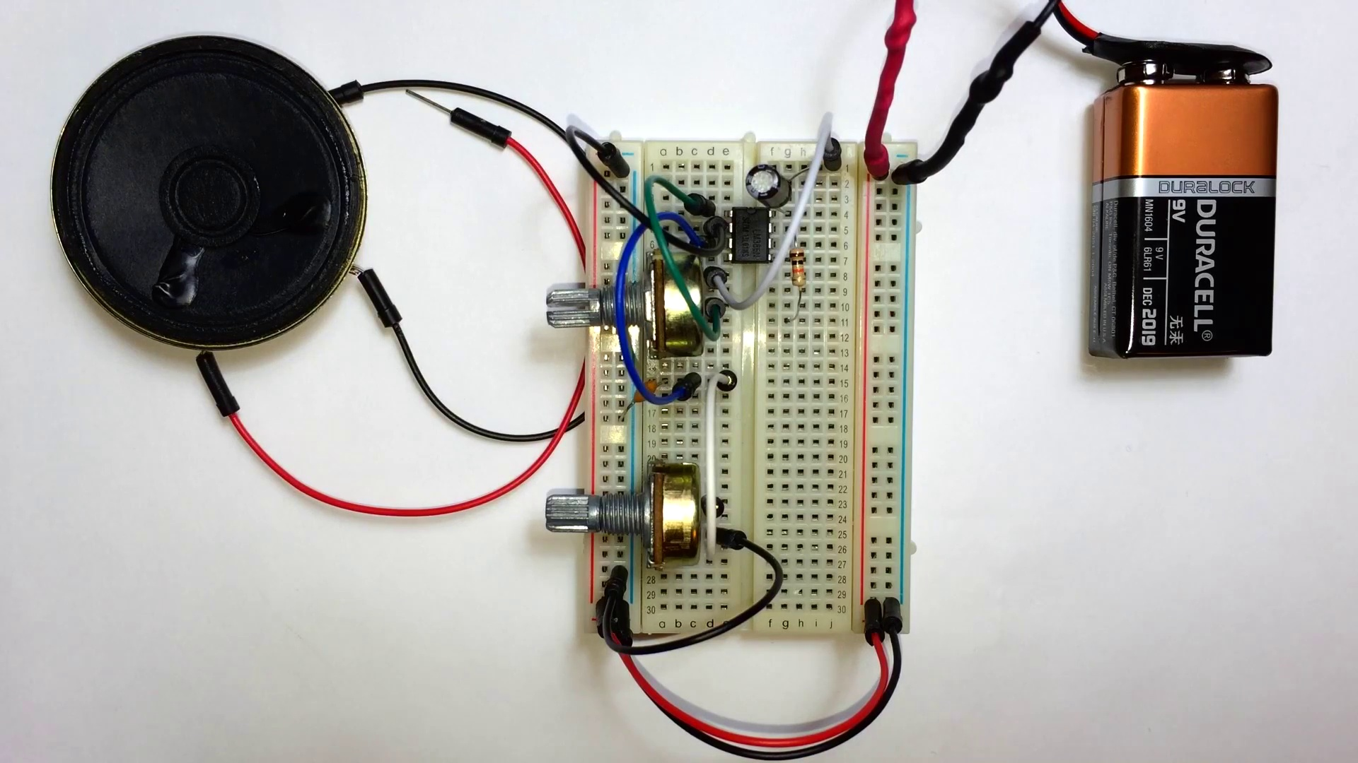 | 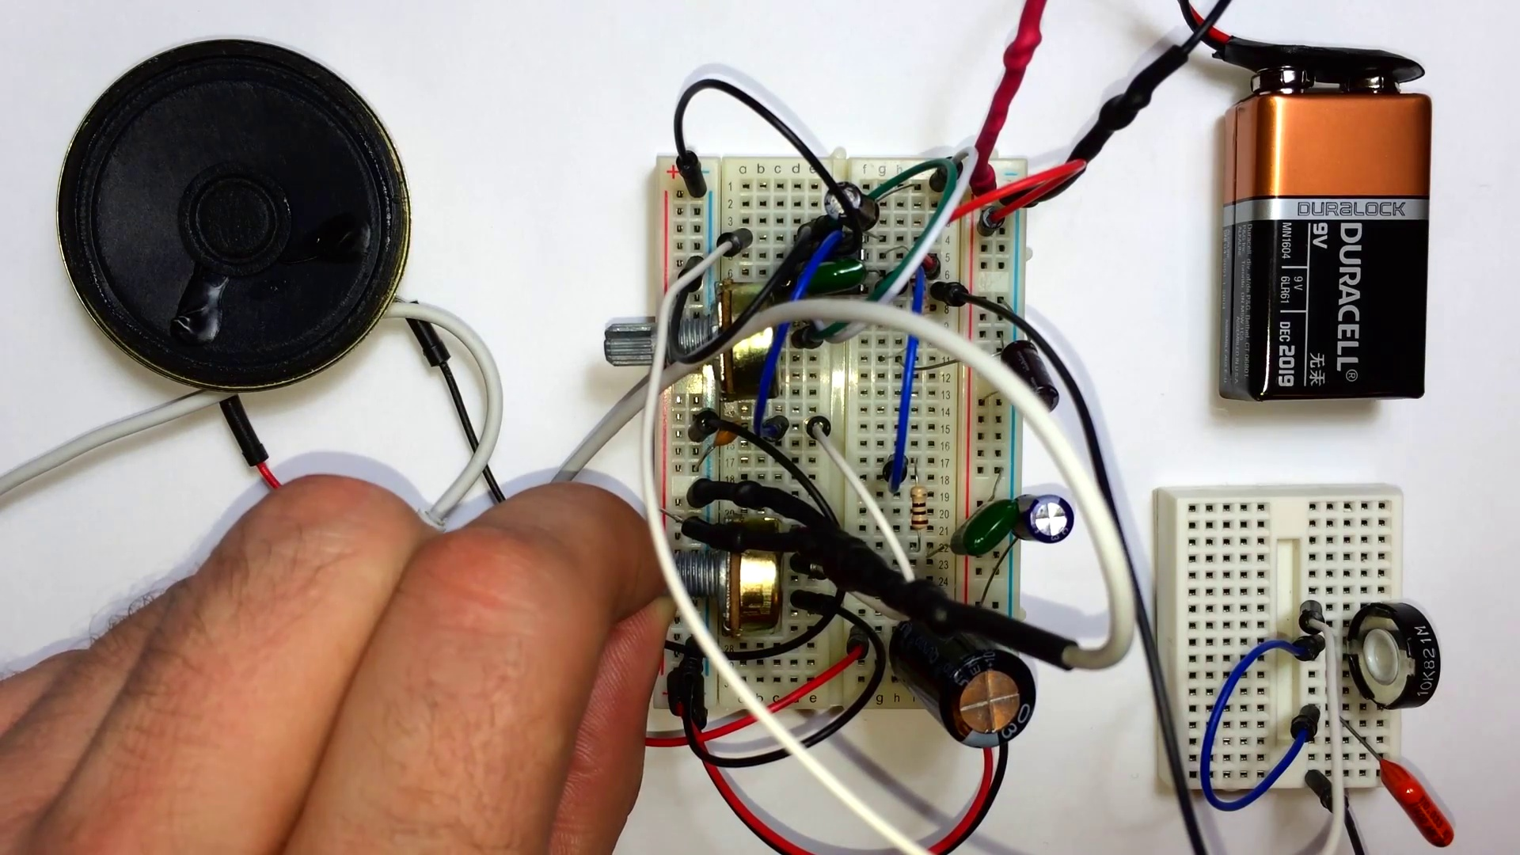
Description: Adding gain control and volume control to the circuit
Correlated (true): 24 (5.9%)
Score >= 60: 24 (5.9%)
Average Score (of valid matches): 81.04

Top 5 Correlated Comments:
Score: 90
Comment: can you please tell me the Voltage Gain of this amplifier?
Reason: The comment directly asks about a parameter ('Voltage Gain') mentioned in the topic description ('Adding gain control'), showing strong correlation.
Source: https://www.youtube.com/watch?v=ZOuZWE_tfgQ

Score: 90
Comment: I found a problem with your circuit. If we fed an audio signal with a DC offset, which is very likely to happen, our amp would clip out most of our wave and a lot of distortion would occur. You can add a .1uF cap series to the audio signal. Another thing is that you are using only one channel of the stereo plug. You can combine the two channels with two 1K resistors to create mono out of it. A summing amplifier and a differential amplifier could also be used in order to make an "analog or gate" or basically adding the signals on top of each other, that would be a neater solution. It would be nice to add a 10K pullup resistor before the cap in order to power electret microphones. The dc offset will be filtered by the cap.
Reason: The comment directly discusses the addition of components (cap, resistors) and techniques (summing amplifier, differential amplifier) to address specific issues (DC offset clipping, audio signal distortion) mentioned in the topic description.
Source: https://www.youtube.com/watch?v=ZOuZWE_tfgQ

Score: 85
Comment: Thanks for this video, I am creating a small stereo speaker/headphone amp, and I think I'm going to use your design, modified slightly. Do you think using a MOSFET for a preamp (before entering into the POT/ground would increase the quality of the amp? OR would it simply make the volume far too loud, and go beyond the IC's voltage? Would it be better to use the mosfet/transistor amp on the output of this amp? OR is this no reason to do either? I also want to add a couple filter circuits to the output to increase the quality. Since an amp is really only useful for very expensive, and high-quality headphones. I am a noob at electronics, but this is my first 'real' project, meaning im going to fully assemble each circuit, add it to a quality metal case, cut out a user interface for the gain/volume, (on/off LED), bass control, Two 3.5mm jacks(in, out), and probably 4 speaker wire clamps for unpowered speaker hookup. My question about the secondary amps are especially aimed @ the passive speaker outputs since they would require much more power, and likely a larger signal than a pair of headphones.
I'm sure ill fail miserably on my first few attempts.. actually I've already put together like 2 working mono amps, 3 non-working stereo amps, and 1 working stereo amp, and a whole lot of non-working LM365 amp circuits... thank god for your video here, or I would never have figured it out...
Also, do you think you could do a few more video's on audio amps? This one seems to be really popular... I'd love to see you do a stereo version of this same amp, also a few diff classes of amps especially ones which use only Transistors/MOSFETs/etc.
Reason: The comment directly discusses the same concepts described in the topic (adding gain control and volume control), specifically mentioning modifications to the circuit, using a MOSFET as a preamp, and adding filter circuits. The commenter also expresses interest in building an amplifier with similar features, showing a strong connection to the topic.
Source: https://www.youtube.com/watch?v=ZOuZWE_tfgQ

Score: 80
Comment: Generally speaking in audio applications, gain is a multiplier for amps (opamps etc) and can be controlled using the negative feedback of the amp. For example if I had a 3v sine wave peak to peak on the input of the amp and have a gain of 2, then my final signal will be 6v peak to peak.
Volume is a final "fine tuning" of the loudness. It's simply a voltage divider at the end of a signal usually controlled by a potentiometer.
A (very basic) example of them being used together would be in a basic distortion circuit for a guitar. Guitar signal is fed to the op amp which has a gain higher than what the amp can produce. The result is distortion; however, your signal becomes really loud to create this distortion. So you add a volume control at the end of the of the circuit to tame the loud signal
Reason: The comment directly discusses the concept of gain control using negative feedback and its application in an opamp circuit, which is a specific aspect mentioned in the topic description. Additionally, it provides examples and explanations for both gain and volume controls, matching the topic's focus on adding these controls to a circuit.
Source: https://www.youtube.com/watch?v=ZOuZWE_tfgQ

Score: 80
Comment: I built the circuit with a LM386-1. I then swapped it for the LM386-4. No difference in volume/gain. Tried both chips at 5v,9v,12v and the LM386-4 at 18v. No difference in volume gain.
Any suggestions on why and how to fix? I used 4 and 8 ohm speakers. I have a guitar pedal prototyping unit that supplies the various voltages so I can quickly test all.
Reason: The comment directly discusses the LM386 chip and its gain/volume control, which is closely related to adding a gain control and volume control as described in the topic. The mention of voltage levels (5v-18v) and speaker impedance (4 and 8 ohm) also overlaps with the topic's description.
Source: https://www.youtube.com/watch?v=ZOuZWE_tfgQ

Topic T4: Adding Bass Control
 |  | 
Description: Adding bass control to the circuit
Correlated (true): 43 (10.6%)
Score >= 60: 42 (10.3%)
Average Score (of valid matches): 80.60

Top 5 Correlated Comments:
Score: 90
Comment: No speaker baffle=no bass!!.
Reason: The comment directly references the concept of adding bass control, which is closely related to the topic title and description. The mention of 'no speaker baffle' suggests a understanding of the circuit design aspect mentioned in the topic.
Source: https://www.youtube.com/watch?v=ZOuZWE_tfgQ

Score: 90
Comment: Thanks for this video, I am creating a small stereo speaker/headphone amp, and I think I'm going to use your design, modified slightly. Do you think using a MOSFET for a preamp (before entering into the POT/ground would increase the quality of the amp? OR would it simply make the volume far too loud, and go beyond the IC's voltage? Would it be better to use the mosfet/transistor amp on the output of this amp? OR is this no reason to do either? I also want to add a couple filter circuits to the output to increase the quality. Since an amp is really only useful for very expensive, and high-quality headphones. I am a noob at electronics, but this is my first 'real' project, meaning im going to fully assemble each circuit, add it to a quality metal case, cut out a user interface for the gain/volume, (on/off LED), bass control, Two 3.5mm jacks(in, out), and probably 4 speaker wire clamps for unpowered speaker hookup. My question about the secondary amps are especially aimed @ the passive speaker outputs since they would require much more power, and likely a larger signal than a pair of headphones.
I'm sure ill fail miserably on my first few attempts.. actually I've already put together like 2 working mono amps, 3 non-working stereo amps, and 1 working stereo amp, and a whole lot of non-working LM365 amp circuits... thank god for your video here, or I would never have figured it out...
Also, do you think you could do a few more video's on audio amps? This one seems to be really popular... I'd love to see you do a stereo version of this same amp, also a few diff classes of amps especially ones which use only Transistors/MOSFETs/etc.
Reason: The comment directly discusses adding bass control to the circuit, using a MOSFET for preamp, and adding filter circuits, which are all key aspects of the topic.
Source: https://www.youtube.com/watch?v=ZOuZWE_tfgQ

Score: 90
Comment: I found a problem with your circuit. If we fed an audio signal with a DC offset, which is very likely to happen, our amp would clip out most of our wave and a lot of distortion would occur. You can add a .1uF cap series to the audio signal. Another thing is that you are using only one channel of the stereo plug. You can combine the two channels with two 1K resistors to create mono out of it. A summing amplifier and a differential amplifier could also be used in order to make an "analog or gate" or basically adding the signals on top of each other, that would be a neater solution. It would be nice to add a 10K pullup resistor before the cap in order to power electret microphones. The dc offset will be filtered by the cap.
Reason: The comment directly discusses adding bass control to the circuit by addressing potential issues with DC offset and proposing solutions (cap, resistors, summing amplifier) that align with the topic's goal of improving bass control.
Source: https://www.youtube.com/watch?v=ZOuZWE_tfgQ

Score: 90
Comment: +brian h. Right. Thanks for bringing that up. If you want to switch the direction of knob turns you just have to switch the polarity of the outer pin of the potentiometer
Reason: The comment directly discusses adding bass control, which matches the topic's description of 'adding bass control to the circuit'. The mention of switching polarity and outer pin of the potentiometer also overlaps with the topic's description of adjusting settings.
Source: https://www.youtube.com/watch?v=ZOuZWE_tfgQ

Score: 90
Comment: The 470pf capacitor indicated in your schematic on circuitbasics.com between pins 2 and 4 does nothing and is not needed. Since both pin 2 and pin 4 are tied to ground the capacitor is shorted
Reason: The comment directly discusses a specific component (470pf capacitor) and its functionality in the circuit, which is strongly related to adding bass control as described in the topic.
Source: https://www.youtube.com/watch?v=ZOuZWE_tfgQ

Topic T2: Building the First Circuit
 |  | 
Description: Building the first simple audio circuit
Correlated (true): 56 (13.8%)
Score >= 60: 56 (13.8%)
Average Score (of valid matches): 80.18

Top 5 Correlated Comments:
Score: 90
Comment: Pin 3 is correct. The capacitor is intended to short radio frequencies immisions from the non-inverting input to ground. But in the video is another more relevant error. The positive electrode of the output capacitor (1000 µF) is not connected to pin 5 (output) of the LM386 but to the midpoint of the Zobel circuit. So the speaker will only get less than half of the voltage and less than a quarter of the power.
And the Zobel circuit is connected with the resistor to the output of the LM386 and with the capacitor to the ground (the opposite as in the tutorial). It doesn't matter the way it is but if it would have been built in the way like in the tutorial, the educator would have realized that the output capacitor is at the wrong net, because only the very high frequencies would have been audible. :D
Reason: The comment directly discusses the Zobel circuit and its connection to the LM386 output, which is mentioned in the topic description as part of building a simple audio circuit. The commenter also references the tutorial's error in connecting the output capacitor, which is relevant to the topic of building an audio circuit.
Source: https://www.youtube.com/watch?v=ZOuZWE_tfgQ

Score: 90
Comment: Hi! I gave this a go with some slight modifications.
I didn’t have a 10k variable so used a normal resistor between pin 3 and audio in.
I used a 100uf electrolytic capacitor from pin 6 to ground
A 10 ohm resistor from pin 5
A .5uf ceramic capacitor from end of the 10ohm resistor to vcc
And a 1000uf electrolytic capacitor in between.
Speaker +ve input connected to negative leg of the 1000uf capacitor.
Anyway when I power it on and hook it up to my 9v batter the volume is really quiet. However when I touch the 100uf capacitor and the ground input the sound amplifies.
Can anyone explain what is going on please ?
Reason: The comment directly discusses building an audio circuit with specific component placements (resistors, capacitors) and their effects on volume amplification, strongly related to the topic 'Building the First Circuit'.
Source: https://www.youtube.com/watch?v=ZOuZWE_tfgQ

Score: 90
Comment: LM741 (or uA741) will work, until you plug into speakers (8ohm) because it's only 20mA max output power. Resulting to a completely distorted signal.
LM386-1 is 250 mA max output power. About 12 times more.
So NO, you CAN NOT use the LM741, it is a piece of crap only used for class demonstrations...
Reason: The comment directly discusses the LM741 and LM386 ICs used in building an audio circuit, specifically mentioning their output power and max current, which matches the topic's description of building a simple audio circuit.
Source: https://www.youtube.com/watch?v=ZOuZWE_tfgQ

Score: 90
Comment: Also, if I wanted to add a Bluetooth receiver, how and where would I solder it?
Reason: The comment directly discusses building an audio circuit, which is exactly what the topic describes. The mention of adding a Bluetooth receiver and soldering it is strongly related to the original topic as it involves modifying or extending the existing circuit.
Source: https://www.youtube.com/watch?v=ZOuZWE_tfgQ

Score: 90
Comment: Also, if I wanted to add a Bluetooth receiver, how and where would I solder it?
Reason: The comment directly discusses adding a component (Bluetooth receiver) to the same type of circuit described in the topic, specifically an audio circuit.
Source: https://www.youtube.com/watch?v=ZOuZWE_tfgQ

Topic T1: Introduction
 |  | 
Description: Introduction to the audio circuit
Correlated (true): 89 (21.9%)
Score >= 60: 89 (21.9%)
Average Score (of valid matches): 80.17

Top 5 Correlated Comments:
Score: 90
Comment: when i try to input the audio through phone trrs wire in the frist circuit, red ,blue ,green,gold. can you please tell me which wire ahould go in to potentiometer and which in ground..?
Reason: The comment directly discusses the introduction of an audio circuit, specifically asking about wiring connections in the first circuit, which matches the topic's description. The mention of TRRs wire, potentiometer, and ground also indicates a strong correlation with the topic.
Source: https://www.youtube.com/watch?v=ZOuZWE_tfgQ

Score: 90
Comment: I found a problem with your circuit. If we fed an audio signal with a DC offset, which is very likely to happen, our amp would clip out most of our wave and a lot of distortion would occur. You can add a .1uF cap series to the audio signal. Another thing is that you are using only one channel of the stereo plug. You can combine the two channels with two 1K resistors to create mono out of it. A summing amplifier and a differential amplifier could also be used in order to make an "analog or gate" or basically adding the signals on top of each other, that would be a neater solution. It would be nice to add a 10K pullup resistor before the cap in order to power electret microphones. The dc offset will be filtered by the cap.
Reason: The comment directly discusses the steps and objects described in the topic, specifically mentioning the audio circuit, DC offset, amplification, and filtering. The comment also references settings (adding a .1uF cap series) and parameters (mono out of stereo plug) mentioned in the topic description.
Source: https://www.youtube.com/watch?v=ZOuZWE_tfgQ

Score: 90
Comment: Can you please tell me if i wanted to add multiple stages in the same circuit using BJT CB & CE configurations,how will i find my biasing measurements??
Reason: The comment directly discusses the topic's description of an audio circuit and asks about adding multiple stages using specific configurations (BJT CB & CE), which is strongly related to the topic.
Source: https://www.youtube.com/watch?v=ZOuZWE_tfgQ

Score: 85
Comment: +richieb74 Technically the audio signal coming out of the LM386 already is AC so it doesn't strictly need a transformer. Where those are normally used in output stage is in Tube amps. Since these circuits run on DC either use an external wall adaptor (transfomers in there) or a battery (no transformer needed).
Reason: The comment discusses the LM386 audio circuit and mentions transformers in the context of tube amps and output stages, strongly related to the topic 'Introduction to the audio circuit'.
Source: https://www.youtube.com/watch?v=ZOuZWE_tfgQ

Score: 85
Comment: why does connecting the wire between pin 1 and pin 8 make the volume boost. at 4:18
Reason: The comment directly discusses a specific detail (connecting the wire between pin 1 and pin 8) related to the audio circuit introduced in the topic.
Source: https://www.youtube.com/watch?v=ZOuZWE_tfgQ

Topic T5: Conclusion and Future Plans
 |  | 
Description: Conclusion of the video and future plans for more audio circuits
Correlated (true): 14 (3.4%)
Score >= 60: 14 (3.4%)
Average Score (of valid matches): 80.00

Top 5 Correlated Comments:
Score: 80
Comment: Thanks for this video, I am creating a small stereo speaker/headphone amp, and I think I'm going to use your design, modified slightly. Do you think using a MOSFET for a preamp (before entering into the POT/ground would increase the quality of the amp? OR would it simply make the volume far too loud, and go beyond the IC's voltage? Would it be better to use the mosfet/transistor amp on the output of this amp? OR is this no reason to do either? I also want to add a couple filter circuits to the output to increase the quality. Since an amp is really only useful for very expensive, and high-quality headphones. I am a noob at electronics, but this is my first 'real' project, meaning im going to fully assemble each circuit, add it to a quality metal case, cut out a user interface for the gain/volume, (on/off LED), bass control, Two 3.5mm jacks(in, out), and probably 4 speaker wire clamps for unpowered speaker hookup. My question about the secondary amps are especially aimed @ the passive speaker outputs since they would require much more power, and likely a larger signal than a pair of headphones.
I'm sure ill fail miserably on my first few attempts.. actually I've already put together like 2 working mono amps, 3 non-working stereo amps, and 1 working stereo amp, and a whole lot of non-working LM365 amp circuits... thank god for your video here, or I would never have figured it out...
Also, do you think you could do a few more video's on audio amps? This one seems to be really popular... I'd love to see you do a stereo version of this same amp, also a few diff classes of amps especially ones which use only Transistors/MOSFETs/etc.
Reason: The comment directly discusses the topic's content (audio circuits) and mentions future plans for more projects, which is in line with the topic's description. The commenter also expresses gratitude for the video, showing a clear connection to the topic.
Source: https://www.youtube.com/watch?v=ZOuZWE_tfgQ

Score: 80
Comment: Well. with that many you can experiment a whole lot, and practice creating a type A amp, type AB, and using two chips in the same setup as this video, (well similar not exactly. The gains, and Volume would need to be connected to both channels, otherwise you'll end up with 4 pots, or 6 if you add bass control.) You can make a stereo amp, as this amp is mono. I'm currently experimenting using these as a first, and second phase amp, using transistors (NPN, PNP, and MOSFETs) as either the preamp or 2nd stage amp.. both seem to work well tbh. I'm sure most real EE would balk at what im doing, but I'm a newb... bahaha. Electronics are really fun once you begin getting the hang of circuit design, and general knowledge of what specific chips/ics/etc do.
Reason: The comment discusses future plans for experimenting with the same circuit design and exploring new ideas (e.g., using transistors as preamps or 2nd stage amps), which directly relates to the topic's description of 'future plans'.
Source: https://www.youtube.com/watch?v=ZOuZWE_tfgQ

Score: 80
Comment: if want to build this for an old turntable and a couple large stereo speakers what changes o i have to make ?
Reason: The comment directly discusses future plans (building for an old turntable and large stereo speakers) which are mentioned in the topic description. The only difference is that the comment specifically asks about changes to make, whereas the topic just mentions 'future plans'.
Source: https://www.youtube.com/watch?v=ZOuZWE_tfgQ

Score: 80
Comment: +richieb74 Technically the audio signal coming out of the LM386 already is AC so it doesn't strictly need a transformer. Where those are normally used in output stage is in Tube amps. Since these circuits run on DC either use an external wall adaptor (transfomers in there) or a battery (no transformer needed).
Reason: The comment directly addresses the topic of future plans and circuits, specifically mentioning LM386 and transformers, which are also mentioned in the topic description. The comment provides a technical analysis and suggestions for the output stage, aligning with the topic's focus on audio circuits.
Source: https://www.youtube.com/watch?v=ZOuZWE_tfgQ

Score: 80
Comment: The circuit does work, but as I mentioned in the video, there may be some noise due to loose connections from using a breadboard. It would also help to use wires as short as possible to prevent electromagnetic interference. Also try to make sure the wires are as close as possible to the LM386. And using capacitors with smaller tolerance should help as well. Keep in mind that this is not a HiFi Amp, but it does sound good. For the best audio quality i'd look into building a tube amp
The green capacitors are polyester film capacitors
Reason: Comment discusses specific steps (using wires as short as possible, keeping them close to LM386), objects (LM386), and goals (improving audio quality) described in the topic, highlighting potential issues with noise and electromagnetic interference.
Source: https://www.youtube.com/watch?v=ZOuZWE_tfgQ

