Comment–Topic Correlation Report
Model: llama3

Summary
Topics processed: 4
Comments available for this video: 305
Comments with correlated=True: 66 (21.6%)
Comments with score >= 60: 66 (21.6%)
Total candidate pairs checked: 800
----------------------------------------

Topic T3: Testing the Op-Amp Circuit
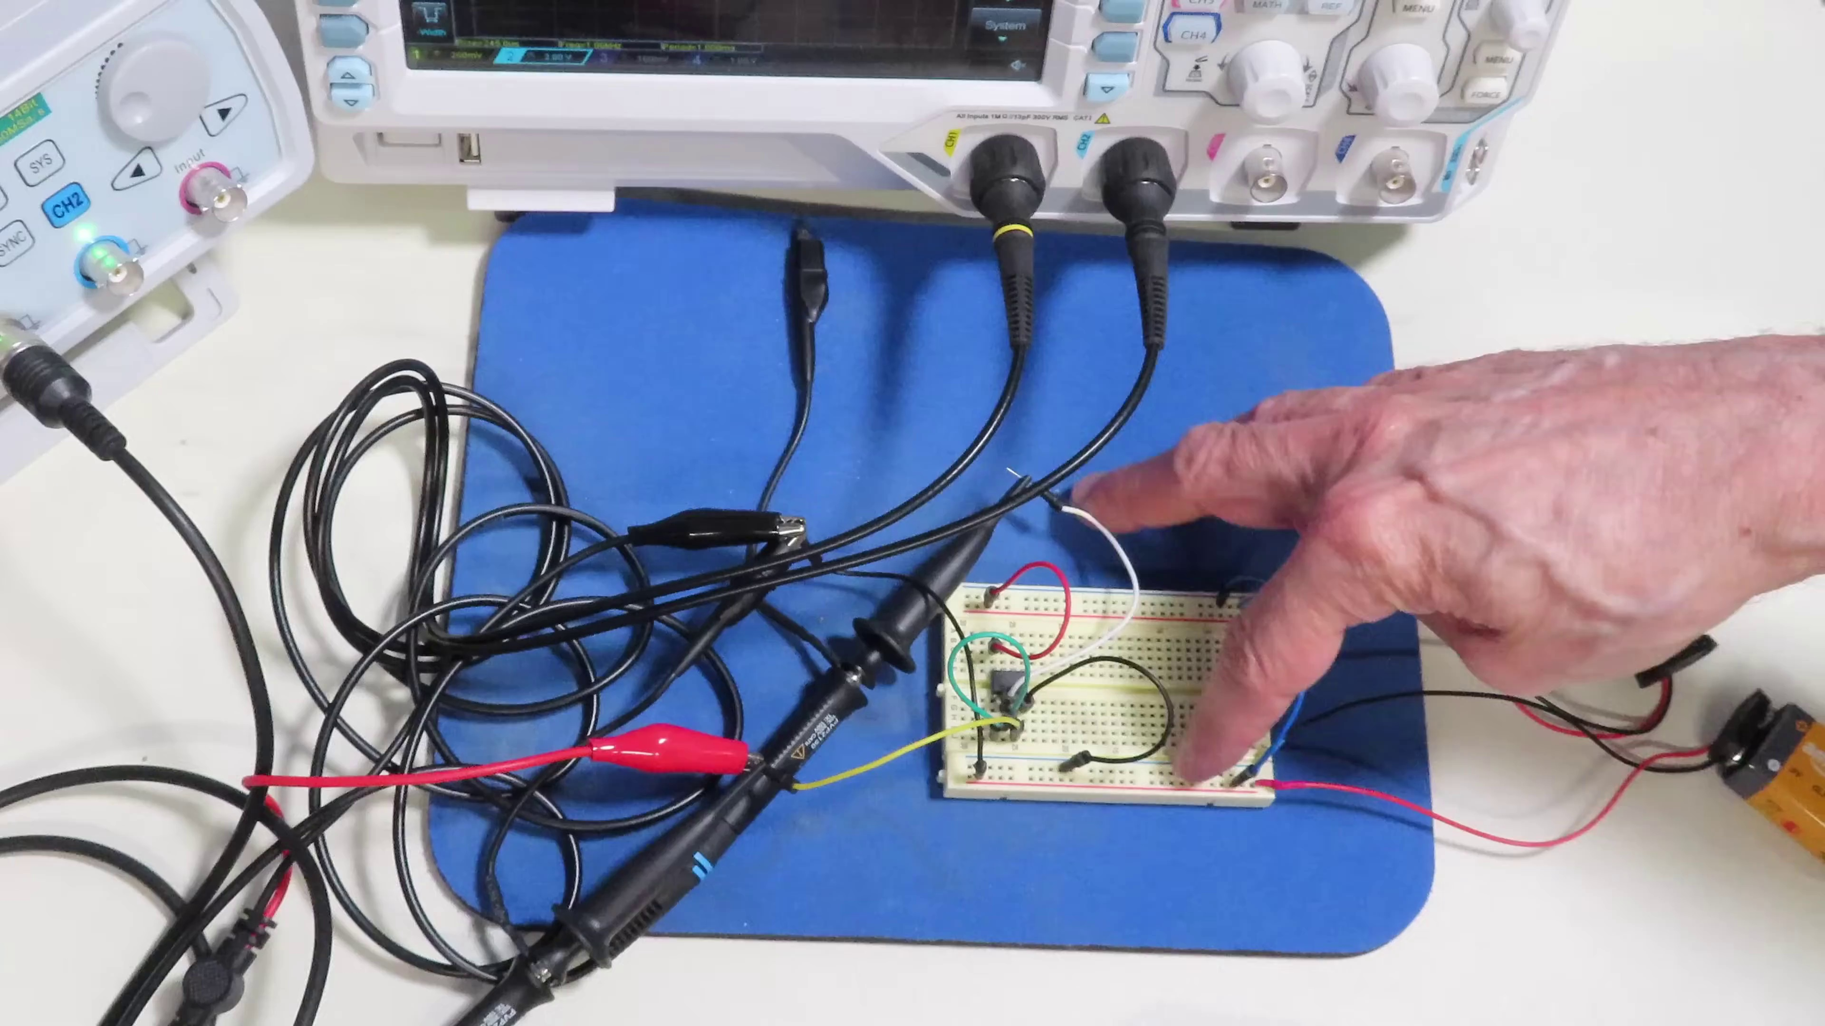 | 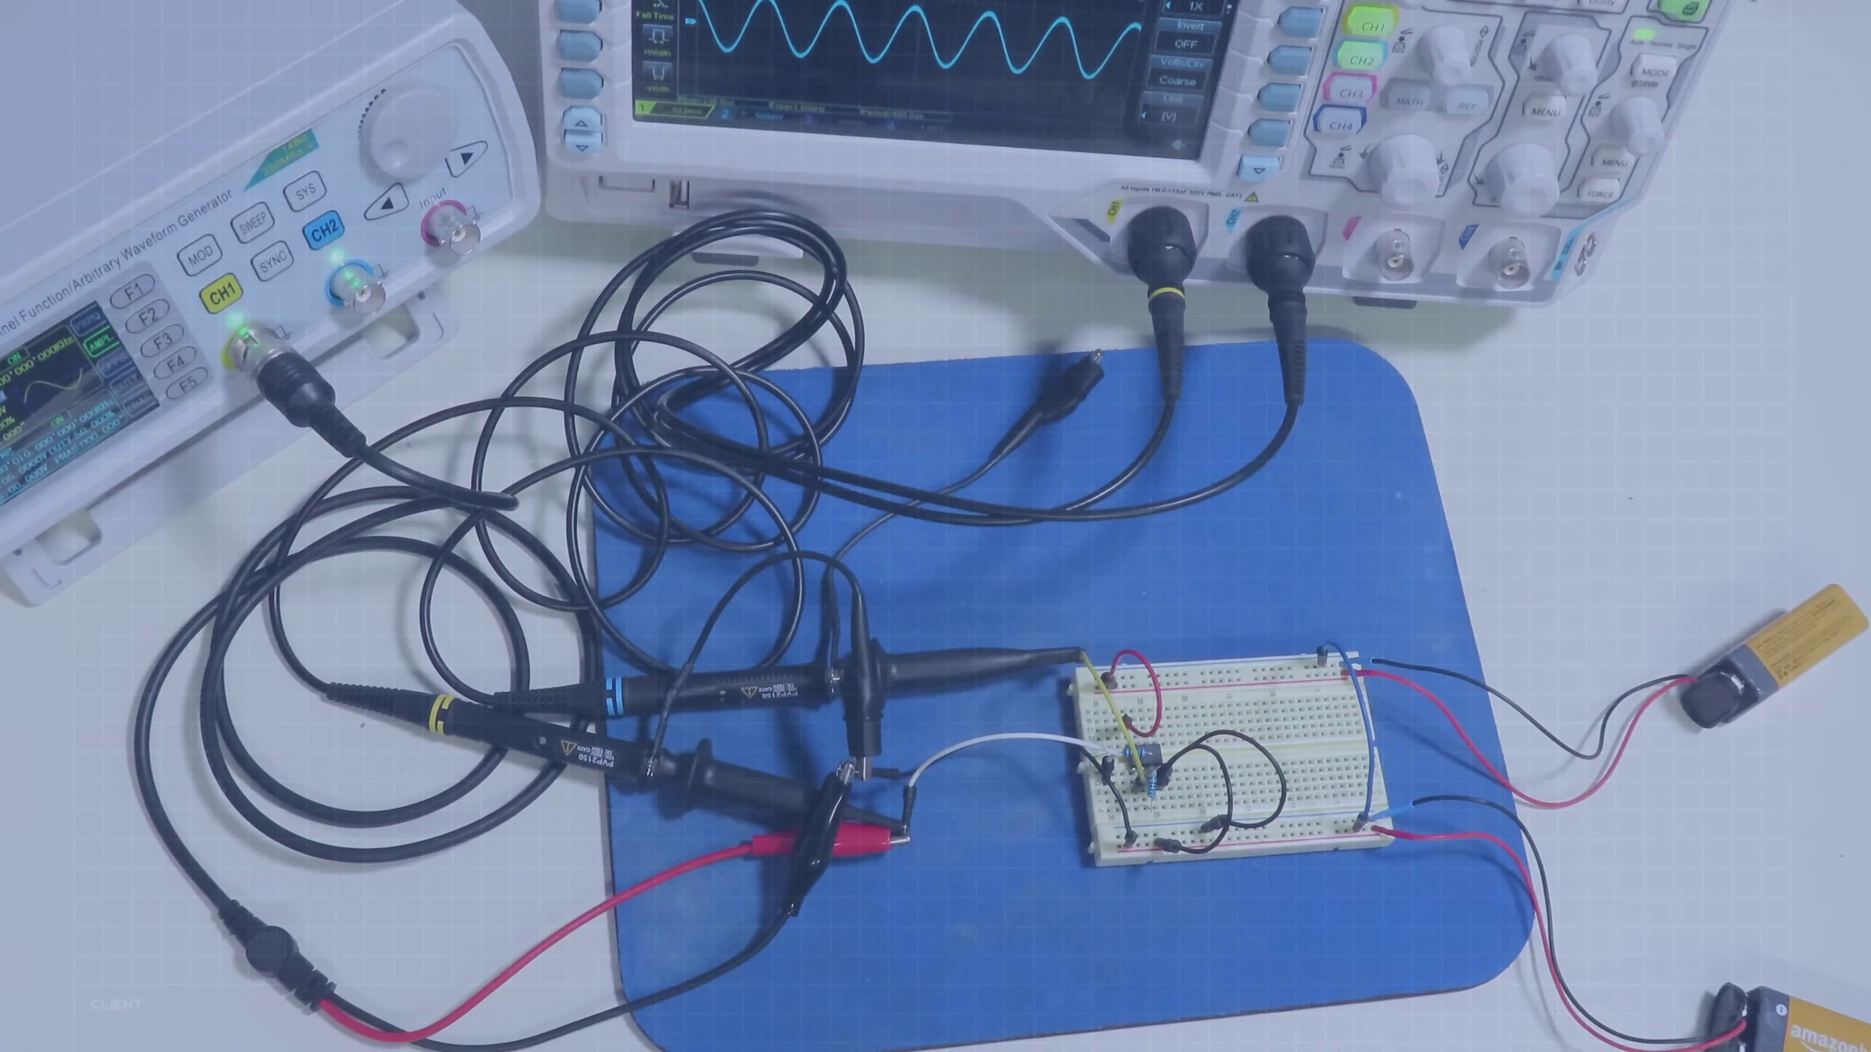 | 
Description: Measuring the voltage and verifying the operation of the op-amp circuit.
Correlated (true): 39 (12.8%)
Score >= 60: 39 (12.8%)
Average Score (of valid matches): 81.92

Top 5 Correlated Comments:
Score: 95
Comment: An extremely important concept, arguably the single most important concept, is that of the "virtual short circuit" between the inverting and non-inverting inputs.
When an op amp is operated closed loop (with feedback) it acts to keep the voltage difference between the two inputs at zero. With real op amps the voltage won't be exactly zero because of finite gain, finite bandwidth and input offset voltage, but it will be very close.
Without understanding this, the feedback networks used to determine the behavior of the circuit make no sense.
For example, the inverting amp with a gain of -1, as shown at about 20:00
The NII is connected to "zero volts" ("ground'). That means that when the loop is closed with feedback, the inverting input will also be at zero volts. The current from the input source through the 1k resistor (again as shown in the video) will be 1 mA per volt. Let's say we apply +0.5 volts, so we have a current of 0.5 mA flowing toward the input pin (conventional current, flowing from positive to negative). It can't flow into the input pin because of the high impedance of that pin, so where does it go? It MUST go through the feedback resistor. If we have 0 V at the input pin and a 1 k feedback resistor from input to output and that resistor has a current of 0.5 mA through it, the voltage drop across it must be 0.5 V with the input-pin end at zero. The output pin must therefore be negative 0.5 volts. The gain of the circuit is therefore minus one. If we used a 10 k feedback resistor, it would still have 0.5 mA through it, flowing in the same direction. The output would have to go to -5.0 V to allow that current to flow. +0.5 V in, -5.0 V out - a gain of -5.
Reason: The comment directly discusses the operation and behavior of an op-amp circuit, specifically mentioning the virtual short circuit, inverting amp gain, and feedback resistor voltage drops, all aligning with the topic's description of measuring the voltage and verifying the operation.
Source: https://www.youtube.com/watch?v=_HHxV-7alwE

Score: 90
Comment: 22:37 I want to offer a correction to the gain formula here. Inverting does follow the -Rf/Ri but the noninverting gain follows 1+Rf/Ri, so for setting Rf and Ri equal, the gain 2 which better matches your oscilloscope readout.
Otherwise very informative video and of the op-amps, as I work with 5V sources a lot, I go by the MCP6022 almost religiously, using a virtual ground set at 2.5V for sinusoidal operations
Reason: The comment directly discusses the same op-amp circuit and its operation, referencing specific formulas (gain formula) and components (MCP6022), which are closely related to the topic of testing the op-amp circuit.
Source: https://www.youtube.com/watch?v=_HHxV-7alwE

Score: 90
Comment: At 4:56 you stated, "...and so our output will go negative. Again, the amplitude of the output will depend on the amount of difference between the two inputs".
Um. I do not think that's true because, when you stated this in the video, there was no feedback to the inverting input so any difference between the inputs would cause the output to go all the way to saturation (high/+VCC or low/-VCC).
Am I misunderstanding what you were trying to say?
Reason: The comment directly discusses the op-amp circuit's operation and output, mentioning specific details like input differences causing saturation. The topic description mentions verifying the circuit's operation, which is closely related to this comment.
Source: https://www.youtube.com/watch?v=_HHxV-7alwE

Score: 90
Comment: How does the Ne55232 receive feedback to pin 2 at NO DC load at the Output ?
Without a DC LOAd the circuit is unstable since TIP31C, TIP32C are both OFF .
Reason: The comment directly discusses the feedback pin (pin 2) and DC load, which are specific settings mentioned in the topic description. The mention of op-amp circuit also shows a clear connection to the testing topic.
Source: https://www.youtube.com/watch?v=_HHxV-7alwE

Score: 90
Comment: For inverting and non-inverting amplifiers, the voltage gain AV should not have the Vin term as a multiplier since AV=Vout/Vin. So AV=-RF/Rin for the inverting amplifier and AV=(1+RF/RD) for the non-inverting amplifier. What is shown is actually the output voltage Vout. The extra 1 term in AV for the non-inverting amplifier has already been pointed out in a previous comment.
Reason: The commenter directly discusses the op-amp circuit and its parameters (AV, Vin, Vout, RF, Rin, RD), which are all mentioned in the topic description. The specific formulas for calculating AV also demonstrate a strong understanding of the topic.
Source: https://www.youtube.com/watch?v=_HHxV-7alwE

Topic T1: Introduction to Operational Amplifiers
 |  | 
Description: Overview of operational amplifiers and their uses.
Correlated (true): 61 (20.0%)
Score >= 60: 61 (20.0%)
Average Score (of valid matches): 81.15

Top 5 Correlated Comments:
Score: 90
Comment: Watching this I think I need to buy a box of assorted op amps for various shenanigans.
Reason: The comment directly references operational amplifiers (op amps) and mentions buying a box of assorted op amps for various uses, which aligns with the topic's description of their applications.
Source: https://www.youtube.com/watch?v=_HHxV-7alwE

Score: 90
Comment: i just made my first amplifier that actually sounds good with an op amp. i used LM358 for it. when i turn the gain up high enough, it even picks up radio signals lol, so i totally see why audio equipment is always in faraday cages. for the dual supply i just used the other side of the LM358 with another NPN transistor and a voltage divider to provide my common ground.
Reason: The comment directly discusses the use of an op amp (LM358), its gain and application in amplifying signals, which are all relevant topics mentioned in the introduction to operational amplifiers. The mention of a common ground using a voltage divider also shows understanding of the concept.
Source: https://www.youtube.com/watch?v=_HHxV-7alwE

Score: 90
Comment: Only partway through but it’s excellent so far as usual. I would like to offer a few corrections from my hobbyist experience building guitar effect pedals:
1. Op amps like NE5532, TL072, etc, do not require dual power supplies — they are commonly used in 9V single-supply designs. When used with single supply, however, they need a bias voltage (usually Vcc/2) so that an ac signal can swing positive and negative, and then need to be ac-coupled (typically with 100n-220n film caps) as a result of the bias voltage.
LM358 and LM324 are special “single supply” op amps because their output voltage can swing all the way to the negative rail — like half of a rail to rail op amp. That means when powered by a single supply, they can handle input and output voltages all the way down to ground (positive voltages are still limited to around Vcc-2).
2. For an inverting op amp, the effective input impedance becomes R(in) — so by using 1K resistors for an inverting op amp, you’re basically wasting the lovely high impedance of the op amp. (IIRC this happens because R(in) winds up in parallel with the op amp’s inherent input impedance, but don’t hold me to that.)
In my experience, you typically see resistor values of 10k-100k for inverting op amps, and even then they are often preceded by an emitter follower or non-inverting buffer to improve the input impedance.
3. The slope of a one-pole filter is -6dB/Oct (not -3dB).
Reason: The comment discusses specific operational amplifier types (NE5532, TL072, LM358, LM324), their characteristics and usage in single-supply designs, which is directly related to the topic of introducing operational amplifiers.
Source: https://www.youtube.com/watch?v=_HHxV-7alwE

Score: 90
Comment: I have some 'analog' q. about your ADC example at 31:00.
1 - What is the purpose of the 10uF cap connected to the 470R resistor? I'm assuming the 470R is there to stop one adjusting to infinite gain.
2 - Why does the nonInvert have a 10K voltage divider
3 - what is the purpose of the 10uF across the lower 10K
4 - Why is there a 1M from the voltage divider into the nonInvert input
Reason: The comment directly discusses the operation and configuration of an operational amplifier (ADC example at 31:00), mentioning specific components and their purposes (10uF cap, 470R resistor, 10K voltage divider), which aligns with the topic description's focus on the uses of operational amplifiers.
Source: https://www.youtube.com/watch?v=_HHxV-7alwE

Score: 90
Comment: Sorry you had all that misfortune.
Regarding your non inverting op amp circuit:
Your non inverting amplifier with the two equal resistors actually has a gain of 2 because the output is divided by 2 and voltage at the inverting input matches that at the non inverting. The gain formula for this configuration is 1 + (Rf / Rd)
Reason: The comment directly discusses the topic of operational amplifiers and their configuration, specifically mentioning 'non inverting op amp circuit' and referencing formulas for gain calculation, which are closely related to the topic description.
Source: https://www.youtube.com/watch?v=_HHxV-7alwE

Topic T2: Designing a Simple Op-Amp Circuit
 |  | 
Description: Building a simple op-amp circuit to split a single power supply into two dual supplies.
Correlated (true): 40 (13.1%)
Score >= 60: 40 (13.1%)
Average Score (of valid matches): 79.88

Top 5 Correlated Comments:
Score: 90
Comment: 22:37 I want to offer a correction to the gain formula here. Inverting does follow the -Rf/Ri but the noninverting gain follows 1+Rf/Ri, so for setting Rf and Ri equal, the gain 2 which better matches your oscilloscope readout.
Otherwise very informative video and of the op-amps, as I work with 5V sources a lot, I go by the MCP6022 almost religiously, using a virtual ground set at 2.5V for sinusoidal operations
Reason: The comment directly discusses the op-amp circuit design, specifically correcting the gain formula and mentioning the MCP6022 chip, which are all related to the topic of designing a simple op-amp circuit.
Source: https://www.youtube.com/watch?v=_HHxV-7alwE

Score: 90
Comment: An extremely important concept, arguably the single most important concept, is that of the "virtual short circuit" between the inverting and non-inverting inputs.
When an op amp is operated closed loop (with feedback) it acts to keep the voltage difference between the two inputs at zero. With real op amps the voltage won't be exactly zero because of finite gain, finite bandwidth and input offset voltage, but it will be very close.
Without understanding this, the feedback networks used to determine the behavior of the circuit make no sense.
For example, the inverting amp with a gain of -1, as shown at about 20:00
The NII is connected to "zero volts" ("ground'). That means that when the loop is closed with feedback, the inverting input will also be at zero volts. The current from the input source through the 1k resistor (again as shown in the video) will be 1 mA per volt. Let's say we apply +0.5 volts, so we have a current of 0.5 mA flowing toward the input pin (conventional current, flowing from positive to negative). It can't flow into the input pin because of the high impedance of that pin, so where does it go? It MUST go through the feedback resistor. If we have 0 V at the input pin and a 1 k feedback resistor from input to output and that resistor has a current of 0.5 mA through it, the voltage drop across it must be 0.5 V with the input-pin end at zero. The output pin must therefore be negative 0.5 volts. The gain of the circuit is therefore minus one. If we used a 10 k feedback resistor, it would still have 0.5 mA through it, flowing in the same direction. The output would have to go to -5.0 V to allow that current to flow. +0.5 V in, -5.0 V out - a gain of -5.
Reason: The comment directly discusses the same concept of virtual short circuit and its application to op-amp circuit design, specifically referencing a video at around 20:00, which aligns with the topic's description of designing an op-amp circuit.
Source: https://www.youtube.com/watch?v=_HHxV-7alwE

Score: 85
Comment: Only partway through but it’s excellent so far as usual. I would like to offer a few corrections from my hobbyist experience building guitar effect pedals:
1. Op amps like NE5532, TL072, etc, do not require dual power supplies — they are commonly used in 9V single-supply designs. When used with single supply, however, they need a bias voltage (usually Vcc/2) so that an ac signal can swing positive and negative, and then need to be ac-coupled (typically with 100n-220n film caps) as a result of the bias voltage.
LM358 and LM324 are special “single supply” op amps because their output voltage can swing all the way to the negative rail — like half of a rail to rail op amp. That means when powered by a single supply, they can handle input and output voltages all the way down to ground (positive voltages are still limited to around Vcc-2).
2. For an inverting op amp, the effective input impedance becomes R(in) — so by using 1K resistors for an inverting op amp, you’re basically wasting the lovely high impedance of the op amp. (IIRC this happens because R(in) winds up in parallel with the op amp’s inherent input impedance, but don’t hold me to that.)
In my experience, you typically see resistor values of 10k-100k for inverting op amps, and even then they are often preceded by an emitter follower or non-inverting buffer to improve the input impedance.
3. The slope of a one-pole filter is -6dB/Oct (not -3dB).
Reason: The comment directly discusses the design of an op-amp circuit, specifically mentioning types of op-amps (NE5532, TL072), their usage with single or dual power supplies, and considerations for inverting op-amps. The topic's focus on designing a simple op-amp circuit to split a single power supply is closely tied to the comment's discussion of op-amp characteristics and design implications.
Source: https://www.youtube.com/watch?v=_HHxV-7alwE

Score: 85
Comment: hi! i see there's a distinction between dual and single power supplies, but does this actually matter? because an OPamp can be used between GND and +VCC, -VCC and +VCC, or even -VCC and GND. do OP amps actually care what they receive? because there really isn't a difference between say, -9v +9v, and 0v +18v. the NE5532 doesn't even have a GND pin listed (so i don't think it cares whether its single or dual), and the LM358 specifically says in the datasheet "Negative (lowest) supply or GND for single supply operation"
edit: nvm. i found out there is a difference. whilst they're very similar (and generally interchangeable), dual supply OP amps guarantee that the differences in behaviour will be more consistent whether positive or negative whilst single supply does not. perfect OP amps do not exist, so dual and single supply ones exist to compensate for that.
Reason: The comment directly discusses the same topic of op-amp circuit design and power supply configurations, specifically highlighting the differences between dual and single supplies. It also quotes datasheets from specific op-amps (NE5532 and LM358) to support its claims, demonstrating a strong connection to the topic.
Source: https://www.youtube.com/watch?v=_HHxV-7alwE

Score: 85
Comment: use a dual power supply withe V+ V- and Ground
Reason: The comment mentions 'dual power supply' which matches the topic's description of splitting a single power supply into two dual supplies. The mention of V+, V-, and Ground also aligns with the topic's focus on op-amp circuit design.
Source: https://www.youtube.com/watch?v=_HHxV-7alwE

Topic T4: Conclusion and Future Directions
 |  | 
Description: Summarizing the importance of operational amplifiers and their applications in electronics projects.
Correlated (true): 46 (15.1%)
Score >= 60: 46 (15.1%)
Average Score (of valid matches): 79.57

Top 5 Correlated Comments:
Score: 90
Comment: Your non inverting amplifier with the 2 equal resistors actually has a gain of 2 because the output is divided by 2 and voltage at the inverting input matches that at the non inverting. The gain formula for this configuration is 1 + (Rf / Rd)
Reason: The comment discusses the gain formula for a specific operational amplifier configuration (non-inverting), which is directly related to the topic's description of operational amplifiers' applications in electronics projects.
Source: https://www.youtube.com/watch?v=_HHxV-7alwE

Score: 90
Comment: @DroneBot Workshop - Hi DroneBot, Actually, the way that an OpAmp works is that the Output will give a value of whatever it takes to make the inputs equal. If there is no feedback from the Output back to the Inputs, then if the Inverting Input is greater than the Non-Inverting Input, the Output will swing to the value of the Negative Power Supply (minus a little amount for the active components in the supply. Only Rail to Rail OpAmps can actually reach the Supply Voltage). If the Non-Inverting Input is greater than the Inverting Input, the Output of the OpAmp will swing to the value of the Positive Supply (again, minus the little value that the active components take to make the supply). In Rail to Rail OpAmps, the Supply Voltages can be reached. The bottom line, though, is that if the OpAmp does not have feedback from the Output to either Input (but typically the Inverting Input), the OpAmp functions as a Comparator, and the Output will be the approximate value of the Power Supply for whichever Input dominates.
Reason: The comment directly discusses how operational amplifiers (OpAmps) work and their behavior without feedback, which is a key aspect of understanding the importance of OpAmps in electronics projects, as described by the topic.
Source: https://www.youtube.com/watch?v=_HHxV-7alwE

Score: 80
Comment: The most critical point you have made was about the amplification range that it is limited to power supply limit (rail-to-rail). 99% of the videos are misleading, present like op-amps could amplify to the moon. Thanks a bunch.
Reason: The comment directly discusses the amplification range and limitations of operational amplifiers, which is a key point mentioned in the topic description regarding their applications.
Source: https://www.youtube.com/watch?v=_HHxV-7alwE

Score: 80
Comment: i just made my first amplifier that actually sounds good with an op amp. i used LM358 for it. when i turn the gain up high enough, it even picks up radio signals lol, so i totally see why audio equipment is always in faraday cages. for the dual supply i just used the other side of the LM358 with another NPN transistor and a voltage divider to provide my common ground.
Reason: The comment discusses the practical application of an operational amplifier (LM358), specifically its use in building an audio amplifier and picking up radio signals. This directly relates to the topic's focus on operational amplifiers and their applications in electronics projects.
Source: https://www.youtube.com/watch?v=_HHxV-7alwE

Score: 80
Comment: Can I use an op-amp or op-amps for a HF ADC ?
Reason: The comment directly discusses the application of op-amps in electronics projects (HF ADC), which is closely related to the topic description's focus on operational amplifiers and their applications.
Source: https://www.youtube.com/watch?v=_HHxV-7alwE

