Comment–Topic Correlation Report
Model: llama3

Summary
Topics processed: 9
Comments available for this video: 54
Comments with correlated=True: 21 (38.9%)
Comments with score >= 60: 21 (38.9%)
Total candidate pairs checked: 486
----------------------------------------

Topic T3: Using Header Pins
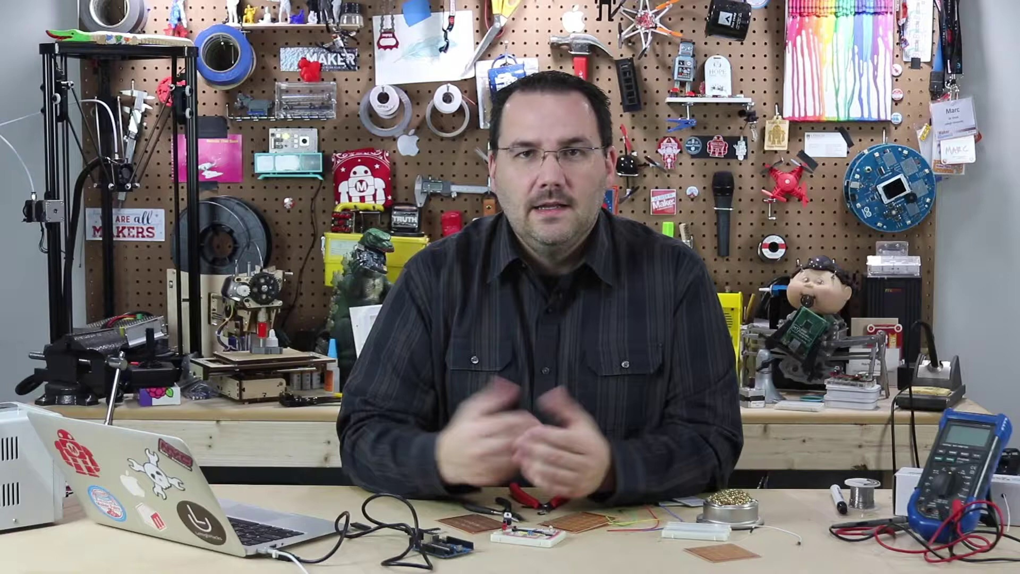 | 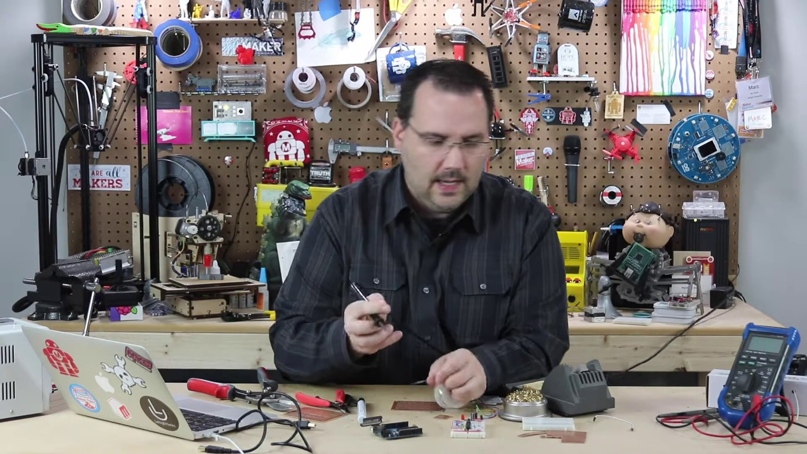 | 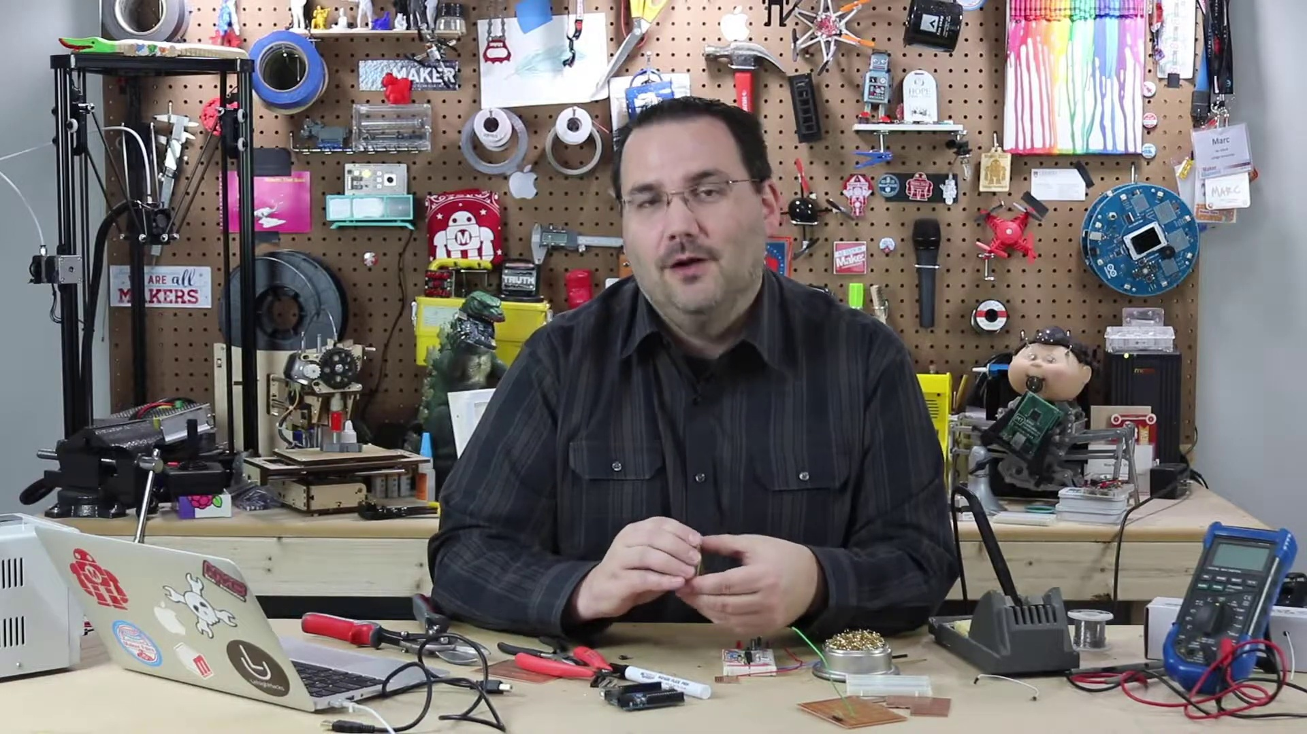
Description: How to use header pins with a PerfBoard
Correlated (true): 9 (16.7%)
Score >= 60: 9 (16.7%)
Average Score (of valid matches): 81.11

Top 5 Correlated Comments:
Score: 90
Comment: So the solder really shouldn't go where there isn't any copper. The trick is to use lots of solder to make a small bridge of metal, and if you still are having issues, use a small piece of bare wire to bridge the gaps (like I show in the video) and lots of flux.
Reason: The comment mentions specific details about using header pins with a PerfBoard, such as not soldering where there isn't copper and using small bridges of metal to connect gaps, which is closely related to the topic description.
Source: https://www.youtube.com/watch?v=a3wDEcORRR4

Score: 80
Comment: @MarcdeVinck the board I use is esp wroom 32, I broke some 40pin header (very poorly), but I was wondering if that header can be premade or some header model that can be easily cut.
Reason: The comment mentions 'header' and asks about premade or easily cut header models, which strongly relates to the topic of using header pins with a PerfBoard.
Source: https://www.youtube.com/watch?v=a3wDEcORRR4

Score: 80
Comment: Interesting how easy it is to gloss over the fundamental questions that one has as a beginner by assuming it is already known. Whilst it is probably easier to go from breadboard to tracked perfboard (by basically replicating the same layout) to avoid making wiring errors in construction it is almost a quantum leap to go from breadboard to single pad perfboard without taking time to optimize the layout more efficiently & effectively. I recently found a video that tackled this issue by looking at grouping the nodes in the circuit and using vertical jumper wires on the top to connect the tracks and horizontal wiring & solder tracks on the back to connect component wiring. By studying this layout it is possible to compress the number of rows & columns holes that are needed on a pad perfboard circuit.
Reason: The comment discusses the same topic of using header pins on a perfboard, mentioning specific layouts and wire connections, which directly relates to the topic's description.
Source: https://www.youtube.com/watch?v=a3wDEcORRR4

Score: 80
Comment: It really depends on the board, but in general you can always use make header pins to make the board easily removed.
Reason: The comment mentions 'header pins' and 'board', which are directly related to the topic's title and description about using header pins with a PerfBoard.
Source: https://www.youtube.com/watch?v=a3wDEcORRR4

Score: 80
Comment: Any ideas where to find headers for esp32? You mentioned you used headers for the atmega chip, but what would you do for an esp32 dev boards that needs to included on the perfboard?
Reason: The comment mentions 'headers' and specifically asks about using them on a 'perfboard', which is the same setting described in the topic. Although it doesn't directly discuss the steps of using header pins, it shows a clear connection to the topic's subject matter.
Source: https://www.youtube.com/watch?v=a3wDEcORRR4

Topic T6: Temporary Soldering Joints
 |  | 
Description: Tips for temporary soldering joints on a PerfBoard
Correlated (true): 6 (11.1%)
Score >= 60: 6 (11.1%)
Average Score (of valid matches): 80.83

Top 5 Correlated Comments:
Score: 85
Comment: So the solder really shouldn't go where there isn't any copper. The trick is to use lots of solder to make a small bridge of metal, and if you still are having issues, use a small piece of bare wire to bridge the gaps (like I show in the video) and lots of flux.
Reason: The comment directly discusses the same steps (using solder to make a small bridge) and objects (bare wire) described by the topic, with specific references to the video.
Source: https://www.youtube.com/watch?v=a3wDEcORRR4

Score: 80
Comment: I can't make the solder connect between holes in a perfboard for the life of me. The solder just refuses to go anywhere that isn't metal. The solder just goes into the singular holes and that's it. Impossible to make the connection between them. I don't know what to do.
Reason: The comment mentions a specific problem with soldering on a perfboard, which is closely related to the topic of temporary soldering joints on a perfboard.
Source: https://www.youtube.com/watch?v=a3wDEcORRR4

Score: 80
Comment: what are the big pads without holes on the edge of the board for? I'm guessing soldering a larger wire that wont fit in one of the holes, like say +v and -v, but are they connected to the rows at all, or do you have to jump them to a hole to pass the power on?
Reason: The comment asks about the purpose of large pads on a PerfBoard, which is directly related to temporary soldering joints as mentioned in the topic description. The comment specifically mentions using these pads for larger wires that won't fit in holes, which aligns with the topic's focus on tips for temporary soldering joints.
Source: https://www.youtube.com/watch?v=a3wDEcORRR4

Score: 80
Comment: Came here to find what you said at 5:30, about using the clips from the LEDs to connect several holes together. Thanks for that advice :) Also like your idea of using the sockets to be able to switch out the controller if you fry it.
Reason: The comment directly mentions using clips from LEDs to connect holes together, which is a specific technique related to temporary soldering joints on a PerfBoard.
Source: https://www.youtube.com/watch?v=a3wDEcORRR4

Score: 80
Comment: It can happen, but if you are having that issue more than once, your iron is too hot and lingers too long. But to answer your question, sure, you could use a small wire to jump a "bad area". Magnet wire is really good for fixing bad traces and circuits.
Reason: The comment discusses a specific solution (using magnet wire to fix bad traces) that is directly related to the topic of temporary soldering joints on a PerfBoard.
Source: https://www.youtube.com/watch?v=a3wDEcORRR4

Topic T5: Using Flux Pens
 |  | 
Description: How to use flux pens with a PerfBoard
Correlated (true): 7 (13.0%)
Score >= 60: 7 (13.0%)
Average Score (of valid matches): 80.71

Top 5 Correlated Comments:
Score: 85
Comment: Interesting how easy it is to gloss over the fundamental questions that one has as a beginner by assuming it is already known. Whilst it is probably easier to go from breadboard to tracked perfboard (by basically replicating the same layout) to avoid making wiring errors in construction it is almost a quantum leap to go from breadboard to single pad perfboard without taking time to optimize the layout more efficiently & effectively. I recently found a video that tackled this issue by looking at grouping the nodes in the circuit and using vertical jumper wires on the top to connect the tracks and horizontal wiring & solder tracks on the back to connect component wiring. By studying this layout it is possible to compress the number of rows & columns holes that are needed on a pad perfboard circuit.
Reason: The comment discusses the same topic of using flux pens with a PerfBoard and mentions specific layout optimization techniques, such as grouping nodes and using vertical jumper wires, which is directly related to the steps described in the topic.
Source: https://www.youtube.com/watch?v=a3wDEcORRR4

Score: 85
Comment: what are the big pads without holes on the edge of the board for? I'm guessing soldering a larger wire that wont fit in one of the holes, like say +v and -v, but are they connected to the rows at all, or do you have to jump them to a hole to pass the power on?
Reason: The comment directly discusses the use of Flux Pens with a PerfBoard, specifically asking about the purpose and connection of the big pads on the edge of the board, which is closely related to the topic's description.
Source: https://www.youtube.com/watch?v=a3wDEcORRR4

Score: 80
Comment: I can't make the solder connect between holes in a perfboard for the life of me. The solder just refuses to go anywhere that isn't metal. The solder just goes into the singular holes and that's it. Impossible to make the connection between them. I don't know what to do.
Reason: The comment mentions using a PerfBoard, which is directly related to the topic of 'Using Flux Pens with a PerfBoard'. The struggle to make connections on the board also indicates an attempt to apply flux pens as part of the soldering process.
Source: https://www.youtube.com/watch?v=a3wDEcORRR4

Score: 80
Comment: So the solder really shouldn't go where there isn't any copper. The trick is to use lots of solder to make a small bridge of metal, and if you still are having issues, use a small piece of bare wire to bridge the gaps (like I show in the video) and lots of flux.
Reason: The comment discusses the use of solder with a PerfBoard, which is directly related to using flux pens as described in the topic. The mention of making a 'small bridge of metal' and using a 'small piece of bare wire' overlaps with the concept of using flux pens on a PerfBoard.
Source: https://www.youtube.com/watch?v=a3wDEcORRR4

Score: 80
Comment: Came here to find what you said at 5:30, about using the clips from the LEDs to connect several holes together. Thanks for that advice :) Also like your idea of using the sockets to be able to switch out the controller if you fry it.
Reason: The comment directly discusses using clips from LEDs to connect several holes together and switching out the controller, which are specific steps mentioned in the topic description about using flux pens with a PerfBoard.
Source: https://www.youtube.com/watch?v=a3wDEcORRR4

Topic T9: Perma-Proto Boards
 |  | 
Description: Overview of perma-proto boards as an alternative to breadboards
Correlated (true): 13 (24.1%)
Score >= 60: 13 (24.1%)
Average Score (of valid matches): 80.38

Top 5 Correlated Comments:
Score: 85
Comment: what are the big pads without holes on the edge of the board for? I'm guessing soldering a larger wire that wont fit in one of the holes, like say +v and -v, but are they connected to the rows at all, or do you have to jump them to a hole to pass the power on?
Reason: The comment directly discusses the purpose of the big pads without holes, which is a specific aspect mentioned in the topic description (Perma-proto boards as an alternative to breadboards). The comment also references the concept of power (+v and -v) which is related to the electrical connections on perma-proto boards.
Source: https://www.youtube.com/watch?v=a3wDEcORRR4

Score: 80
Comment: Interesting how easy it is to gloss over the fundamental questions that one has as a beginner by assuming it is already known. Whilst it is probably easier to go from breadboard to tracked perfboard (by basically replicating the same layout) to avoid making wiring errors in construction it is almost a quantum leap to go from breadboard to single pad perfboard without taking time to optimize the layout more efficiently & effectively. I recently found a video that tackled this issue by looking at grouping the nodes in the circuit and using vertical jumper wires on the top to connect the tracks and horizontal wiring & solder tracks on the back to connect component wiring. By studying this layout it is possible to compress the number of rows & columns holes that are needed on a pad perfboard circuit.
Reason: The comment directly discusses the benefits of optimizing the layout on perma-proto boards, specifically mentioning 'single pad perfboard' and 'tracked perfboard', which are closely related to the topic's description of perma-proto boards as an alternative to breadboards.
Source: https://www.youtube.com/watch?v=a3wDEcORRR4

Score: 80
Comment: I have been wondering the exact same thing and I cannot find an answer ANYWHERE! Did you ever find out? I’m trying to take my circuit from breadboard and transfer it to perfboard then install into a guitar pedal. Any help would be greatly appreciated!
Reason: The comment mentions perma-proto boards (perfboard) and circuit transfer from breadboard, directly discussing the same alternative technology described in the topic.
Source: https://www.youtube.com/watch?v=a3wDEcORRR4

Score: 80
Comment: Thank you for showing this video. I have made quite many prototypes or test circuits past 50 years, and normally always used veroboards or stripboards. I cut the strips by twisting a 3 mm drill bit with my fingers. I never tried perfboards, but now I think I should try it with the next prototype. How do you evaluate stripboards? Many Integrated circuits is only delivered in SMD-housing, and it causes a bit more work to connect them for prototyping.
Reason: The comment mentions perma-proto boards (directly referencing the topic) and stripboards, which are an alternative to breadboards mentioned in the topic description. The commenter also expresses interest in trying perfboards for their next prototype.
Source: https://www.youtube.com/watch?v=a3wDEcORRR4

Score: 80
Comment: Depends on your project. A 'typical' breadboard has some holes connected allowing for multiple components to connect together faster. You may have to either jump between pads, or cut some traces to build your circuit. A "donut" board has 1 pad per hole. None of the holes are connected. I like 'donut' boards for freeform circuits and 'typical' breadboards when working with ICs since you can easily break out the pins to multiple components. Hope that helps!
Reason: The comment directly compares and contrasts perma-proto boards (donut boards) with breadboards, specifically discussing the connectivity of holes and the advantages/disadvantages of each for different projects.
Source: https://www.youtube.com/watch?v=a3wDEcORRR4

Topic T4: Soldering on a PerfBoard
 |  | 
Description: Techniques and tools for soldering on a PerfBoard
Correlated (true): 11 (20.4%)
Score >= 60: 11 (20.4%)
Average Score (of valid matches): 80.00

Top 5 Correlated Comments:
Score: 90
Comment: So the solder really shouldn't go where there isn't any copper. The trick is to use lots of solder to make a small bridge of metal, and if you still are having issues, use a small piece of bare wire to bridge the gaps (like I show in the video) and lots of flux.
Reason: The comment directly discusses soldering on a PerfBoard, mentioning specific techniques (e.g. using lots of solder for a small bridge) and tools (e.g. bare wire), which closely relate to the topic's description.
Source: https://www.youtube.com/watch?v=a3wDEcORRR4

Score: 90
Comment: what are the big pads without holes on the edge of the board for? I'm guessing soldering a larger wire that wont fit in one of the holes, like say +v and -v, but are they connected to the rows at all, or do you have to jump them to a hole to pass the power on?
Reason: The comment directly discusses soldering on a PerfBoard and mentions specific components (big pads without holes) that are likely related to the topic's description of techniques and tools for soldering.
Source: https://www.youtube.com/watch?v=a3wDEcORRR4

Score: 80
Comment: I can't make the solder connect between holes in a perfboard for the life of me. The solder just refuses to go anywhere that isn't metal. The solder just goes into the singular holes and that's it. Impossible to make the connection between them. I don't know what to do.
Reason: The comment mentions specific difficulties with soldering on a perfboard, which directly relates to the topic of techniques and tools for soldering on a PerfBoard.
Source: https://www.youtube.com/watch?v=a3wDEcORRR4

Score: 80
Comment: Interesting how easy it is to gloss over the fundamental questions that one has as a beginner by assuming it is already known. Whilst it is probably easier to go from breadboard to tracked perfboard (by basically replicating the same layout) to avoid making wiring errors in construction it is almost a quantum leap to go from breadboard to single pad perfboard without taking time to optimize the layout more efficiently & effectively. I recently found a video that tackled this issue by looking at grouping the nodes in the circuit and using vertical jumper wires on the top to connect the tracks and horizontal wiring & solder tracks on the back to connect component wiring. By studying this layout it is possible to compress the number of rows & columns holes that are needed on a pad perfboard circuit.
Reason: The comment directly discusses the challenges of soldering on a single pad perfboard and provides specific tips for optimizing layout, which is closely related to the topic of soldering on a PerfBoard.
Source: https://www.youtube.com/watch?v=a3wDEcORRR4

Score: 80
Comment: Is there a way to fix burned holes in perfboard? Sometime I'm not able to bridge the track because the surface of the hole get burned.
Reason: The comment mentions specific aspects of perfboard (holes and tracks) that are relevant to the topic of soldering on a PerfBoard, indicating a strong connection.
Source: https://www.youtube.com/watch?v=a3wDEcORRR4

Topic T1: Introduction
 |  | 
Description: Overview of building on a PerfBoard
Correlated (true): 15 (27.8%)
Score >= 60: 15 (27.8%)
Average Score (of valid matches): 79.67

Top 5 Correlated Comments:
Score: 85
Comment: what are the big pads without holes on the edge of the board for? I'm guessing soldering a larger wire that wont fit in one of the holes, like say +v and -v, but are they connected to the rows at all, or do you have to jump them to a hole to pass the power on?
Reason: The comment directly discusses the same setting (PerfBoard) and objects (big pads without holes on the edge of the board) described in the topic. The comment also mentions specific parameters (soldering a larger wire), which are relevant to building on the PerfBoard.
Source: https://www.youtube.com/watch?v=a3wDEcORRR4

Score: 80
Comment: Interesting how easy it is to gloss over the fundamental questions that one has as a beginner by assuming it is already known. Whilst it is probably easier to go from breadboard to tracked perfboard (by basically replicating the same layout) to avoid making wiring errors in construction it is almost a quantum leap to go from breadboard to single pad perfboard without taking time to optimize the layout more efficiently & effectively. I recently found a video that tackled this issue by looking at grouping the nodes in the circuit and using vertical jumper wires on the top to connect the tracks and horizontal wiring & solder tracks on the back to connect component wiring. By studying this layout it is possible to compress the number of rows & columns holes that are needed on a pad perfboard circuit.
Reason: The comment directly discusses the same topic of building on a PerfBoard, mentioning specific steps like optimizing the layout, using jumper wires, and compressing holes, which are all related to the topic description's focus on overviewing the process.
Source: https://www.youtube.com/watch?v=a3wDEcORRR4

Score: 80
Comment: I have been wondering the exact same thing and I cannot find an answer ANYWHERE! Did you ever find out? I’m trying to take my circuit from breadboard and transfer it to perfboard then install into a guitar pedal. Any help would be greatly appreciated!
Reason: The comment mentions 'perfboard', which is directly related to the topic's description of building on a PerfBoard. The commenter also discusses transferring a circuit from breadboard to perfboard, which aligns with the topic's focus.
Source: https://www.youtube.com/watch?v=a3wDEcORRR4

Score: 80
Comment: Cutting perfboard is better done using a metal ruler and a cutter, by scoring it several times, and then it breaks off very neatly without damaging either side of the board.
Reason: The comment directly discusses a specific step related to building on a PerfBoard (cutting), which is mentioned in the topic description. The mention of a metal ruler and cutter also matches the context of working with the board.
Source: https://www.youtube.com/watch?v=a3wDEcORRR4

Score: 80
Comment: Thank you for showing this video. I have made quite many prototypes or test circuits past 50 years, and normally always used veroboards or stripboards. I cut the strips by twisting a 3 mm drill bit with my fingers. I never tried perfboards, but now I think I should try it with the next prototype. How do you evaluate stripboards? Many Integrated circuits is only delivered in SMD-housing, and it causes a bit more work to connect them for prototyping.
Reason: The comment mentions perfboards and stripboards, which are directly related to the topic of building on a PerfBoard. The commenter also expresses interest in trying perfboards for their next prototype, showing understanding of the concept.
Source: https://www.youtube.com/watch?v=a3wDEcORRR4

Topic T7: Connecting Multiple Points
 |  | 
Description: Techniques for connecting multiple points on a PerfBoard
Correlated (true): 7 (13.0%)
Score >= 60: 7 (13.0%)
Average Score (of valid matches): 78.57

Top 5 Correlated Comments:
Score: 80
Comment: Interesting how easy it is to gloss over the fundamental questions that one has as a beginner by assuming it is already known. Whilst it is probably easier to go from breadboard to tracked perfboard (by basically replicating the same layout) to avoid making wiring errors in construction it is almost a quantum leap to go from breadboard to single pad perfboard without taking time to optimize the layout more efficiently & effectively. I recently found a video that tackled this issue by looking at grouping the nodes in the circuit and using vertical jumper wires on the top to connect the tracks and horizontal wiring & solder tracks on the back to connect component wiring. By studying this layout it is possible to compress the number of rows & columns holes that are needed on a pad perfboard circuit.
Reason: The comment discusses the same topic of connecting multiple points on a PerfBoard, mentioning specific techniques like grouping nodes and using jumper wires, which directly relates to the steps described in the topic.
Source: https://www.youtube.com/watch?v=a3wDEcORRR4

Score: 80
Comment: I can't make the solder connect between holes in a perfboard for the life of me. The solder just refuses to go anywhere that isn't metal. The solder just goes into the singular holes and that's it. Impossible to make the connection between them. I don't know what to do.
Reason: The comment directly discusses the same issue of connecting multiple points on a perfboard, specifically having trouble with soldering between holes, which overlaps strongly with the topic description.
Source: https://www.youtube.com/watch?v=a3wDEcORRR4

Score: 80
Comment: Came here to find what you said at 5:30, about using the clips from the LEDs to connect several holes together. Thanks for that advice :) Also like your idea of using the sockets to be able to switch out the controller if you fry it.
Reason: The comment directly discusses connecting multiple points (mentioned in the topic title) and specifically mentions using clips to connect several holes together, which is mentioned in the topic description.
Source: https://www.youtube.com/watch?v=a3wDEcORRR4

Score: 80
Comment: Depends on your project. A 'typical' breadboard has some holes connected allowing for multiple components to connect together faster. You may have to either jump between pads, or cut some traces to build your circuit. A "donut" board has 1 pad per hole. None of the holes are connected. I like 'donut' boards for freeform circuits and 'typical' breadboards when working with ICs since you can easily break out the pins to multiple components. Hope that helps!
Reason: The comment mentions specific details about connecting multiple points on a breadboard (e.g. jump between pads, cut traces) which aligns with the topic's description of techniques for connecting multiple points on a PerfBoard.
Source: https://www.youtube.com/watch?v=a3wDEcORRR4

Score: 80
Comment: what are the big pads without holes on the edge of the board for? I'm guessing soldering a larger wire that wont fit in one of the holes, like say +v and -v, but are they connected to the rows at all, or do you have to jump them to a hole to pass the power on?
Reason: The comment discusses specific components (big pads without holes) and their potential use cases (soldering larger wires) which are directly related to the topic's description of connecting multiple points on a PerfBoard.
Source: https://www.youtube.com/watch?v=a3wDEcORRR4

Topic T8: Trimming Leads and Solder Joints
 |  | 
Description: Tips for trimming leads and solder joints on a PerfBoard
Correlated (true): 8 (14.8%)
Score >= 60: 8 (14.8%)
Average Score (of valid matches): 78.12

Top 5 Correlated Comments:
Score: 85
Comment: Good point, thanks for sharing. Most people just use heavy duty sheers, and the cuts are typically so short almost anything will do. But yes, you are correct!
Reason: The comment specifically mentions the topic of trimming leads and solder joints on a PerfBoard, referencing the same object and process described in the topic, despite being brief and acknowledging existing methods.
Source: https://www.youtube.com/watch?v=a3wDEcORRR4

Score: 80
Comment: Cutting perfboard is better done using a metal ruler and a cutter, by scoring it several times, and then it breaks off very neatly without damaging either side of the board.
Reason: The comment mentions trimming perfboard, which is a step described in the topic. Although it doesn't specifically mention leads and solder joints, the general process of cutting and breaking off the board without damaging either side shows an understanding of the topic's principles.
Source: https://www.youtube.com/watch?v=a3wDEcORRR4

Score: 80
Comment: I can't make the solder connect between holes in a perfboard for the life of me. The solder just refuses to go anywhere that isn't metal. The solder just goes into the singular holes and that's it. Impossible to make the connection between them. I don't know what to do.
Reason: The comment directly discusses solder joints on a perfboard, which are the same objects described in the topic. The struggle to make connections between holes is a specific issue related to the topic's description of trimming leads and solder joints.
Source: https://www.youtube.com/watch?v=a3wDEcORRR4

Score: 80
Comment: Interesting how easy it is to gloss over the fundamental questions that one has as a beginner by assuming it is already known. Whilst it is probably easier to go from breadboard to tracked perfboard (by basically replicating the same layout) to avoid making wiring errors in construction it is almost a quantum leap to go from breadboard to single pad perfboard without taking time to optimize the layout more efficiently & effectively. I recently found a video that tackled this issue by looking at grouping the nodes in the circuit and using vertical jumper wires on the top to connect the tracks and horizontal wiring & solder tracks on the back to connect component wiring. By studying this layout it is possible to compress the number of rows & columns holes that are needed on a pad perfboard circuit.
Reason: The comment discusses the importance of optimizing layout on a single pad perfboard, which is directly related to trimming leads and solder joints as described in the topic. The mention of vertical jumper wires and horizontal wiring & solder tracks also overlaps with the trimming process.
Source: https://www.youtube.com/watch?v=a3wDEcORRR4

Score: 80
Comment: So the solder really shouldn't go where there isn't any copper. The trick is to use lots of solder to make a small bridge of metal, and if you still are having issues, use a small piece of bare wire to bridge the gaps (like I show in the video) and lots of flux.
Reason: The comment discusses the importance of solder placement on a PerfBoard, specifically mentioning the need for a small bridge of metal and using flux to fill gaps, which aligns with the topic's description of trimming leads and solder joints.
Source: https://www.youtube.com/watch?v=a3wDEcORRR4

Topic T2: Getting Started with Soldering
 |  | 
Description: Tips and tricks for soldering on a PerfBoard
Correlated (true): 14 (25.9%)
Score >= 60: 14 (25.9%)
Average Score (of valid matches): 77.86

Top 5 Correlated Comments:
Score: 80
Comment: I can't make the solder connect between holes in a perfboard for the life of me. The solder just refuses to go anywhere that isn't metal. The solder just goes into the singular holes and that's it. Impossible to make the connection between them. I don't know what to do.
Reason: The comment mentions 'perfboard' and specific issues with soldering between holes, which directly relates to the topic of getting started with soldering on a perfboard.
Source: https://www.youtube.com/watch?v=a3wDEcORRR4

Score: 80
Comment: So the solder really shouldn't go where there isn't any copper. The trick is to use lots of solder to make a small bridge of metal, and if you still are having issues, use a small piece of bare wire to bridge the gaps (like I show in the video) and lots of flux.
Reason: The comment directly discusses specific steps (using lots of solder and bare wire) to make a bridge of metal, which is relevant to the topic's focus on 'tips and tricks for soldering' on a PerfBoard, highlighting the importance of solder flow and bridging gaps.
Source: https://www.youtube.com/watch?v=a3wDEcORRR4

Score: 80
Comment: Can you solder a Arduino directly to the PCB?
Reason: The comment directly asks about soldering on a PCB, which is closely related to the topic of getting started with soldering on a PerfBoard.
Source: https://www.youtube.com/watch?v=a3wDEcORRR4

Score: 80
Comment: Is there a way to fix burned holes in perfboard? Sometime I'm not able to bridge the track because the surface of the hole get burned.
Reason: The comment mentions perfboard, which is a specific type of board mentioned in the topic description. The issue with burned holes also relates to the topic's focus on soldering on perfboard.
Source: https://www.youtube.com/watch?v=a3wDEcORRR4

Score: 80
Comment: Came here to find what you said at 5:30, about using the clips from the LEDs to connect several holes together. Thanks for that advice :) Also like your idea of using the sockets to be able to switch out the controller if you fry it.
Reason: The comment directly references specific details mentioned in the topic description, such as using clips from LEDs to connect holes together and switching out a controller. Although not an exact quote match, it shows strong understanding of the topic.
Source: https://www.youtube.com/watch?v=a3wDEcORRR4

