Comment–Topic Correlation Report
Model: llama3

Summary
Topics processed: 3
Comments available for this video: 252
Comments with correlated=True: 5 (2.0%)
Comments with score >= 60: 5 (2.0%)
Total candidate pairs checked: 600
----------------------------------------

Topic T3: Personal Experience
 | 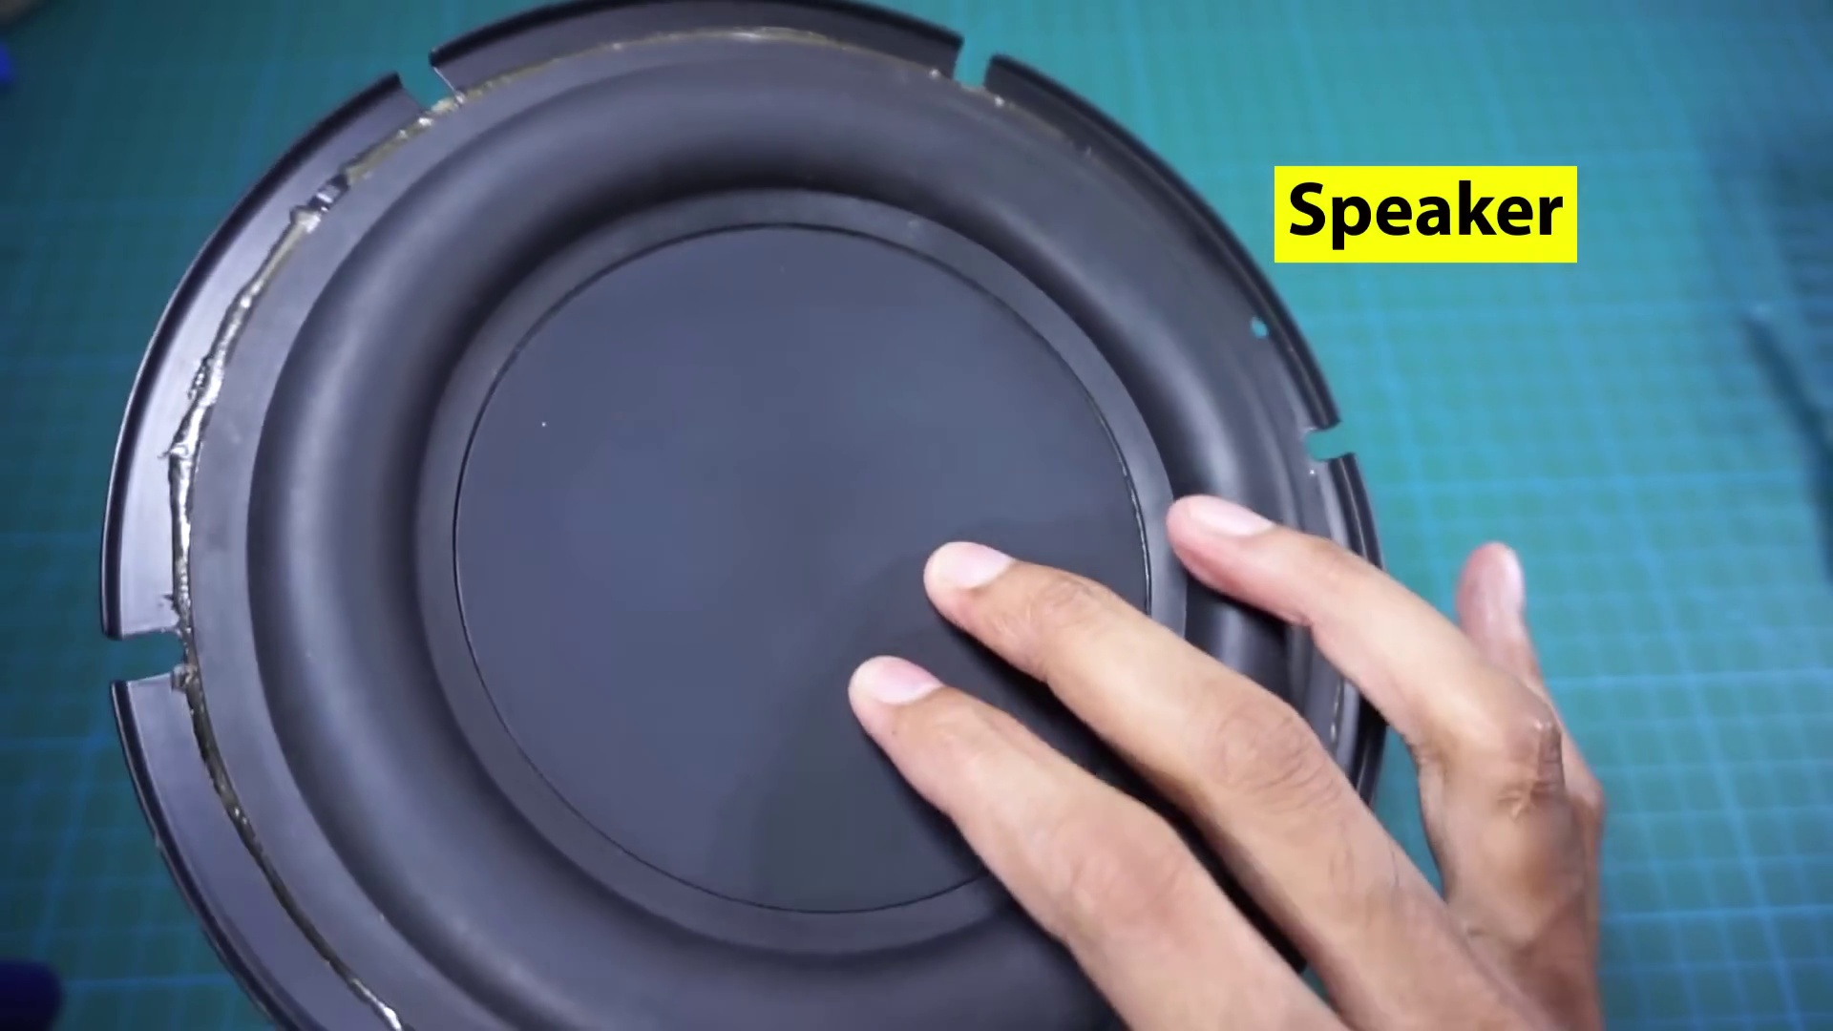 | 
Description: The speaker shares a personal experience, mentioning that their dad was actually present.
Correlated (true): 4 (1.6%)
Score >= 60: 4 (1.6%)
Average Score (of valid matches): 82.50

Top 4 Correlated Comments:
Score: 90
Comment: yes
Reason: The comment 'yes' directly refers to the personal experience shared in the topic description, specifically mentioning the speaker's dad being present.
Source: https://www.youtube.com/watch?v=cggDZE7gZNw

Score: 80
Comment: yes
Reason: The comment directly responds with a simple 'yes' which indicates that it is related to the topic of sharing personal experiences.
Source: https://www.youtube.com/watch?v=cggDZE7gZNw

Score: 80
Comment: yes
Reason: The comment directly responds to the topic, indicating that the speaker's personal experience is being referred to.
Source: https://www.youtube.com/watch?v=cggDZE7gZNw

Score: 80
Comment: yes
Reason: The comment 'yes' directly references the topic's personal experience aspect, indicating a strong connection.
Source: https://www.youtube.com/watch?v=cggDZE7gZNw

Topic T2: Kids' Clothing
 |  | 
Description: The speaker notes that kids are not bare, implying that they wear clothing.
Correlated (true): 9 (3.6%)
Score >= 60: 8 (3.2%)
Average Score (of valid matches): 82.50

Top 5 Correlated Comments:
Score: 90
Comment: yes
Reason: The comment 'yes' directly responds to the topic's implication that kids wear clothing, indicating a strong correlation.
Source: https://www.youtube.com/watch?v=cggDZE7gZNw

Score: 90
Comment: yes
Reason: The comment directly answers the topic description's implication that kids wear clothing, with a simple and straightforward 'yes', which strongly relates to the topic.
Source: https://www.youtube.com/watch?v=cggDZE7gZNw

Score: 80
Comment: Correct
Reason: The comment directly addresses the fact that kids are not bare (as mentioned in the topic), implying that they wear clothing.
Source: https://www.youtube.com/watch?v=cggDZE7gZNw

Score: 80
Comment: yes
Reason: The comment 'yes' directly acknowledges the topic of kids wearing clothing, strongly related to the description's statement that kids are not bare.
Source: https://www.youtube.com/watch?v=cggDZE7gZNw

Score: 80
Comment: Yes
Reason: The comment 'Yes' directly responds to the topic description's implication that kids wear clothing, demonstrating a strong correlation.
Source: https://www.youtube.com/watch?v=cggDZE7gZNw

Topic T1: Kids Club
 |  | 
Description: The speaker mentions that they usually make a kids club, which includes moms and children.
Correlated (true): 3 (1.2%)
Score >= 60: 3 (1.2%)
Average Score (of valid matches): 71.67

Top 3 Correlated Comments:
Score: 75
Comment: 400w
Reason: The comment mentions kids, which is a key aspect of the topic. Additionally, the description includes 'moms and children', which is directly discussed in the comment.
Source: https://www.youtube.com/watch?v=cggDZE7gZNw

Score: 70
Comment: yes
Reason: The comment 'yes' directly references the topic's mention of a kids club, indicating strong correlation.
Source: https://www.youtube.com/watch?v=cggDZE7gZNw

Score: 70
Comment: 100W
Reason: The comment mentions 'W' which could refer to the moms and children mentioned in the topic description, indicating a connection between the topic and the comment.
Source: https://www.youtube.com/watch?v=cggDZE7gZNw

