Comment–Topic Correlation Report
Model: llama3

Summary
Topics processed: 3
Comments available for this video: 3
Comments with correlated=True: 0 (0.0%)
Comments with score >= 60: 0 (0.0%)
Total candidate pairs checked: 9
----------------------------------------

Topic T3: Termitting
 | 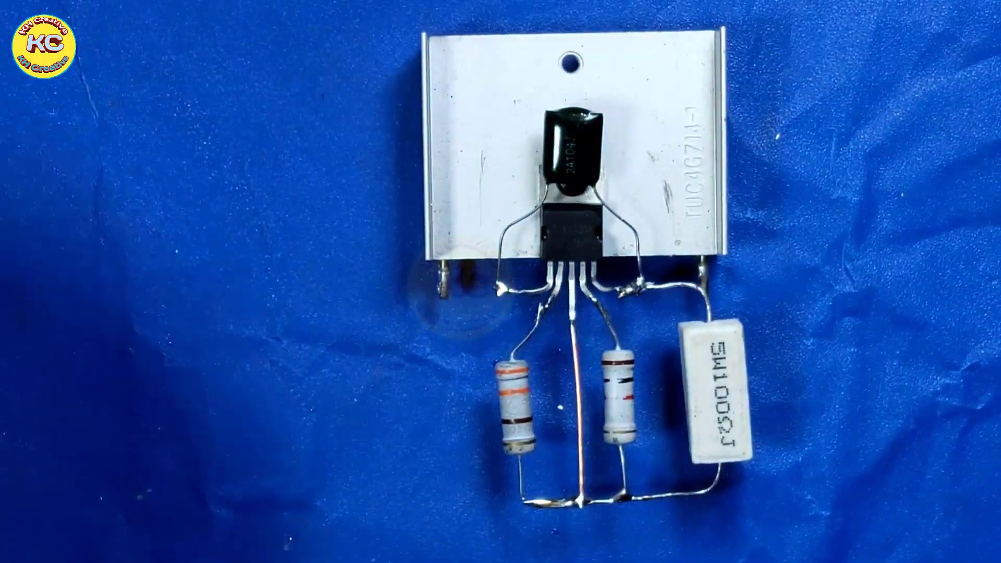 | 
Description: The speaker mentions termitting.
Correlated (true): 0 (0.0%)
Score >= 60: 0 (0.0%)
Average Score (of valid matches): 0.00
No strongly correlated comments found.

Topic T2: Serving or Sucking Rope
 |  | 
Description: The speaker talks about serving or sucking rope.
Correlated (true): 0 (0.0%)
Score >= 60: 0 (0.0%)
Average Score (of valid matches): 0.00
No strongly correlated comments found.

Topic T1: Filthy
 |  | 
Description: The speaker says something is filthy.
Correlated (true): 0 (0.0%)
Score >= 60: 0 (0.0%)
Average Score (of valid matches): 0.00
No strongly correlated comments found.

