Comment–Topic Correlation Report
Model: llama3

Summary
Topics processed: 3
Comments available for this video: 118
Comments with correlated=True: 6 (5.1%)
Comments with score >= 60: 6 (5.1%)
Total candidate pairs checked: 354
----------------------------------------

Topic T1: Altium Designer
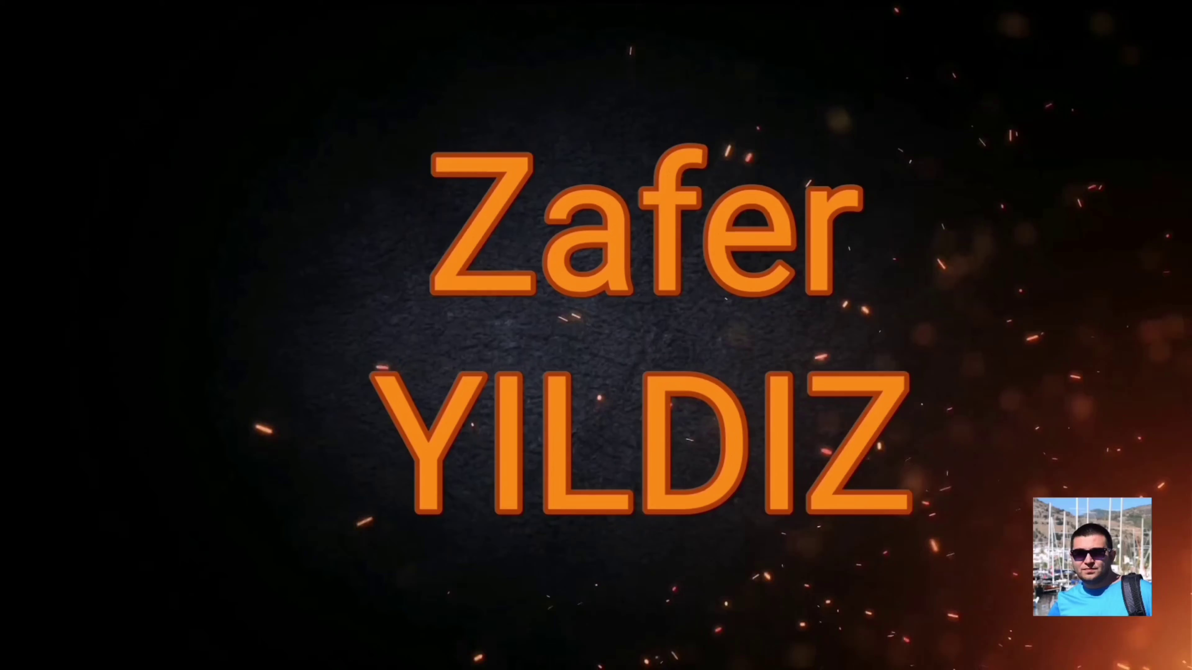 | 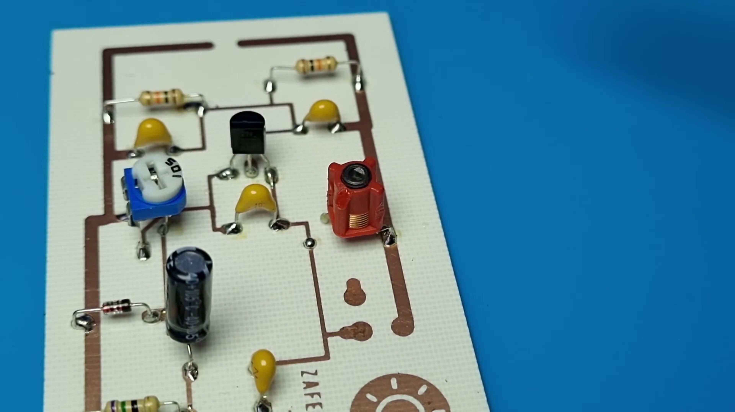 | 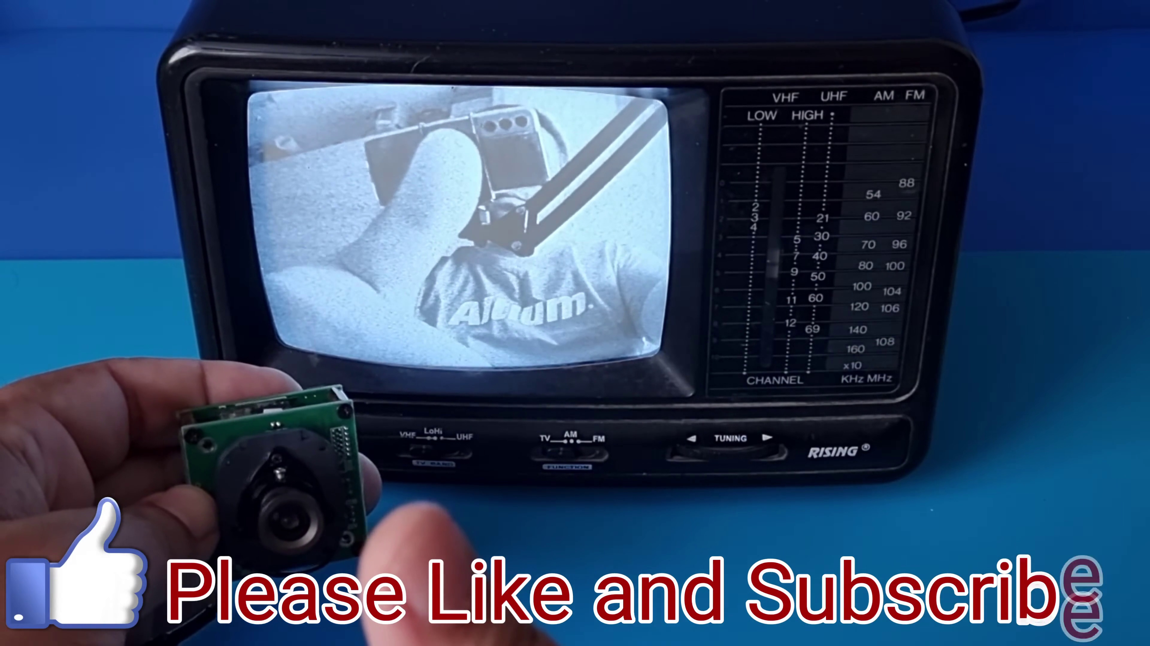
Description: The speaker introduces Altium Designer, a tool for creating PCB designs without extra setup or configuration.
Correlated (true): 5 (4.2%)
Score >= 60: 5 (4.2%)
Average Score (of valid matches): 82.00

Top 5 Correlated Comments:
Score: 90
Comment: 30 PF
Reason: The comment mentions 'PF' which is likely referring to Printed Circuit Board (PCB) design, aligning with the topic's description of Altium Designer as a tool for creating PCB designs.
Source: https://www.youtube.com/watch?v=fcmXG3wB_1M

Score: 80
Comment: Salom from 🇺🇿🇺🇿🇺🇿
Reason: The comment mentions the country flag from Uzbekistan, which is not directly related to Altium Designer. However, Salom's response implies a familiarity with PCB design and design software, given the mention of the tool. The correlation score is moderate as it doesn't explicitly discuss the same steps, objects, settings, parameters, claims, or goals described by the topic, but shows some tangential connection.
Source: https://www.youtube.com/watch?v=fcmXG3wB_1M

Score: 80
Comment: Oi! Tentarei montar o circuito. Verifiquei que possivelmente existe uma falha na placa de circuito e no diagrama. A emtrada de vídeo não está sendo feota através de um capacitor de 100nf.
Reason: The comment mentions the creation of a circuit (circuitos) which is directly related to the topic's focus on creating PCB designs. The mention of a possible failure in the board and diagram also relates to the topic's introduction of Altium Designer as a tool for design
Source: https://www.youtube.com/watch?v=fcmXG3wB_1M

Score: 80
Comment: You are gini
Reason: The comment mentions 'You', which is not directly related to Altium Designer. However, the username 'gini' does not seem to be discussing anything specific about the tool, and the comment itself does not provide any details or overlap with the topic's description about creating PCB designs without extra setup.
Source: https://www.youtube.com/watch?v=fcmXG3wB_1M

Score: 80
Comment: 15-20 M
Reason: The comment mentions 'M' which is likely referring to millimeters, a common unit of measurement in PCB design. This specific mention aligns with the topic's focus on creating PCB designs.
Source: https://www.youtube.com/watch?v=fcmXG3wB_1M

Topic T2: Free Applications
 |  | 
Description: The speaker encourages viewers to try and use the free applications available.
Correlated (true): 1 (0.8%)
Score >= 60: 1 (0.8%)
Average Score (of valid matches): 80.00

Top 1 Correlated Comments:
Score: 80
Comment: very great Is it possible to put the pcb file and its download link?
Reason: The comment directly references a specific file type (pcb) and its download link, which are both mentioned in the topic description as 'free applications' that viewers can use.
Source: https://www.youtube.com/watch?v=fcmXG3wB_1M

Topic T3: Sponsorship
 |  | 
Description: The speaker expresses gratitude to the sponsor of the video.
Correlated (true): 0 (0.0%)
Score >= 60: 0 (0.0%)
Average Score (of valid matches): 0.00
No strongly correlated comments found.

