Comment–Topic Correlation Report
Model: llama3

Summary
Topics processed: 3
Comments available for this video: 225
Comments with correlated=True: 5 (2.2%)
Comments with score >= 60: 5 (2.2%)
Total candidate pairs checked: 600
----------------------------------------

Topic T3: Thank You and Calculations
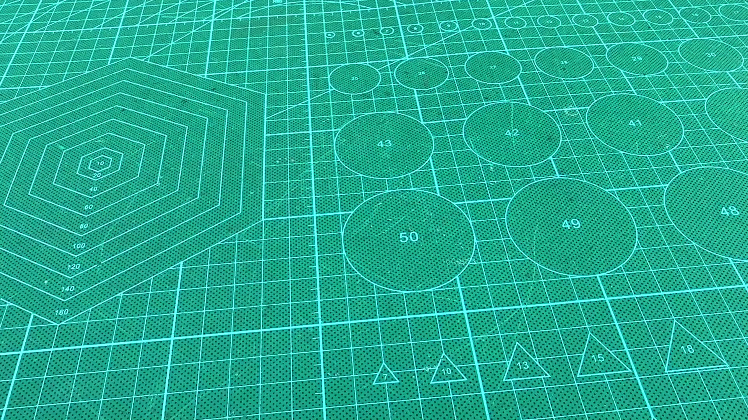 | 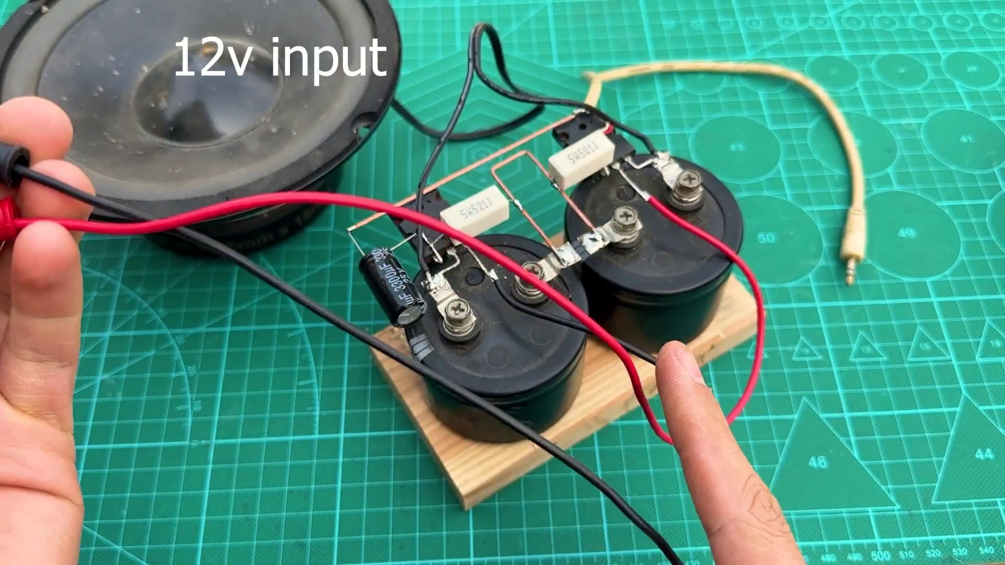 | 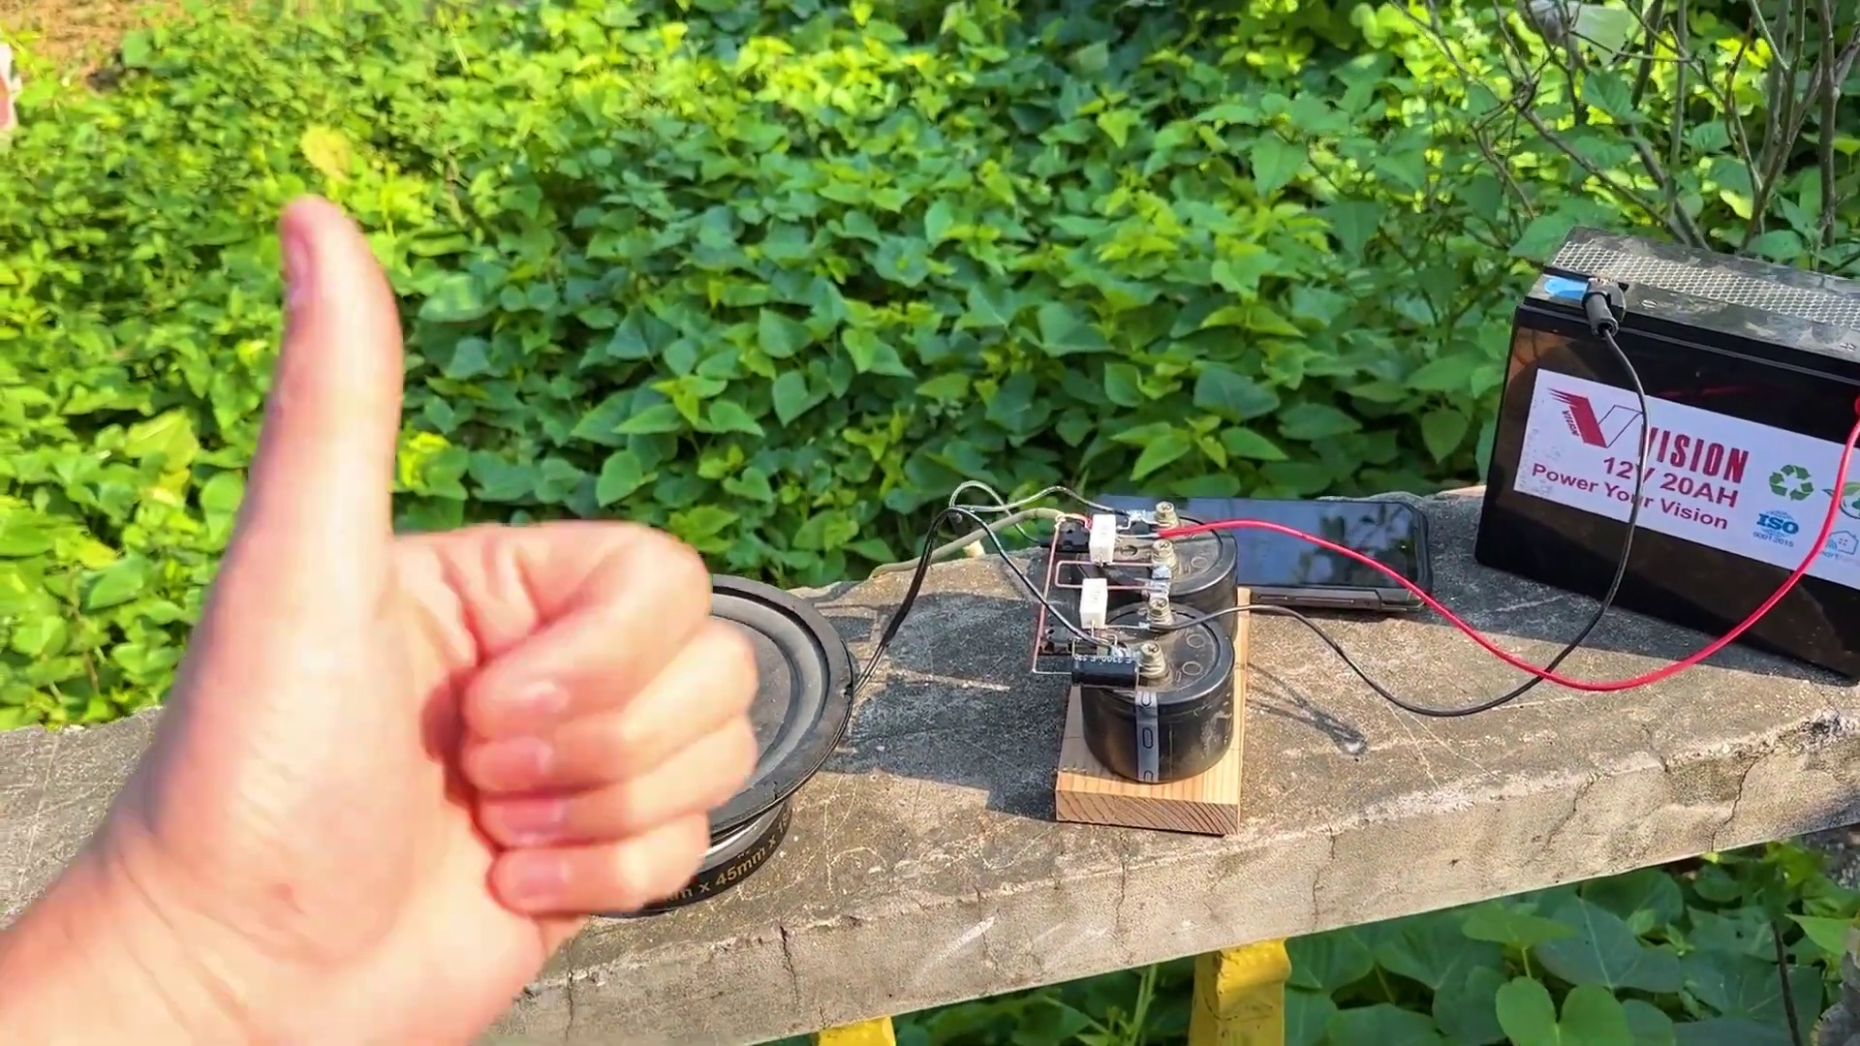
Description: The speaker thanks someone and mentions calculations and twist.
Correlated (true): 3 (1.3%)
Score >= 60: 3 (1.3%)
Average Score (of valid matches): 83.33

Top 3 Correlated Comments:
Score: 90
Comment: P=6000W U =12V I=500A 😂. R=0,2om perpetum mobile...
Reason: The comment directly mentions calculations (P=6000W, U=12V, I=500A) and references a specific concept (perpetum mobile), which is strongly related to the topic's mention of 'calculations'.
Source: https://www.youtube.com/watch?v=gdJHi9I0V4w

Score: 80
Comment: Tiszteletem. Minden elismerésem az Öné. Szeretnék én is ilyet készíteni. Csak nem tudom, hogy megkapok-e minden hozzávalót. Azt az egyet nem értem, hogy a hang bemenetnél a jobb és bal rövidre van zárva. Hogy nem teszi tönkre a telefont? Hogy tud úgy szólni? A stereónál három vezeték ér szükséges és nem szokták összezárni. Mindegy, én nem értem. Az ötlet jó, ha lesz lehetőségem,elkészítem.Előbb bemérem műszerrel, hogy nem jön e vissza áram a fülhallgató kábelen, nehogy szétégjen a telefon. Köszönöm a feltöltést. Üdv.
Reason: The comment mentions specific settings (hang bemenetnél) and parameters (három vezeték) related to the topic's 'calculations' and 'twist'. It also expresses concerns about potential damage (szétégjen a telefon) which aligns with the topic's focus on careful consideration.
Source: https://www.youtube.com/watch?v=gdJHi9I0V4w

Score: 80
Comment: alguien que por favor me diga como calcular las resistencias para poder polarizar un transistor, para hacer un amplificador. por favor quien me me ayuda.
Reason: The comment mentions calculating resistances and polarizing a transistor, which directly relates to the topic's mention of 'calculations' and 'twist'.
Source: https://www.youtube.com/watch?v=gdJHi9I0V4w

Topic T1: Association with Old Things
 |  | 
Description: The speaker associates themselves with old things.
Correlated (true): 2 (0.9%)
Score >= 60: 2 (0.9%)
Average Score (of valid matches): 82.50

Top 2 Correlated Comments:
Score: 85
Comment: This dude makes me laugh, he repurposes a pair of 35 year old 400 V caps to use in a circuit that runs off a 12 V supply and then has the nerve to label his 'speaker rated at 6,000 W.
Reason: The comment directly discusses the association with old things (35 year old caps), which is a key element of the topic. The tone and use of old components also aligns with the idea of 'old' in the topic.
Source: https://www.youtube.com/watch?v=gdJHi9I0V4w

Score: 80
Comment: Yea its his famous bluetooth receiving "battery" thats too light, and sounds hollow.
Reason: The comment mentions an 'old thing' (the speaker's famous bluetooth receiving battery) and describes its characteristics (too light, sounds hollow), which aligns with the topic's description of associating with old things.
Source: https://www.youtube.com/watch?v=gdJHi9I0V4w

Topic T2: Saint's Introduction
 |  | 
Description: The speaker introduces themselves as a saint.
Correlated (true): 0 (0.0%)
Score >= 60: 0 (0.0%)
Average Score (of valid matches): 0.00
No strongly correlated comments found.

