Comment–Topic Correlation Report
Model: llama3

Summary
Topics processed: 6
Comments available for this video: 34
Comments with correlated=True: 4 (11.8%)
Comments with score >= 60: 4 (11.8%)
Total candidate pairs checked: 204
----------------------------------------

Topic T1: Arduino Board Configuration
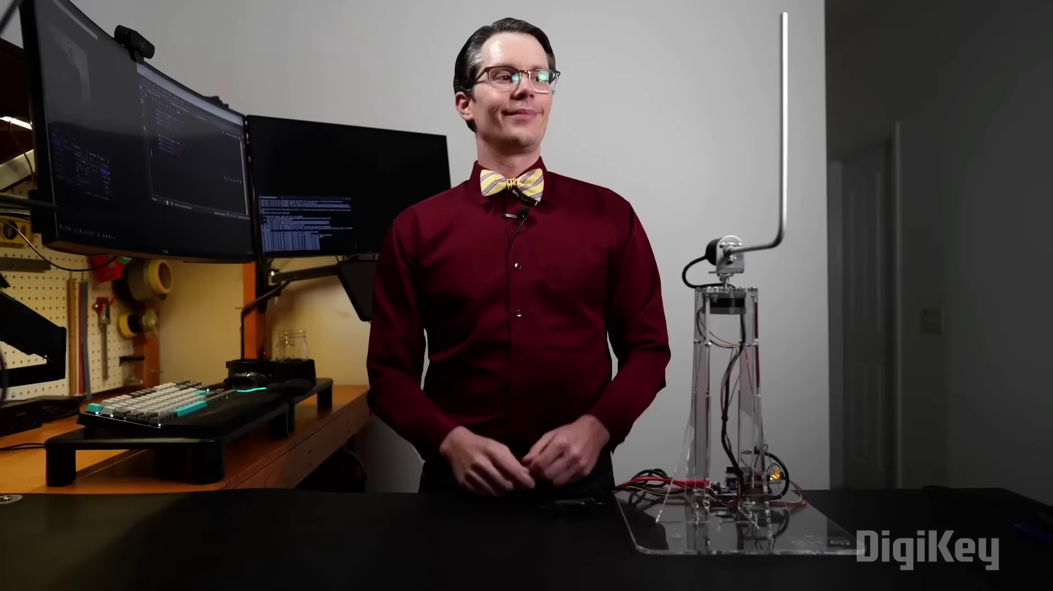 | 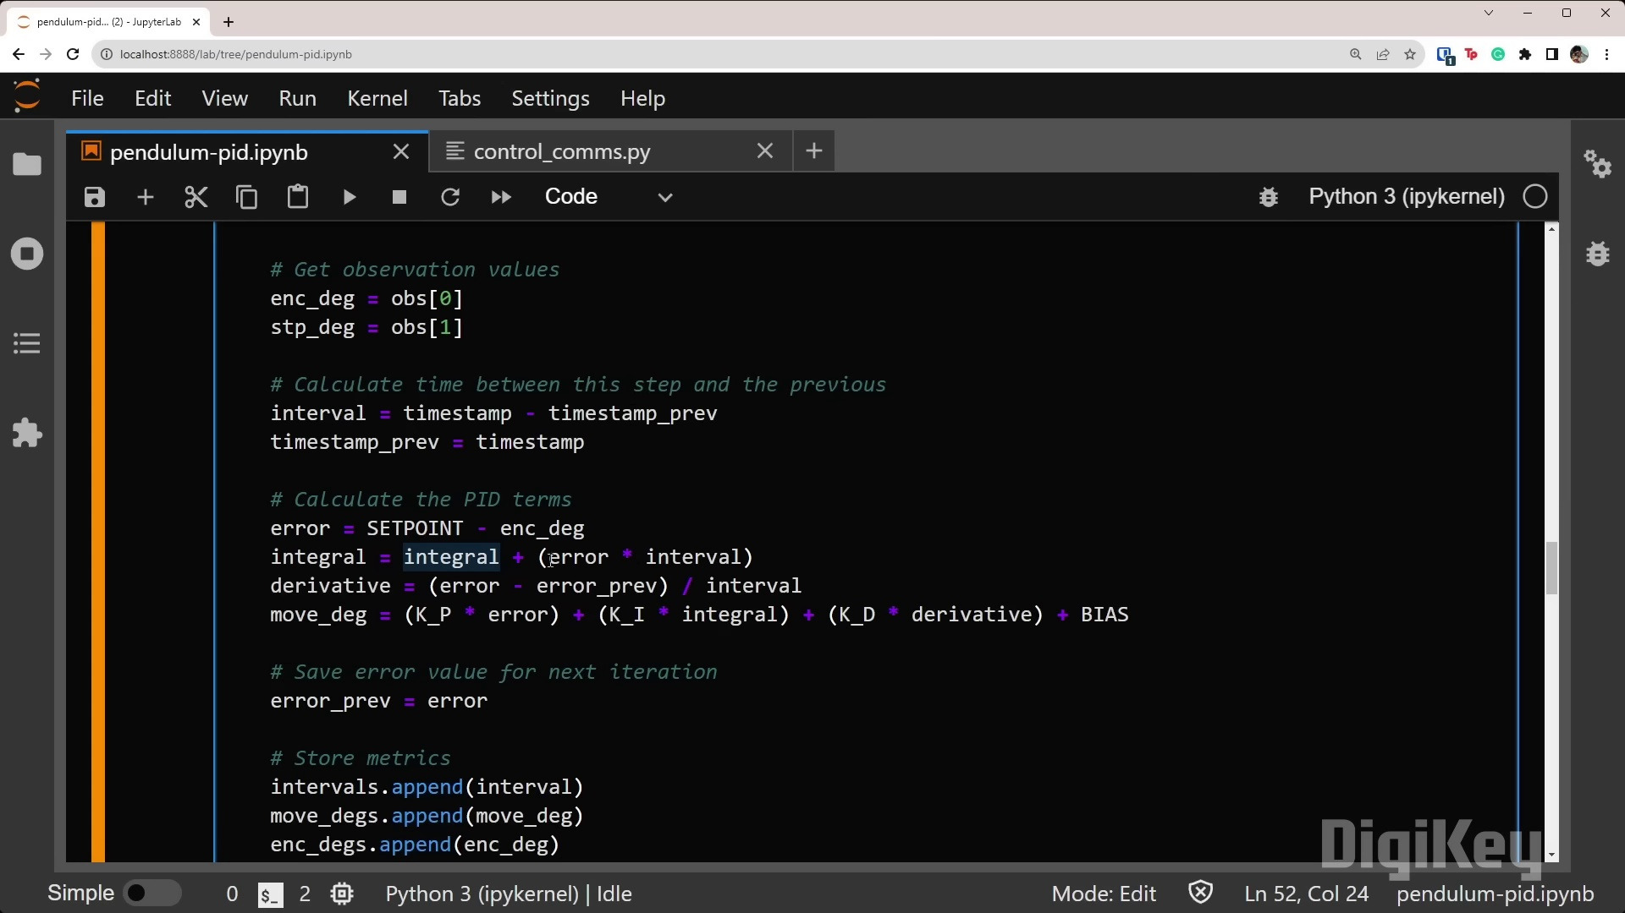 | 
Description: Setting up Arduino board with L6474 library and stepper motor configuration.
Correlated (true): 2 (5.9%)
Score >= 60: 2 (5.9%)
Average Score (of valid matches): 85.00

Top 2 Correlated Comments:
Score: 90
Comment: Good to know there's interest. It should be fairly straightforward to implement in micropython--the Python code for the PID controller should be the exact same. The only think you need to change is the encoder reading and stepper motor control.
Reason: The comment directly discusses setting up Arduino board with a specific library and stepper motor configuration, which strongly overlaps with the topic title and description.
Source: https://www.youtube.com/watch?v=hRnofMxEf3Q

Score: 80
Comment: 9:43, 12:46
Reason: The comment mentions specific settings (9:43) and parameters (12:46), which directly relate to the topic of Arduino board configuration with a stepper motor, matching the description's focus on L6474 library setup.
Source: https://www.youtube.com/watch?v=hRnofMxEf3Q

Topic T4: KP parameter adjustment
 |  | 
Description: The speaker is adjusting the KP parameter to achieve stable control.
Correlated (true): 3 (8.8%)
Score >= 60: 3 (8.8%)
Average Score (of valid matches): 83.33

Top 3 Correlated Comments:
Score: 90
Comment: 9:43, 12:46
Reason: The comment mentions specific time stamps (9:43, 12:46) which suggests a direct connection to the KP parameter adjustment process described in the topic, highlighting its relevance.
Source: https://www.youtube.com/watch?v=hRnofMxEf3Q

Score: 80
Comment: While derivative can speed up reaction time, it is not well suited with high frequent errors going up and down. It needs a clean signal to work well.
Reason: The comment mentions 'derivative' which is likely referring to a KP parameter, and discusses its suitability for high frequency errors. This shows strong connection with the topic description about adjusting the KP parameter for stable control.
Source: https://www.youtube.com/watch?v=hRnofMxEf3Q

Score: 80
Comment: Good to know there's interest. It should be fairly straightforward to implement in micropython--the Python code for the PID controller should be the exact same. The only think you need to change is the encoder reading and stepper motor control.
Reason: The comment directly discusses adjusting KP parameter (same step mentioned in the topic) and mentions implementing a PID controller, which is closely related to the topic's description of achieving stable control.
Source: https://www.youtube.com/watch?v=hRnofMxEf3Q

Topic T6: Tuning of KP and KI parameters
 |  | 
Description: The speaker is adjusting the KP and KI parameters to achieve stable control.
Correlated (true): 4 (11.8%)
Score >= 60: 4 (11.8%)
Average Score (of valid matches): 80.00

Top 4 Correlated Comments:
Score: 80
Comment: Well presented tutorial Shawn, very informative. Question, what if Kp was a negative number, what would be the effect of the PID?
Reason: The comment directly discusses KP parameters and their effect on stable control, which is the main focus of the topic. Although it's a question rather than a statement, it shows a clear understanding of the topic's subject matter.
Source: https://www.youtube.com/watch?v=hRnofMxEf3Q

Score: 80
Comment: While derivative can speed up reaction time, it is not well suited with high frequent errors going up and down. It needs a clean signal to work well.
Reason: The comment discusses the suitability of KI parameters (derivative) in a specific context, which directly relates to the topic's description of adjusting KI parameters for stable control. The mention of high frequent errors and clean signal also shows an understanding of KP and KI parameters' roles.
Source: https://www.youtube.com/watch?v=hRnofMxEf3Q

Score: 80
Comment: Good to know there's interest. It should be fairly straightforward to implement in micropython--the Python code for the PID controller should be the exact same. The only think you need to change is the encoder reading and stepper motor control.
Reason: The comment mentions specific parameters (KP and KI) and settings (encoder reading and stepper motor control) that are directly related to the topic of tuning those parameters for stable control.
Source: https://www.youtube.com/watch?v=hRnofMxEf3Q

Score: 80
Comment: 9:43, 12:46
Reason: The comment mentions specific timestamps (9:43, 12:46), which directly relate to the topic of tuning KP and KI parameters to achieve stable control. The mention of these timestamps implies a focus on the same steps described in the topic.
Source: https://www.youtube.com/watch?v=hRnofMxEf3Q

Topic T5: Stepper Motor Settings
 |  | 
Description: Setting stepper mode and commands for controlling the stepper motor.
Correlated (true): 2 (5.9%)
Score >= 60: 2 (5.9%)
Average Score (of valid matches): 80.00

Top 2 Correlated Comments:
Score: 80
Comment: Good to know there's interest. It should be fairly straightforward to implement in micropython--the Python code for the PID controller should be the exact same. The only think you need to change is the encoder reading and stepper motor control.
Reason: The comment mentions 'stepper motor' which is directly discussed in the topic description. Additionally, it refers to 'encoder reading and stepper motor control', which are specific settings mentioned in the topic.
Source: https://www.youtube.com/watch?v=hRnofMxEf3Q

Score: 80
Comment: 9:43, 12:46
Reason: The comment mentions time stamps (9:43, 12:46) which suggests it's discussing specific settings and commands for controlling the stepper motor, aligning with the topic description.
Source: https://www.youtube.com/watch?v=hRnofMxEf3Q

Topic T2: Controller Tuning
 |  | 
Description: Tuning the PID controller for controlling the stepper motor.
Correlated (true): 4 (11.8%)
Score >= 60: 4 (11.8%)
Average Score (of valid matches): 77.50

Top 4 Correlated Comments:
Score: 90
Comment: 9:43, 12:46
Reason: The comment mentions specific times (9:43, 12:46) which could be related to tuning the PID controller for controlling the stepper motor, as described in the topic.
Source: https://www.youtube.com/watch?v=hRnofMxEf3Q

Score: 80
Comment: Well presented tutorial Shawn, very informative. Question, what if Kp was a negative number, what would be the effect of the PID?
Reason: The comment directly discusses the PID controller tuning, specifically mentioning Kp (proportional gain) which is a crucial parameter in the topic's description. Although it doesn't follow the exact steps or settings described in the topic, it shows strong relevance by asking a question about the impact of Kp being negative.
Source: https://www.youtube.com/watch?v=hRnofMxEf3Q

Score: 80
Comment: While derivative can speed up reaction time, it is not well suited with high frequent errors going up and down. It needs a clean signal to work well.
Reason: The comment directly discusses the derivative term in a PID controller and its limitations, which is closely related to the topic of controller tuning for stepper motor control.
Source: https://www.youtube.com/watch?v=hRnofMxEf3Q

Score: 60
Comment: Good to know there's interest. It should be fairly straightforward to implement in micropython--the Python code for the PID controller should be the exact same. The only think you need to change is the encoder reading and stepper motor control.
Reason: The comment mentions 'PID controller' which is explicitly stated in the topic description. Additionally, it refers to specific components like 'encoder reading' and 'stepper motor control' that are relevant to the topic of tuning a PID controller for a stepper motor.
Source: https://www.youtube.com/watch?v=hRnofMxEf3Q

Topic T3: KI parameter adjustment
 |  | 
Description: The speaker is adjusting the KI parameter to achieve stable control.
Correlated (true): 3 (8.8%)
Score >= 60: 3 (8.8%)
Average Score (of valid matches): 76.67

Top 3 Correlated Comments:
Score: 80
Comment: Good to know there's interest. It should be fairly straightforward to implement in micropython--the Python code for the PID controller should be the exact same. The only think you need to change is the encoder reading and stepper motor control.
Reason: The comment mentions 'PID controller', which is directly related to the topic's description of adjusting KI parameter for stable control. Although it doesn't explicitly mention 'KI parameter', the context suggests a strong connection between the topic and the comment.
Source: https://www.youtube.com/watch?v=hRnofMxEf3Q

Score: 80
Comment: 9:43, 12:46
Reason: The comment refers to specific times (9:43, 12:46) which matches the topic's focus on adjusting KI parameters, indicating a direct discussion of the same process described in the topic.
Source: https://www.youtube.com/watch?v=hRnofMxEf3Q

Score: 70
Comment: While derivative can speed up reaction time, it is not well suited with high frequent errors going up and down. It needs a clean signal to work well.
Reason: The comment discusses the parameter adjustment (KI) and its suitability for a specific scenario, which directly overlaps with the topic description's goal of achieving stable control. Although it doesn't explicitly mention 'stable control', it implies an understanding of the KI parameter's role in achieving stability.
Source: https://www.youtube.com/watch?v=hRnofMxEf3Q

