Comment–Topic Correlation Report
Model: llama3

Summary
Topics processed: 2
Comments available for this video: 19
Comments with correlated=True: 8 (42.1%)
Comments with score >= 60: 8 (42.1%)
Total candidate pairs checked: 38
----------------------------------------

Topic T2: LM386 Audio Amplifier Kit
 | 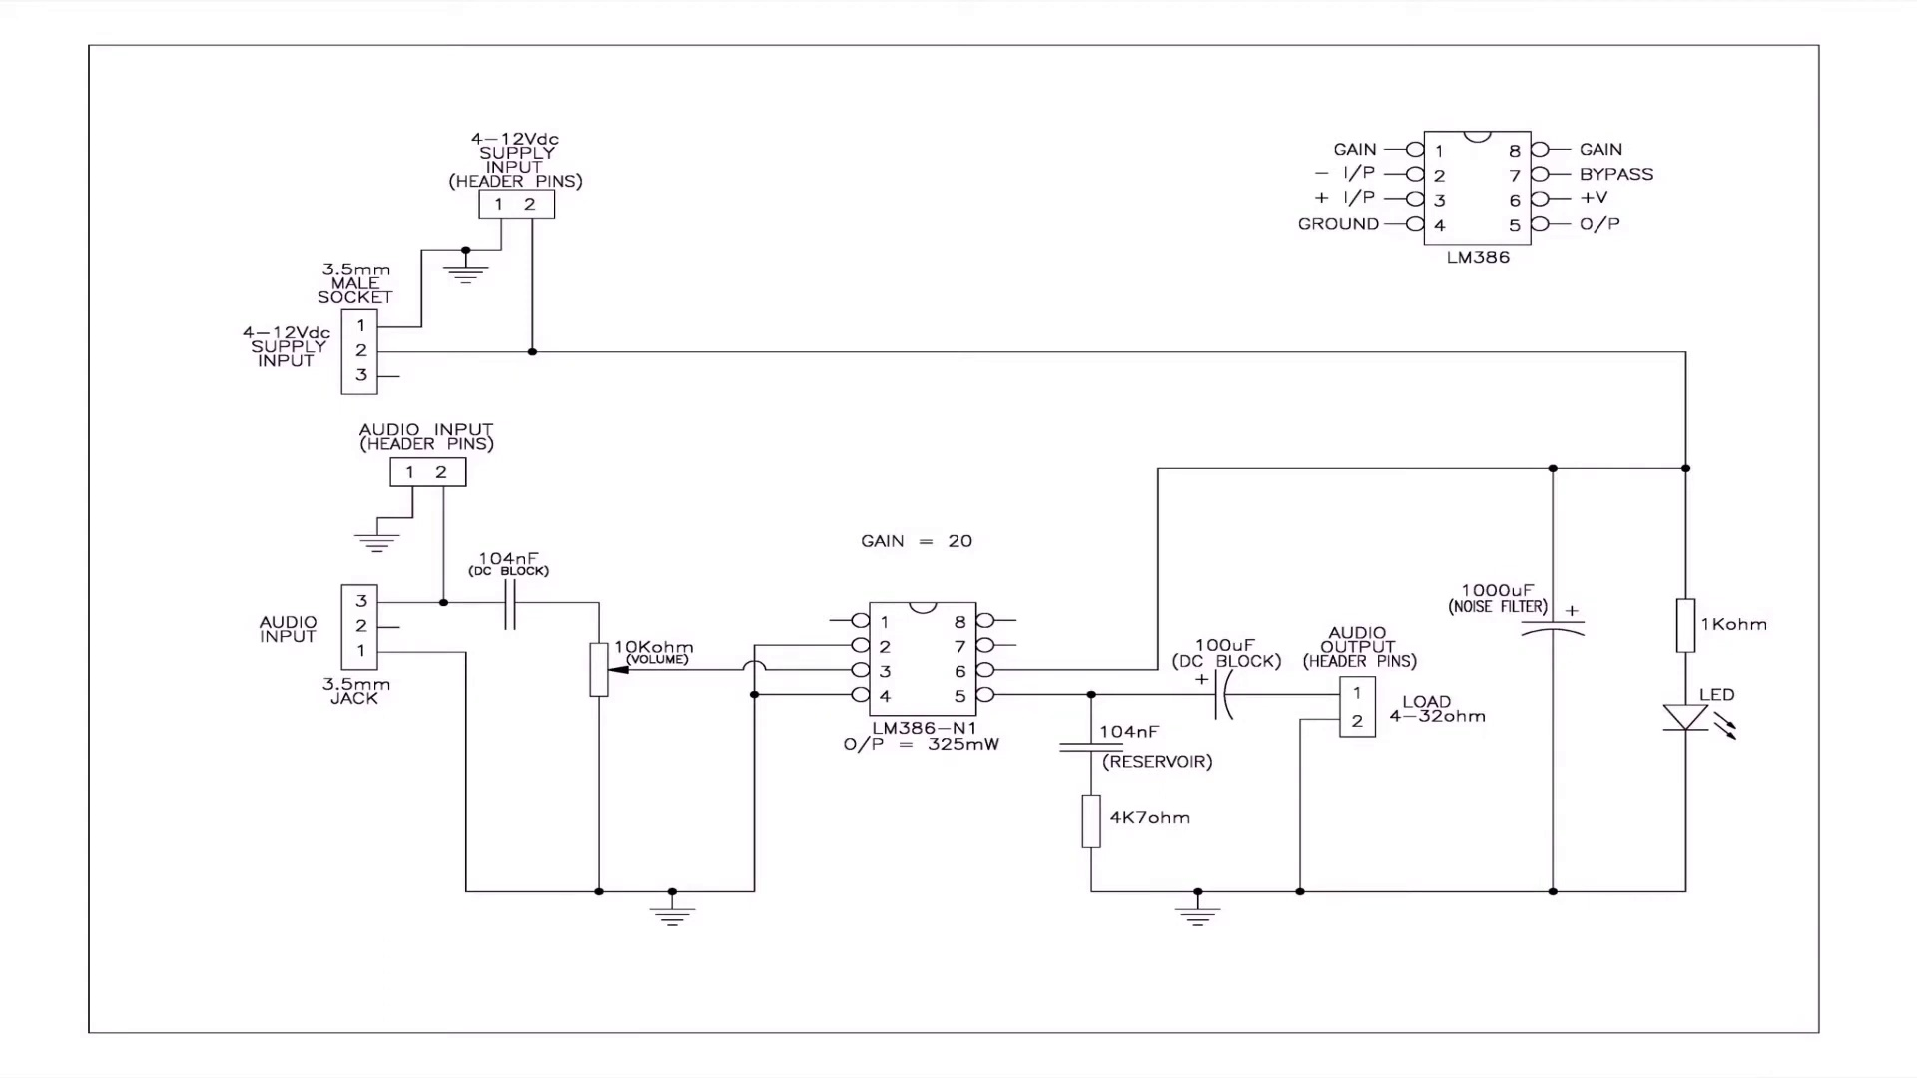 | 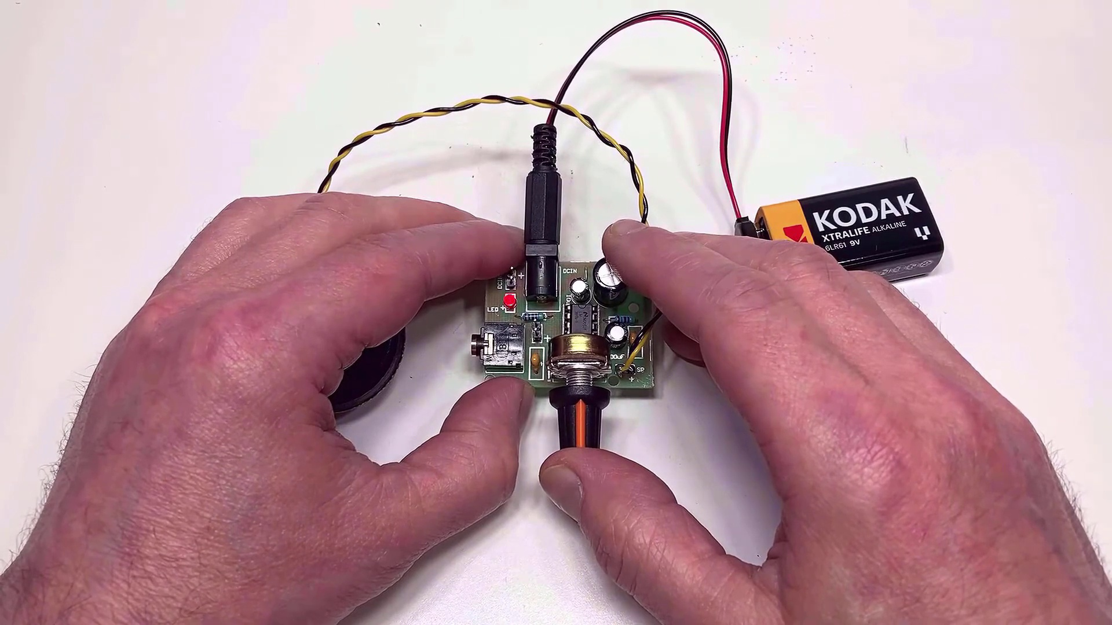
Description: A review of the LM386 audio amplifier kit, including its features and performance.
Correlated (true): 8 (42.1%)
Score >= 60: 8 (42.1%)
Average Score (of valid matches): 82.50

Top 5 Correlated Comments:
Score: 90
Comment: Hi, thanks for getting back to me. Once you have gone past the 4Vdc supply level (you were previously using a 3.7V battery), you are within the recommended power supply voltage levels, so you won’t really get much more out of this little amp. Assuming that you have a 10uF capacitor between pins 1 & 8 on the chip, (this gives a gain of 200) then you are also at max gain. As mentioned before, the LM386 audio chip used in this kit is the lower O/P version LM386-N1. If you swap for a LM386-N4 it will give you a little more gain and hence, a slightly higher output. However, please bear in mind though that this little amp is used primarily for small portable devices like radios etc. If you need a lot more power then you may need to look at a different amplifier. BTW not sure if you have one or two speakers connected, but their impedance should be between 4 & 16 ohms. Might be worth checking, as if you have two 4ohm speakers connected in parallel, it would result in a 2ohm load for the amp which may cause issues. Hope this helps – please come back to me if I can assist you any further
Reason: The comment directly discusses the LM386 audio amplifier kit, mentioning its features (e.g. max gain), performance (e.g. output power), and usage recommendations (e.g. speaker impedance). It also specifically references the topic's description of the chip version used in the kit.
Source: https://www.youtube.com/watch?v=hnPi6i8Ua1M

Score: 90
Comment: Hi, sorry to hear your little amp didn't work out. However, it would be worth checking a few things before you give up. These might sound a little basic, but I have done some of these myself on more than a few occasions! Firstly, ensure that electrolytic capacitors have been correctly fitted as they are polarised & so will not perform reversed. Is the LM386 fitted the correct way around, (and a check to see if a pin has been bent)? Suggest you also check for any dry joints, (sometimes component leads require a quick rub with fine wet and dry to remove oxidisation especially if new old stock items are used), solder bridges between PCB tracks etc. All worth checking - good luck!
Reason: The comment directly discusses specific details about the LM386 audio amplifier kit, including electrolytic capacitor polarity, pin orientation, and potential issues with dry joints, solder bridges, and component leads. These are all relevant to the topic's description of the kit's features and performance.
Source: https://www.youtube.com/watch?v=hnPi6i8Ua1M

Score: 80
Comment: Hi, thanks for getting in touch. Assuming the gain is at maximum, (i.e. 10uF cap between pins 1 & 8) then there are a couple of things to look at. I'm not sure how you have connected three speakers to the amp, but if these are in parallel, then their overall impedance may be too low for the amp, (it needs at least 4 ohms). Your 3.7V dc supply is a little low, (some data sheets for the LM386 give a minimum of 4Vdc. As you say, a higher voltage will improve the output power a little). Note that the LM386 amp provided in the kit is rated between 200 & 300mW depending upon voltage. You could substitute it for an LM386-N4 which has higher output of approx. 1Watt. Hope this helps and good luck with your speaker build.
Reason: The comment directly discusses the LM386 audio amplifier kit, mentioning specific features (gain, impedance, voltage), performance (output power), and components (LM386 amp, capacitor, speakers). The topics match with a high degree of overlap, making the correlation strong.
Source: https://www.youtube.com/watch?v=hnPi6i8Ua1M

Score: 80
Comment: Hi, that sounds a very interesting project. Your speaker connections to SP+ - are correct. If you not getting any O/P, you might want to re-check a few items:
1. Check the polarity of your DC supply connections if you are using the 3.5mm jack as it is easy to get these crossed.
2. Check that all the electrolytic capacitors are correctly connected polarity wise.
3. Check for any unintended solder bridges.
4. Check that the DIL socket is not fitted the opposite way round & hence, the LM38 chip may end up being fitted 180 deg. to what it should be.
5. Check for any dry solder joints
6. If still no joy, try another speaker.
I would be interested on how you get on. Thanks for getting touch.
TWCG
Reason: The comment directly addresses troubleshooting steps and component connections mentioned in the topic description, specifically checking DC supply polarity, electrolytic capacitor connections, solder bridges, DIL socket orientation, and dry joints.
Source: https://www.youtube.com/watch?v=hnPi6i8Ua1M

Score: 80
Comment: Nice build! I building one now I want to use as a small battery power amplifier for my 3 string cigar box guitar. I connected the guitar Jack to the audio input, is that correct. I not getting any sound out of the speaker I connected the speaker to the SP +- on the PCB.
Thanks
Reason: The comment mentions building an LM386 audio amplifier kit and using it for a specific application (amplifying a cigar box guitar), which directly relates to the topic's features and performance. The mention of PCB, SP, and speaker also overlaps with the topic's description.
Source: https://www.youtube.com/watch?v=hnPi6i8Ua1M

Topic T1: Adjusting Gain
 |  | 
Description: The LM386 chip has a feature that allows you to adjust its gain.
Correlated (true): 1 (5.3%)
Score >= 60: 1 (5.3%)
Average Score (of valid matches): 75.00

Top 1 Correlated Comments:
Score: 75
Comment: Hi, thanks for getting back to me. Once you have gone past the 4Vdc supply level (you were previously using a 3.7V battery), you are within the recommended power supply voltage levels, so you won’t really get much more out of this little amp. Assuming that you have a 10uF capacitor between pins 1 & 8 on the chip, (this gives a gain of 200) then you are also at max gain. As mentioned before, the LM386 audio chip used in this kit is the lower O/P version LM386-N1. If you swap for a LM386-N4 it will give you a little more gain and hence, a slightly higher output. However, please bear in mind though that this little amp is used primarily for small portable devices like radios etc. If you need a lot more power then you may need to look at a different amplifier. BTW not sure if you have one or two speakers connected, but their impedance should be between 4 & 16 ohms. Might be worth checking, as if you have two 4ohm speakers connected in parallel, it would result in a 2ohm load for the amp which may cause issues. Hope this helps – please come back to me if I can assist you any further
Reason: The comment discusses adjusting gain of the LM386 chip and mentions specific values (e.g. 4Vdc, 10uF, 200) and parameters (e.g. power supply voltage levels), directly related to the topic.
Source: https://www.youtube.com/watch?v=hnPi6i8Ua1M

