Comment–Topic Correlation Report
Model: llama3

Summary
Topics processed: 6
Comments available for this video: 19
Comments with correlated=True: 0 (0.0%)
Comments with score >= 60: 0 (0.0%)
Total candidate pairs checked: 114
----------------------------------------

Topic T6: Sound Test
 | 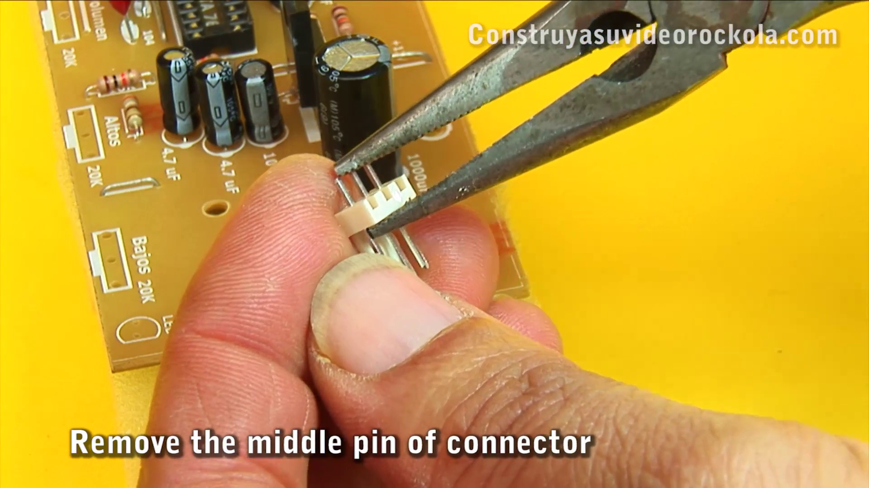 | 
Description: Demonstrating the project's audio capabilities
Correlated (true): 0 (0.0%)
Score >= 60: 0 (0.0%)
Average Score (of valid matches): 0.00
No strongly correlated comments found.

Topic T5: Tone Control and Microphone Preamp
 |  | 
Description: Building the tone control circuit with microphone preamplifier
Correlated (true): 0 (0.0%)
Score >= 60: 0 (0.0%)
Average Score (of valid matches): 0.00
No strongly correlated comments found.

Topic T4: Connections
 |  | 
Description: Assembling cables and connectors for signal input and output
Correlated (true): 0 (0.0%)
Score >= 60: 0 (0.0%)
Average Score (of valid matches): 0.00
No strongly correlated comments found.

Topic T3: Measurements
 |  | 
Description: Checking voltage levels and circuit performance
Correlated (true): 0 (0.0%)
Score >= 60: 0 (0.0%)
Average Score (of valid matches): 0.00
No strongly correlated comments found.

Topic T2: PCB Cleaning
 |  | 
Description: Washing and drying the PCB
Correlated (true): 0 (0.0%)
Score >= 60: 0 (0.0%)
Average Score (of valid matches): 0.00
No strongly correlated comments found.

Topic T1: Introduction
 |  | 
Description: Project overview and setup
Correlated (true): 0 (0.0%)
Score >= 60: 0 (0.0%)
Average Score (of valid matches): 0.00
No strongly correlated comments found.

