Comment–Topic Correlation Report
Model: llama3

Summary
Topics processed: 1
Comments available for this video: 104
Comments with correlated=True: 1 (1.0%)
Comments with score >= 60: 1 (1.0%)
Total candidate pairs checked: 104
----------------------------------------

Topic T1: Music
 | 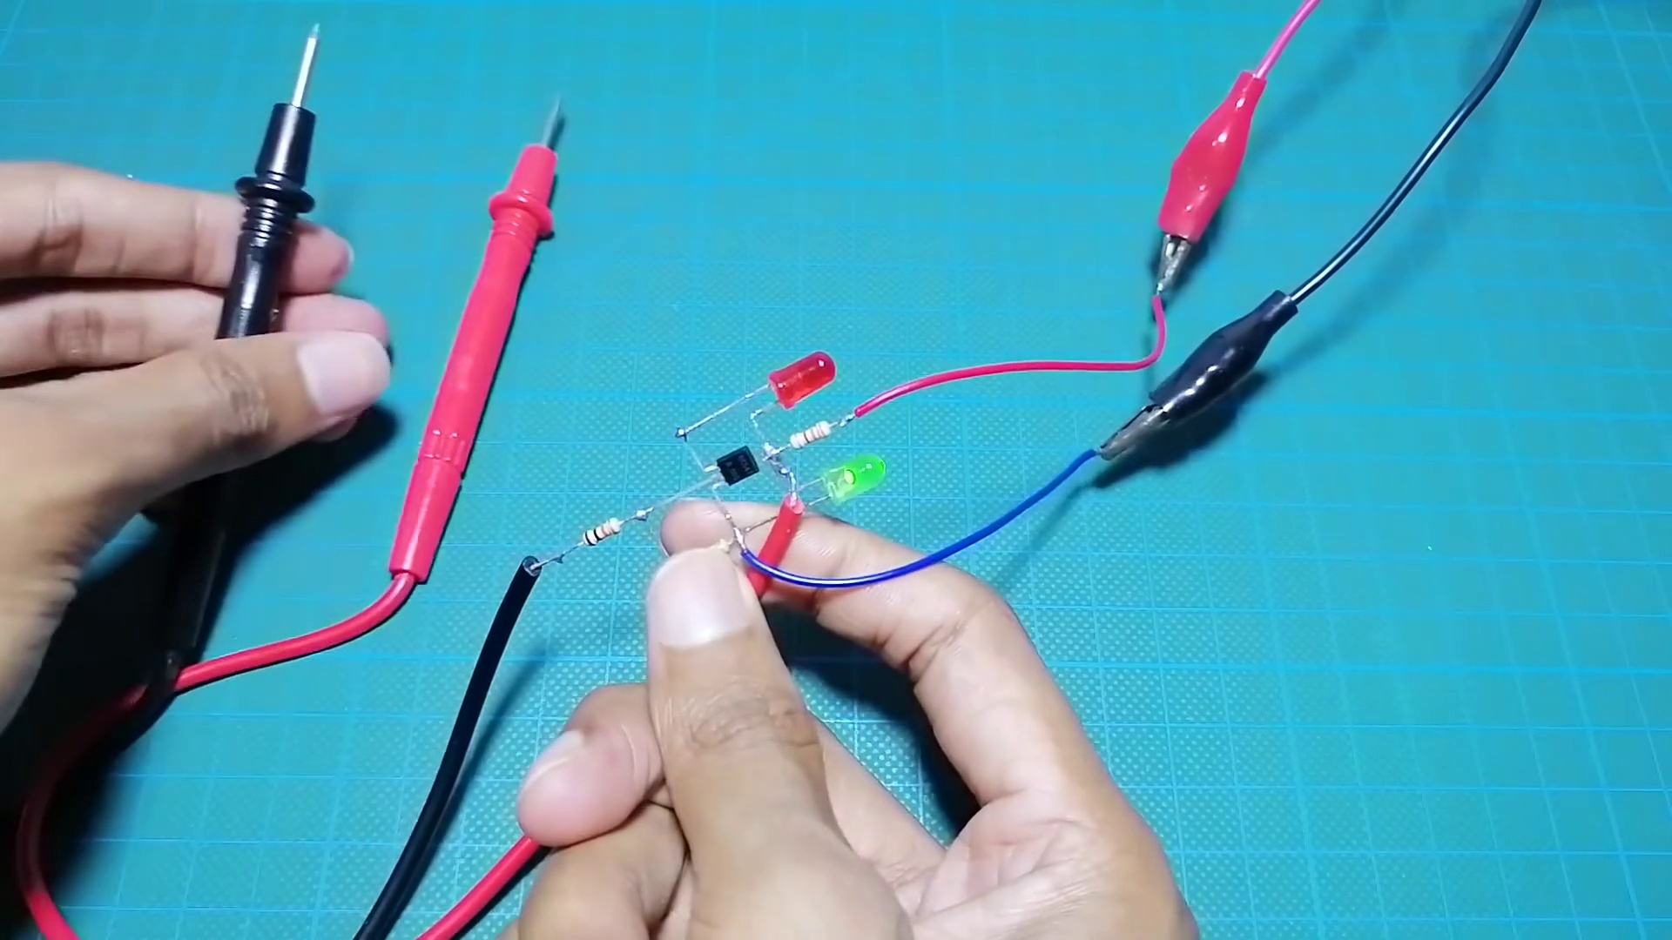 | 
Description: The speaker talks about music.
Correlated (true): 1 (1.0%)
Score >= 60: 1 (1.0%)
Average Score (of valid matches): 80.00

Top 1 Correlated Comments:
Score: 80
Comment: yes
Reason: The comment 'yes' directly corresponds to the topic 'Music', specifically discussing the same subject described in the description.
Source: https://www.youtube.com/watch?v=nxMkX0wtLm4

