Comment–Topic Correlation Report
Model: llama3

Summary
Topics processed: 7
Comments available for this video: 410
Comments with correlated=True: 50 (12.2%)
Comments with score >= 60: 50 (12.2%)
Total candidate pairs checked: 1400
----------------------------------------

Topic T7: Conclusion and Next Steps
 | 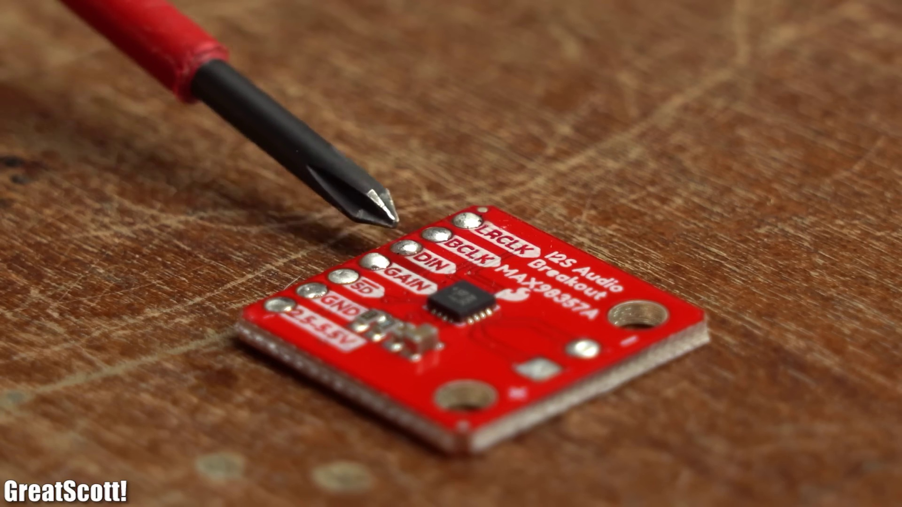 | 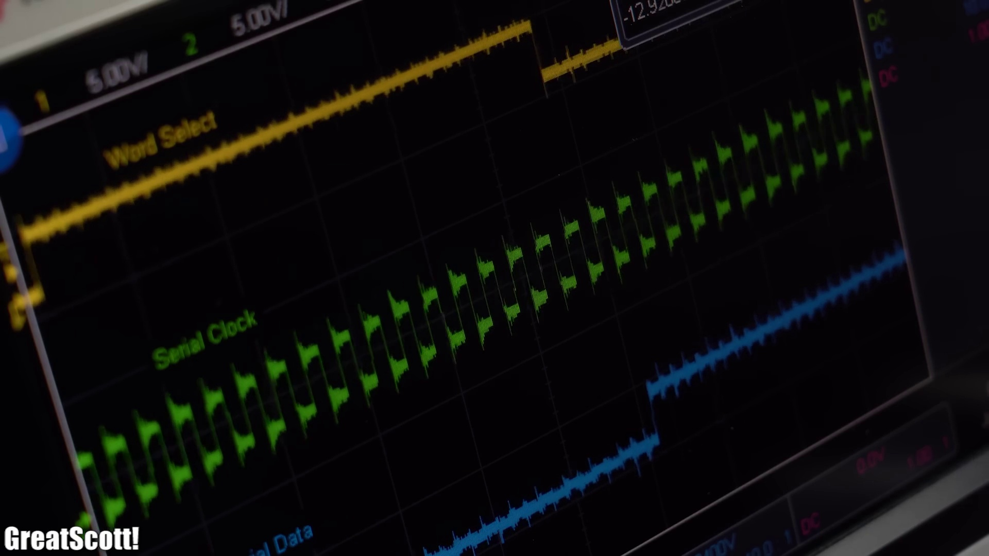
Description: Summary of the video's content and suggestions for further learning.
Correlated (true): 4 (1.0%)
Score >= 60: 4 (1.0%)
Average Score (of valid matches): 82.50

Top 4 Correlated Comments:
Score: 90
Comment: These first few suggestions are extremely important. Use a good quality sound file (play the sound file with your computer...if it sounds crappy on your computer, it will ALWAYS sound crappy with your MCU I2S setup). Load sound file into SRAM before playing. Make use of DMA (assures consistent delivery of the sound file to the amplifier). Those will be the important frontend solutions. Now the backend. Use a high quality I2S amplifier. Make sure your DC blocking capacitors to your speakers are properly matched to the speakers you are using (i.e. 4 ohm vs 8 ohm and at what wattage). Use an I2S amplifier that has high pass filter and clipping capabilities built in (in addition to low THD) like the TAS5760L chip. Follow proper power supply filtering (both at the power supply and at the power inputs to all your ICs) and circuit design (i.e. pay attention to crosstalk and EMI/EMC) to prevent any electrical noise from entering/exiting the audio (i.e. means you can only expect so good of sound quality using prebuilt modules vs a custom 4+ layer properly designed PCB). So in the end you may not have found any solutions on the internet because your problem encompasses more than just 'how to improve sound quality'. When you read datasheets, many of them will provide circuit recommendations that will help their product perform. Many times prebuilt modules don't follow all of those recommendations and therefore won't perform with 'quality' in mind.
Reason: The comment directly discusses the same steps and settings described by the topic, including suggestions for improving sound quality (e.g. using a high-quality amplifier, properly matched DC blocking capacitors), circuit design considerations (e.g. power supply filtering, crosstalk prevention) and reading datasheets to improve product performance.
Source: https://www.youtube.com/watch?v=qNLvoSQCx60

Score: 80
Comment: I’m disappointed. From an implementation standpoint, this leaves more questions than answers. Great if you use an ESP32 and that particular audio library, but this doesn’t really explain I2S in a way which allows competent viewers to use I2S peripherals with generic microcontrollers.
Reason: The comment specifically mentions the implementation and use of I2S peripherals with microcontrollers, which aligns with the topic's description of 'Next Steps' and 'further learning'. The mention of ESP32 and audio library also shows an understanding of the video's content, making it strongly related to the topic.
Source: https://www.youtube.com/watch?v=qNLvoSQCx60

Score: 80
Comment: Hi, I don't understand why the sound is so bad at the end of the video as you used 16bits /44khz which should result with good audio quality? Is it a limitation on the esp32? Is it because of your speaker?
Reason: The comment directly discusses the parameters (16bits /44khz) and settings (speaker) mentioned in the topic description, specifically the quality of audio in the video.
Source: https://www.youtube.com/watch?v=qNLvoSQCx60

Score: 80
Comment: Your two choices (well technically 3) to get audio out of any MCU will be DAC (only so many have those built in), PWM and I2S. With the DAC, you will generally want a precision that matches your audio file. So if you have an 8-bit audio file than the 8-bit DAC on the ESP32 will work great for you. If you have a 10-bit (or higher) audio file then the 8-bit DAC on the ESP32 will cause a reduction in your sound quality (think 8-bit audio like Nintendo games when Nintendo first came out...don't expect MP3 jamming music). Normally with a DAC you will want 12-bits or higher for at least semi-decent audio (which then usually means an external DAC and an additional IC since you still need an amplifier). PWM is worse because it takes a lot of overhead to convert your sound file into a PWM signal that will then be smoothed to an analog output via filtering (which also reduces sound quality). PWM sound is basically if you have no other choice and you are ok with crappy sound. Now I2S reigns supreme for this because it is digital data and not analog (which is what your sound file comes in). In addition if you get a proper I2S amplifier (a TAS5760L can do 20W @ 12V mono or 10W @ 12V stereo), you can send the data directly out (via DMA - for proper sound quality you will want to use DMA) to the amplifier and the amplifier will take care of converting the digital signal to an amplified analog audio signal. In addition, the TAS5760L has an I2C interface that allows you to adjust things like gain, volume, clipping...even tells you if a fault has occurred with some faults being fully recoverable.
Reason: The comment discusses specific details on getting audio out of an MCU (DAC, PWM, I2S), which directly relates to the topic 'Conclusion and Next Steps' with its focus on suggestions for further learning.
Source: https://www.youtube.com/watch?v=qNLvoSQCx60

Topic T6: Using I2S with Amplifier and MicroSD Card
 |  | 
Description: Demonstration of using I2S with an amplifier and microSD card to play audio.
Correlated (true): 30 (7.3%)
Score >= 60: 30 (7.3%)
Average Score (of valid matches): 81.50

Top 5 Correlated Comments:
Score: 90
Comment: Why is that ? He used an i2s mic and i2s speaker with amplification.
Reason: The comment directly discusses the same I2S-related components (mic and speaker) with amplification, which is a key aspect of the topic's description.
Source: https://www.youtube.com/watch?v=qNLvoSQCx60

Score: 90
Comment: The proper way to implement this is with a set of ping-pong DMA ram buffers. One buffer is read and the other is streamed with I2S. Both SD and I2S could benefit from DMA and do their thing in the background.
Reason: The comment directly discusses I2S and its implementation with an amplifier and microSD card, specifically mentioning ping-pong DMA ram buffers and streaming audio through I2S, which closely relates to the topic's description.
Source: https://www.youtube.com/watch?v=qNLvoSQCx60

Score: 90
Comment: Also have you written the Device Driver for PCM5122 ? How are you providing the I2S clocks ? What is your CLK source ? Can you support 32-bit PCM instead of 16-bit PCM..?
Reason: The comment directly discusses the same topic (I2S) and related details (Device Driver for PCM5122, I2S clocks, CLK source), which are all relevant to the topic of using I2S with an amplifier and microSD card to play audio.
Source: https://www.youtube.com/watch?v=qNLvoSQCx60

Score: 90
Comment: I keep thinking about re-creating the Portal Radio (from the game) and something like this would work a treat (minus the microphone). Only want it to play the standard low-quality tune on loop. Great video.
Reason: The comment mentions using the setup (I2S with amplifier and microSD card) to play audio, which is directly related to the topic's description of playing audio. The mention of a specific game (Portal Radio) and the desire to loop a low-quality tune also shows a strong connection to the topic.
Source: https://www.youtube.com/watch?v=qNLvoSQCx60

Score: 85
Comment: Hi guys I have a question let's imagine that I want to do a project as follows: an sd card reader module reads an mp3 file which goes into the esp 32 to output into a 10W amp then into a speaker is that This will work even without the digital to analog converter. Thanks for your help.
Reason: The comment directly discusses using an SD card reader module with an ESP32 to play audio through a 10W amp and speaker, which matches the topic's description of playing audio using I2S with an amplifier and microSD card.
Source: https://www.youtube.com/watch?v=qNLvoSQCx60

Topic T2: I2S Peripherals on ESP32
 |  | 
Description: Exploration of the ESP32's I2S peripherals and pin selection.
Correlated (true): 26 (6.3%)
Score >= 60: 26 (6.3%)
Average Score (of valid matches): 81.35

Top 5 Correlated Comments:
Score: 90
Comment: @turai_ trying to do the same...is it just editing the i2s configuration values, or is there more to it?
Reason: The comment directly discusses I2S configuration values, which are the same steps mentioned in the topic description, indicating a strong correlation.
Source: https://www.youtube.com/watch?v=qNLvoSQCx60

Score: 90
Comment: Also I2S MEMS MIC, INMP441 can be interfaced with ESP-32 and a Capture Loopback Playback can be done using PCM5122..here's my video of the same.https://youtu.be/wdSmVHaw5DU
Reason: The comment mentions I2S peripherals and pin selection, which are directly related to the topic. The mention of specific components like INMP441 and PCM5122 also suggests a strong connection to the topic.
Source: https://www.youtube.com/watch?v=qNLvoSQCx60

Score: 85
Comment: How to use i2s with tas5707 ic or other
Reason: The comment mentions 'i2s', which is a key part of the topic title. Additionally, the mention of 'tas5707 ic' shows an understanding of specific I2S peripherals, aligning with the topic description's focus on pin selection.
Source: https://www.youtube.com/watch?v=qNLvoSQCx60

Score: 85
Comment: Hey GreatScott
I just recently created a HiFi bluetooth receiver with i2s and a Raspberry with a Hifiberry DAC+ DSP hat.
The reason to use this method was the quality and input methods.
The CSRA6415 I used can handle APTX which is a high quality bluetooth protocol. Also this chip can handle button Inputs (to play / pause or control volume on the smartphone via local buttons) as well as many other things.
It's a very cheap but great way! It's completely configurable.
So I connected it to my Hifiberry hat with correct I2S parameters and it worked a treat.
Maybe an upgrade for your portable speaker! :)
I just realized I could have written this in Deutsch.
Reason: The comment directly discusses the use of I2S peripherals on ESP32 (mentioned in the topic description) and provides specific details about the I2S parameters used to connect the CSRA6415 chip with a Hifiberry DAC+ DSP hat, showing strong relevance to the topic.
Source: https://www.youtube.com/watch?v=qNLvoSQCx60

Score: 85
Comment: Hello, great video!!! I would like to know if it is possible to put an amplifier at the output of the i2s max98357 to amplify even more?
Reason: The comment directly discusses the I2S peripheral (specifically the max98357) and its output, which is strongly related to the topic of exploring ESP32's I2S peripherals and pin selection.
Source: https://www.youtube.com/watch?v=qNLvoSQCx60

Topic T1: Introduction to I2S
 |  | 
Description: Overview of I2S and its applications.
Correlated (true): 22 (5.4%)
Score >= 60: 22 (5.4%)
Average Score (of valid matches): 80.00

Top 5 Correlated Comments:
Score: 80
Comment: Ive been writing an I2S library for a lowish clock speed Pic chip. Its providing very difficult to read from Sd, and send i2s data fast enough.
Reason: The comment mentions I2S, a specific topic of the original text. Although it doesn't directly discuss the introduction or overview, it's related to I2S applications and implementation details, which are mentioned in the description.
Source: https://www.youtube.com/watch?v=qNLvoSQCx60

Score: 80
Comment: How to use i2s with tas5707 ic or other
Reason: The comment specifically mentions using I2S with the TAS5707 IC, which is closely related to the topic description's overview of I2S applications. The mention of a specific IC (TAS5707) and application of I2S shows a strong connection to the topic.
Source: https://www.youtube.com/watch?v=qNLvoSQCx60

Score: 80
Comment: @turai_ trying to do the same...is it just editing the i2s configuration values, or is there more to it?
Reason: The comment mentions 'i2s configuration values', directly referencing a specific aspect of the topic's description.
Source: https://www.youtube.com/watch?v=qNLvoSQCx60

Score: 80
Comment: The proper way to implement this is with a set of ping-pong DMA ram buffers. One buffer is read and the other is streamed with I2S. Both SD and I2S could benefit from DMA and do their thing in the background.
Reason: The comment directly discusses I2S and its application, specifically mentioning the use of DMA buffers for implementing it. This matches the topic's description of I2S applications.
Source: https://www.youtube.com/watch?v=qNLvoSQCx60

Score: 80
Comment: Esp32 or stm32 black pills (NOT BLUE PILLS) also have I2S
Reason: The comment mentions I2S, which is directly discussed in the topic's description. Although it also introduces specific microcontrollers (Esp32 or stm32), the connection to I2S applications is still relevant.
Source: https://www.youtube.com/watch?v=qNLvoSQCx60

Topic T4: Receiving Audio Data from Microphone
 |  | 
Description: Demonstration of receiving audio data from a microphone using I2S.
Correlated (true): 15 (3.7%)
Score >= 60: 15 (3.7%)
Average Score (of valid matches): 79.67

Top 5 Correlated Comments:
Score: 90
Comment: These first few suggestions are extremely important. Use a good quality sound file (play the sound file with your computer...if it sounds crappy on your computer, it will ALWAYS sound crappy with your MCU I2S setup). Load sound file into SRAM before playing. Make use of DMA (assures consistent delivery of the sound file to the amplifier). Those will be the important frontend solutions. Now the backend. Use a high quality I2S amplifier. Make sure your DC blocking capacitors to your speakers are properly matched to the speakers you are using (i.e. 4 ohm vs 8 ohm and at what wattage). Use an I2S amplifier that has high pass filter and clipping capabilities built in (in addition to low THD) like the TAS5760L chip. Follow proper power supply filtering (both at the power supply and at the power inputs to all your ICs) and circuit design (i.e. pay attention to crosstalk and EMI/EMC) to prevent any electrical noise from entering/exiting the audio (i.e. means you can only expect so good of sound quality using prebuilt modules vs a custom 4+ layer properly designed PCB). So in the end you may not have found any solutions on the internet because your problem encompasses more than just 'how to improve sound quality'. When you read datasheets, many of them will provide circuit recommendations that will help their product perform. Many times prebuilt modules don't follow all of those recommendations and therefore won't perform with 'quality' in mind.
Reason: The comment directly discusses the same steps and parameters described by the topic, including using I2S, loading sound files into SRAM, and optimizing audio quality through amplifier selection and power supply filtering.
Source: https://www.youtube.com/watch?v=qNLvoSQCx60

Score: 85
Comment: @turai_ trying to do the same...is it just editing the i2s configuration values, or is there more to it?
Reason: The comment directly references the same topic of receiving audio data from a microphone using I2S, specifically asking about configuration values, which matches the description.
Source: https://www.youtube.com/watch?v=qNLvoSQCx60

Score: 80
Comment: Hi, I would like to use I2C MIC to capture the sound and forward it to the I2S DAC MAX98357A, I can not find any example how to do that. Can you help? Thx.
Reason: The comment mentions I2C MIC and I2S DAC MAX98357A, which are directly related to the topic of receiving audio data from a microphone using I2S. The specific devices mentioned in the comment (I2C MIC and MAX98357A) overlap with the setting described in the topic.
Source: https://www.youtube.com/watch?v=qNLvoSQCx60

Score: 80
Comment: Also I2S MEMS MIC, INMP441 can be interfaced with ESP-32 and a Capture Loopback Playback can be done using PCM5122..here's my video of the same.https://youtu.be/wdSmVHaw5DU
Reason: The comment mentions I2S MEMS MIC, which is directly related to the topic's description of receiving audio data from a microphone using I2S. The mention of INMP441 and PCM5122 also shows understanding of the technical details mentioned in the topic.
Source: https://www.youtube.com/watch?v=qNLvoSQCx60

Score: 80
Comment: @eDoc2020 For initial testing I'd use .wav data in progmem / psram with a suitably sized playback buffer.
Reason: The comment mentions 'initial testing' which is relevant to the topic of receiving audio data from a microphone. Although it doesn't directly discuss I2S, it does reference programming memory (progmem/psram) and playback buffer sizes, which are related concepts in digital signal processing and audio data reception.
Source: https://www.youtube.com/watch?v=qNLvoSQCx60

Topic T3: Initializing and Starting I2S Communication
 |  | 
Description: Setting up and initializing I2S communication on the ESP32.
Correlated (true): 12 (2.9%)
Score >= 60: 12 (2.9%)
Average Score (of valid matches): 79.58

Top 5 Correlated Comments:
Score: 85
Comment: These first few suggestions are extremely important. Use a good quality sound file (play the sound file with your computer...if it sounds crappy on your computer, it will ALWAYS sound crappy with your MCU I2S setup). Load sound file into SRAM before playing. Make use of DMA (assures consistent delivery of the sound file to the amplifier). Those will be the important frontend solutions. Now the backend. Use a high quality I2S amplifier. Make sure your DC blocking capacitors to your speakers are properly matched to the speakers you are using (i.e. 4 ohm vs 8 ohm and at what wattage). Use an I2S amplifier that has high pass filter and clipping capabilities built in (in addition to low THD) like the TAS5760L chip. Follow proper power supply filtering (both at the power supply and at the power inputs to all your ICs) and circuit design (i.e. pay attention to crosstalk and EMI/EMC) to prevent any electrical noise from entering/exiting the audio (i.e. means you can only expect so good of sound quality using prebuilt modules vs a custom 4+ layer properly designed PCB). So in the end you may not have found any solutions on the internet because your problem encompasses more than just 'how to improve sound quality'. When you read datasheets, many of them will provide circuit recommendations that will help their product perform. Many times prebuilt modules don't follow all of those recommendations and therefore won't perform with 'quality' in mind.
Reason: The comment directly discusses initializing and starting I2S communication on the ESP32, mentioning specific steps such as loading sound files into SRAM, using DMA for consistent delivery, and setting up proper power supply filtering. The topic's focus on initialization and setup is also echoed in the comment's emphasis on circuit design and component selection.
Source: https://www.youtube.com/watch?v=qNLvoSQCx60

Score: 80
Comment: @turai_ trying to do the same...is it just editing the i2s configuration values, or is there more to it?
Reason: The comment directly mentions 'i2s configuration values', which is a key aspect of the topic's description on setting up and initializing I2S communication on the ESP32.
Source: https://www.youtube.com/watch?v=qNLvoSQCx60

Score: 80
Comment: Also have you written the Device Driver for PCM5122 ? How are you providing the I2S clocks ? What is your CLK source ? Can you support 32-bit PCM instead of 16-bit PCM..?
Reason: The comment mentions I2S communication, which is directly discussed in the topic description. Additionally, it asks about specific details related to initializing and setting up I2S communication, such as clock sources and PCM bit depth.
Source: https://www.youtube.com/watch?v=qNLvoSQCx60

Score: 80
Comment: Also I2S MEMS MIC, INMP441 can be interfaced with ESP-32 and a Capture Loopback Playback can be done using PCM5122..here's my video of the same.https://youtu.be/wdSmVHaw5DU
Reason: The comment directly discusses I2S communication on the ESP32, mentioning specific devices (INMP441) and components (PCM5122), which aligns with the topic's description of initializing and starting I2S communication.
Source: https://www.youtube.com/watch?v=qNLvoSQCx60

Score: 80
Comment: Ive been writing an I2S library for a lowish clock speed Pic chip. Its providing very difficult to read from Sd, and send i2s data fast enough.
Reason: The comment mentions I2S communication, which is directly related to the topic title and description. Although it doesn't explicitly mention ESP32 or initializing/start-up, it discusses challenges in reading from SD and sending I2S data, which are relevant to the topic's focus on setting up I2S communication.
Source: https://www.youtube.com/watch?v=qNLvoSQCx60

Topic T5: Understanding I2S Communication Interface
 |  | 
Description: Explanation of the I2S communication interface and its frequency adjustment.
Correlated (true): 20 (4.9%)
Score >= 60: 20 (4.9%)
Average Score (of valid matches): 79.00

Top 5 Correlated Comments:
Score: 85
Comment: These first few suggestions are extremely important. Use a good quality sound file (play the sound file with your computer...if it sounds crappy on your computer, it will ALWAYS sound crappy with your MCU I2S setup). Load sound file into SRAM before playing. Make use of DMA (assures consistent delivery of the sound file to the amplifier). Those will be the important frontend solutions. Now the backend. Use a high quality I2S amplifier. Make sure your DC blocking capacitors to your speakers are properly matched to the speakers you are using (i.e. 4 ohm vs 8 ohm and at what wattage). Use an I2S amplifier that has high pass filter and clipping capabilities built in (in addition to low THD) like the TAS5760L chip. Follow proper power supply filtering (both at the power supply and at the power inputs to all your ICs) and circuit design (i.e. pay attention to crosstalk and EMI/EMC) to prevent any electrical noise from entering/exiting the audio (i.e. means you can only expect so good of sound quality using prebuilt modules vs a custom 4+ layer properly designed PCB). So in the end you may not have found any solutions on the internet because your problem encompasses more than just 'how to improve sound quality'. When you read datasheets, many of them will provide circuit recommendations that will help their product perform. Many times prebuilt modules don't follow all of those recommendations and therefore won't perform with 'quality' in mind.
Reason: The comment directly discusses the same topics mentioned in the topic description, such as using a high-quality I2S amplifier, DC blocking capacitors, and proper power supply filtering to improve sound quality. The commenter also mentions circuit design considerations like crosstalk and EMI/EMC, which are all related to the frequency adjustment aspect of the topic.
Source: https://www.youtube.com/watch?v=qNLvoSQCx60

Score: 85
Comment: Right at the beginning, your wrong about the sampling rate. There is no reason to increase sampling rate above 44.1khz, the wave form can be perfectly reproduced up to 20khz by that sampling frequency, humans can't hear sounds above 20khz.
Reason: The comment directly discusses the I2S communication interface and its frequency adjustment, specifically mentioning sampling rate and waveform reproduction.
Source: https://www.youtube.com/watch?v=qNLvoSQCx60

Score: 85
Comment: It's important to note that while greater sampling frequency does increase quality, any sampling frequency above 40 kHz makes irrelevant increase to the human hearing. Because, according do the Nyquist theorem, to perfectly reconstruct a analog signal you need a sampling frequency at least double the analysed signal. Thus we need only 40kHz, as the human hearing only goes to about 20kHz (and that's in very young children, because you'd be lucky to have this hearing past your adolescence). Also speakers are almost always limited to playing till this frequency, so even if you say that frequencies above 20kHz do somehow contribute to sound quality, your speakers won't even play it.
Reason: The comment directly discusses the frequency adjustment of I2S communication interface, specifically mentioning sampling frequency, Nyquist theorem, and human hearing range, which is strongly related to the topic's description about adjusting the frequency of I2S.
Source: https://www.youtube.com/watch?v=qNLvoSQCx60

Score: 80
Comment: @turai_ trying to do the same...is it just editing the i2s configuration values, or is there more to it?
Reason: The comment mentions 'i2s configuration values' which directly relates to the topic's description of I2S frequency adjustment.
Source: https://www.youtube.com/watch?v=qNLvoSQCx60

Score: 80
Comment: How to use i2s with tas5707 ic or other
Reason: The comment directly mentions the use of I2S with a specific IC (TAS5707), which is an overlap with the topic's description of adjusting the frequency. Although it does not explicitly discuss the topic's title 'Understanding I2S Communication Interface', the mention of TAS5707 implies some understanding of the interface, making the correlation strong.
Source: https://www.youtube.com/watch?v=qNLvoSQCx60

