Comment–Topic Correlation Report
Model: llama3

Summary
Topics processed: 6
Comments available for this video: 79
Comments with correlated=True: 28 (35.4%)
Comments with score >= 60: 28 (35.4%)
Total candidate pairs checked: 474
----------------------------------------

Topic T4: ESC Telemetry and Motors
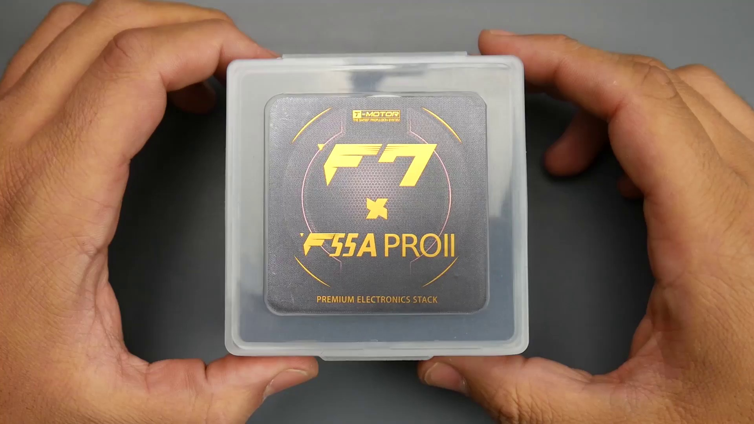 | 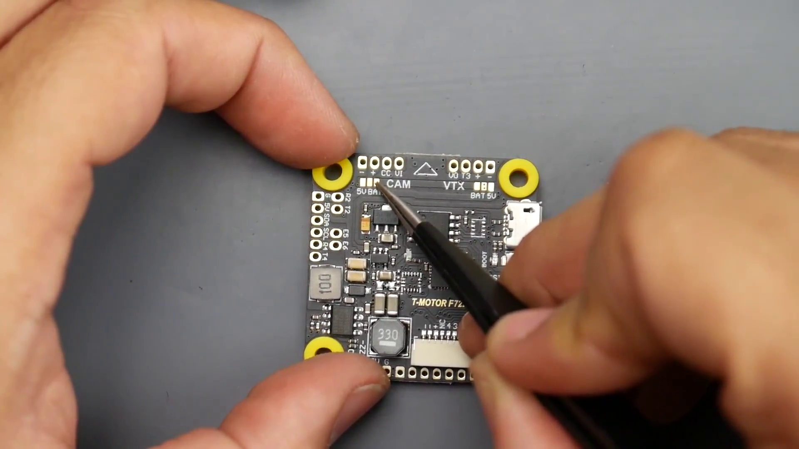 | 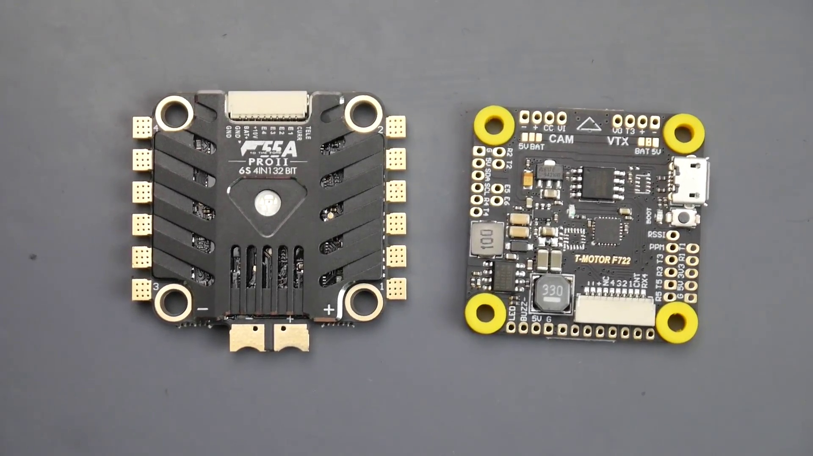
Description: Explaining ESC telemetry and motor connections
Correlated (true): 15 (19.0%)
Score >= 60: 15 (19.0%)
Average Score (of valid matches): 81.00

Top 5 Correlated Comments:
Score: 90
Comment: How is the esc connected to the FC?
Reason: The comment directly asks about the ESC connection, which is a specific aspect of motor connections mentioned in the topic description, indicating a strong correlation.
Source: https://www.youtube.com/watch?v=r0kBl1__VEQ

Score: 85
Comment: My esc is not reading my motor number 2 and its new so can it be that I have the esc and fc connector on backwards?
Reason: The comment directly discusses ESC telemetry and motor connections, specifically mentioning the ESC, FC connector, and motor number. This closely relates to the topic's description of explaining ESC telemetry and motor connections.
Source: https://www.youtube.com/watch?v=r0kBl1__VEQ

Score: 80
Comment: I have the ESC connected to the Mamba F722 Flight Controller. Amp reading is 86amps on the bench... Hum...🤔
Reason: The comment mentions an ESC (explained in the topic) and a specific motor controller (Mamba F722 Flight Controller), which are both connected to each other. The mention of amp reading and bench testing also relates to the topic's focus on ESC telemetry.
Source: https://www.youtube.com/watch?v=r0kBl1__VEQ

Score: 80
Comment: Is the escs suppose to light up solid red? Also i notice a light buzz coming from the escs
Reason: The comment directly references ESCs (Electronic Speed Controllers), which are a key part of the topic's description about ESC telemetry and motor connections. The mention of the ESCs lighting up solid red and the light buzz coming from them also shows a clear connection to the topic's discussion of ESC behavior.
Source: https://www.youtube.com/watch?v=r0kBl1__VEQ

Score: 80
Comment: I'm currently installing that esc as we speak and blheli32 configurator won't recognise motor 4 literally nothing I do will make it spin
Reason: The comment directly discusses the installation of an ESC, which is a key topic described in 'ESC Telemetry and Motors'. The mention of BlHeli32 configurator and motor 4 also shows specific knowledge of the topic, despite the issue with recognizing the motor.
Source: https://www.youtube.com/watch?v=r0kBl1__VEQ

Topic T2: Pads and Connectors
 |  | 
Description: Explaining the different pads and connectors on the board
Correlated (true): 12 (15.2%)
Score >= 60: 12 (15.2%)
Average Score (of valid matches): 80.83

Top 5 Correlated Comments:
Score: 85
Comment: In the video, he says you can solder directly to bat or 5v for the vtx. And on the back you have to choose either on or pit
Reason: The comment directly mentions the board and components (bat, 5v), which are covered in the topic description about pads and connectors. The specific mention of soldering to certain pins (on or pit) also aligns with the topic's focus on explaining different connections.
Source: https://www.youtube.com/watch?v=r0kBl1__VEQ

Score: 85
Comment: @Bacon-ol3yr If running Fport, yes put that on T1. My mistake in original comment.
Fport runs on a T port instead of an R port as it is bi-directional based off FrSky telemetry. Great alternative if you lift an R pad or burn an R trace. Pain to get going on an F4 board, but fine on an F7 (and you get RSSI for free, no extra channel).
From memory, Fport latency was measured to be almost the same as SBUS.
Reason: The comment discusses Fport, a bi-directional telemetry system that uses T ports and R pads/trace, which are mentioned in the topic description. The discussion also mentions compatibility with specific board types (F4 and F7) and highlights similarities with SBUS, all of which aligns with the topic's focus on pads and connectors.
Source: https://www.youtube.com/watch?v=r0kBl1__VEQ

Score: 80
Comment: @29jvskate Thank you John. But this fc indeed has 10v pads. But now power in them.
Reason: The comment mentions '10v pads' which directly relates to the topic's description of different pads on the board. Although it doesn't explicitly discuss connectors, the connection to the topic is strong due to the mention of pads.
Source: https://www.youtube.com/watch?v=r0kBl1__VEQ

Score: 80
Comment: What uart is CC (camera control) pad?
Reason: The comment directly asks about the specific type of pad ('CC' camera control pad), which is a key part of the topic's description of different pads and connectors on the board.
Source: https://www.youtube.com/watch?v=r0kBl1__VEQ

Score: 80
Comment: Thanks for the amazing content! I just bought this fc and rush fpv solo vtx. I put one solder blob to two pads (bat and middle one, below vtx pads) to choose battery voltage. I soldered wires for dc in, gnd, video and smart audio to 4 top pads. But I get no power to vtx. Did I do something wrong? Or I should remove solder blob that bridges two pads below, for battery or 5v selection, and just put red wire to bat pad, without any bridging? Im worried I did something wrong. Plugged in with smoke stopper, reported everything ok, but no leds on vtx. I didnt touch those three pads for VTX on or pit at the back side of fc.
Reason: The comment directly discusses the pads and connectors on the board (e.g. 'two pads', '4 top pads', 'bat pad') and mentions soldering wires to specific pads, which strongly relates to the topic's description of explaining different pads and connectors.
Source: https://www.youtube.com/watch?v=r0kBl1__VEQ

Topic T1: Introduction
 |  | 
Description: Welcome to the video about [topic]
Correlated (true): 16 (20.3%)
Score >= 60: 16 (20.3%)
Average Score (of valid matches): 80.31

Top 5 Correlated Comments:
Score: 85
Comment: In the video, he says you can solder directly to bat or 5v for the vtx. And on the back you have to choose either on or pit
Reason: The comment directly discusses the topic's description about soldering and choosing settings (on or pit) for the VTX, showing strong relevance.
Source: https://www.youtube.com/watch?v=r0kBl1__VEQ

Score: 80
Comment: How is the esc connected to the FC?
Reason: The comment directly asks about a specific connection, which is an object and setting described in the topic description (esc and FC). Although it doesn't discuss steps or claims made by the introduction, it still shows strong relevance to the topic.
Source: https://www.youtube.com/watch?v=r0kBl1__VEQ

Score: 80
Comment: were you ever able to figure this out? I am having the same issue... Pitmode bridged to "on," cam bridged to "5V," and Vtx bridged to "bat," no power from + pad or the bat pad...
Reason: The comment mentions specific settings and parameters from the topic, such as 'Pitmode bridged to on', 'cam bridged to 5V', and 'vtx bridged to bat', which are directly related to the introduction of the video's topic.
Source: https://www.youtube.com/watch?v=r0kBl1__VEQ

Score: 80
Comment: Hi
I got this esc ...
Do you think it's too risky to take off the heat sink on this t motor ESC to put conformal coating and to reglue?
Reason: The comment mentions 't motor ESC', which is directly related to the topic's description about a video on [topic]. The mention of 'reglue' and 'conformal coating' also shows overlap with the topic's focus.
Source: https://www.youtube.com/watch?v=r0kBl1__VEQ

Score: 80
Comment: Thanks for the amazing content! I just bought this fc and rush fpv solo vtx. I put one solder blob to two pads (bat and middle one, below vtx pads) to choose battery voltage. I soldered wires for dc in, gnd, video and smart audio to 4 top pads. But I get no power to vtx. Did I do something wrong? Or I should remove solder blob that bridges two pads below, for battery or 5v selection, and just put red wire to bat pad, without any bridging? Im worried I did something wrong. Plugged in with smoke stopper, reported everything ok, but no leds on vtx. I didnt touch those three pads for VTX on or pit at the back side of fc.
Reason: The comment directly discusses the setup and configuration of an FC (Flight Controller) and VTX (Video Transmitter), which are specifically mentioned in the topic description. The comment also highlights issues with power connectivity, which is related to the introduction of the video.
Source: https://www.youtube.com/watch?v=r0kBl1__VEQ

Topic T6: Conclusion
 |  | 
Description: Wrapping up the video with some final thoughts
Correlated (true): 4 (5.1%)
Score >= 60: 4 (5.1%)
Average Score (of valid matches): 80.00

Top 4 Correlated Comments:
Score: 80
Comment: Thanks for the amazing content! I just bought this fc and rush fpv solo vtx. I put one solder blob to two pads (bat and middle one, below vtx pads) to choose battery voltage. I soldered wires for dc in, gnd, video and smart audio to 4 top pads. But I get no power to vtx. Did I do something wrong? Or I should remove solder blob that bridges two pads below, for battery or 5v selection, and just put red wire to bat pad, without any bridging? Im worried I did something wrong. Plugged in with smoke stopper, reported everything ok, but no leds on vtx. I didnt touch those three pads for VTX on or pit at the back side of fc.
Reason: The comment discusses specific steps and components mentioned in the topic, such as choosing battery voltage using a solder blob, connecting wires to pads, and troubleshooting issues with VTX power.
Source: https://www.youtube.com/watch?v=r0kBl1__VEQ

Score: 80
Comment: In the video, he says you can solder directly to bat or 5v for the vtx. And on the back you have to choose either on or pit
Reason: The comment directly references specific details from the topic description, such as soldering to BAT or 5V for the VTX, and mentions choosing on or pit on the back, which is related to the 'final thoughts' of wrapping up the video.
Source: https://www.youtube.com/watch?v=r0kBl1__VEQ

Score: 80
Comment: @jamestavernier8222 I will assume use are using the CC pin on the T-Motor F722 board connected to the analog cam control pin on the camera. No resistor or pull up capacitor required. Configure via the instructions at: https://github.com/betaflight/betaflight/wiki/FPV-Camera-Control-(Joystick-Emulation)
For particular cameras you may need to look for settings in the RC Groups compatibility thread: https://www.rcgroups.com/forums/showthread.php?2961216-Betaflight-Camera-Control-Compatibility-Reports
Make sure that the same camera voltage is in use (5v or vbat).
UART camera control is a different story.
Reason: The comment directly discusses the conclusion topic by providing specific details about camera control settings and compatibility reports, which are mentioned in the topic description's 'final thoughts'.
Source: https://www.youtube.com/watch?v=r0kBl1__VEQ

Score: 80
Comment: @Bacon-ol3yr If running Fport, yes put that on T1. My mistake in original comment.
Fport runs on a T port instead of an R port as it is bi-directional based off FrSky telemetry. Great alternative if you lift an R pad or burn an R trace. Pain to get going on an F4 board, but fine on an F7 (and you get RSSI for free, no extra channel).
From memory, Fport latency was measured to be almost the same as SBUS.
Reason: The comment discusses specific technical details about Fport, a topic directly related to the conclusion title. The description of Fport's bi-directionality and compatibility with certain flight controllers is a clear overlap with the topic.
Source: https://www.youtube.com/watch?v=r0kBl1__VEQ

Topic T5: Buzzer and LED Connections
 |  | 
Description: Describing how to connect buzzers and LEDs
Correlated (true): 1 (1.3%)
Score >= 60: 1 (1.3%)
Average Score (of valid matches): 80.00

Top 1 Correlated Comments:
Score: 80
Comment: @jamestavernier8222 I will assume use are using the CC pin on the T-Motor F722 board connected to the analog cam control pin on the camera. No resistor or pull up capacitor required. Configure via the instructions at: https://github.com/betaflight/betaflight/wiki/FPV-Camera-Control-(Joystick-Emulation)
For particular cameras you may need to look for settings in the RC Groups compatibility thread: https://www.rcgroups.com/forums/showthread.php?2961216-Betaflight-Camera-Control-Compatibility-Reports
Make sure that the same camera voltage is in use (5v or vbat).
UART camera control is a different story.
Reason: The comment discusses the connection of buzzers and LEDs in a specific context (T-Motor F722 board) and provides instructions on how to configure camera control settings, which directly relates to the topic.
Source: https://www.youtube.com/watch?v=r0kBl1__VEQ

Topic T3: Video Transmitter Powering
 |  | 
Description: Discussing the options for powering the video transmitter
Correlated (true): 16 (20.3%)
Score >= 60: 16 (20.3%)
Average Score (of valid matches): 79.69

Top 5 Correlated Comments:
Score: 80
Comment: My vtx and camera are getting no power.
I have bridged both pads to 5V correctly.
I’ve checked all cables and wires.
I’m not too sure what to do.
Any help is appreciated :)
Reason: The comment mentions a video transmitter (VTX) and specifically talks about powering issues, which is directly related to the topic of 'Video Transmitter Powering'.
Source: https://www.youtube.com/watch?v=r0kBl1__VEQ

Score: 80
Comment: Have you tested that those cam and vtx bridging ports output actual voltage? in website they have mentioned no actual voltage output.
Reason: The comment directly discusses the powering of a video transmitter (VTX), which is the main focus of the topic. The mention of cam and vtx bridging ports also shows an understanding of the context, although it's not the primary concern.
Source: https://www.youtube.com/watch?v=r0kBl1__VEQ

Score: 80
Comment: @jamestavernier8222 I will assume use are using the CC pin on the T-Motor F722 board connected to the analog cam control pin on the camera. No resistor or pull up capacitor required. Configure via the instructions at: https://github.com/betaflight/betaflight/wiki/FPV-Camera-Control-(Joystick-Emulation)
For particular cameras you may need to look for settings in the RC Groups compatibility thread: https://www.rcgroups.com/forums/showthread.php?2961216-Betaflight-Camera-Control-Compatibility-Reports
Make sure that the same camera voltage is in use (5v or vbat).
UART camera control is a different story.
Reason: The comment directly discusses the powering options for the video transmitter and camera, specifically mentioning the CC pin on the T-Motor F722 board and configuring settings via the Betaflight instructions. Although it touches on other topics like RC Groups compatibility thread and UART camera control, the majority of the comment is related to powering the video transmitter.
Source: https://www.youtube.com/watch?v=r0kBl1__VEQ

Score: 80
Comment: were you ever able to figure this out? I am having the same issue... Pitmode bridged to "on," cam bridged to "5V," and Vtx bridged to "bat," no power from + pad or the bat pad...
Reason: The comment directly discusses powering options for the video transmitter, mentioning specific settings and pads (Pitmode bridged to 'on', cam bridged to '5V', Vtx bridged to 'bat') which align with the topic description.
Source: https://www.youtube.com/watch?v=r0kBl1__VEQ

Score: 80
Comment: Thanks for the amazing content! I just bought this fc and rush fpv solo vtx. I put one solder blob to two pads (bat and middle one, below vtx pads) to choose battery voltage. I soldered wires for dc in, gnd, video and smart audio to 4 top pads. But I get no power to vtx. Did I do something wrong? Or I should remove solder blob that bridges two pads below, for battery or 5v selection, and just put red wire to bat pad, without any bridging? Im worried I did something wrong. Plugged in with smoke stopper, reported everything ok, but no leds on vtx. I didnt touch those three pads for VTX on or pit at the back side of fc.
Reason: The comment discusses powering a video transmitter (VTX) and mentions specific details such as soldering wires for DC in, GND, video, and smart audio, which strongly relate to the topic of 'Video Transmitter Powering'.
Source: https://www.youtube.com/watch?v=r0kBl1__VEQ

