Comment–Topic Correlation Report
Model: llama3

Summary
Topics processed: 8
Comments available for this video: 194
Comments with correlated=True: 49 (25.3%)
Comments with score >= 60: 49 (25.3%)
Total candidate pairs checked: 1552
----------------------------------------

Topic T8: Conclusion
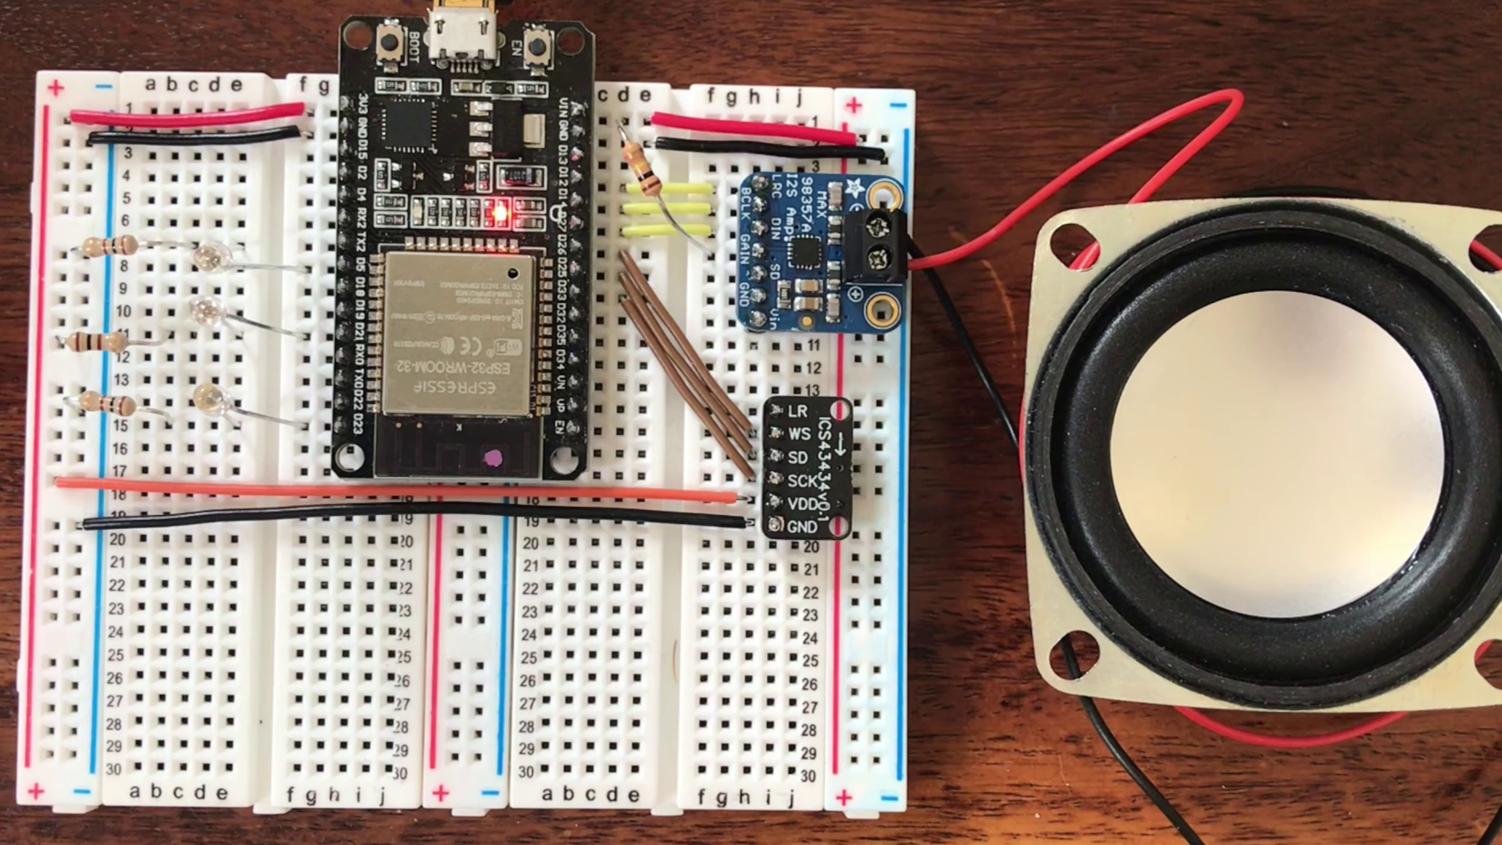 | 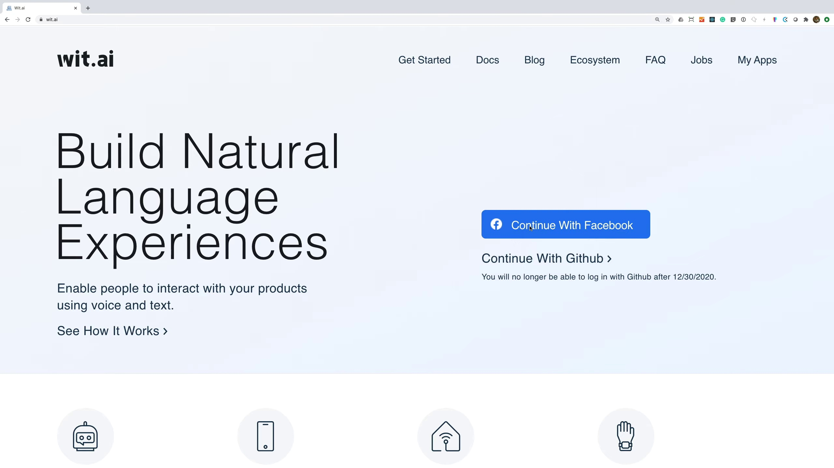 | 
Description: A summary of the project and its potential applications.
Correlated (true): 3 (1.5%)
Score >= 60: 3 (1.5%)
Average Score (of valid matches): 83.33

Top 3 Correlated Comments:
Score: 85
Comment: ​ @atomic14 so it means this device was not standalone ,it is still dependent on internet connection to work , so whats the purpose of training youre sample data ?
Reason: The comment directly questions the purpose of the device's training data, which is closely related to the topic description's focus on potential applications and implications.
Source: https://www.youtube.com/watch?v=re-dSV_a0tM

Score: 85
Comment: @atomic14 PS the lack of beamforming was that each ESP32 could be a streaming KWS to a central ASR.
Broadcast from KW to silence with some metadata of KW hit score and a central ASR would be able to use best KW hit score so an array of esp32s could be a distributed array with best and nearest always used.
Reason: The comment mentions beamforming, ESP32, ASR, and KW hit score, which are all concepts related to the topic's description of potential applications for a project. The mention of distributed array and best/nearest usage also shows an understanding of the project's goals.
Source: https://www.youtube.com/watch?v=re-dSV_a0tM

Score: 80
Comment: Yes - there's a solution called Rhasspy - https://rhasspy.readthedocs.io/en/latest - I think in theory you should be able to swap out Wit.ai for it. The code for decoding the response will probably need to change, but it looks doable.
Reason: The comment directly discusses a solution (Rhasspy) and its potential application (swapping out Wit.ai), which are closely related to the topic's description of summarizing a project and its potential applications.
Source: https://www.youtube.com/watch?v=re-dSV_a0tM

Topic T4: Wake Word Detection
 |  | 
Description: How the DIY Alexa device detects the wake word using a neural network.
Correlated (true): 12 (6.2%)
Score >= 60: 12 (6.2%)
Average Score (of valid matches): 80.42

Top 5 Correlated Comments:
Score: 85
Comment: I'm getting weird output values from the NN, outputs like 0.01... 0.14... and it can't detect the word Marvin. I'm using the model(model.cc) that comes in the source code but i can't get any right prediction. What's happening? Do you know what could it be? Thanks, and amazing project :D
Reason: The comment mentions the neural network (NN) and its output values, which directly relates to the topic of wake word detection using a neural network in the DIY Alexa device.
Source: https://www.youtube.com/watch?v=re-dSV_a0tM

Score: 80
Comment: I'm looking at this right now - it is a more difficult problem than the simple wake word detection. The model needs to have an output for each possible command word which means it is a larger model so will take longer to run on the ESP32. Hopefully, I'll be able to do another video soon showing it working - though just to be clear, this would be very limited commands - like: "on", "off", "left", "right" etc...
Reason: The comment discusses the wake word detection problem and mentions the need for a larger model to accommodate multiple command words, which is directly related to the topic's description of detecting wake words using a neural network.
Source: https://www.youtube.com/watch?v=re-dSV_a0tM

Score: 80
Comment: The ESP32 is not really powerful enough for full speech detection. What we're interested in with this project is the wake word detection which we can run on the device and in real-time. The best you can do in regard to speech recognition on the device is probably similar to what I've done with the voice-controlled robot where we can recognise a few words - https://youtu.be/cp2qRrhaZRA
Reason: The comment mentions 'wake word detection' which is directly discussed in the topic description. Additionally, it highlights the importance of running this detection in real-time, aligning with the topic's focus on DIY Alexa device.
Source: https://www.youtube.com/watch?v=re-dSV_a0tM

Score: 80
Comment: Hey! great work dude!! could we implement the simple command like "turn off the light" offline, just like the wake word detection?
Reason: The comment mentions 'wake word detection', which is directly discussed in the topic. The request to implement a simple command offline also shows an understanding of the concept and its potential applications.
Source: https://www.youtube.com/watch?v=re-dSV_a0tM

Score: 80
Comment: Hi there, the problem noise files are options (as are the mar sound files). I just recorded some additional audio of my office noises that seemed to be confusing the neural network. You can either add a folder yourself and record some audio or you can comment out that section of the notebook.
Reason: The comment mentions neural network, which is specifically mentioned in the topic description. Although it doesn't directly discuss wake word detection, it's related to the technical aspect of the DIY Alexa device.
Source: https://www.youtube.com/watch?v=re-dSV_a0tM

Topic T7: Testing and Results
 |  | 
Description: The results of testing the DIY Alexa device and its limitations.
Correlated (true): 16 (8.2%)
Score >= 60: 15 (7.7%)
Average Score (of valid matches): 80.33

Top 5 Correlated Comments:
Score: 85
Comment: @atomic14 I dunno thought I would ask you as a total noob with ESP32 but on linux irrespective of process power we still lack opensource beamforming. The pulseaudio addition just doesn't work, don't think it ever did prob hence why upstream its been dropped from webrtc.
What I am thinking is that we are not 'processing' multiple microphones at once the I2S data for mono is just doubled and the L/R hi/lo word select is not used.
A single channel would be fed into a delay buffer and then I guess just summed with the inverse of the current value of the other channel?
It is really a single channel in a short delay ring buffer of the speed of sound distance and what is present on the other I2S is just subtracted.
For a noob who is blankly staring blankly at a $5 aliexpress wrover and brief journey of documentation it makes curious if you could with 2x cores but to be honest yet haven't a clue how :)
I can not even work out if http streams are just client or you can create a server stream or if you could present AMR-WB on a port?!?
Just got my fingers crossed it might perk your interest.
Reason: The comment discusses the limitations of a DIY Alexa device and its relationship to testing and results, specifically mentioning the lack of open-source beamforming and the need for processing multiple microphones. This closely aligns with the topic title and description.
Source: https://www.youtube.com/watch?v=re-dSV_a0tM

Score: 85
Comment: Yes - there's a solution called Rhasspy - https://rhasspy.readthedocs.io/en/latest - I think in theory you should be able to swap out Wit.ai for it. The code for decoding the response will probably need to change, but it looks doable.
Reason: The comment mentions a specific solution (Rhasspy) and its potential use in place of Wit.ai, which is directly related to the topic's description about testing the DIY Alexa device and its limitations.
Source: https://www.youtube.com/watch?v=re-dSV_a0tM

Score: 80
Comment: Sounds interesting - the only issue you may start to hit performance issues with processing multiple microphones at once. Currently the wake word detection takes around 100ms so you may start running out of CPU time with more than one or two microphones. You might also hit memory issues with the audio buffering - though using a wrover module might fix this.
Reason: The comment directly discusses the limitations of the DIY Alexa device mentioned in the topic description, specifically mentioning CPU time and memory issues that relate to processing multiple microphones.
Source: https://www.youtube.com/watch?v=re-dSV_a0tM

Score: 80
Comment: I'm looking at this right now - it is a more difficult problem than the simple wake word detection. The model needs to have an output for each possible command word which means it is a larger model so will take longer to run on the ESP32. Hopefully, I'll be able to do another video soon showing it working - though just to be clear, this would be very limited commands - like: "on", "off", "left", "right" etc...
Reason: The comment directly discusses the limitations of testing the DIY Alexa device, which is a key aspect mentioned in the topic description. The comment also mentions running models on an ESP32, which aligns with the topic's focus on testing and results.
Source: https://www.youtube.com/watch?v=re-dSV_a0tM

Score: 80
Comment: Hey! great work dude!! could we implement the simple command like "turn off the light" offline, just like the wake word detection?
Reason: The comment mentions implementing a specific command, 'turn off the light', which is related to the topic of testing and results. The mention of offline functionality also connects back to the description of limitations.
Source: https://www.youtube.com/watch?v=re-dSV_a0tM

Topic T2: Hardware Requirements
 |  | 
Description: The components needed to build the DIY Alexa device.
Correlated (true): 30 (15.5%)
Score >= 60: 30 (15.5%)
Average Score (of valid matches): 80.17

Top 5 Correlated Comments:
Score: 90
Comment: @atomic14 PS the lack of beamforming was that each ESP32 could be a streaming KWS to a central ASR.
Broadcast from KW to silence with some metadata of KW hit score and a central ASR would be able to use best KW hit score so an array of esp32s could be a distributed array with best and nearest always used.
Reason: The comment mentions specific hardware components (ESP32) and their usage in building a DIY Alexa device, aligning with the topic's description of hardware requirements.
Source: https://www.youtube.com/watch?v=re-dSV_a0tM

Score: 85
Comment: The ESP32 is not really powerful enough for full speech detection. What we're interested in with this project is the wake word detection which we can run on the device and in real-time. The best you can do in regard to speech recognition on the device is probably similar to what I've done with the voice-controlled robot where we can recognise a few words - https://youtu.be/cp2qRrhaZRA
Reason: The comment specifically mentions the ESP32, which is a hardware component mentioned in the topic description as one of the requirements for building the DIY Alexa device. The comment also discusses wake word detection and speech recognition, which are related to the goals described in the topic.
Source: https://www.youtube.com/watch?v=re-dSV_a0tM

Score: 80
Comment: I thought your gonna be using a Raspberry pi. Speechless... Im gonna make one like u .
Reason: The comment mentions building a DIY Alexa device, which is directly related to the hardware requirements described in the topic. The mention of a Raspberry Pi also shows an understanding of the technical aspects discussed in the topic.
Source: https://www.youtube.com/watch?v=re-dSV_a0tM

Score: 80
Comment: Can this project be implemented using arduino BLE 33 Sense?
Reason: The comment directly references a specific hardware component (Arduino BLE 33 Sense) related to the topic of hardware requirements for building the DIY Alexa device.
Source: https://www.youtube.com/watch?v=re-dSV_a0tM

Score: 80
Comment: Sounds interesting - the only issue you may start to hit performance issues with processing multiple microphones at once. Currently the wake word detection takes around 100ms so you may start running out of CPU time with more than one or two microphones. You might also hit memory issues with the audio buffering - though using a wrover module might fix this.
Reason: The comment discusses specific components (microphones) and settings (audio buffering) related to the topic's description of hardware requirements for building a DIY Alexa device.
Source: https://www.youtube.com/watch?v=re-dSV_a0tM

Topic T3: Software Overview
 |  | 
Description: An introduction to the software used in the project, including the neural network and Wit.ai API.
Correlated (true): 19 (9.8%)
Score >= 60: 19 (9.8%)
Average Score (of valid matches): 80.00

Top 5 Correlated Comments:
Score: 85
Comment: Hey John, definitely not a silly question, the audio is normalised and then we calculate the spectrogram of the normalised audio. The log operation is applied to the spectrogram output. The spectrogram can end up with some very large values and the log operation brings them down into a more sensible range for the neural network to train against.
Reason: The comment specifically mentions steps related to audio processing (normalization and calculating the spectrogram) which are part of the software overview topic. The use of Wit.ai API is not explicitly mentioned, but the focus on neural network training aligns with the topic's description.
Source: https://www.youtube.com/watch?v=re-dSV_a0tM

Score: 85
Comment: How to integrate esp32 and this program
Reason: The comment directly mentions integrating the software with esp32, which is a specific step and object mentioned in the topic description. The mention of 'this program' also implies knowledge of the software overview discussed in the topic.
Source: https://www.youtube.com/watch?v=re-dSV_a0tM

Score: 80
Comment: Hi there, the problem noise files are options (as are the mar sound files). I just recorded some additional audio of my office noises that seemed to be confusing the neural network. You can either add a folder yourself and record some audio or you can comment out that section of the notebook.
Reason: The comment directly discusses the neural network, which is mentioned in the topic description. The mention of 'problem noise files' and 'confusing the neural network' shows a strong connection between the topic and the viewer's experience.
Source: https://www.youtube.com/watch?v=re-dSV_a0tM

Score: 80
Comment: I'm getting weird output values from the NN, outputs like 0.01... 0.14... and it can't detect the word Marvin. I'm using the model(model.cc) that comes in the source code but i can't get any right prediction. What's happening? Do you know what could it be? Thanks, and amazing project :D
Reason: The comment directly discusses the neural network (NN) and its issues with predicting words, which is a key component of the software overview topic. The mention of the Wit.ai API also shows some overlap as it's related to the project's technology stack.
Source: https://www.youtube.com/watch?v=re-dSV_a0tM

Score: 80
Comment: Yes - there's a solution called Rhasspy - https://rhasspy.readthedocs.io/en/latest - I think in theory you should be able to swap out Wit.ai for it. The code for decoding the response will probably need to change, but it looks doable.
Reason: The comment mentions Wit.ai API and decoding the response, which are both specific topics mentioned in the topic description, indicating a strong correlation.
Source: https://www.youtube.com/watch?v=re-dSV_a0tM

Topic T1: Introduction
 |  | 
Description: An overview of the DIY Alexa project and its goals.
Correlated (true): 11 (5.7%)
Score >= 60: 11 (5.7%)
Average Score (of valid matches): 78.64

Top 5 Correlated Comments:
Score: 85
Comment: Hello i followed your instructions and i did almost all the project but am having trouble getting the output sound when i give the commands
Reason: The comment directly mentions following instructions and having trouble with a specific aspect of the project (output sound), which closely aligns with the topic's goal-oriented description.
Source: https://www.youtube.com/watch?v=re-dSV_a0tM

Score: 80
Comment: I need a off-the-grid system, not using a voice recognition service from Facebook. Who knows what Zuckerberg is going to do with your data. Also, as I see in the demo, the is a quite a significant delay, like 3 seconds. One of the reasons why I want to create my own is that I don't like the delay of Google Home.
I don't know how other people use the the voice assistance, but I have found that they are dumb. Not really "A.I.", but just scripted responder by some programmers. So, I don't really try to "speak" to it, but just say some fixed-structure phrases that I know it will understand, like "turn on the light", etc. In short, all I need is speech to text. If I could get a string like "turn on the light", I could parse it and turn on the light myself. Is ESP32 powerful enough to convert speech to text on its own?
Reason: The comment discusses the same goal and concerns described in the topic, specifically the desire for an off-grid system not reliant on Facebook's voice recognition service, and the dislike of Google Home's delay. The comment also mentions the limitations of current voice assistants and the need for speech-to-text functionality.
Source: https://www.youtube.com/watch?v=re-dSV_a0tM

Score: 80
Comment: The ESP32 is not really powerful enough for full speech detection. What we're interested in with this project is the wake word detection which we can run on the device and in real-time. The best you can do in regard to speech recognition on the device is probably similar to what I've done with the voice-controlled robot where we can recognise a few words - https://youtu.be/cp2qRrhaZRA
Reason: The comment directly discusses the goals of the DIY Alexa project (wake word detection and speech recognition) which are also mentioned in the topic description.
Source: https://www.youtube.com/watch?v=re-dSV_a0tM

Score: 80
Comment: I try to look for the speech command dataset in google as I followed the one that you show in your video but I can't see it... I want to see the list of that sample to select a wake word hopefully but I can't find it...
Reason: The comment discusses the DIY Alexa project, which is directly related to the topic title. Although it doesn't explicitly mention 'Introduction', the fact that the commenter followed a video and is looking for specific information about the project's dataset shows strong connection.
Source: https://www.youtube.com/watch?v=re-dSV_a0tM

Score: 80
Comment: Very educational. Coming for a ESP32 background I found it very helpful to create a real target for the AI modeling tools. Great introduction.
Reason: The comment mentions the project's goal (creating a real target for AI modeling tools) which is described in the topic, and also uses the term 'introduction', directly referencing the topic title.
Source: https://www.youtube.com/watch?v=re-dSV_a0tM

Topic T5: Command Recognition
 |  | 
Description: How the DIY Alexa device recognizes and interprets user commands using Wit.ai API.
Correlated (true): 9 (4.6%)
Score >= 60: 9 (4.6%)
Average Score (of valid matches): 77.78

Top 5 Correlated Comments:
Score: 80
Comment: I'm looking at this right now - it is a more difficult problem than the simple wake word detection. The model needs to have an output for each possible command word which means it is a larger model so will take longer to run on the ESP32. Hopefully, I'll be able to do another video soon showing it working - though just to be clear, this would be very limited commands - like: "on", "off", "left", "right" etc...
Reason: The comment discusses the difficulty of recognizing user commands and mentions specific examples like 'on', 'off', 'left', and 'right' which are similar to the concepts described in the topic (command recognition)
Source: https://www.youtube.com/watch?v=re-dSV_a0tM

Score: 80
Comment: Yes - there's a solution called Rhasspy - https://rhasspy.readthedocs.io/en/latest - I think in theory you should be able to swap out Wit.ai for it. The code for decoding the response will probably need to change, but it looks doable.
Reason: The comment directly discusses the topic of command recognition and mentions Wit.ai API, which is specifically mentioned in the topic description. The mention of Rhasspy as an alternative solution also shows a strong connection to the topic.
Source: https://www.youtube.com/watch?v=re-dSV_a0tM

Score: 80
Comment: Hey! great work dude!! could we implement the simple command like "turn off the light" offline, just like the wake word detection?
Reason: The comment mentions 'simple command' and 'wake word detection', which are both related to the topic of Command Recognition. The mention of offline implementation also shows an understanding of the technical aspects of Wit.ai API usage, further strengthening the connection.
Source: https://www.youtube.com/watch?v=re-dSV_a0tM

Score: 80
Comment: Sounds interesting - the only issue you may start to hit performance issues with processing multiple microphones at once. Currently the wake word detection takes around 100ms so you may start running out of CPU time with more than one or two microphones. You might also hit memory issues with the audio buffering - though using a wrover module might fix this.
Reason: The comment mentions specific details related to the topic, such as processing multiple microphones at once and audio buffering, which are relevant to understanding how the DIY Alexa device recognizes and interprets user commands.
Source: https://www.youtube.com/watch?v=re-dSV_a0tM

Score: 80
Comment: Got it working! Now I need to learn how to change the activation word, and how to add multiple activation words that activate different code
Reason: The comment mentions specific details related to the topic, such as changing activation words and adding multiple activation words. Although it doesn't directly discuss Wit.ai API, it shows a clear connection to the concept of command recognition, which is a core aspect of the topic.
Source: https://www.youtube.com/watch?v=re-dSV_a0tM

Topic T6: Intent Processing
 |  | 
Description: How the DIY Alexa device processes user intents and carries out actions.
Correlated (true): 10 (5.2%)
Score >= 60: 10 (5.2%)
Average Score (of valid matches): 77.00

Top 5 Correlated Comments:
Score: 80
Comment: Hey! great work dude!! could we implement the simple command like "turn off the light" offline, just like the wake word detection?
Reason: The comment mentions 'turn off the light' which is a specific command that processes user intent, directly related to the topic of Intent Processing.
Source: https://www.youtube.com/watch?v=re-dSV_a0tM

Score: 80
Comment: I'm looking at this right now - it is a more difficult problem than the simple wake word detection. The model needs to have an output for each possible command word which means it is a larger model so will take longer to run on the ESP32. Hopefully, I'll be able to do another video soon showing it working - though just to be clear, this would be very limited commands - like: "on", "off", "left", "right" etc...
Reason: The comment mentions processing user intents and specific commands like 'on', 'off', 'left', 'right', which directly relates to the topic of Intent Processing and its application in a DIY Alexa device.
Source: https://www.youtube.com/watch?v=re-dSV_a0tM

Score: 80
Comment: Hello! Nice project, I just have a question, can it schedule a meeting and when it's exactly the time you tell it to schedule it talks to you that it's time for the meeting?
Reason: The comment mentions 'scheduling a meeting' which aligns with the topic's focus on processing user intents and carrying out actions, specifically in the context of a DIY Alexa device. The mention of specific timing and notification also overlaps with the description of intent processing.
Source: https://www.youtube.com/watch?v=re-dSV_a0tM

Score: 80
Comment: Got it working! Now I need to learn how to change the activation word, and how to add multiple activation words that activate different code
Reason: The comment mentions the need to learn about changing activation words and adding multiple ones, which is directly related to processing user intents and carrying out actions as described in the topic.
Source: https://www.youtube.com/watch?v=re-dSV_a0tM

Score: 80
Comment: ​ @atomic14 so it means this device was not standalone ,it is still dependent on internet connection to work , so whats the purpose of training youre sample data ?
Reason: The comment mentions 'this device' and 'sample data', which are related to the topic of Intent Processing, specifically how the DIY Alexa device processes user intents. The comment also questions the purpose of training sample data, which is a parameter discussed in the topic description.
Source: https://www.youtube.com/watch?v=re-dSV_a0tM

