Comment–Topic Correlation Report
Model: llama3

Summary
Topics processed: 1
Comments available for this video: 365
Comments with correlated=True: 0 (0.0%)
Comments with score >= 60: 0 (0.0%)
Total candidate pairs checked: 200
----------------------------------------

Topic T1: Greetings
 | 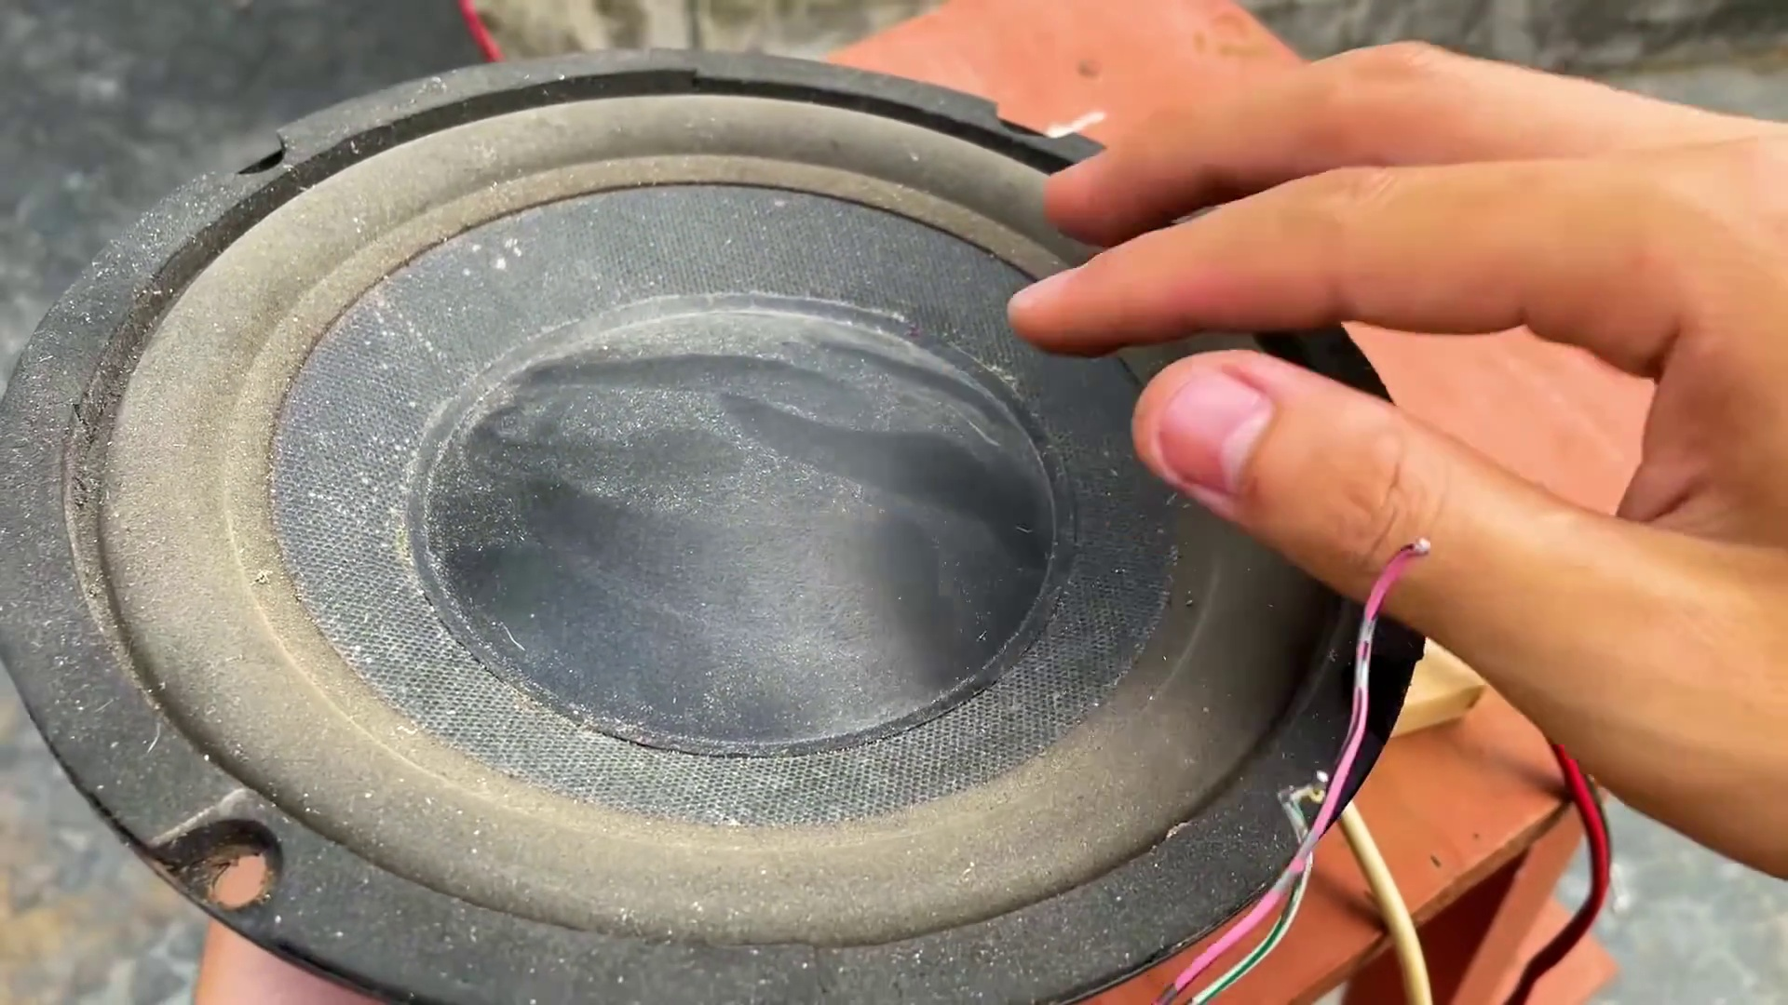 | 
Description: The speaker greets the audience multiple times.
Correlated (true): 0 (0.0%)
Score >= 60: 0 (0.0%)
Average Score (of valid matches): 0.00
No strongly correlated comments found.

