Comment–Topic Correlation Report
Model: llama3

Summary
Topics processed: 2
Comments available for this video: 290
Comments with correlated=True: 28 (9.7%)
Comments with score >= 60: 28 (9.7%)
Total candidate pairs checked: 400
----------------------------------------

Topic T1: PID Tuning
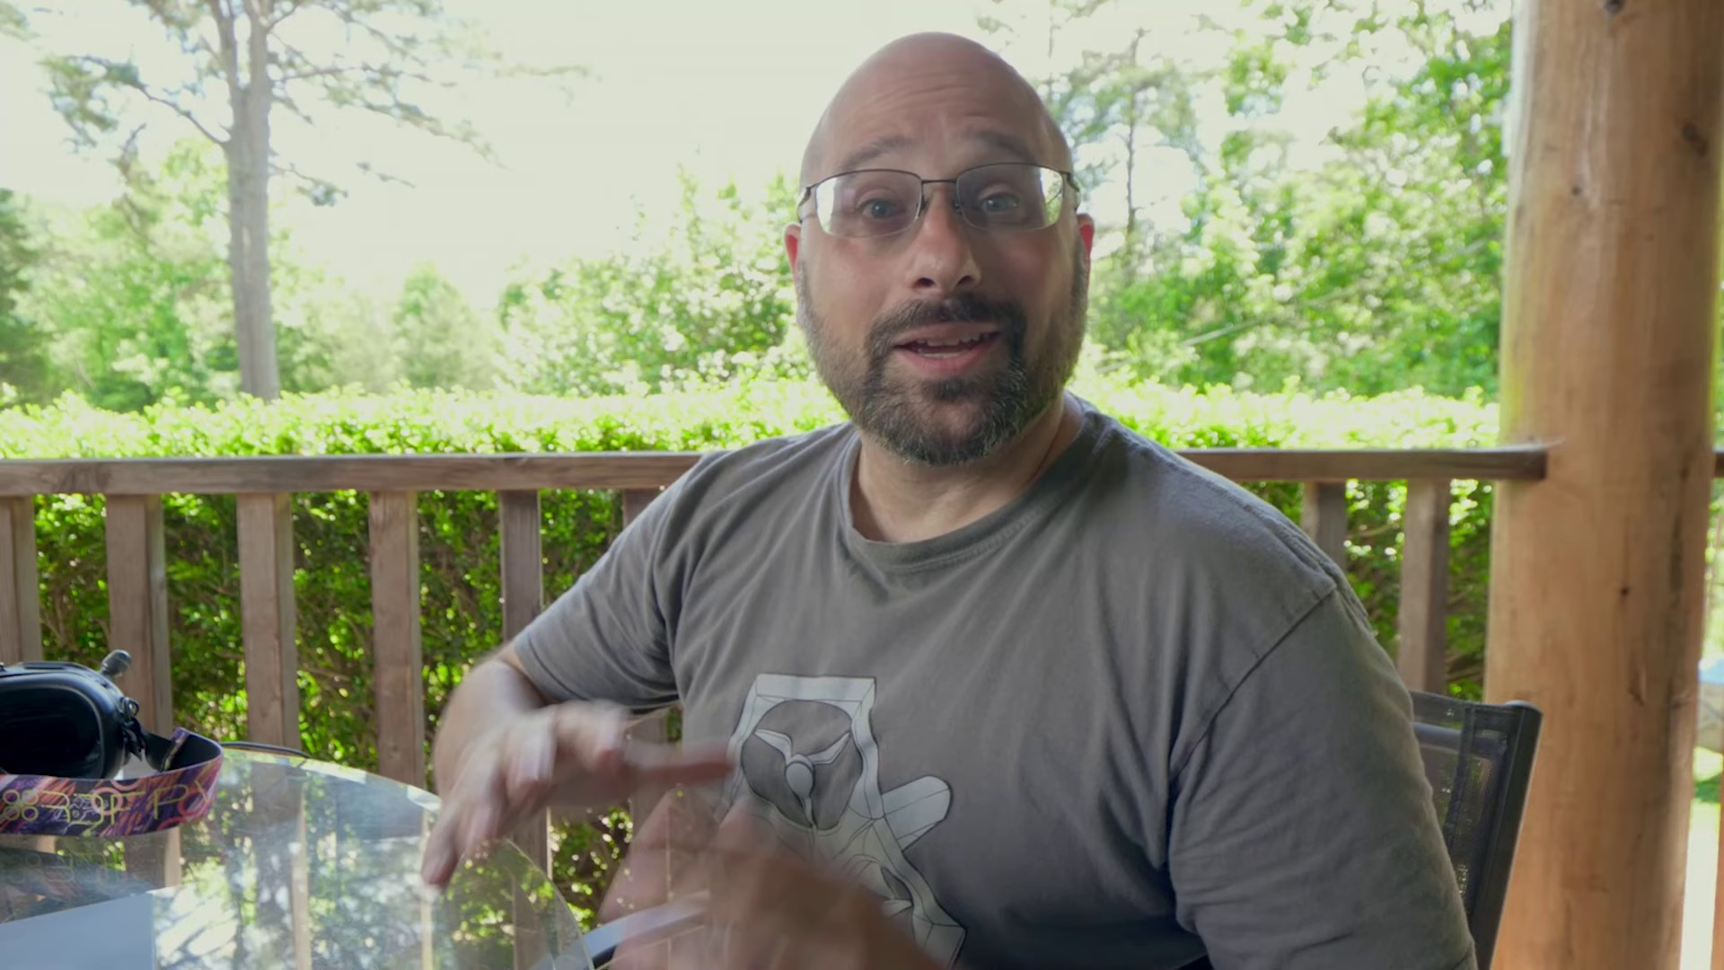 | 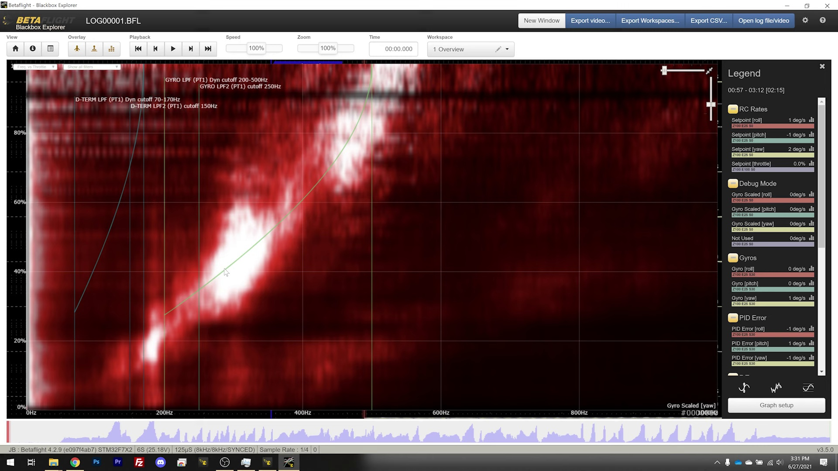 | 
Description: We're going to take that down to 1.4, and we're going to see how we do.
Correlated (true): 25 (8.6%)
Score >= 60: 25 (8.6%)
Average Score (of valid matches): 81.20

Top 5 Correlated Comments:
Score: 90
Comment: AFAIK, lifting pidsum limit is only necessary if your pidsum traces bottom-out in the tuning flight logs. Does this maybe give some overhead to help prevent motor saturation? I seem to remember reading an old PR that had some og devs commenting on the importance of this. EDIT: checked my logs and I am reaching default pidsum limit on snap flips and rolls on my final tune (before I pushed up the master it was fine though). SO I'm gonna retune with these cli commands entered.
Reason: The comment directly discusses PID tuning, mentioning specific parameters (pidsum limit) and its impact on motor saturation, which are all described in the topic. The comment also references logging data to validate the need for retuning, aligning with the topic's goal of reducing PID values.
Source: https://www.youtube.com/watch?v=s0dNRe0XWJ8

Score: 90
Comment: Joshua, you know people at DJI. Why don't you send them a link to these VIDs so that they can fix the GOD DAMN PID TUNING ON THE DJI FPV DRONE. Sorry, this makes me a tad emotional. ;-)
Reason: The comment directly mentions PID Tuning, which is the same topic discussed in the title and description. The mention of DJI FPV drone also overlaps with the context described in the topic.
Source: https://www.youtube.com/watch?v=s0dNRe0XWJ8

Score: 90
Comment: Exact same method applies.
Reason: The comment directly references the same method (i.e. PID tuning) and goal (improving performance by reducing value to 1.4), which are central to the topic description.
Source: https://www.youtube.com/watch?v=s0dNRe0XWJ8

Score: 85
Comment: I really like this way of PID tuning, a lot of tutorials on pidtuning are basically "I feel I need to up/lower X based on how I feel the quad should move. Just avoid hot motors". Which in all honestly is pretty useless metric seeing as a viewer like myself can't feel the changes by watching a video, let alone have the feeling to change certain value without it being just a whole lot of blind trail and error. And at that point is such a tutorial really useful?
This data driven way of PID tuning is quite useful as you remove most of the guess work and don't need to base it on feeling alone.
Reason: The comment directly discusses PID tuning and the importance of a data-driven approach, specifically mentioning the topic's description of adjusting values based on performance.
Source: https://www.youtube.com/watch?v=s0dNRe0XWJ8

Score: 85
Comment: 1
Reason: The comment mentions the specific PID tuning value (1.4) and its adjustment, which directly relates to the topic of PID tuning.
Source: https://www.youtube.com/watch?v=s0dNRe0XWJ8

Topic T2: Conclusion
 |  | 
Description: That's so good. Damn, son.
Correlated (true): 6 (2.1%)
Score >= 60: 6 (2.1%)
Average Score (of valid matches): 80.83

Top 5 Correlated Comments:
Score: 85
Comment: Joshua, you know people at DJI. Why don't you send them a link to these VIDs so that they can fix the GOD DAMN PID TUNING ON THE DJI FPV DRONE. Sorry, this makes me a tad emotional. ;-)
Reason: The comment directly mentions DJI FPV drone and its PID tuning, which is a specific setting or parameter mentioned in the topic description ('That's so good. Damn, son.').
Source: https://www.youtube.com/watch?v=s0dNRe0XWJ8

Score: 80
Comment: Exact same method applies.
Reason: The comment directly references the word 'method', which is mentioned in the topic description ('That's so good. Damn, son.'). Although the tone and language are different, the focus on a specific approach or technique is a strong overlap with the topic.
Source: https://www.youtube.com/watch?v=s0dNRe0XWJ8

Score: 80
Comment: I followed these steps on a GEPRC mark 4 prebuilt(They somehow give me a prebuilt quad with no factory tune). But then I keep frying the left front motor when i was tuning D term, the other three are just fine and cool. I sent it back to their shop for repair all they did was to replace the motor and put tune in, then the quad was flying fine. I recently find a lot of prop wash on it so I kind wanna follow these steps and retune it again, i find out they have crazy amount of filter in their factory tune and pit loop time of only 1.6khz. So I raised the loop fz to 3.2(they have slower gyro on this one),and reduced to the filter setting by the recommendation of this video. Immediately I fired the left front motor again with a 360 row, I really couldn't figure out why It seems to act nomarl but keep frying the left front motor the moment i try a flip.
Reason: The comment directly discusses the conclusion of following steps and retuning a drone to address motor issues, which aligns with the topic title 'Conclusion'.
Source: https://www.youtube.com/watch?v=s0dNRe0XWJ8

Score: 80
Comment: I followed his tutorials to tune my newest Betaflight build and my quad is flying amazingly well.
The stock settings in Betaflight just didn't work well at all for me, I was having those low throttle wobbles and instability after flips and rolls on stock, but after following his tutorials the quad flies amazing now.
Reason: The comment directly discusses the same steps (following tutorials) and goal (improving flight stability) described by the topic. The mention of Betaflight settings and quad flying well also aligns with the topic's tone.
Source: https://www.youtube.com/watch?v=s0dNRe0XWJ8

Score: 80
Comment: first off we love Joshuas videos and follow every word.So I heard you say tune on old props,my problem with that is if the props are worn or weighted differently from being worn or even knicked .It will make every prop different and screw up your tune.I get your reasoning but I believe you should start from perfection (as close as you can)as the props get old you will feel problems and know better when to replace.We would still be stuck on camera drones if it wasn't for Joshua.As it is we have about 20 succesful builds and many more prebuilts and we couldn't have done it without your help.My common sense says you might be wrong on this and since so many of us follow your every word please prove me wrong,lol Thank-you
Reason: The comment mentions 'Joshua's videos' and references tuning props, which is closely related to the topic title 'Conclusion'. Although it starts with praise for Joshua, the main point of the comment discusses the importance of starting from perfection when working with props, which overlaps with the topic description.
Source: https://www.youtube.com/watch?v=s0dNRe0XWJ8

