Comment–Topic Correlation Report
Model: llama3

Summary
Topics processed: 7
Comments available for this video: 630
Comments with correlated=True: 153 (24.3%)
Comments with score >= 60: 153 (24.3%)
Total candidate pairs checked: 1400
----------------------------------------

Topic T5: Tripping and Recovery
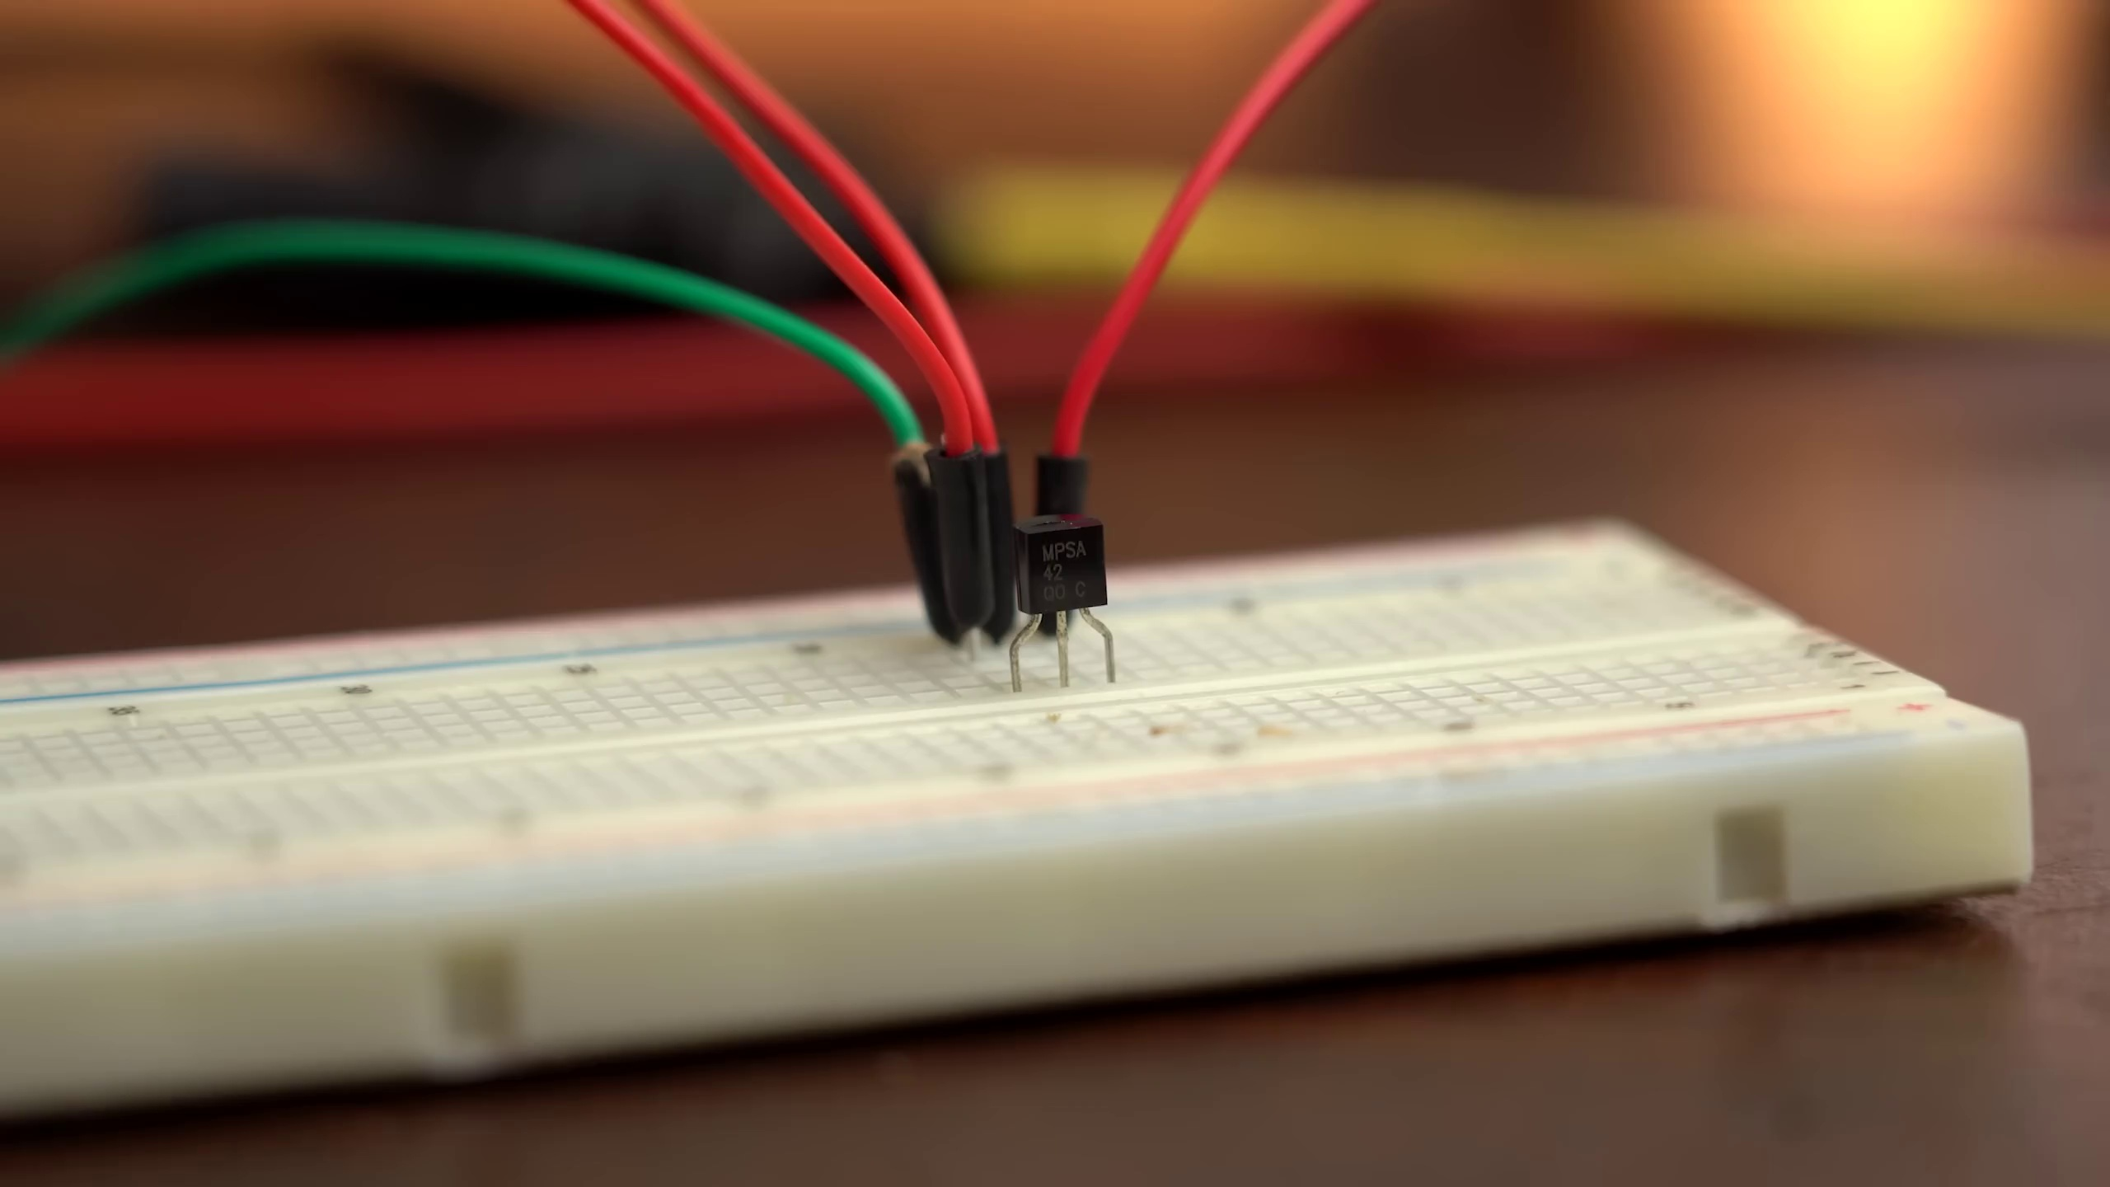 | 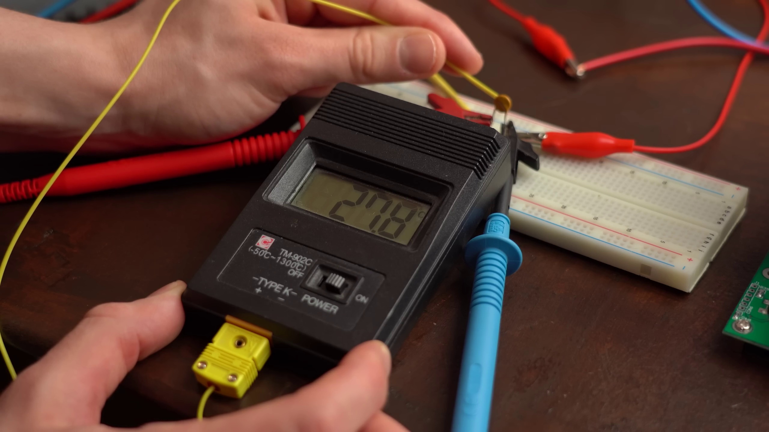 | 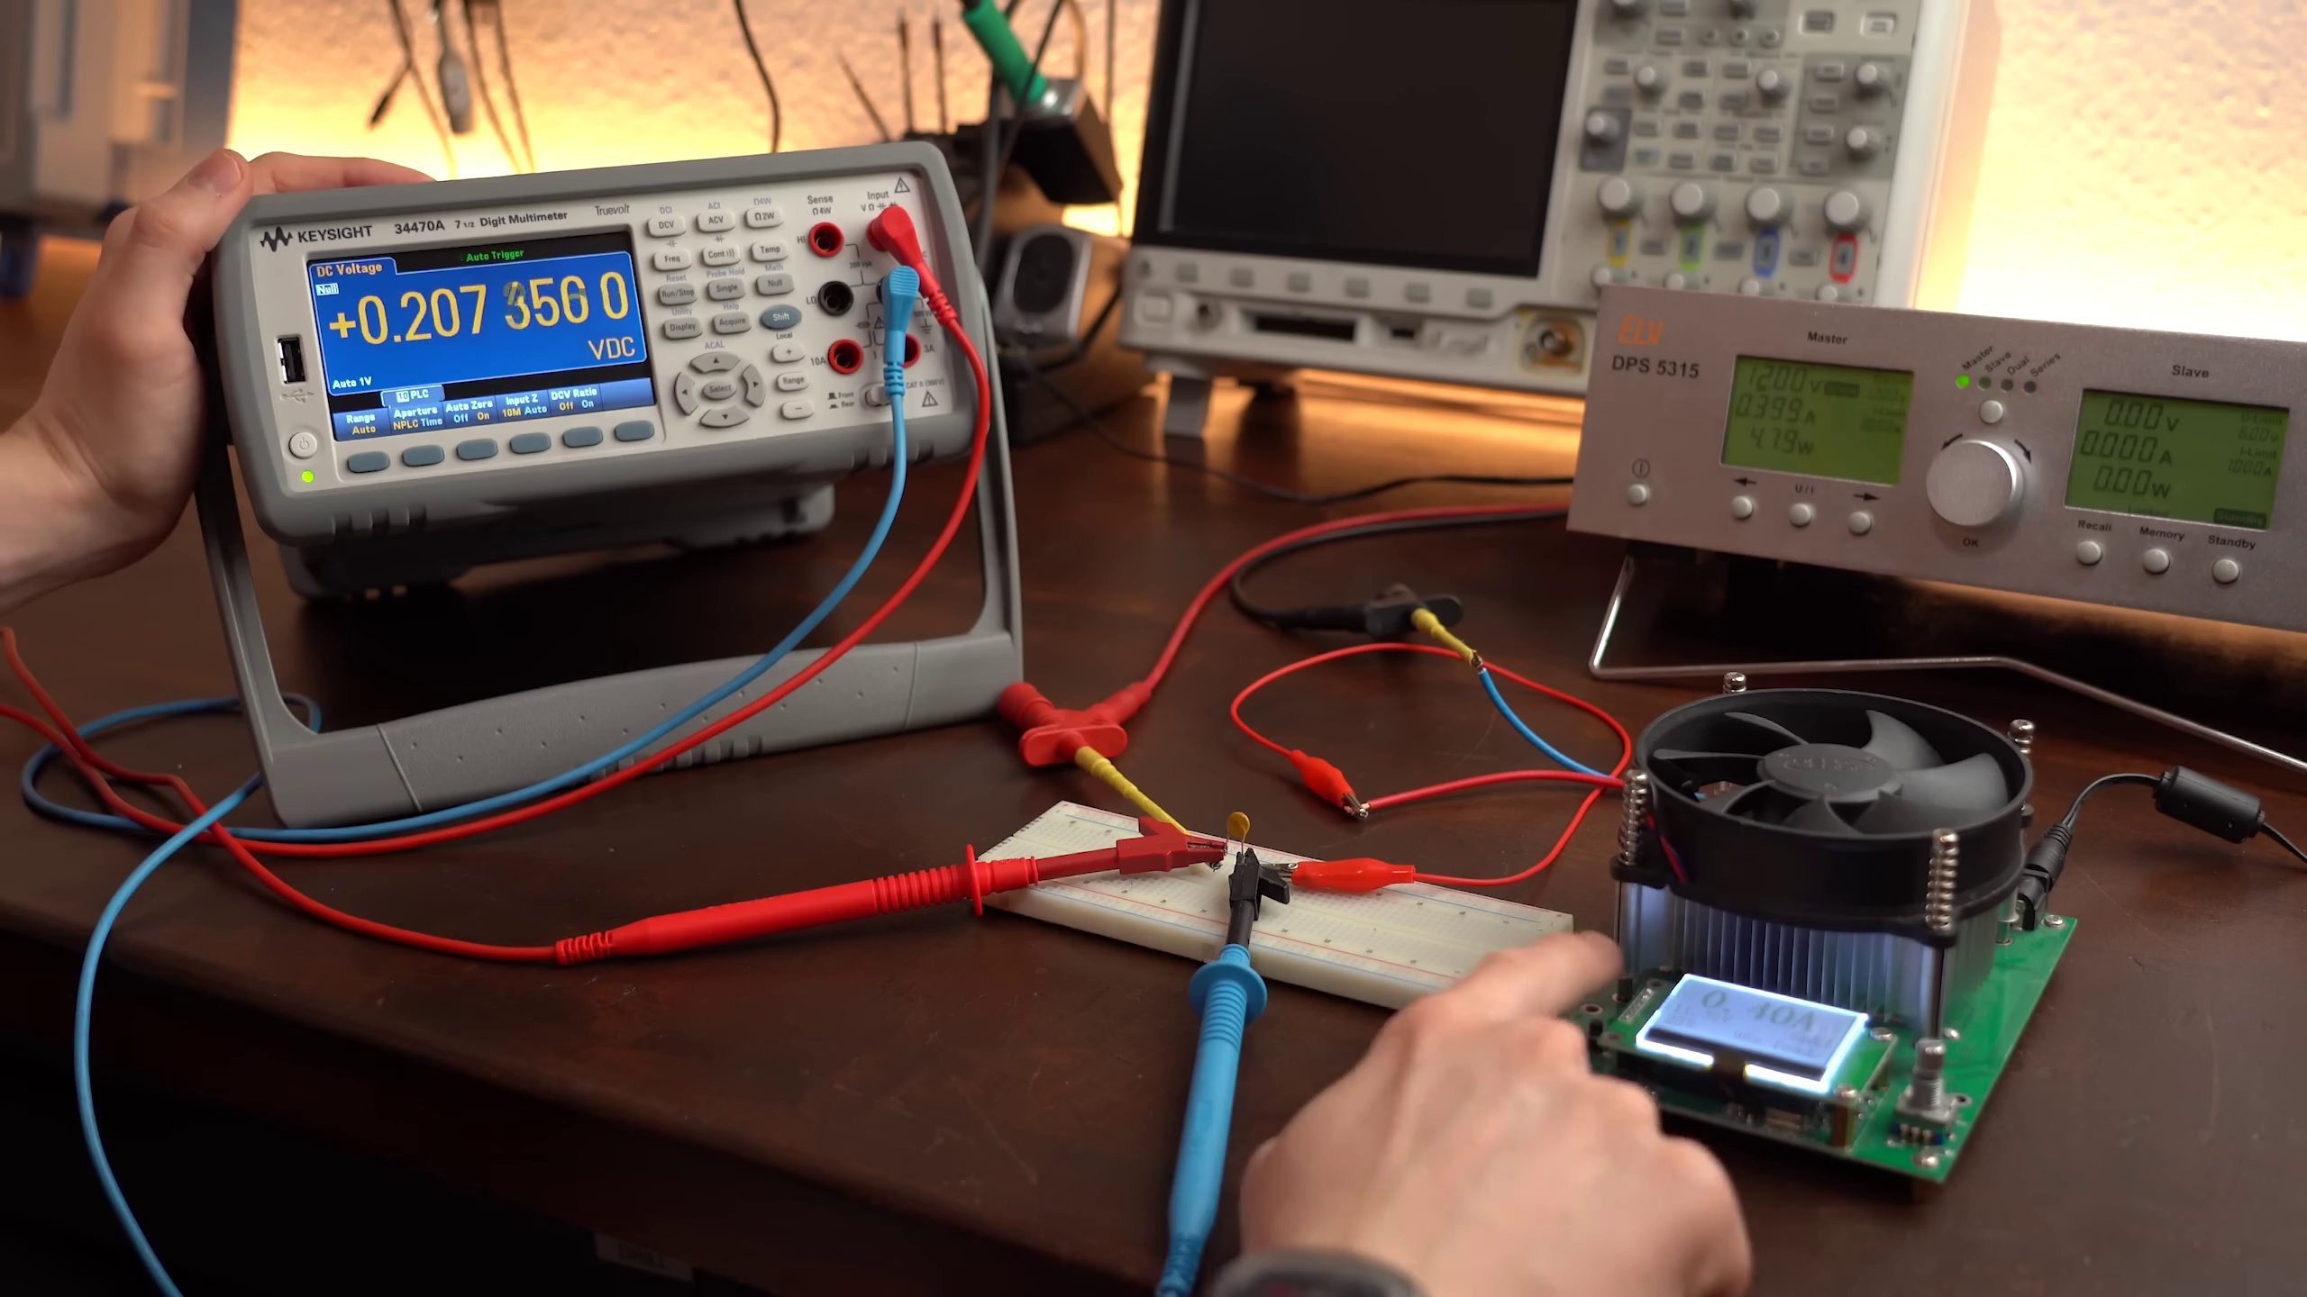
Description: Behavior when resettable fuses trip and recover.
Correlated (true): 64 (10.2%)
Score >= 60: 64 (10.2%)
Average Score (of valid matches): 80.39

Top 5 Correlated Comments:
Score: 90
Comment: But when the resetabble fuse trips it just limits current right? Becahse otherwise it would just cycle kn and off right?
Reason: The comment directly discusses the tripping of resettable fuses and its effect on current flow, which is a key aspect of the topic's description about behavior when they trip and recover.
Source: https://www.youtube.com/watch?v=sF0KOVWj9p8

Score: 90
Comment: @GreatScott! You are wrong about the tripping speed of normal fuses. If you take so called "very fast-acting" fuse, which is designed to trip fast - it trips in time of a few hundreds of milliseconds @ a double current. Used for very current sensitive circuits. So you had to mention the type of the glass fuse you were using. The other reason the world is not completely displaced the melting fuses with PPTCs is that they degrade over the number of times they trip. They are normally used in the environment when the overcurrent situation is rare. The other disadvantage of PPTC is that its resistance before and after it trips differs. It will never be the same again due to the material PPTC is made of. There is another type of fuse you haven't mentioned: the so called "TBU". This guy trips in about 100 nanoseconds time (the datasheet stated time is 1 uS, to stay on the safe side) and is fully resettable. But as it is the mosfet based device - it's very sensitive to the voltage.
Reason: The comment discusses the tripping and recovery of fuses, specifically mentioning different types (normal, fast-acting, PPTC) and their characteristics, such as tripping speed, degradation, and resetability. The topic's description about resettable fuses tripping and recovering is directly addressed in the comment.
Source: https://www.youtube.com/watch?v=sF0KOVWj9p8

Score: 90
Comment: If current instantly crosses rated Amp, will thermal fuse be blown just like normal glass fuse?
Reason: The comment directly discusses the tripping of a fuse, which is described in the topic. The mention of thermal fuses and normal glass fuses also shows a clear connection to the topic's description about resettable fuses.
Source: https://www.youtube.com/watch?v=sF0KOVWj9p8

Score: 90
Comment: My favorite technique is to use a resettable fuse followed by a transient-absorbing Zener such as a 1N6373 in parallel with the load. This not only protects from overvoltage but also protects against reverse voltage since the Zener would then be forward-biased instead of reverse-biased. I ran my own set of tests and melted the insulation on my power supply wires because the resettable fuse - transient Zener could handle more power than my power supply leads could. (The combo did get very hot though - space them away from your PWB!)
Reason: The comment discusses the same topic of resettable fuses tripping and recovering, mentioning specific details like using a transient-absorbing Zener (1N6373) in parallel with the load, which is closely related to the topic description.
Source: https://www.youtube.com/watch?v=sF0KOVWj9p8

Score: 85
Comment: You can get resetable car fuses that moves a leaver when blown an a led comes on to show you it's blown,then you just pull the leaver back to reset it
Reason: The comment directly discusses the same concept of a fuse tripping and recovering, specifically mentioning resettable car fuses and the process of resetting them. The mention of an LED indicator also overlaps with the topic's description of showing the blown state.
Source: https://www.youtube.com/watch?v=sF0KOVWj9p8

Topic T4: How Resettable Fuses Work
 |  | 
Description: Explanation of how PPTCs increase resistance with temperature.
Correlated (true): 85 (13.5%)
Score >= 60: 85 (13.5%)
Average Score (of valid matches): 80.06

Top 5 Correlated Comments:
Score: 90
Comment: 8:50 I think you need to consider the temperature derating curve of the device, since its now running at 95C not 23C. After all, it is a PTC, therefore the resistance increases with temperature and so P = R * I² increases as well.
Reason: The comment directly discusses the temperature-related properties of PPTCs (increasing resistance with temperature) and its effect on power (P = R * I²), which is a key aspect of the topic's description.
Source: https://www.youtube.com/watch?v=sF0KOVWj9p8

Score: 90
Comment: If you really needed a resettable fuse that completely opens the circuit, there's probably a way to use a PPTC in conjunction with a relay, I'm trying to picture the circuit in my head but I'd need to draw and test some versions to see if it could work!
Reason: The comment directly discusses PPTCs (resettable fuses), specifically mentioning using them in conjunction with a relay to achieve complete circuit opening. The topic description explains how PPTCs increase resistance with temperature, which is closely related to the discussion in the comment.
Source: https://www.youtube.com/watch?v=sF0KOVWj9p8

Score: 90
Comment: @greatscottlab So, I will describe the circuit, as I can not upload a image and I did not find it online.
Between the positive of the power supply and the load is an 2N3055, collector to PSU, emitter to the load. Between the collector and the base is connected the tyristor (anode to base) and between the base and emitter a resistor of 0.2-1Ohm (it sets the fuse current). The tyristor gate is connected trough a push-button and a 47k resistor to its cathode and transistor collector.
To power the load, have to push the button to latch the tyristor; when the overcurrent, the transistor opens, shorting the tyristor, making it to shutdown and powers off the load.
Hope it is clear enough to be replicate and analyzed.
Reason: The comment describes a circuit using a tyristor and PPTC fuse to protect the load from overcurrent, which directly relates to the topic of how resettable fuses work. The specific components mentioned, such as the 2N3055 transistor, tyristor, and resistor, match the topic's description of increasing resistance with temperature.
Source: https://www.youtube.com/watch?v=sF0KOVWj9p8

Score: 85
Comment: If the resettabel fuse is in a hot place, one should take set temperature into account.
The datasheets usually state trip-current vs ambient temperature, in a chart...
Reason: The comment directly discusses the same concept of temperature affecting the behavior of resettable fuses (PPTCs), specifically mentioning datasheets and trip-current vs ambient temperature charts, which strongly relates to the topic's description.
Source: https://www.youtube.com/watch?v=sF0KOVWj9p8

Score: 85
Comment: Seen it in a homebuilt led lamp for plants. It was used to prevent thermal runaway in a 2s3p build. The goal was to achieve protection if one series broke and the other 2 got a higher current flow. When one was disconnected to simulate a brakeage it made the lamp dim because it limited the current. Interesting enough the other fuses actually restored themselves very slowly(almost simultaneously) until they tripped again. It will therefor slowly "blink" which can hint that something has happened. A perfect way to save the LEDs which can be pretty expensive in comparison to one of the PPTCs. Also the plants therefor never completely lost their lights.
Reason: The comment directly discusses the use of PPTCs to prevent thermal runaway and achieve protection in a specific application (2s3p build), which is strongly related to the topic's description of how PPTCs increase resistance with temperature.
Source: https://www.youtube.com/watch?v=sF0KOVWj9p8

Topic T3: Example: LED Strip Protection
 |  | 
Description: Application of resettable fuses in an LED strip example.
Correlated (true): 82 (13.0%)
Score >= 60: 82 (13.0%)
Average Score (of valid matches): 79.88

Top 5 Correlated Comments:
Score: 85
Comment: And that because you don't understand the difference between over voltage and over current protection.
So you would use a circuit without knowing what it is designed to do?
Crowbar circuits protect against over voltage.
Fuses protect against over current.
Do you understand the difference between current and voltage? Current is the flow of electrons (measured in Coulombs per second which equals amps) and voltage is.....
Reason: The comment directly discusses the same concepts (over voltage and over current protection) described in the topic, specifically referencing resettable fuses as an example of over current protection.
Source: https://www.youtube.com/watch?v=sF0KOVWj9p8

Score: 85
Comment: The glass/ceramic fuses are similar to those used to protect your house installation as they will trigger at 10x their rated current within 10ms(FF Superflink) to 3s(TT Superträge) depending on the class/characteristic of the fuse.
Die Schmelzsicherungen für Geräte sind ähnlich, zu denen, die in der Hausinstallation verwendet werden, da sie auch erst beim 10x ihres Nennstromes sofort 10ms bzw. innerhalb von 3s abhängig von ihrer Charakteristik auslösen.
Reason: The comment discusses the same type of fuses (resettable) and their characteristics (triggering at 10x rated current), which are directly related to the topic's description of applying resettable fuses in an LED strip.
Source: https://www.youtube.com/watch?v=sF0KOVWj9p8

Score: 85
Comment: I like pptcs, but if you use a diode for reverse voltage protection and you have basically a short circuit I think they trip too late compared to a conventional fuse.
Reason: The comment mentions specific components (diode, conventional fuse) and concepts (reverse voltage protection, short circuit) that are directly related to the topic's description of using resettable fuses in an LED strip example.
Source: https://www.youtube.com/watch?v=sF0KOVWj9p8

Score: 85
Comment: 11:44 eFuse is resetable, but it is *resetable*. It has to be reset manually. PPTCs don't need any action after tripping and act like nothing happened. eFuse has a con of needing to reset, but better than a standard fuse
Reason: The comment directly discusses the application of resettable fuses (eFuse) in an LED strip, mentioning specific examples and comparisons with PPTCs, which aligns with the topic description.
Source: https://www.youtube.com/watch?v=sF0KOVWj9p8

Score: 85
Comment: My favorite technique is to use a resettable fuse followed by a transient-absorbing Zener such as a 1N6373 in parallel with the load. This not only protects from overvoltage but also protects against reverse voltage since the Zener would then be forward-biased instead of reverse-biased. I ran my own set of tests and melted the insulation on my power supply wires because the resettable fuse - transient Zener could handle more power than my power supply leads could. (The combo did get very hot though - space them away from your PWB!)
Reason: The comment directly discusses the application of resettable fuses and transient-absorbing Zener diodes to protect an LED strip from overvoltage and reverse voltage, which aligns with the topic description.
Source: https://www.youtube.com/watch?v=sF0KOVWj9p8

Topic T1: Introduction
 |  | 
Description: Overview of the topic and importance of resettable fuses.
Correlated (true): 84 (13.3%)
Score >= 60: 84 (13.3%)
Average Score (of valid matches): 79.64

Top 5 Correlated Comments:
Score: 90
Comment: @6:35 The 1A at the glass fuse is the hold current. So you should use a 500mA glass fuse. An the time it needs to get triggered depends on the characteristic. You did not mention it. But it looks like you use a slow one. A fast triggering glass fuse should trigger with double current in about 30ms.
Reason: The comment directly discusses the importance of resettable fuses (mentioned in the topic description) and specific characteristics like trigger time and hold current, which are relevant to the topic's goals.
Source: https://www.youtube.com/watch?v=sF0KOVWj9p8

Score: 85
Comment: if something does not work, first of all, change resettable fuse. Like @ferrumignis said, they degrage badly, especialy on hot surrounding.
Reason: The comment mentions 'resettable fuse' and discusses its degradation in hot surrounding conditions, which is directly related to the topic's description of resettable fuses.
Source: https://www.youtube.com/watch?v=sF0KOVWj9p8

Score: 85
Comment: @mrfrenzy. I didn't mean the main fuse of a compressor unit. It's more like the internal air handler unit which is mounted on a ceiling, that works with a cold water heat exchanger. I'm talking about industrial sized cooling here, not domestic.
You just need to supply power, cold water supply run, warm water return run and a drain line to it and you're good to go (as long as you have some machine, that cools the water circuit down).
These only have to run the fan, the solenoid valve for the water circuit and the internal drain pump on occasion.
It's always the little fuse on the control board which blows, but that power line is supplying power to the whole thing.
Reason: The comment discusses resettable fuses in the context of industrial cooling systems, specifically mentioning internal air handler units and control boards, which aligns with the topic's focus on resettable fuses in a similar setting.
Source: https://www.youtube.com/watch?v=sF0KOVWj9p8

Score: 85
Comment: If you are in a country with regular power fluctuations you should have motor starters in your aircon, refrigerator etc with a delay that prevents fuses tripping after short brownouts.
Reason: The comment discusses the importance of resettable fuses in a specific context (power fluctuations), which is mentioned in the topic description. The mention of motor starters and appliances like aircon and refrigerator also aligns with the topic's focus on resettable fuses.
Source: https://www.youtube.com/watch?v=sF0KOVWj9p8

Score: 85
Comment: The advantage with convention swappable fuses is , the onsafe situation is being lifted and the device needs to be repared and the fuse swapped , but in the case of such an PPTC element the overcurent situation is not lifted if it's not detected right away, the circuit is broken for a while but when the PPTC cools down the circuit is restored , thus creating a loop , there should be somethin in place with a relay circuit that switches it off other wise the situation is being maintained ?, or am i seeing that wrong?.
Reason: The comment discusses the advantages and limitations of resettable fuses (PPTC elements), which is directly related to the topic's description of their importance. The specific mention of 'onsafe situation' and 'circuit is restored' aligns with the topic's overview of resettable fuses.
Source: https://www.youtube.com/watch?v=sF0KOVWj9p8

Topic T2: What are Resettable Fuses?
 |  | 
Description: Definition, characteristics, and differences from traditional fuses.
Correlated (true): 83 (13.2%)
Score >= 60: 83 (13.2%)
Average Score (of valid matches): 79.58

Top 5 Correlated Comments:
Score: 90
Comment: 4:19 wait I thought hold current is the current that will keep the fuse tripped once it activates. So the fuse to be reset it needs to go below I hold (by disconnecting the power supply for example). Current up to I trip can flow continuously without tripping the fuse. Correct me if I'm wrong
Reason: The comment directly discusses the concept of 'hold current' and its relation to resetting a fuse, which is a key characteristic described in the topic. The comment also uses specific terminology ('I trip', 'I hold') that matches the language used in the topic description.
Source: https://www.youtube.com/watch?v=sF0KOVWj9p8

Score: 90
Comment: Most eFuses are resettable by simply cycling the power.
Reason: The comment directly discusses the characteristic of resettable fuses by mentioning their ability to be reset by cycling power, which is a key aspect highlighted in the topic description.
Source: https://www.youtube.com/watch?v=sF0KOVWj9p8

Score: 90
Comment: There's still one important question uncovered: what about very high fault currents? Can the PTC withstand 100 or 200 Amps or will it explode hopefully cutting the circuit? Or will it even get conductive permanently like many semiconductors? Traditional fuses can handle fault currents of up to several 10 kA! And what about overvoltage?
Reason: The comment directly discusses the characteristics and limitations of resettable fuses (PTC), comparing them to traditional fuses, which is in line with the topic's description. The specific overlap is the mention of fault currents and overvoltage, which are mentioned in the topic's description as important aspects to consider.
Source: https://www.youtube.com/watch?v=sF0KOVWj9p8

Score: 85
Comment: Long ago, when thinking about my prototype EV builds. I thought about just replacing all fuses with Circuit-breakers, to not only save money on blowing fuses during experiments, but also keep me from being stranded. Breaker trips, just readjust something, reset breaker, and continue testing or riding around doing my delivery job. But the only circuit-breakers I knew about at the time were too big for a bike. I'm going to revisit that idea. But thank you for teaching me about this option.
Reason: The comment directly discusses the concept of replacing fuses with circuit-breakers to avoid being stranded, which is a key point discussed in the topic description about resettable fuses. Additionally, it mentions re-adjusting and resetting the breaker, which relates to the characteristics and differences from traditional fuses.
Source: https://www.youtube.com/watch?v=sF0KOVWj9p8

Score: 80
Comment: A VERY big plus on resetable fuses is many models also act as a heat protection device, disconnecting at a certain temperature.
Reason: The comment specifically mentions the characteristics of resettable fuses, including their ability to disconnect at a certain temperature, which is directly discussed in the topic description.
Source: https://www.youtube.com/watch?v=sF0KOVWj9p8

Topic T6: Comparison to Traditional Fuses
 |  | 
Description: Advantages and disadvantages of resettable fuses compared to traditional fuses.
Correlated (true): 86 (13.7%)
Score >= 60: 86 (13.7%)
Average Score (of valid matches): 79.24

Top 5 Correlated Comments:
Score: 90
Comment: Not on their own. If they trigger you will have to reset them manually. Resettable fuses do this automatically
Reason: The comment directly discusses the limitation of traditional fuses (manually resetting after triggering), which is a key point mentioned in the topic description. The mention of resettable fuses also shows strong connection to the topic as it's being used for comparison.
Source: https://www.youtube.com/watch?v=sF0KOVWj9p8

Score: 85
Comment: When you said traditional fuses are slower, is that Fast-Acting, or Slo-blow/ Time delay?
Reason: The comment directly addresses the topic's description about traditional fuses, specifically asking if the slow response is referring to Fast-Acting or Time delay. This shows a strong correlation with the topic's discussion on advantages and disadvantages of resettable fuses compared to traditional fuses.
Source: https://www.youtube.com/watch?v=sF0KOVWj9p8

Score: 85
Comment: Interesting in my experience most circuits protect the standard fuse by blowing first!!!
Reason: The comment discusses specific circuits and protection mechanisms, which directly relate to the topic's comparison of resettable fuses vs traditional fuses. The mention of standard fuses blowing first matches the topic's focus on advantages and disadvantages.
Source: https://www.youtube.com/watch?v=sF0KOVWj9p8

Score: 85
Comment: 4:19 wait I thought hold current is the current that will keep the fuse tripped once it activates. So the fuse to be reset it needs to go below I hold (by disconnecting the power supply for example). Current up to I trip can flow continuously without tripping the fuse. Correct me if I'm wrong
Reason: The comment directly discusses the concept of hold current (I hold) and its relation to resetting a fuse, which is mentioned in the topic description as one of the key differences between resettable fuses and traditional fuses.
Source: https://www.youtube.com/watch?v=sF0KOVWj9p8

Score: 85
Comment: There's still one important question uncovered: what about very high fault currents? Can the PTC withstand 100 or 200 Amps or will it explode hopefully cutting the circuit? Or will it even get conductive permanently like many semiconductors? Traditional fuses can handle fault currents of up to several 10 kA! And what about overvoltage?
Reason: The comment directly addresses the topic's concern of fault currents and high-amperage scenarios, specifically mentioning traditional fuses' ability to handle several 10 kA. The discussion of overvoltage also ties in with the topic's focus on advantages and disadvantages.
Source: https://www.youtube.com/watch?v=sF0KOVWj9p8

Topic T7: Conclusion and Comparison to E-Fuses
 |  | 
Description: Summary and pros/cons of using resettable fuses vs. E-fuses.
Correlated (true): 76 (12.1%)
Score >= 60: 76 (12.1%)
Average Score (of valid matches): 79.08

Top 5 Correlated Comments:
Score: 90
Comment: be careful to observe the maximum short circuit current rating. the polymer is flammable and the fuse will catch on fire if the max short circuit current is exceeded. for example, if you have a 1 amp ptc fuse and your battery can give a short circuit current of 50 amps , no problem. if you have a car battery that can give a short circuit current of 500 amps, the ptc can catch on fire. this is similar to the interrupting rating of a conventional fuse.
Reason: The comment discusses specific details related to the topic, such as maximum short circuit current rating, polymer flammability, and interrupting ratings, which are all relevant to the comparison between resettable fuses (PTC) and E-fuses.
Source: https://www.youtube.com/watch?v=sF0KOVWj9p8

Score: 90
Comment: Most eFuses are resettable by simply cycling the power.
Reason: The comment directly discusses the ability to reset eFuses by cycling power, which is a key aspect of the topic's description of resettable fuses vs. E-fuses.
Source: https://www.youtube.com/watch?v=sF0KOVWj9p8

Score: 85
Comment: I could understand this type of fuses to use with any type of controller that detects the trip and use as alarm (for example, in lithium batteries to detect shorts and disconnect the output with an additional power transistor). Or with sensible electronics, to limit the current in case of critical failure.
But not for use with big loads that requires instant disconnect and non reset without supervision.
Reason: The comment directly compares the use of resettable fuses with E-fuses, discussing specific applications and limitations (e.g. detecting shorts in lithium batteries), which aligns with the topic's focus on pros/cons comparison.
Source: https://www.youtube.com/watch?v=sF0KOVWj9p8

Score: 80
Comment: A VERY big plus on resetable fuses is many models also act as a heat protection device, disconnecting at a certain temperature.
Reason: The comment directly discusses the benefits of resettable fuses (mentioned in the topic), specifically mentioning their ability to disconnect as a heat protection device. This is a strong overlap with the topic's description of pros of using resettable fuses.
Source: https://www.youtube.com/watch?v=sF0KOVWj9p8

Score: 80
Comment: It's depend. Resettable fuse is not better in all cases
Reason: The comment mentions 'Resettable fuse' which is a specific topic discussed in the description, and also implies comparing pros and cons, aligning with the comparison mentioned in the title.
Source: https://www.youtube.com/watch?v=sF0KOVWj9p8

