Comment–Topic Correlation Report
Model: llama3

Summary
Topics processed: 1
Comments available for this video: 38
Comments with correlated=True: 1 (2.6%)
Comments with score >= 60: 1 (2.6%)
Total candidate pairs checked: 38
----------------------------------------

Topic T1: STA 182. WOW FUTURE
 | 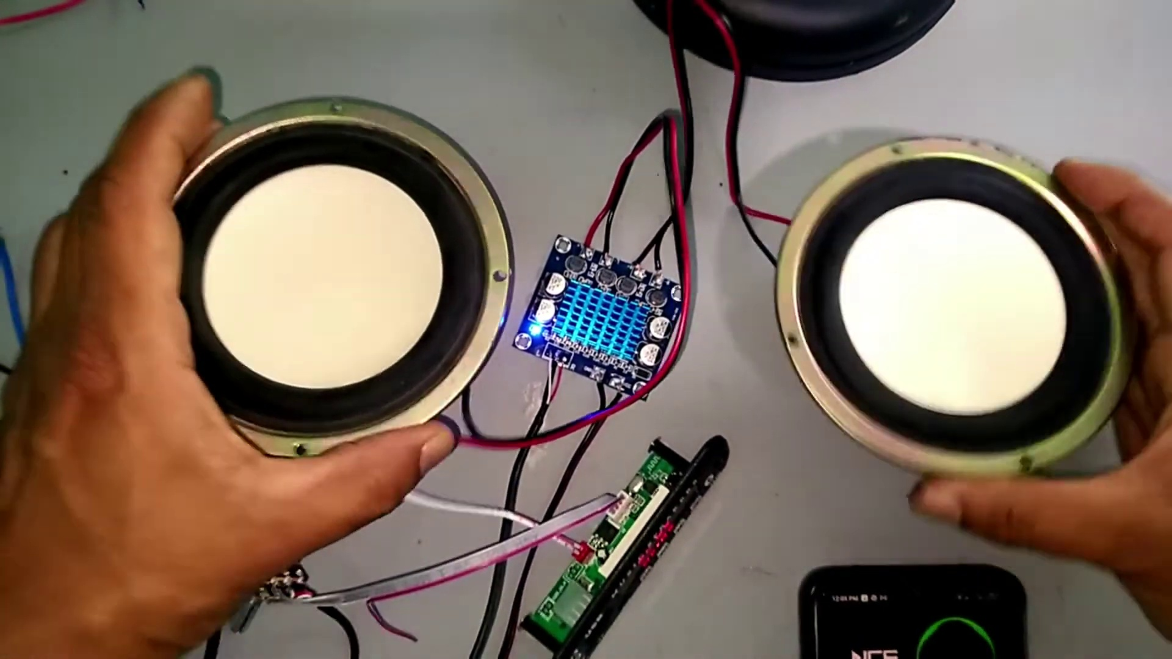 | 
Description: The speaker introduces a topic or event called STA 182 with enthusiasm.
Correlated (true): 1 (2.6%)
Score >= 60: 1 (2.6%)
Average Score (of valid matches): 80.00

Top 1 Correlated Comments:
Score: 80
Comment: I tested this amp on a 100wnom 350wmax speaker using a 19v and 1.5a as the power supply and i can say it has good bass but please dont use this amp under 5ampere if u are using below 3a i recommend to use a speaker below 40watts if im not wrong.
Reason: The comment mentions 'amp' and 'speaker', which are specific objects described in the topic. The commenter also provides detailed information about power supply (19v and 1.5a) and speaker settings (100wnom 350wmax), which align with the enthusiastic tone of the topic description.
Source: https://www.youtube.com/watch?v=sHwSIcIdeDI

