Comment–Topic Correlation Report
Model: llama3

Summary
Topics processed: 6
Comments available for this video: 344
Comments with correlated=True: 41 (11.9%)
Comments with score >= 60: 41 (11.9%)
Total candidate pairs checked: 1200
----------------------------------------

Topic T6: Conclusion
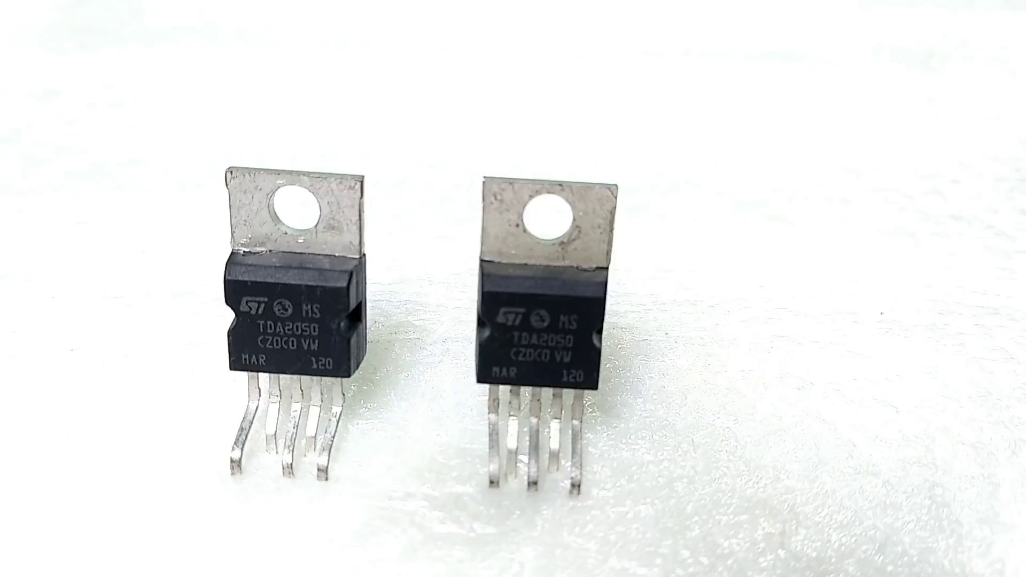 | 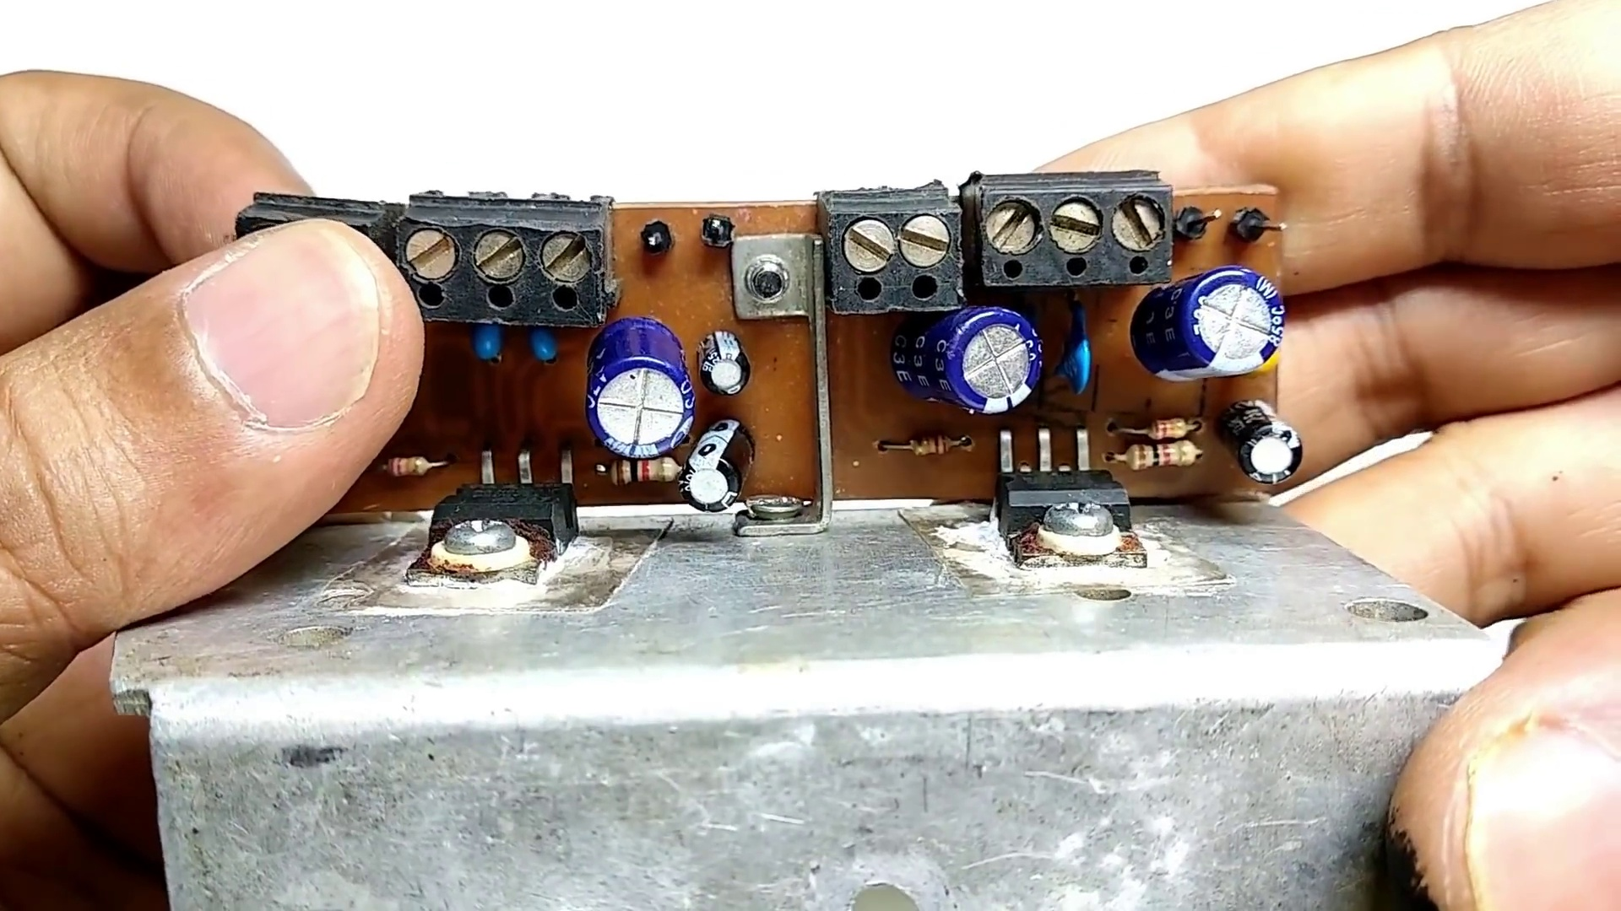 | 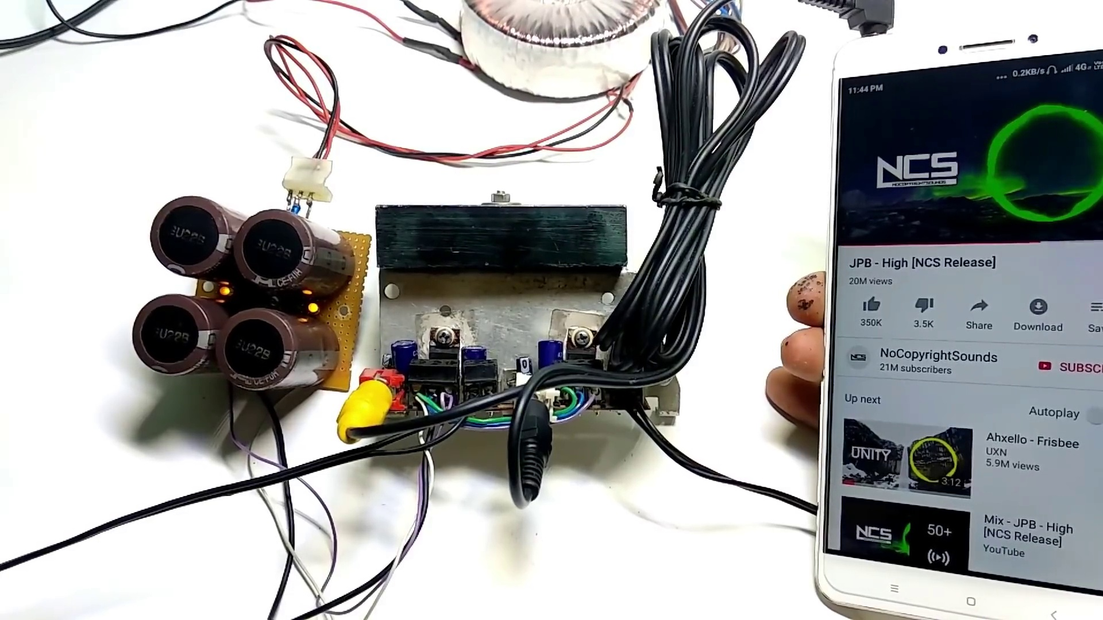
Description: A summary of the key points discussed in the video and a call to action for viewers.
Correlated (true): 2 (0.6%)
Score >= 60: 2 (0.6%)
Average Score (of valid matches): 80.00

Top 2 Correlated Comments:
Score: 80
Comment: Para esquemático, faça o download da folha de dados do TDA2050. Eu também mostrei em vídeo.
Reason: The comment mentions a specific action (download da folha de dados) and references the topic title 'Conclusion', suggesting that it is strongly related to the topic as it wraps up the discussion with a call to action.
Source: https://www.youtube.com/watch?v=t4LPzGIr41c

Score: 80
Comment: Sir mere circuit me 7pieces TDA2030 laga hua hai, 5.1 system hai,toh subwoofer ke liye 2 IC aur satellite speakers ke liye 5 IC, aab subwoofer me koi sound nhi aa rha music bajane paar, tor maine check kiya toh subwoofer ke liye jo 2 IC hai, wo dono hi kharab ho chuka hai. Toh mai kya 2 TDA2030 ke jayga 2 LM1875 laga sakta hu? Bina kuch circuit me change kiye? Kyounki TDA2030 mil nhi rha mere idhar, Chinese wali mil rhi hai. Isiliye nhi lene ka soch rha hu.
Transformer hai 12-0-12 ka.
Reason: The topic discusses the conclusion and call to action, which is directly related to the viewer's concern about fixing their amplifier circuit. The comment mentions specific ICs (TDA2030 and LM1875) and their usage in a subwoofer and satellite speakers, showing a strong connection to the topic.
Source: https://www.youtube.com/watch?v=t4LPzGIr41c

Topic T5: Volume Control and Audio Quality
 |  | 
Description: Tips on how to control the volume of the audio IC's output and improve its quality.
Correlated (true): 6 (1.7%)
Score >= 60: 6 (1.7%)
Average Score (of valid matches): 80.00

Top 5 Correlated Comments:
Score: 80
Comment: Sir mere pass car speaker hai jo 100 rms & 600 w max hai aur ise mai LA4446 3w6 50+50 2 channel ke amplifier se chalata hu but mujhe sound clarity ni pati & volume tej karne par bahut distortion hoti hai to sound clarity lane ke liye kya karu please bataiyena sir & is speaker best amplifier bataiyena class ab & d dono please sir reply me plz plz plz🙏
Reason: The comment directly discusses audio quality and volume control issues with a specific speaker (LA4446) and amplifier setup, mentioning distortion when increasing the volume. The topic's focus on improving audio quality aligns with the commenter's concerns about sound clarity.
Source: https://www.youtube.com/watch?v=t4LPzGIr41c

Score: 80
Comment: Aaj maine subwoofer ke 2030 ke jagah 2050 ic lagake check kiya chal gaya achhe se lekin 2030 jaise hi chala sound nahi badha sound badhne ke liye kya karu
Reason: The comment discusses specific steps related to the topic, mentioning replacement of an IC and testing its sound quality. Although it does not directly address volume control, it is strongly related as it involves audio quality improvement, which is a key aspect of the topic.
Source: https://www.youtube.com/watch?v=t4LPzGIr41c

Score: 80
Comment: Sir 2030/2050 wala kuch home theater board me ic ka speaker output point do diode ke madat se positive & negetive supply ki saath jora rata hai... wo kisliea ?? Datasheet me vi uss diode ka use likha hai ....
Reason: The comment discusses the specific component 'IC speaker output point' and its connection to positive and negative supplies using diodes, which is directly related to the topic's description of controlling audio IC's output.
Source: https://www.youtube.com/watch?v=t4LPzGIr41c

Score: 80
Comment: Sir mere circuit me 7pieces TDA2030 laga hua hai, 5.1 system hai,toh subwoofer ke liye 2 IC aur satellite speakers ke liye 5 IC, aab subwoofer me koi sound nhi aa rha music bajane paar, tor maine check kiya toh subwoofer ke liye jo 2 IC hai, wo dono hi kharab ho chuka hai. Toh mai kya 2 TDA2030 ke jayga 2 LM1875 laga sakta hu? Bina kuch circuit me change kiye? Kyounki TDA2030 mil nhi rha mere idhar, Chinese wali mil rhi hai. Isiliye nhi lene ka soch rha hu.
Transformer hai 12-0-12 ka.
Reason: The comment mentions specific ICs (TDA2030 and LM1875) and their usage in a 5.1 system, which directly relates to the topic of volume control and audio quality. The mention of subwoofer and satellite speakers also aligns with the topic's description.
Source: https://www.youtube.com/watch?v=t4LPzGIr41c

Score: 80
Comment: @WhatIThink .
Tda 7388 me kitne volt or amp ka transformer laga sakte ha ..jisse best sound quality mile ?
Reason: The comment mentions the TDA 7388 IC, which is a specific audio component that aligns with the topic of volume control and audio quality. The question about the transformer also indirectly relates to improving sound quality, which is a key goal described in the topic.
Source: https://www.youtube.com/watch?v=t4LPzGIr41c

Topic T2: Audio IC Basics
 |  | 
Description: A detailed explanation of the audio IC's working principle and components.
Correlated (true): 22 (6.4%)
Score >= 60: 22 (6.4%)
Average Score (of valid matches): 79.77

Top 5 Correlated Comments:
Score: 80
Comment: Sir 2030/2050 wala kuch home theater board me ic ka speaker output point do diode ke madat se positive & negetive supply ki saath jora rata hai... wo kisliea ?? Datasheet me vi uss diode ka use likha hai ....
Reason: The comment discusses the speaker output point of a home theater board and mentions diodes used with positive and negative supplies, which directly relates to the audio IC's working principle and components described in the topic. The mention of datasheet usage further strengthens the correlation.
Source: https://www.youtube.com/watch?v=t4LPzGIr41c

Score: 80
Comment: Sir mere circuit me 7pieces TDA2030 laga hua hai, 5.1 system hai,toh subwoofer ke liye 2 IC aur satellite speakers ke liye 5 IC, aab subwoofer me koi sound nhi aa rha music bajane paar, tor maine check kiya toh subwoofer ke liye jo 2 IC hai, wo dono hi kharab ho chuka hai. Toh mai kya 2 TDA2030 ke jayga 2 LM1875 laga sakta hu? Bina kuch circuit me change kiye? Kyounki TDA2030 mil nhi rha mere idhar, Chinese wali mil rhi hai. Isiliye nhi lene ka soch rha hu.
Transformer hai 12-0-12 ka.
Reason: The comment discusses the use of TDA2030 ICs in a circuit, specifically for subwoofer and satellite speakers. This is directly related to the topic 'Audio IC Basics' as it explains how different ICs are used in an audio circuit, which is one of the key components described in the topic.
Source: https://www.youtube.com/watch?v=t4LPzGIr41c

Score: 80
Comment: Sir mene tda 2050 ka circuit banaya laken volume badaney per bass fatt raha hai, mene capacitors change bhi kiye paheley mene 330uf ke capacitors se DC supply banaai thi uskey baad 4700uf K 2 capacitors lagaai speaker bhi dusra laga K dekha. Bina Bass waaley song to bahut clear baj rahey hai laken jaisehi gaaney me Bass aata awaaj fatney lagti hai
Reason: The comment mentions specific audio IC components (TDA 2050), circuit design changes (capacitor values), and testing results (volume and bass quality). Although it's not a direct discussion of the audio IC's working principle, the mention of circuit components and experimentation is strongly related to the topic.
Source: https://www.youtube.com/watch?v=t4LPzGIr41c

Score: 80
Comment: Sir in the home theater boards two IC are in bridge mode... How much is the output power in bridge mode ?
Reason: The comment mentions a specific type of IC (audio IC) and a configuration mode (bridge mode), which are directly related to the topic's description of audio IC components and working principle.
Source: https://www.youtube.com/watch?v=t4LPzGIr41c

Score: 80
Comment: itna jyada value ke capacitor ki jaroorat nahi hai .Mere paas pade the to laga diya. Is amplifier ke stereo board ke liye 4700uf/35 volt ke 4 capacitor kaafi hai.
Reason: The comment mentions specific component values (4700uf/35 volt) and types (capacitors) that are relevant to the working principle of an audio IC, as described in the topic. The mention of a stereo board also shows a connection to the topic's description.
Source: https://www.youtube.com/watch?v=t4LPzGIr41c

Topic T4: Audio IC Setup
 |  | 
Description: A step-by-step guide on how to set up the audio IC for use in various applications.
Correlated (true): 26 (7.6%)
Score >= 60: 26 (7.6%)
Average Score (of valid matches): 79.42

Top 5 Correlated Comments:
Score: 85
Comment: @WhatIThink can we actually use 2050 in series config ??... Won't that burn the secondary IC ?
Reason: The comment directly discusses the setup of an audio IC (secondary IC) in a specific configuration (series config), which is highly related to the topic.
Source: https://www.youtube.com/watch?v=t4LPzGIr41c

Score: 80
Comment: 2030ic board me. Subwoofer ko Directly pin 4 se out kiya gya rahta hai.. To pin 4 se Directly na le kar kuch filter use kr skte hn.. koi capacitor ya resistance.. agr resistance ya capacitor laga de to Subwoofer me kya fark padega
Reason: The comment mentions specific technical details about the audio IC setup, such as pin 4 and filtering techniques (capacitor or resistance), which are directly related to the topic of setting up an audio IC.
Source: https://www.youtube.com/watch?v=t4LPzGIr41c

Score: 80
Comment: Aaj maine subwoofer ke 2030 ke jagah 2050 ic lagake check kiya chal gaya achhe se lekin 2030 jaise hi chala sound nahi badha sound badhne ke liye kya karu
Reason: The comment mentions setting up an IC (likely a reference to the audio IC setup topic), specifically replacing a previous model (2030) with a new one (2050). The topic description mentions setting up the audio IC for various applications, which is indirectly related to the commenter's experience.
Source: https://www.youtube.com/watch?v=t4LPzGIr41c

Score: 80
Comment: Sir 2030/2050 wala kuch home theater board me ic ka speaker output point do diode ke madat se positive & negetive supply ki saath jora rata hai... wo kisliea ?? Datasheet me vi uss diode ka use likha hai ....
Reason: The comment directly discusses the setup of audio IC's speaker output point using diodes for positive and negative supply, which is strongly related to the topic description about setting up the audio IC.
Source: https://www.youtube.com/watch?v=t4LPzGIr41c

Score: 80
Comment: Mera home theater 5.1 hai usme 2030 ke 7 ic lage hai subwoofer ke jo 2 ic hai uski jagah 2050 ya 1875 ic lagane ke liye transformer kitne watts aur amp ka lagana padega aur circuit me change karna hai ya na kiya to bhi chalega already mere kit me har channel me 1 transistor laga hai
Reason: The comment specifically mentions the audio IC (2030/2050/1875) and discusses setting up a home theater with a subwoofer, which is directly related to the topic of Audio IC Setup.
Source: https://www.youtube.com/watch?v=t4LPzGIr41c

Topic T3: Dual Supply Circuit
 |  | 
Description: How to create a dual supply circuit for the audio IC using a bridge rectifier and capacitors.
Correlated (true): 17 (4.9%)
Score >= 60: 17 (4.9%)
Average Score (of valid matches): 78.24

Top 5 Correlated Comments:
Score: 90
Comment: Two in parallel again in series, center becomes ground.yes it is dual supply.
Reason: The comment directly references the concept of a 'dual supply circuit' and mentions specifics like 'two in parallel again in series', which closely matches the topic description's discussion of creating a dual supply circuit using a bridge rectifier. The mention of 'center becomes ground' also indicates a clear understanding of the circuit's operation, showing strong correlation with the topic.
Source: https://www.youtube.com/watch?v=t4LPzGIr41c

Score: 80
Comment: Sir in the home theater boards two IC are in bridge mode... How much is the output power in bridge mode ?
Reason: The comment mentions a specific circuit configuration (bridge mode) and ICs, which are directly related to the topic's description of creating a dual supply circuit for an audio IC. Although it doesn't explicitly discuss bridge rectifiers or capacitors, the context suggests that the commenter is familiar with the same underlying technology.
Source: https://www.youtube.com/watch?v=t4LPzGIr41c

Score: 80
Comment: itna jyada value ke capacitor ki jaroorat nahi hai .Mere paas pade the to laga diya. Is amplifier ke stereo board ke liye 4700uf/35 volt ke 4 capacitor kaafi hai.
Reason: The comment mentions specific values of capacitors (4700uf/35 volt) and quantities (4) which are related to the topic's description of creating a dual supply circuit with capacitors. The use of Hindi language does not detract from the correlation as the topic is technical in nature.
Source: https://www.youtube.com/watch?v=t4LPzGIr41c

Score: 80
Comment: 2030a ic ka datasheet Me c8 or r5 likha Hai c8=1/2πBR1. Kaise value nikale split power supply circuit me. Please value bataye na
Reason: The comment mentions specific values (C8, R1) and calculation formula (1/2πBR1) related to the creation of a dual supply circuit, which is the main topic.
Source: https://www.youtube.com/watch?v=t4LPzGIr41c

Score: 80
Comment: Sir 2030/2050 wala kuch home theater board me ic ka speaker output point do diode ke madat se positive & negetive supply ki saath jora rata hai... wo kisliea ?? Datasheet me vi uss diode ka use likha hai ....
Reason: The comment discusses the use of a diode to combine positive and negative supplies for an IC's speaker output, which is directly related to creating a dual supply circuit as described in the topic. The mention of a datasheet also shows that the commenter is referencing specific details about the diode's usage, similar to the steps outlined in the topic description.
Source: https://www.youtube.com/watch?v=t4LPzGIr41c

Topic T1: Introduction to Audio IC
 |  | 
Description: An introduction to audio IC and its applications.
Correlated (true): 22 (6.4%)
Score >= 60: 22 (6.4%)
Average Score (of valid matches): 77.95

Top 5 Correlated Comments:
Score: 80
Comment: Sir mere circuit me 7pieces TDA2030 laga hua hai, 5.1 system hai,toh subwoofer ke liye 2 IC aur satellite speakers ke liye 5 IC, aab subwoofer me koi sound nhi aa rha music bajane paar, tor maine check kiya toh subwoofer ke liye jo 2 IC hai, wo dono hi kharab ho chuka hai. Toh mai kya 2 TDA2030 ke jayga 2 LM1875 laga sakta hu? Bina kuch circuit me change kiye? Kyounki TDA2030 mil nhi rha mere idhar, Chinese wali mil rhi hai. Isiliye nhi lene ka soch rha hu.
Transformer hai 12-0-12 ka.
Reason: The comment specifically mentions TDA2030 ICs and their application in a 5.1 system, which directly relates to the topic's description of audio IC and its applications. The commenter also questions whether they can substitute two TDA2030 with two LM1875 without modifying the circuit, showing strong connection to the topic.
Source: https://www.youtube.com/watch?v=t4LPzGIr41c

Score: 80
Comment: itna jyada value ke capacitor ki jaroorat nahi hai .Mere paas pade the to laga diya. Is amplifier ke stereo board ke liye 4700uf/35 volt ke 4 capacitor kaafi hai.
Reason: The comment mentions specific values and applications of capacitors in an amplifier's stereo board, which is directly related to the topic of audio ICs and its applications.
Source: https://www.youtube.com/watch?v=t4LPzGIr41c

Score: 80
Comment: Sir 2030/2050 wala kuch home theater board me ic ka speaker output point do diode ke madat se positive & negetive supply ki saath jora rata hai... wo kisliea ?? Datasheet me vi uss diode ka use likha hai ....
Reason: The comment discusses the usage of a diode in an audio IC-based home theater board to manage positive and negative supply, which is directly related to the topic's description of audio IC applications.
Source: https://www.youtube.com/watch?v=t4LPzGIr41c

Score: 80
Comment: Sir in the home theater boards two IC are in bridge mode... How much is the output power in bridge mode ?
Reason: The comment directly discusses a specific application of audio ICs (home theater) and mentions the configuration (bridge mode), which is closely related to the topic's description.
Source: https://www.youtube.com/watch?v=t4LPzGIr41c

Score: 80
Comment: Isko tda7294 ke sath me lagane ke liye kya kare sir.muze 2.1 amplifier banana hai.
Reason: The comment mentions a specific IC (TDA7294) and its application in amplifier design, which is directly related to the topic of introduction to audio ICs and their applications.
Source: https://www.youtube.com/watch?v=t4LPzGIr41c

