Comment–Topic Correlation Report
Model: llama3

Summary
Topics processed: 2
Comments available for this video: 268
Comments with correlated=True: 74 (27.6%)
Comments with score >= 60: 74 (27.6%)
Total candidate pairs checked: 400
----------------------------------------

Topic T2: Importance of Decoupling Capacitors
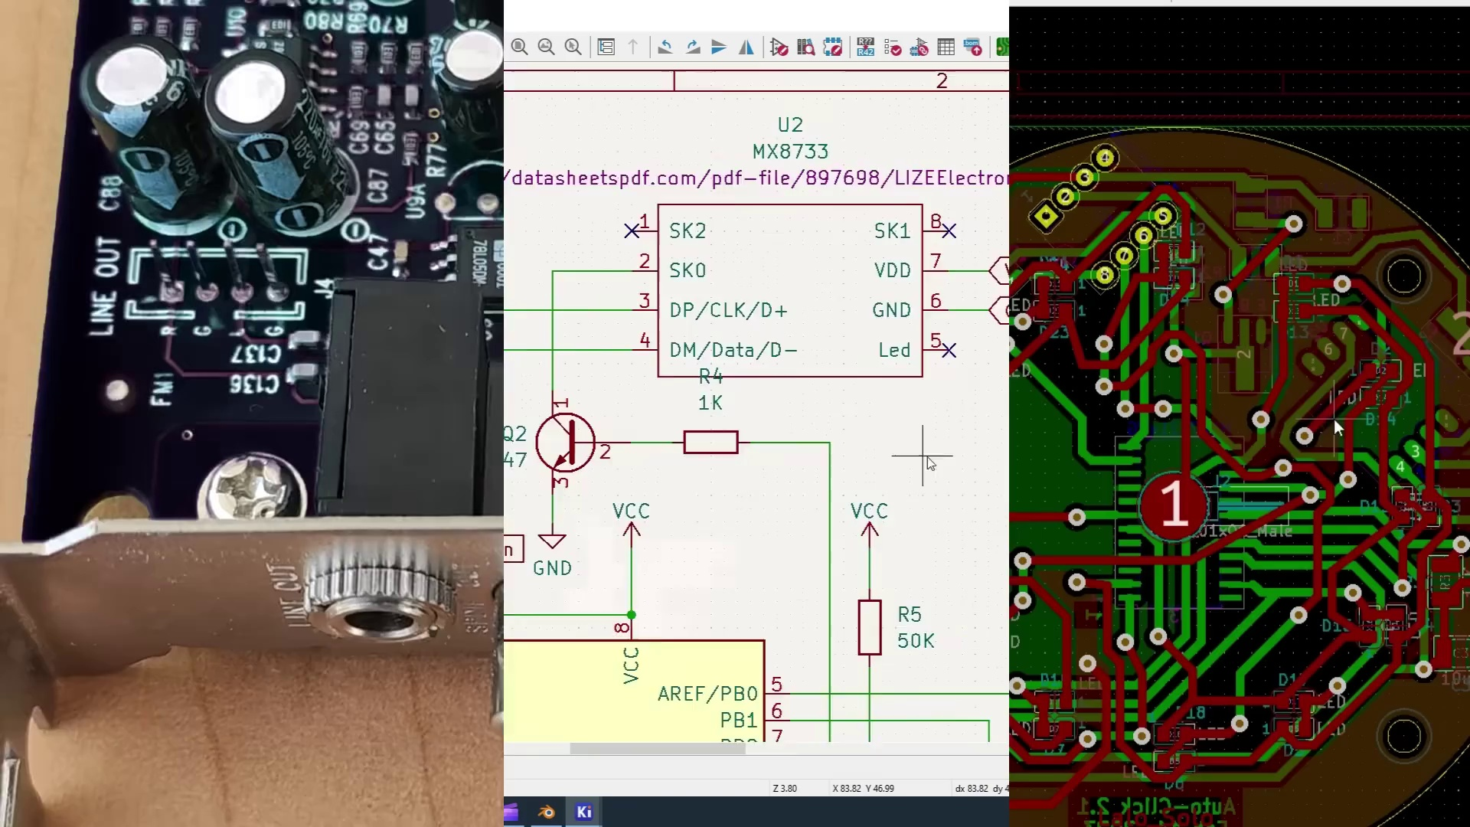 | 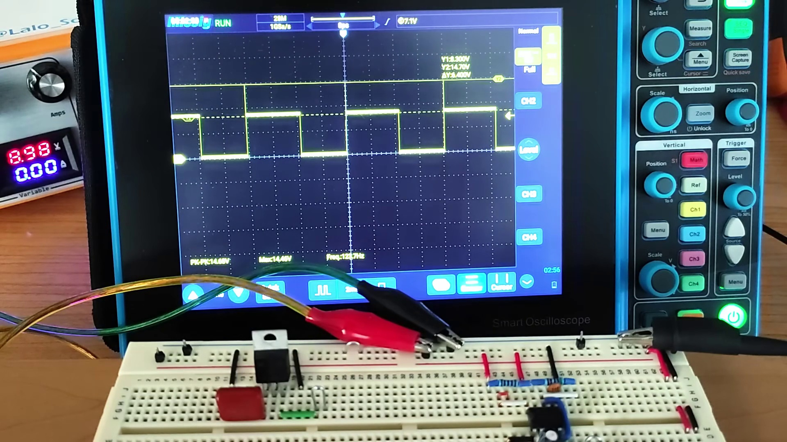 | 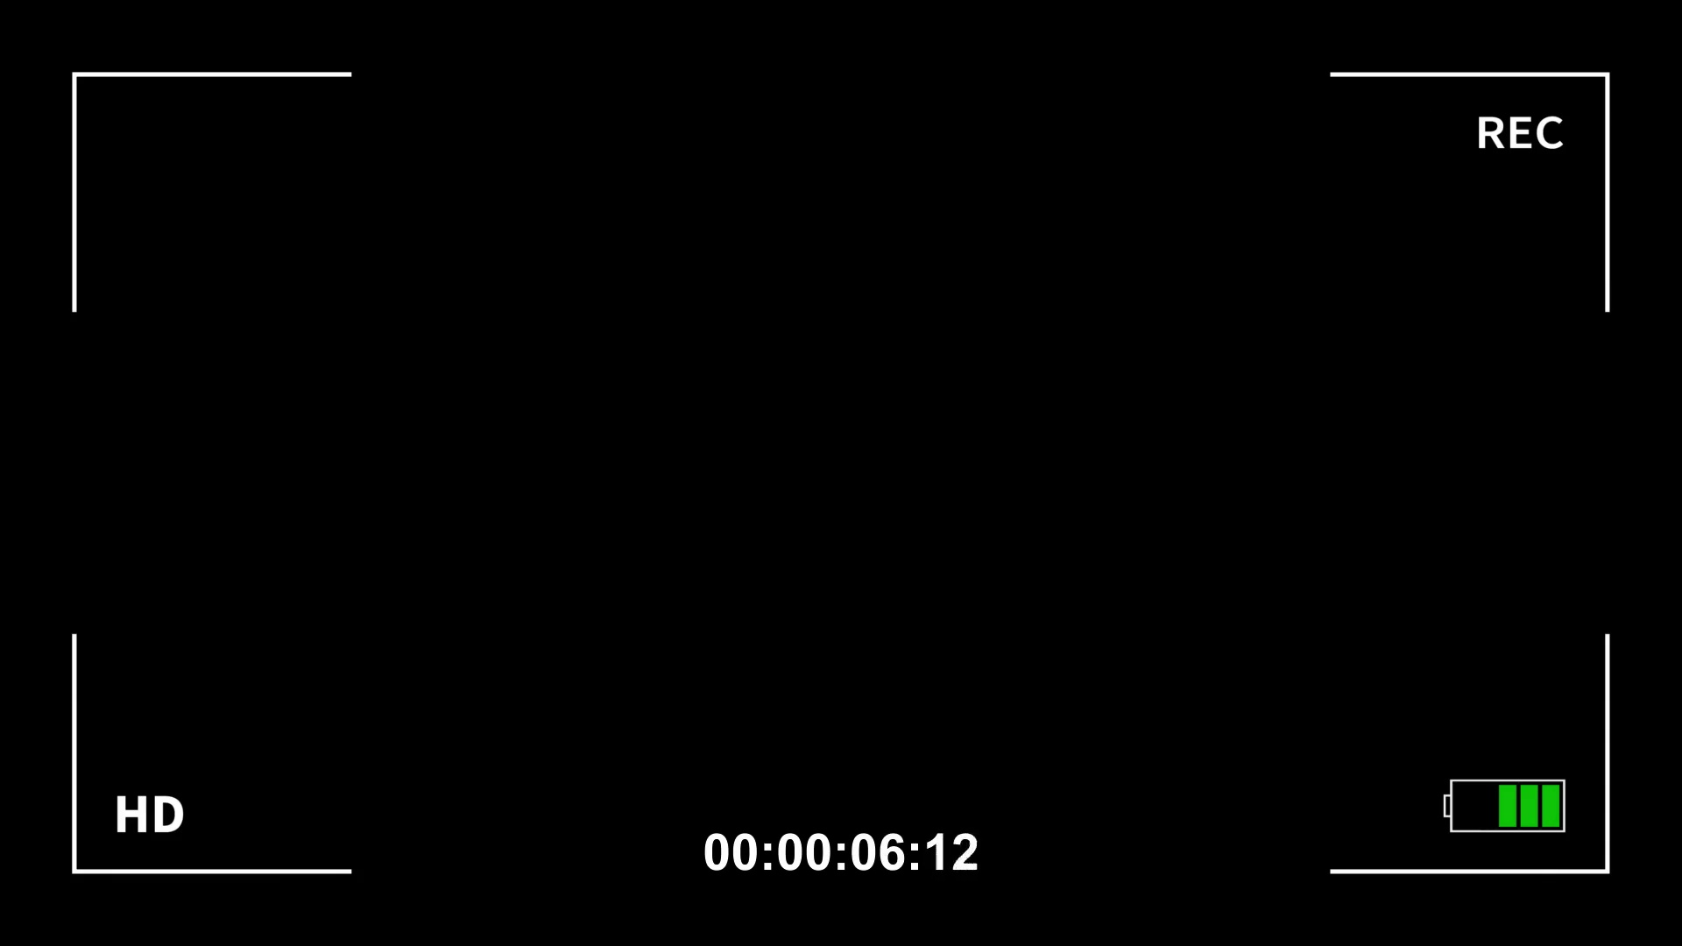
Description: The video discusses the significance of decoupling capacitors in reducing electrical noise and improving signal quality.
Correlated (true): 63 (23.5%)
Score >= 60: 63 (23.5%)
Average Score (of valid matches): 80.95

Top 5 Correlated Comments:
Score: 90
Comment: Good video. To explain decoupling for high speed devices with lots of simultaneous switching noise (like FPGAs), inductance plays a big part. Notice: AC takes the path of least inductance, so at very high noise frequencies, any small inductance between the capacitors and noise generating device can render the capacitors less effective or useless. Even the ground/power planes have some inductance and the leads on the device and capacitors have even a bit more inductance. On a breadboard, it is difficult to keep the leads short and close to the device. Even a millimeter of lead length can add enough inductance so Very High Frequency (VHF) components of the noise are not decoupled. This is why Surface Mount Technology (SMT) capacitors and devices are now used rather than through-hole components, even the length of the trace through the holes and vias add inductance. This is why decoupling capacitors are placed directly under components right next to power pins with many redundant vias to reduce the inductance. Also, capacitors with a low Effective Series Resistance (ESR) have lower internal inductance and thus can decouple a wider bandwidth of noise. At this point each group of capacitors and power pin is a tiny localized Ultra High Frequency (UHF) Resistor Capacitor Inductor (RCL) circuit - the symbol L is used for inductance. Dr. Howard Johnson has awesome seminars on this. At today's billions of transitors switching at many GHz rates, these tiny dimensions become critical and you can't even look at a millimeter of Copper clad from a DC perspective anymore, you have to consider the high frequency AC aspects more and more - it becomes all very mechanically sensitive at this point. This is why it is common to have 3 decoupling capacitors for every power pin. A 0.01uf, a 0.1uf, and a 1uf, all SMT devices, all very close to the power pins with the smaller values closest to the power pins. This gives a wide band of decoupling from UHF down to Medium Frequencies (MF). For circuits that consume a lot of power and have Low Frequecy (LF) and Very Low Frequency (VLF) noise down to DC, larger 10uf to 100uf capacitors are required all over the board but these can be a bit further from the power pins due to inductance has less effect on lower frequencies as you approach DC. This creates islands of "hold up voltage" or "power reservoirs" all over the board - with the inductance between the circuits keeping the islands isolated at UHF even though there is a large DC path between them.
In your example, even though it was a breadboard and you were using leaded components (as an example), you put the larger capacitor close to the 555 Timer. In your case it didn't really matter on a breadboard. People need to remember this video was a good demo, but you need to get into the habit of placing the smaller capacitor values closest to the power pins, with virtally no leads and no wires (mounted on the power/ground planes directly with SMT devices with low ESR and lots of Vias).
That jumper wire you made from the Regulator to the 555 Timer has a lot of relative inductance, so as the 555 Timer output switches, the change in current (AC) that is supplying the Timer from the Regulator is partially blocked by that inductance and thus the circuits inside the Timer don't have enough local power reserves to recover properly.
Remember:
Capacitors block DC and pass AC, while Inductors pass DC and block AC.
Even a tiny piece of of wire/lead/via/through-hole has significant inductance at UHF, and even DC planes have some inductance.
Reason: The comment directly discusses decoupling capacitors, specifically mentioning inductance, noise frequencies, and the importance of placing capacitors close to power pins. The commenter also explains the difference between DC and AC paths, highlighting the significance of decoupling capacitors in reducing electrical noise.
Source: https://www.youtube.com/watch?v=u40kX1DYKdA

Score: 90
Comment: Why doesn’t the manufacturer include the decoupling caps in the ICs directly? Is this for cost-savings or user configurability?
Reason: The comment directly discusses the importance of decoupling capacitors (mentioned in the topic description) and its potential implications for cost-savings or user configurability, which is a specific aspect mentioned in the topic title.
Source: https://www.youtube.com/watch?v=u40kX1DYKdA

Score: 90
Comment: All the decoupling capacitors do is to compensate for your PDN’s (power delivery network) inductance. They essentially act as Columb buckets of charge to handle local power demand. The noise you see at the 7805 regulator’s input is generated by your bench’s switching power supply along with the long connection leads. If you improve your PDN ‘s design & layout you may find that the decoupling capacitors aren’t needed at all. The measurement of power supply noise is also greatly affected by probing technique. It is best to have the probe’s signal and signal return’s (i.e.) as close together & as short as possible as not to introduce unwanted impedance mismatch which’ll create false noise readings.
Reason: The comment directly discusses the importance of decoupling capacitors in handling power demand and reducing noise, aligning with the topic's description. The mention of PDN, regulator input, and probing technique also overlaps with the topic's focus on signal quality.
Source: https://www.youtube.com/watch?v=u40kX1DYKdA

Score: 90
Comment: Fantastic! I just designed a circuit for production and was blaming my scope for the noise. I was wrongly taught that the caps were to keep the regulator from breaking into self oscillation. You just saved me thousands of $$ in product recalls. Thank you.
Reason: The comment directly discusses the same issue of electrical noise and its relation to decoupling capacitors, specifically mentioning the impact on signal quality and a personal experience with improving circuit design.
Source: https://www.youtube.com/watch?v=u40kX1DYKdA

Score: 90
Comment: how to add decoupling cap for any exist power source or module?
Reason: The comment directly discusses the same concept of decoupling capacitors mentioned in the topic, specifically mentioning adding decoupling caps for power sources or modules, which is a step-by-step implementation of the idea discussed in the topic.
Source: https://www.youtube.com/watch?v=u40kX1DYKdA

Topic T1: Analyzing Electrical Noise
 |  | 
Description: The video presents techniques for analyzing and eliminating electrical noise, including the use of decoupling capacitors.
Correlated (true): 69 (25.7%)
Score >= 60: 69 (25.7%)
Average Score (of valid matches): 80.87

Top 5 Correlated Comments:
Score: 90
Comment: Good video. To explain decoupling for high speed devices with lots of simultaneous switching noise (like FPGAs), inductance plays a big part. Notice: AC takes the path of least inductance, so at very high noise frequencies, any small inductance between the capacitors and noise generating device can render the capacitors less effective or useless. Even the ground/power planes have some inductance and the leads on the device and capacitors have even a bit more inductance. On a breadboard, it is difficult to keep the leads short and close to the device. Even a millimeter of lead length can add enough inductance so Very High Frequency (VHF) components of the noise are not decoupled. This is why Surface Mount Technology (SMT) capacitors and devices are now used rather than through-hole components, even the length of the trace through the holes and vias add inductance. This is why decoupling capacitors are placed directly under components right next to power pins with many redundant vias to reduce the inductance. Also, capacitors with a low Effective Series Resistance (ESR) have lower internal inductance and thus can decouple a wider bandwidth of noise. At this point each group of capacitors and power pin is a tiny localized Ultra High Frequency (UHF) Resistor Capacitor Inductor (RCL) circuit - the symbol L is used for inductance. Dr. Howard Johnson has awesome seminars on this. At today's billions of transitors switching at many GHz rates, these tiny dimensions become critical and you can't even look at a millimeter of Copper clad from a DC perspective anymore, you have to consider the high frequency AC aspects more and more - it becomes all very mechanically sensitive at this point. This is why it is common to have 3 decoupling capacitors for every power pin. A 0.01uf, a 0.1uf, and a 1uf, all SMT devices, all very close to the power pins with the smaller values closest to the power pins. This gives a wide band of decoupling from UHF down to Medium Frequencies (MF). For circuits that consume a lot of power and have Low Frequecy (LF) and Very Low Frequency (VLF) noise down to DC, larger 10uf to 100uf capacitors are required all over the board but these can be a bit further from the power pins due to inductance has less effect on lower frequencies as you approach DC. This creates islands of "hold up voltage" or "power reservoirs" all over the board - with the inductance between the circuits keeping the islands isolated at UHF even though there is a large DC path between them.
In your example, even though it was a breadboard and you were using leaded components (as an example), you put the larger capacitor close to the 555 Timer. In your case it didn't really matter on a breadboard. People need to remember this video was a good demo, but you need to get into the habit of placing the smaller capacitor values closest to the power pins, with virtally no leads and no wires (mounted on the power/ground planes directly with SMT devices with low ESR and lots of Vias).
That jumper wire you made from the Regulator to the 555 Timer has a lot of relative inductance, so as the 555 Timer output switches, the change in current (AC) that is supplying the Timer from the Regulator is partially blocked by that inductance and thus the circuits inside the Timer don't have enough local power reserves to recover properly.
Remember:
Capacitors block DC and pass AC, while Inductors pass DC and block AC.
Even a tiny piece of of wire/lead/via/through-hole has significant inductance at UHF, and even DC planes have some inductance.
Reason: The comment directly discusses the same steps and concepts described by the topic, such as decoupling capacitors, inductance, AC/DC blocking, and the importance of placing capacitors close to power pins. The comment also provides specific examples and explanations of why certain design choices are important, making it strongly related to the topic.
Source: https://www.youtube.com/watch?v=u40kX1DYKdA

Score: 90
Comment: @ddognine Thanks for the comment. Not only have I been doing this since high school electronics in 1977, I teach it in my free Summer STEM class. I first learned about decoupling in high school electronics. I was building a multi stage counter circuit with 74 series TTL chips. It was counting wrong at times, my teacher showed me how to look for noise on the o-scope and to put in decoupling caps next to each chip. It fixed the problem. If you ever have a chance to attend any of Dr. Howard Johnson's seminars on signal integrity, take them. He sacles things up 10x so you can see the mechanics of it all and to lower the bandwidth on effects for discussion and examination. I once asked him if he could do a seminar on Ball Grid Array (BGA) inductance and decoupling. He did, I think he has a video on it. These days, FPGA pins are mounted underneath the chip with a matrix of tiny solder balls, when heated, they melt and make 100's of connections between the chip and board in seconds. The thing is, FPGAs (and many CPUs) get so hot you have to bond a thin aluminum plate to the bottom of the board as a heat sink. So you can't probe any pins... you have to use JTAG to test the connections or use JTAG to monitor the signals. I made a JTAG tool that allowed us to monitor signals between non JTAG devices and some JTAG-able FPGAs in real time, we had to slow down the signals but it gave a graphic display on the toggling of the pins (balls) to see if any are stuck/shorted/open. I designed that tool back in 2001, I hear they still use it on the F-22 project. We had an in-house subject matter expert on signal integrity, and I was the JTAG subject matter expert. We had regular "lunch-n-learn" seminars at work... so many companies forget that we each have our areas of expertise and sharing these ideas at lunch (company buys us lunch) is a great way for a company to really move ahead down the high tech road. I have to give credit to one of my mentors when I was a young pup engineer. Harry Clayton showed me to select capacitors that had the lowest ESR and the shortest leads to reduce the inductance and widen the capacitor's filtering bandwidth for better and higher frequency decoupling. The guy had an IQ of about 200, I was dirt compared to him at a mere 165 IQ, so he took me under his wing... a great guy, great engineer, and great beer homebrewer.
Reason: The comment directly discusses decoupling capacitors and signal integrity, matching the topic's description. The commenter shares personal experiences and anecdotes related to the video's content, such as using decoupling caps in a multi-stage counter circuit and designing a JTAG tool for monitoring signals.
Source: https://www.youtube.com/watch?v=u40kX1DYKdA

Score: 90
Comment: 4700uf is much too large. Although it won’t directly affect the circuit it’s overkill. To eliminate noise smaller capacitors are better. Although the larger electrolytic capacitors can remove some noise, they are mainly used to accommodate for inrush current demands for transient signals as often times power supplies cannot supply a large peak currents quickly as their series inductance is usually quite high. I would say get rid of the 4700u and go around 200u electrolytic and 2.2u or below ceramic
Reason: The comment directly discusses the same topic of electrical noise analysis and elimination, specifically mentioning decoupling capacitors (200u electrolytic and 2.2u or below ceramic) and their role in removing noise, which is mentioned in the topic description.
Source: https://www.youtube.com/watch?v=u40kX1DYKdA

Score: 90
Comment: how to add decoupling cap for any exist power source or module?
Reason: The comment directly discusses decoupling capacitors, which is a specific technique mentioned in the topic description for analyzing and eliminating electrical noise.
Source: https://www.youtube.com/watch?v=u40kX1DYKdA

Score: 90
Comment: @SheikhN-bible-syndrome If the amplifer is in the audio range and the noise is in that range too, then a few millimeters of lead between the cap and the device won't make much difference. But, if you get into the Giga Hz, then 1 millimeter starts to become a significant inductance that will limit the bandwidth of the to cap to filter out noise. The lead and the cap start to act as a tuned tank circuit. This is why high frequency AC travels along the surface of a wire (skin effect)... if you can imagine that the cross section of a wire is in fact an infinite series of concentric circles of copper (an infinite series of inductors) with the least inductance being the outer surface where the inductance is least, and the center of the wire where the tighter radius inductance is the most... since AC travels along the path of least inductance, the AC electrons travel more along the surface of the wire. This is also why wires are rated to carry more DC current than AC. So when the frequecy goes up, inductance and capacitance start to factor in to everything.
Reason: The comment directly discusses the analysis and elimination of electrical noise, specifically highlighting the importance of lead length and its effect on inductance and capacitance, which aligns with the topic's focus on analyzing and eliminating electrical noise.
Source: https://www.youtube.com/watch?v=u40kX1DYKdA

