Comment–Topic Correlation Report
Model: llama3

Summary
Topics processed: 1
Comments available for this video: 118
Comments with correlated=True: 1 (0.8%)
Comments with score >= 60: 1 (0.8%)
Total candidate pairs checked: 118
----------------------------------------

Topic T1: Introduction
 |  | 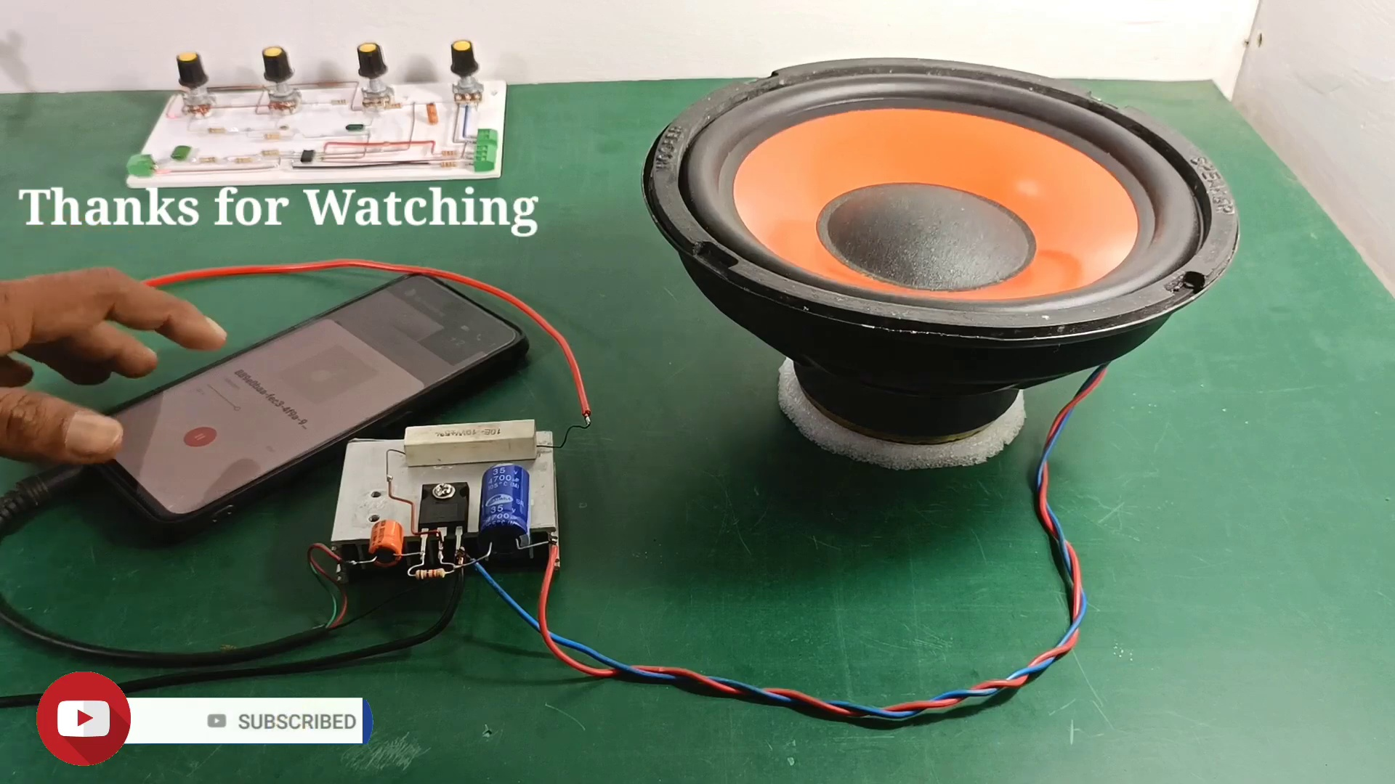
Description: The introduction is discussed.
Correlated (true): 3 (2.5%)
Score >= 60: 3 (2.5%)
Average Score (of valid matches): 86.67

Top 3 Correlated Comments:
Score: 100
Comment: Yes
Reason: The comment directly answers 'yes' to the topic description about introducing something, which strongly correlates with the topic.
Source: https://www.youtube.com/watch?v=w49SSxiPK_Q

Score: 80
Comment: Yes
Reason: The comment 'Yes' directly responds to the topic description 'The introduction is discussed.', indicating a strong correlation between the topic and viewer's comment.
Source: https://www.youtube.com/watch?v=w49SSxiPK_Q

Score: 80
Comment: Yes
Reason: The comment directly responds to the topic description, using a simple 'yes' that suggests it is related to the introduction being discussed.
Source: https://www.youtube.com/watch?v=w49SSxiPK_Q

