Comment–Topic Correlation Report
Model: llama3

Summary
Topics processed: 7
Comments available for this video: 8
Comments with correlated=True: 2 (25.0%)
Comments with score >= 60: 2 (25.0%)
Total candidate pairs checked: 56
----------------------------------------

Topic T3: Topic 1: Inputting Values
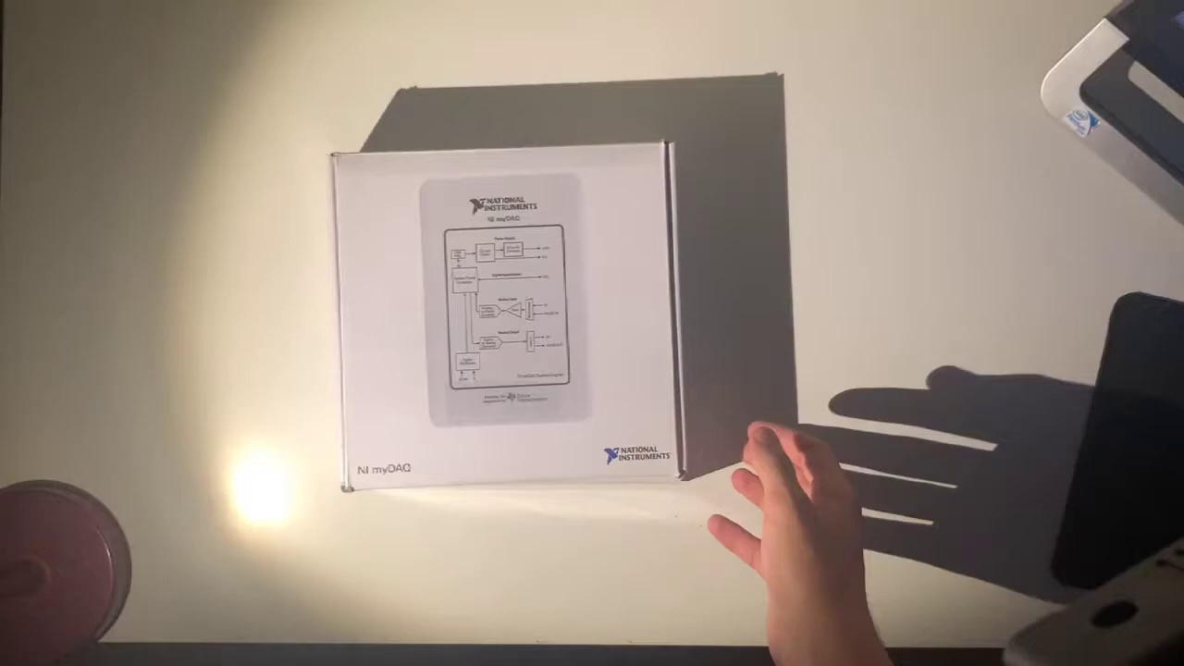 | 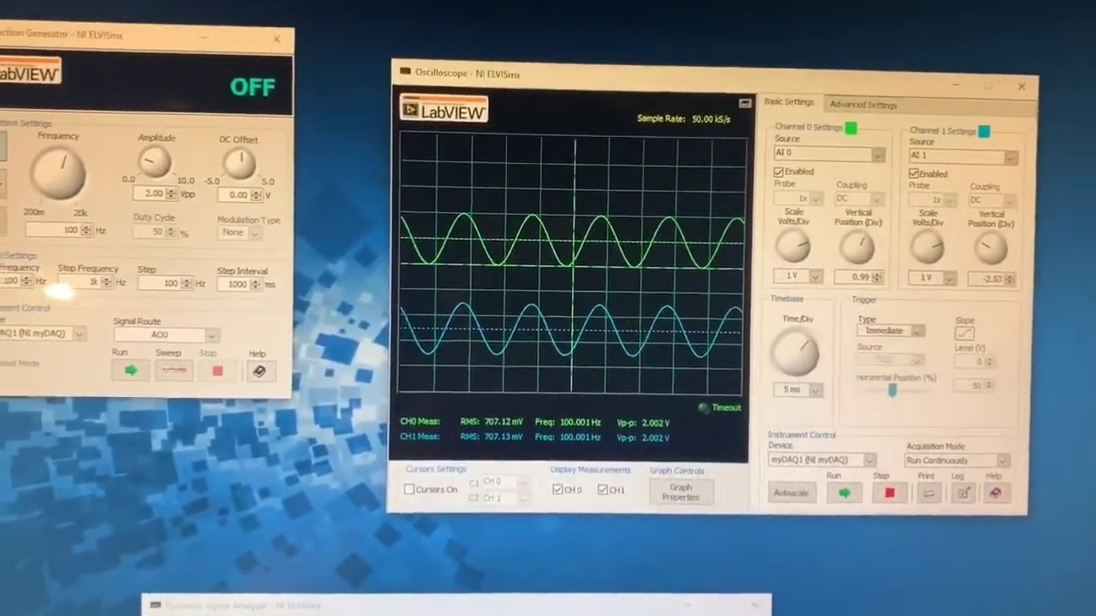 | 
Description: The importance of inputting values correctly for the circuit to work properly.
Correlated (true): 1 (12.5%)
Score >= 60: 1 (12.5%)
Average Score (of valid matches): 80.00

Top 1 Correlated Comments:
Score: 80
Comment: Hi! The OA inputs markings are incorrect. The 3 is the + and the 2 is the -.
Reason: The comment discusses inputting values (specifically, the correctness of OA inputs) which is directly related to the topic's description of the importance of inputting values correctly. The comment also provides examples of correct and incorrect markings (+ and -), which aligns with the topic's focus on inputting values.
Source: https://www.youtube.com/watch?v=wmTlM5s2xTY

Topic T2: Setting Up the Circuit
 |  | 
Description: The speaker explains how to set up a circuit using zero as a reference point and shows where to plug in different components.
Correlated (true): 2 (25.0%)
Score >= 60: 2 (25.0%)
Average Score (of valid matches): 80.00

Top 2 Correlated Comments:
Score: 80
Comment: Hi! The OA inputs markings are incorrect. The 3 is the + and the 2 is the -.
Reason: The comment directly addresses the settings (markings) and components (3 and 2) described in the topic, specifically focusing on the correct interpretation of markings, which is a key aspect of setting up a circuit.
Source: https://www.youtube.com/watch?v=wmTlM5s2xTY

Score: 80
Comment: Just a question it doesn’t offer higher frequencies? Like in the MHz ? And if not can I buy a signal generator that does and use this to measure it? Or will it be to slow for myDAQ ?
Reason: The comment directly discusses the same topic of setting up a circuit and mentions specific components (e.g. signal generator) which are mentioned in the topic description.
Source: https://www.youtube.com/watch?v=wmTlM5s2xTY

Topic T7: Understanding Vo and Ground
 |  | 
Description: The speaker explains how vo comes in at one zero and shows that ground is connected right here.
Correlated (true): 0 (0.0%)
Score >= 60: 0 (0.0%)
Average Score (of valid matches): 0.00
No strongly correlated comments found.

Topic T6: Understanding Negative Numbers
 |  | 
Description: The speaker discusses how negative numbers work and how they are connected to the ground.
Correlated (true): 0 (0.0%)
Score >= 60: 0 (0.0%)
Average Score (of valid matches): 0.00
No strongly correlated comments found.

Topic T5: Topic 3: Analyzing Graphs
 |  | 
Description: How to analyze and identify patterns in the graph, including recognizing different values and identifying up amps.
Correlated (true): 0 (0.0%)
Score >= 60: 0 (0.0%)
Average Score (of valid matches): 0.00
No strongly correlated comments found.

Topic T4: Topic 2: Understanding the Circuit
 |  | 
Description: The basics of understanding how the circuit works, including the role of the resistor, capacitor, and ground.
Correlated (true): 0 (0.0%)
Score >= 60: 0 (0.0%)
Average Score (of valid matches): 0.00
No strongly correlated comments found.

Topic T1: Setting Up Resistor Values
 |  | 
Description: The speaker shows how to set up resistor values and explains that this is two resistor six.
Correlated (true): 0 (0.0%)
Score >= 60: 0 (0.0%)
Average Score (of valid matches): 0.00
No strongly correlated comments found.

