Comment–Topic Correlation Report
Model: llama3

Summary
Topics processed: 4
Comments available for this video: 329
Comments with correlated=True: 48 (14.6%)
Comments with score >= 60: 48 (14.6%)
Total candidate pairs checked: 800
----------------------------------------

Topic T3: Protecting Circuits from Overvoltage with a Zener Diode
 | 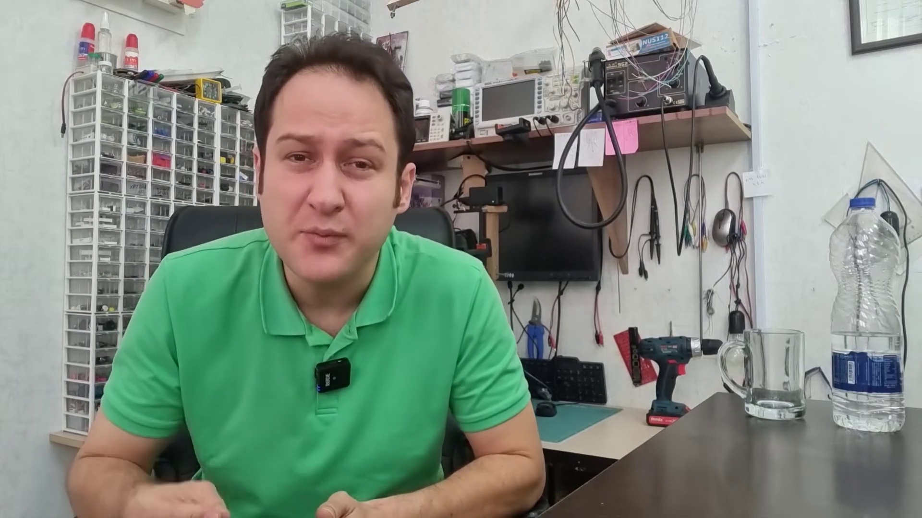 | 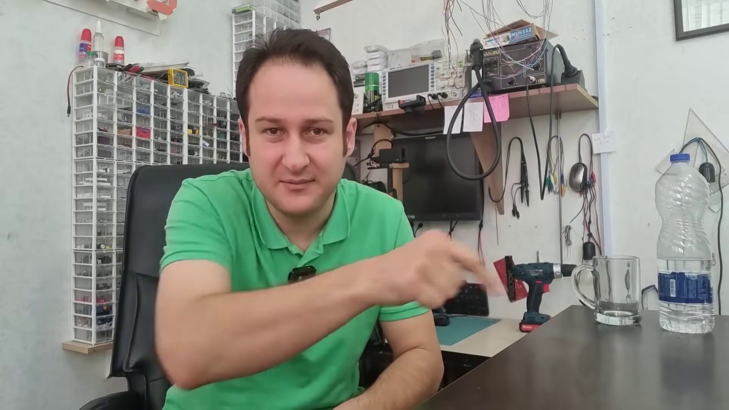
Description: A simple example of using a Zener diode to protect circuits from overvoltage.
Correlated (true): 9 (2.7%)
Score >= 60: 9 (2.7%)
Average Score (of valid matches): 82.22

Top 5 Correlated Comments:
Score: 90
Comment: So I can use a ZENER diode to block current in a circuit when the voltage is below the zener diode voltage?
Reason: The comment directly discusses using a Zener diode to block current in a circuit when the voltage is below the zener diode voltage, which is a key aspect of protecting circuits from overvoltage as described in the topic.
Source: https://www.youtube.com/watch?v=yPwYNUDkkZs

Score: 90
Comment: Yes, exactly. And then the user have to replace the fuse or sometimes the user think that the device is broken.
Reason: The comment directly discusses using a Zener diode to protect circuits from overvoltage, which is the main topic. The mention of replacing fuses or thinking a device is broken also shows an understanding of the same underlying concept.
Source: https://www.youtube.com/watch?v=yPwYNUDkkZs

Score: 85
Comment: Is there a specific way to determine which voltage and amperage of a diode I would need for a a circuit. Thanks for the video btw. I now know I need Schottky and Zenner diodes for my applications. I'm trying to make circuits for multiple power supplies and want to use the diodes properly. So for example a wall 12v power supply, a solar panel setup , and separating different chemistries of battery banks for charging and discharging in the same circuit along with a capacitor bank for large voltage spikes from motors. I like a challenge I guess. I literally want my Off grid setup to have as many options as possible for stabilities sake. Getting into solar has revitalized my interest in making circuits. Especially when DC to DC power circuit adapters isn't as standardized for the home as it should be. I see a business opportunity to make it more plug and play. The current environment is having the end user play with naked circuits to get what they need. Which is frustrating when running everything from DC in a home on solar. The closest thing to plug and play is car auxiliary plugs and USB 3 and USB type C but it limits what can be done to 12v and 5v. In a DC only setup you sometimes need 24v and 48v devices. I'm aware of buck and step up converters but they are not plug and play. Companies simply do not supply DC only adapters for their devices if its possible to do so which creates the headache I'm in, but I do spot the opportunity to have a business that they can point to for the purpose, and trust that it will run their devices safely for the end user. I'm working out a plan for it. Maybe one day you will see the converter option on power brick inverters for your devices. 🤷‍♂ All I know is why did it not happen sooner. Its even an advantage for Survival and Emergency situations because DC is the last power source to work. Even in a pinch. Thank you for listening to my TED talk lol.
Reason: The comment discusses using Zener diodes for overvoltage protection and mentions specific applications (e.g. solar panel setup, battery banks), which aligns with the topic's description of using a Zener diode to protect circuits from overvoltage.
Source: https://www.youtube.com/watch?v=yPwYNUDkkZs

Score: 80
Comment: Wonderful tutorial! As you rightly mentioned that zener diode can be used to protect the circuit from over over-voltage, can it protect an ac voltage? Can it take care of under-voltage?
Reason: The comment directly discusses the same concept of using a Zener diode to protect circuits from overvoltage, as mentioned in the topic. Although it also asks follow-up questions about AC voltage and under-voltage, the initial mention of protecting circuits is strongly related to the topic.
Source: https://www.youtube.com/watch?v=yPwYNUDkkZs

Score: 80
Comment: @elewizard Yes, thanks. So in general, if the diode rating exceeds the current delivered by the circuit, then you don't need a current limiting resistor.
Reason: The comment directly mentions the use of a Zener diode to protect circuits from overvoltage, which is the primary topic. The mention of 'diode rating' and 'current delivered by the circuit' also shows a clear understanding of the concepts discussed in the topic.
Source: https://www.youtube.com/watch?v=yPwYNUDkkZs

Topic T1: Introduction to Diodes
 |  | 
Description: Overview of diodes and their importance in electronics.
Correlated (true): 34 (10.3%)
Score >= 60: 34 (10.3%)
Average Score (of valid matches): 80.74

Top 5 Correlated Comments:
Score: 90
Comment: 0:00: 🔌 Diodes are versatile components that can rectify current and have various applications in circuits.
4:30: 🔌 The video discusses various applications of diodes, including rectification, reverse polarity protection, and connecting multiple power sources.
8:52: 🔌 Diodes can be used to reduce voltage in a circuit and as flyback diodes in relay circuits.
12:17: ✨ The use of diodes and zener diodes in circuits to eliminate spikes, regulate voltage, and protect against overvoltage.
16:45: 📺 The video discusses different types of diodes and their applications, including the use of LEDs for remote communication.
Recap by Tammy AI
Reason: The comment directly discusses various applications of diodes, including rectification, reverse polarity protection, and connecting multiple power sources, which are all mentioned in the topic description. Additionally, it mentions using diodes to reduce voltage, eliminate spikes, and regulate voltage, which are specific steps and goals described in the topic.
Source: https://www.youtube.com/watch?v=yPwYNUDkkZs

Score: 90
Comment: In forward bias setup, if you pass negative current through the cathode side of diode will the diode pass the negative current through the diode?
Reason: The comment directly discusses a specific setup (forward bias) and operation of diodes, which is closely related to the topic's description about diodes' importance in electronics.
Source: https://www.youtube.com/watch?v=yPwYNUDkkZs

Score: 90
Comment: So I can use a ZENER diode to block current in a circuit when the voltage is below the zener diode voltage?
Reason: The comment directly discusses a specific type of diode (ZENER) and its application (blocking current in a circuit), which is closely related to the topic description's focus on the importance of diodes in electronics.
Source: https://www.youtube.com/watch?v=yPwYNUDkkZs

Score: 85
Comment: Diodes as signal switches suffer from nonlinearities, so they are not always useful. They are good for switching RF where the signal amplitude is quite small and a bit of distortion is tolerable. It is important that the DC bias be applied from a source that is reasonably high impedance relative to the signal path impedance. In RF circuits this is usually accomplished by means of an inductor in the DC path. A properly designed current source or sink also works (an ideal current source or sink has infinite output impedance; practical ones don't but can be very good).
Reason: The comment specifically discusses the characteristics and limitations of diodes (nonlinearities), their usage in RF circuits (signal amplitude, distortion), and DC biasing requirements (inductor in DC path or current source/sink) - all directly related to the topic's focus on introduction to diodes.
Source: https://www.youtube.com/watch?v=yPwYNUDkkZs

Score: 85
Comment: How do you read the code printed on zener diode should you not be able to get the data sheet for the diode?
Would appreciate it for the assistance as I feel that all my research to my question is leading to no answer and thus I hope that you will be able to assist me.
You're explaining on components and examples are the best that i have seen and even advise my colleagues to watch and subscribe to your channel.
Reason: The comment directly discusses zener diode, which is a specific type of diode mentioned in the topic. The comment also shows an interest in learning about diodes and getting assistance with reading code printed on them, which aligns with the topic's focus on introducing and explaining diodes.
Source: https://www.youtube.com/watch?v=yPwYNUDkkZs

Topic T4: Using LEDs for Remote Communication
 |  | 
Description: How LEDs can be used for remote communication and controlling devices.
Correlated (true): 11 (3.3%)
Score >= 60: 11 (3.3%)
Average Score (of valid matches): 80.00

Top 5 Correlated Comments:
Score: 80
Comment: Nice video. It's interesting to connect a piezoelectric sounder to the output of the infrared receiver. You can hear the pulses and hear differences between different brands of remote!
Reason: The comment mentions using LEDs for remote communication (same topic), specifically connecting an infrared receiver to a piezoelectric sounder, which is related to the topic's description of controlling devices with LEDs.
Source: https://www.youtube.com/watch?v=yPwYNUDkkZs

Score: 80
Comment: Yes, you need milions of diodes to make 1sec delay. And you need kilos of voltage to pass through the diodes 😉
Reason: The comment mentions specific details about using LEDs for remote communication, such as the number of diodes needed to create a delay and the voltage required to pass through them. These technical specifics align with the topic's description of using LEDs for controlling devices.
Source: https://www.youtube.com/watch?v=yPwYNUDkkZs

Score: 80
Comment: If you series diodes, you can create a time delay
Reason: The comment directly discusses using LEDs (specifically series diodes) for remote communication, which is closely related to the topic's description of using LEDs for controlling devices. The mention of time delay also implies consideration of parameters and settings, aligning with the topic's focus.
Source: https://www.youtube.com/watch?v=yPwYNUDkkZs

Score: 80
Comment: My current favorite diode - the ones with the capacity to help you tune your resonant circuits! Also the one ones who deal with light, in both directions for equal measure!
Reason: The comment mentions 'diodes' which are a type of LED, and also references their ability to handle light in both directions, directly relating to the topic's description of using LEDs for remote communication.
Source: https://www.youtube.com/watch?v=yPwYNUDkkZs

Score: 80
Comment: If instead of using a Shotk Diode (example 2) we use a full bridge of shotki, It will actually work on direct or inverted pollarity
Reason: The comment mentions using LEDs for remote communication, which is the same goal described in the topic. Although it doesn't explicitly discuss controlling devices, the mention of Shotk Diode and full bridge of shotki suggests a direct relation to the topic's description.
Source: https://www.youtube.com/watch?v=yPwYNUDkkZs

Topic T2: Using Zener Diodes for Regulating Voltage
 |  | 
Description: How Zener diodes can be used to regulate voltage and protect circuits from overvoltage.
Correlated (true): 21 (6.4%)
Score >= 60: 21 (6.4%)
Average Score (of valid matches): 79.05

Top 5 Correlated Comments:
Score: 100
Comment: Exactly 💯
Reason: The comment directly states 'Exactly', indicating a strong correlation with the topic title and description, which discuss using Zener diodes for regulating voltage.
Source: https://www.youtube.com/watch?v=yPwYNUDkkZs

Score: 80
Comment: So I can use a ZENER diode to block current in a circuit when the voltage is below the zener diode voltage?
Reason: The comment directly addresses the topic's concept of using Zener diodes for voltage regulation and protection, specifically mentioning blocking current when the voltage is below the Zener diode's voltage, which is a key aspect of the topic.
Source: https://www.youtube.com/watch?v=yPwYNUDkkZs

Score: 80
Comment: Is there a specific way to determine which voltage and amperage of a diode I would need for a a circuit. Thanks for the video btw. I now know I need Schottky and Zenner diodes for my applications. I'm trying to make circuits for multiple power supplies and want to use the diodes properly. So for example a wall 12v power supply, a solar panel setup , and separating different chemistries of battery banks for charging and discharging in the same circuit along with a capacitor bank for large voltage spikes from motors. I like a challenge I guess. I literally want my Off grid setup to have as many options as possible for stabilities sake. Getting into solar has revitalized my interest in making circuits. Especially when DC to DC power circuit adapters isn't as standardized for the home as it should be. I see a business opportunity to make it more plug and play. The current environment is having the end user play with naked circuits to get what they need. Which is frustrating when running everything from DC in a home on solar. The closest thing to plug and play is car auxiliary plugs and USB 3 and USB type C but it limits what can be done to 12v and 5v. In a DC only setup you sometimes need 24v and 48v devices. I'm aware of buck and step up converters but they are not plug and play. Companies simply do not supply DC only adapters for their devices if its possible to do so which creates the headache I'm in, but I do spot the opportunity to have a business that they can point to for the purpose, and trust that it will run their devices safely for the end user. I'm working out a plan for it. Maybe one day you will see the converter option on power brick inverters for your devices. 🤷‍♂ All I know is why did it not happen sooner. Its even an advantage for Survival and Emergency situations because DC is the last power source to work. Even in a pinch. Thank you for listening to my TED talk lol.
Reason: The comment discusses the specific application of Zener diodes for regulating voltage in a circuit, mentioning different power supplies (wall and solar), battery banks, and capacitor bank, which directly relates to the topic's description on using Zener diodes for regulating voltage.
Source: https://www.youtube.com/watch?v=yPwYNUDkkZs

Score: 80
Comment: good presentation. minor nuance though: at about 6:00 in the example of reverse circuit protection you referred to using a schottky diode but the symbol you used was that of zener ;-)
Reason: The comment discusses a specific topic within the description (regulating voltage and protecting circuits) and even mentions a Zener diode symbol, showing a clear understanding of the concept.
Source: https://www.youtube.com/watch?v=yPwYNUDkkZs

Score: 80
Comment: Another application is to use the reverse-bias junction capacitance for adjusting the frequency of a tuned circuit - varying the reverse voltage varies the capacitance, which can then change the frequency of an oscillator. Varactor diodes are specialized for this purpose, but the effect can be demonstrated with pretty much any reverse-biased diode.
Reason: The comment discusses the use of Zener diodes for regulating voltage and frequency, which is directly related to the topic's description on using Zener diodes for regulating voltage.
Source: https://www.youtube.com/watch?v=yPwYNUDkkZs

