Comment–Topic Correlation Report
Model: llama3

Summary
Topics processed: 2
Comments available for this video: 1
Comments with correlated=True: 1 (100.0%)
Comments with score >= 60: 1 (100.0%)
Total candidate pairs checked: 2
----------------------------------------

Topic T1: akan
 | 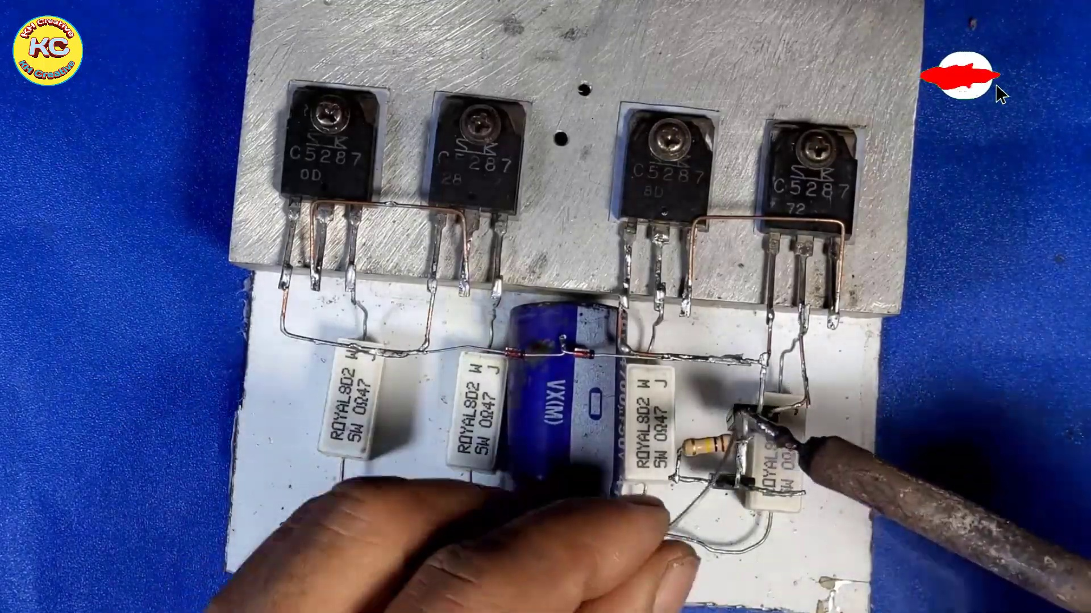 | 
Description: The speaker mentions akan.
Correlated (true): 1 (100.0%)
Score >= 60: 1 (100.0%)
Average Score (of valid matches): 80.00

Top 1 Correlated Comments:
Score: 80
Comment: No like, more info. Parts used step by step. Schematic maybe
Reason: The comment requests more information about the akan, specifically mentioning parts and a schematic, indicating a direct connection to the topic.
Source: https://www.youtube.com/watch?v=zZE4AejgDOA

Topic T2: Statistic
 |  | 
Description: The speaker talks about statistics, specifically saying something.
Correlated (true): 0 (0.0%)
Score >= 60: 0 (0.0%)
Average Score (of valid matches): 0.00
No strongly correlated comments found.

