Engagement Analysis: 7JH1_ZKV7t4

Section 0: Outdoor Scenes
Time: 0:00 - 0:45

Summary
The video shows various outdoor scenes with objects such as airplanes, boats, grassy areas, and trees.

Representative Frames
0:07  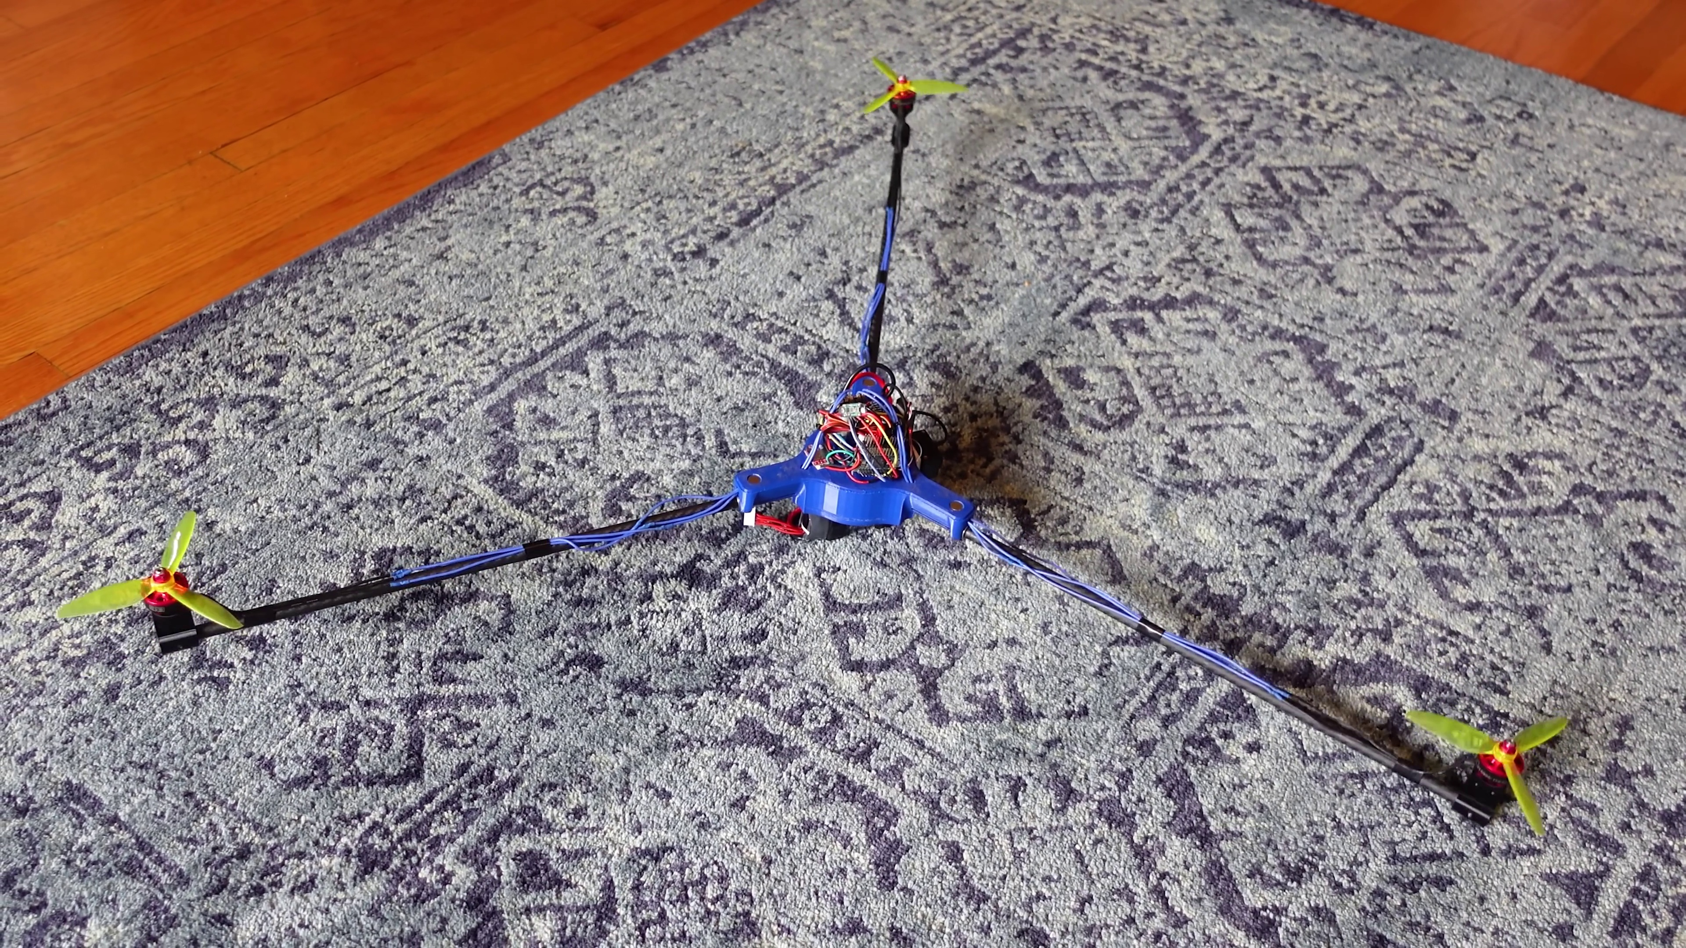 | 0:15  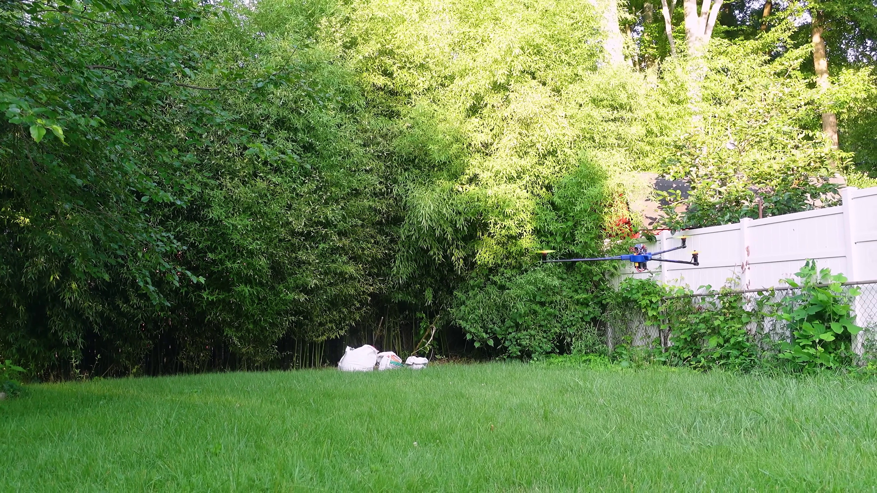 | 0:22  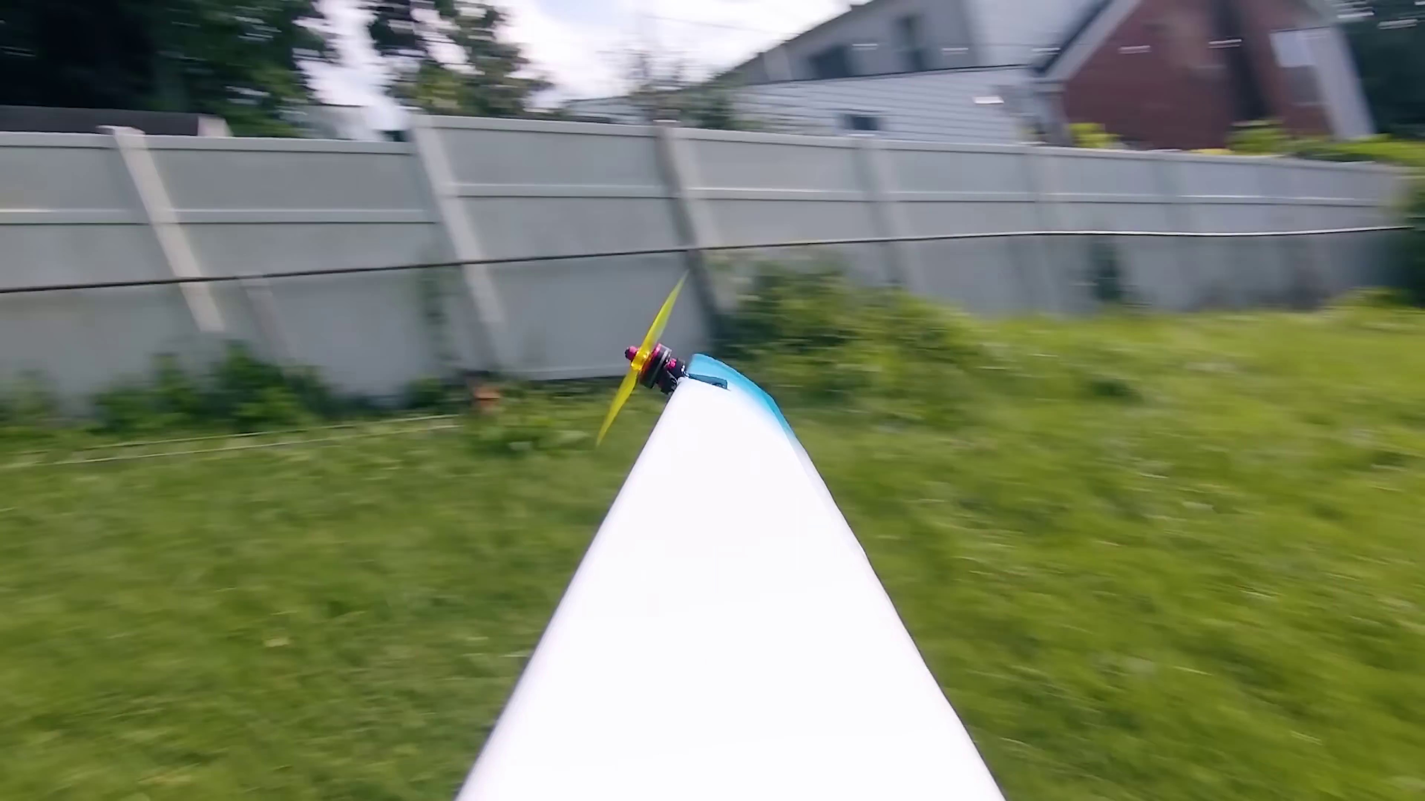 | 0:30  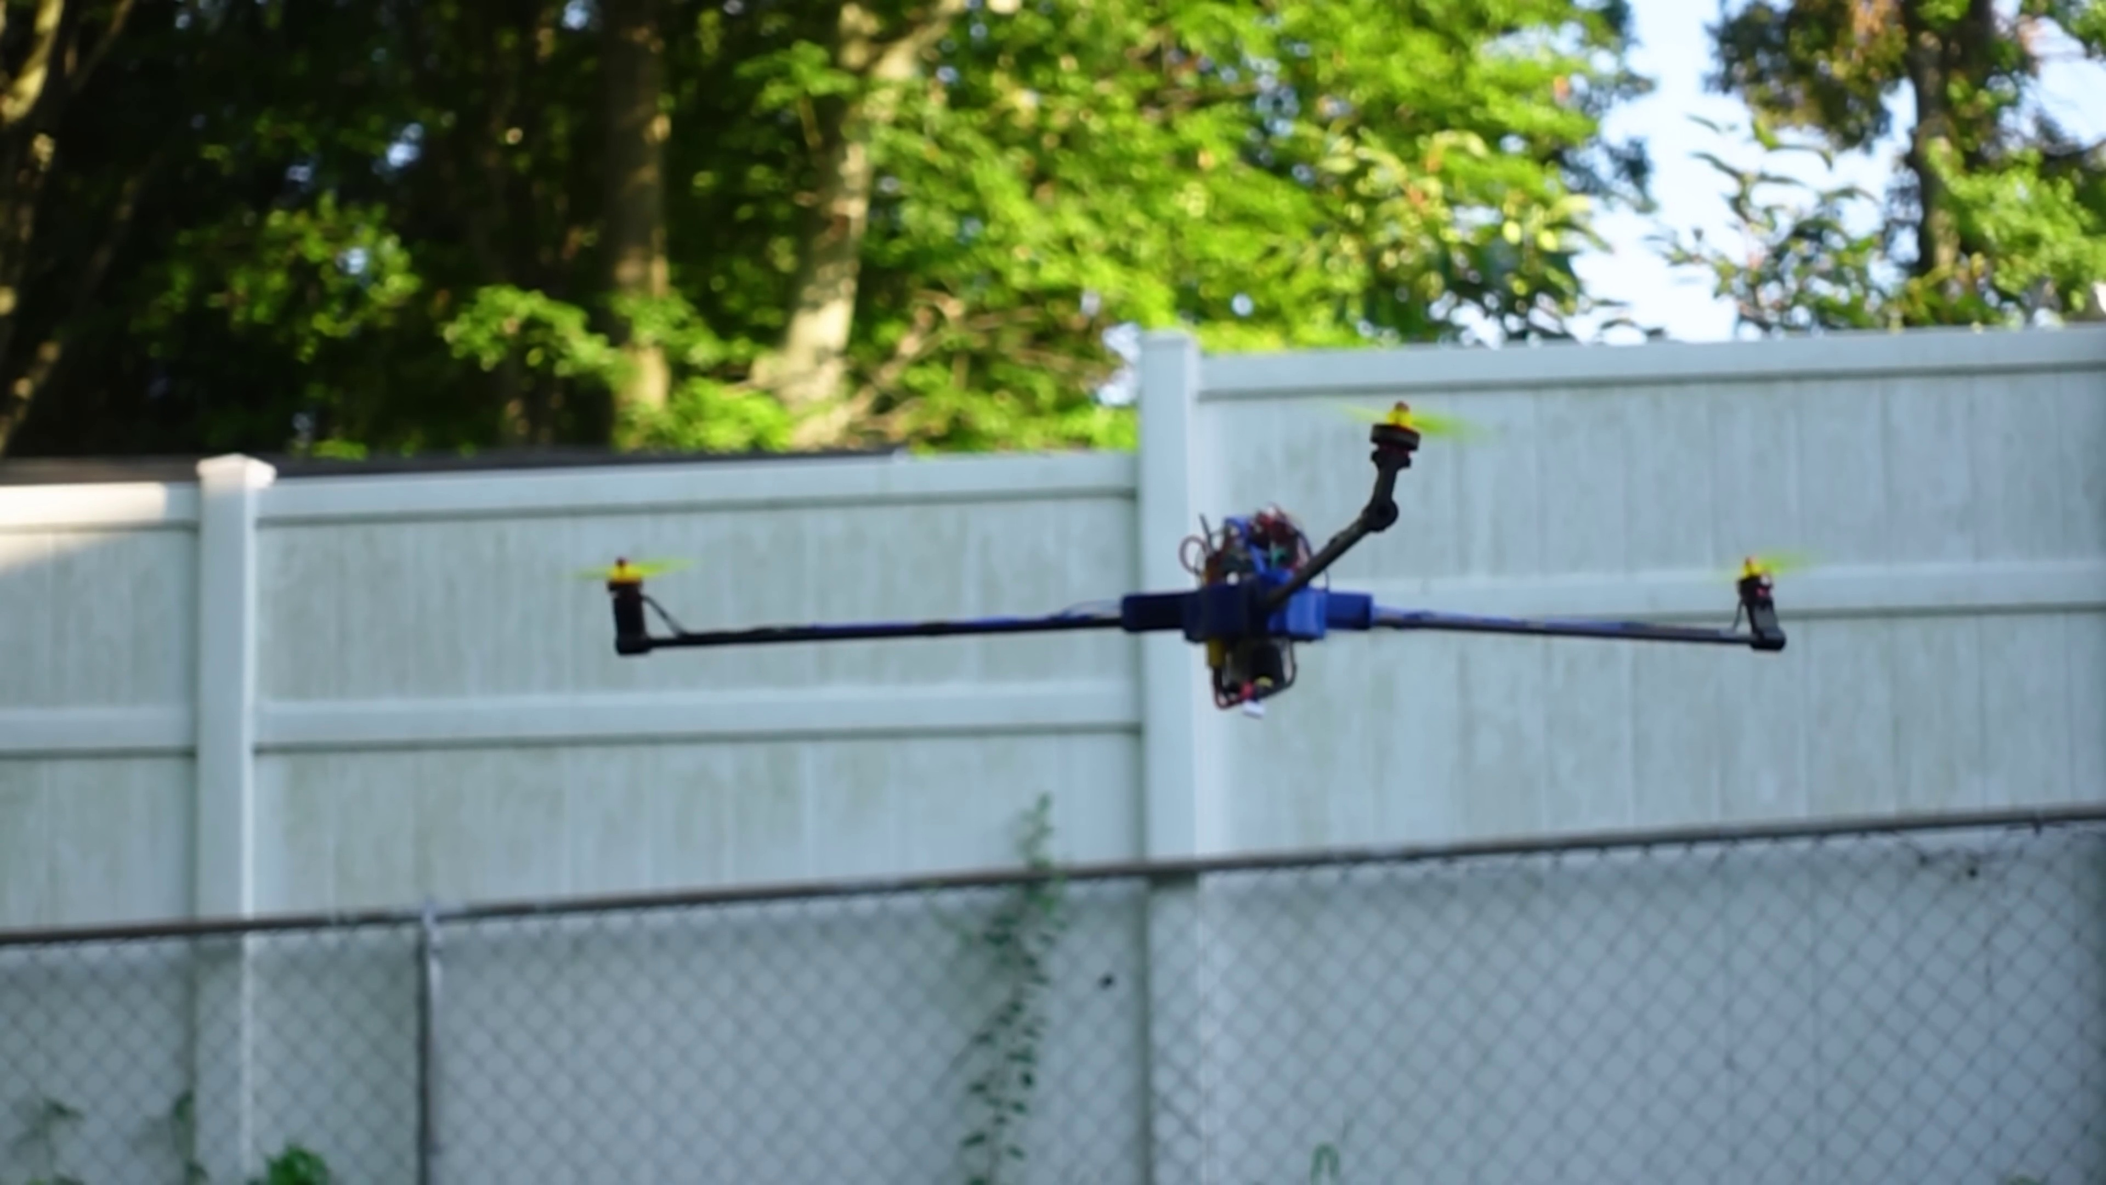 | 0:37  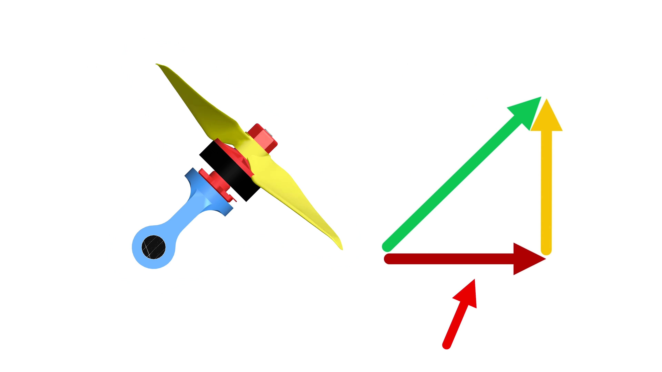

Transcript
[0:00] This might look like just a regular old tricopter drone, but unlike a typical tricopter, all
[0:04] of the motors tilt with a single servo so it can spin at extreme speeds.
[0:11] Why would I want it to spin so darn fast?
[0:13] Well, when fitted with some wings on the arms, and when the tilt angle of all of them is
[0:17] just right, it actually requires substantially less power to hover than if the three motors
[0:21] were just oriented vertically like a regular tricopter drone.
[0:25] This seems very counterintuitive.
[0:26] If we tilt the motors to enable this spinning, a substantial fraction of their upwards thrust
[0:31] force is lost.
[0:33] If they tilt to 45 degrees for example, that's half of the total thrust now pushing sideways
[0:38] and not up.
[0:40] This means that the drone will fall if throttle isn't increased.

