Engagement Analysis: -qCO7NUpLc0

Section 0: Introduction to Tale Tech
Time: 0:00 - 0:45

Summary
The output shows a series of images related to electronics and audio equipment, including speakers, transformers, and oscilloscopes.

Representative Frames
0:07  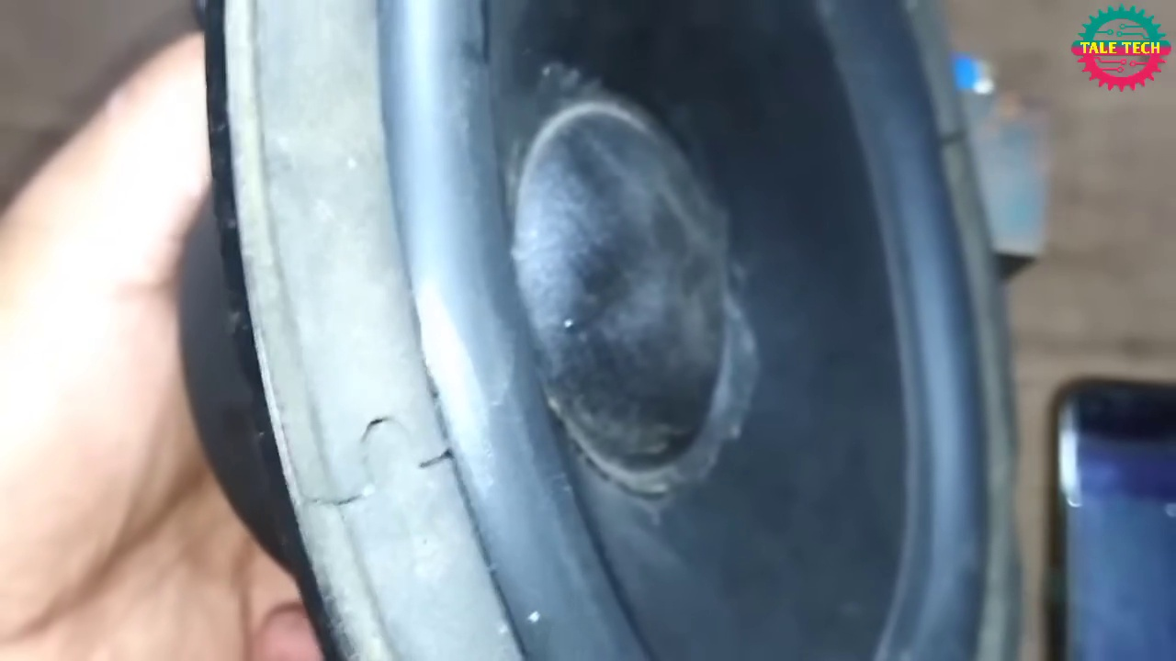 | 0:15  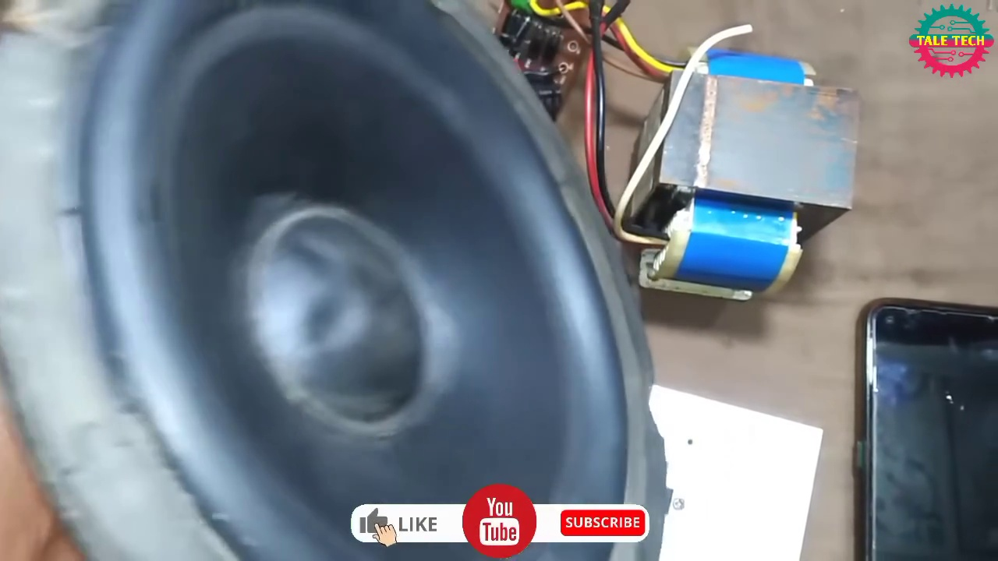 | 0:22  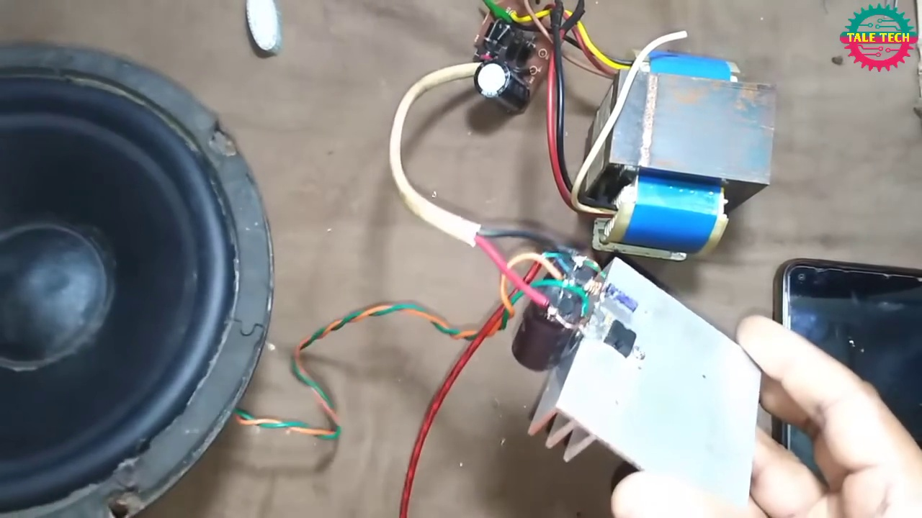 | 0:30   | 0:37  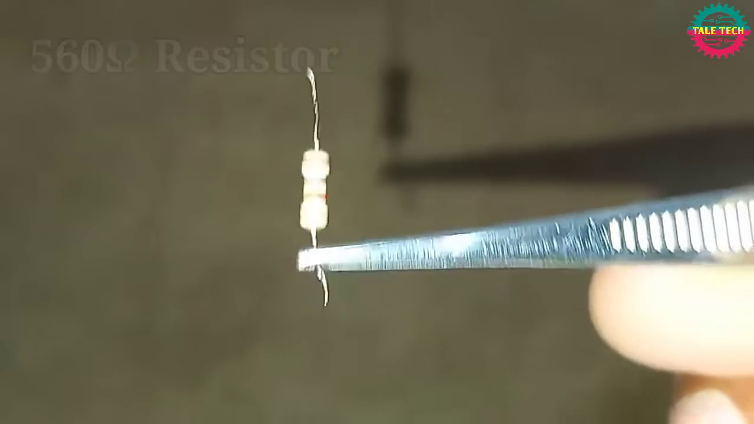

Transcript
[0:00] And
[0:02] and

Section 0: Image 1: Speaker and Circuit Board
Time: 0:05 - 0:10

Summary
The image shows a speaker connected to a circuit board with wires.

Representative Frames
0:05  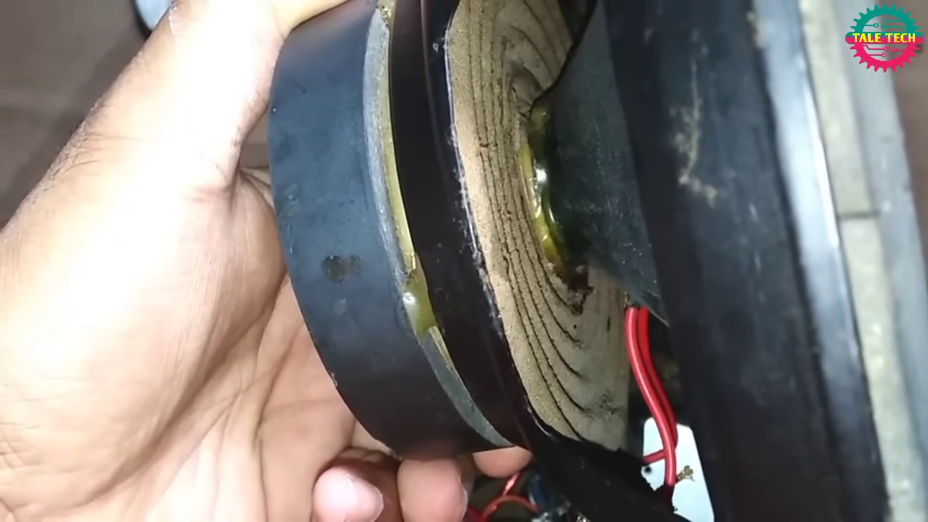 | 0:06   | 0:07   | 0:08   | 0:09  

Transcript
(No speech detected in this section)

Section 0: Image 2: Close-up of Speaker
Time: 0:11 - 0:16

Summary
The image shows a close-up view of a speaker's cone and wires.

Representative Frames
0:11  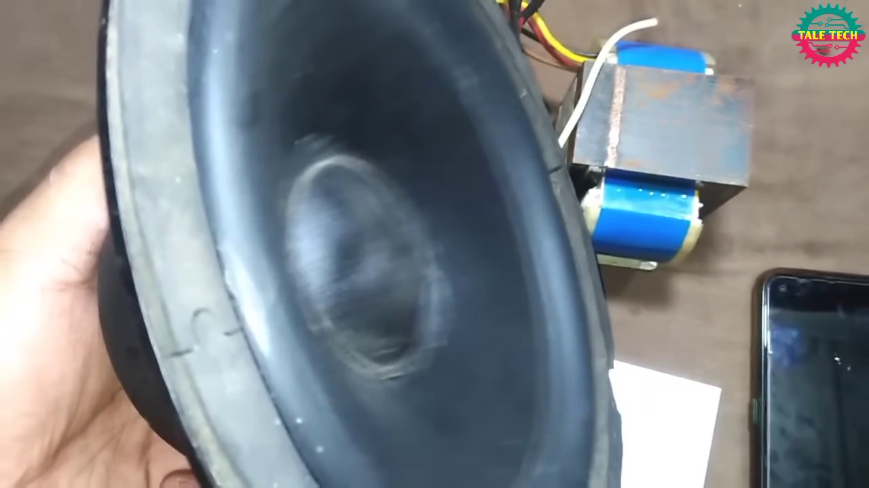 | 0:12   | 0:13   | 0:14   | 0:15  

Transcript
(No speech detected in this section)

Section 0: Image 3: Transformer and Audio System
Time: 0:17 - 0:22

Summary
The image shows a transformer connected to an audio system.

Representative Frames
0:17  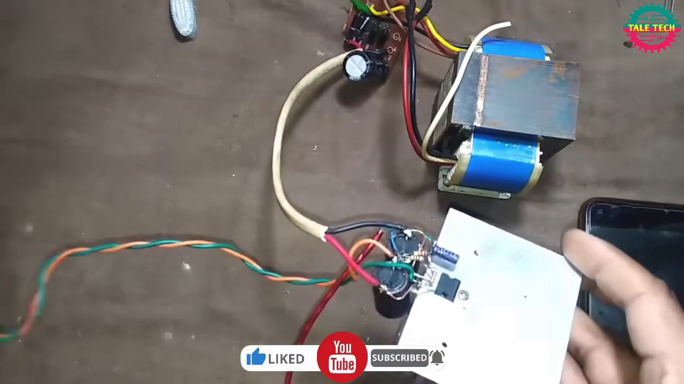 | 0:18   | 0:19   | 0:20   | 0:21  

Transcript
(No speech detected in this section)

Section 0: Image 4: Close-up of Hands and Devices
Time: 0:23 - 0:28

Summary
The image shows a close-up view of hands interacting with electronic devices.

Representative Frames
0:23   | 0:24   | 0:25   | 0:26  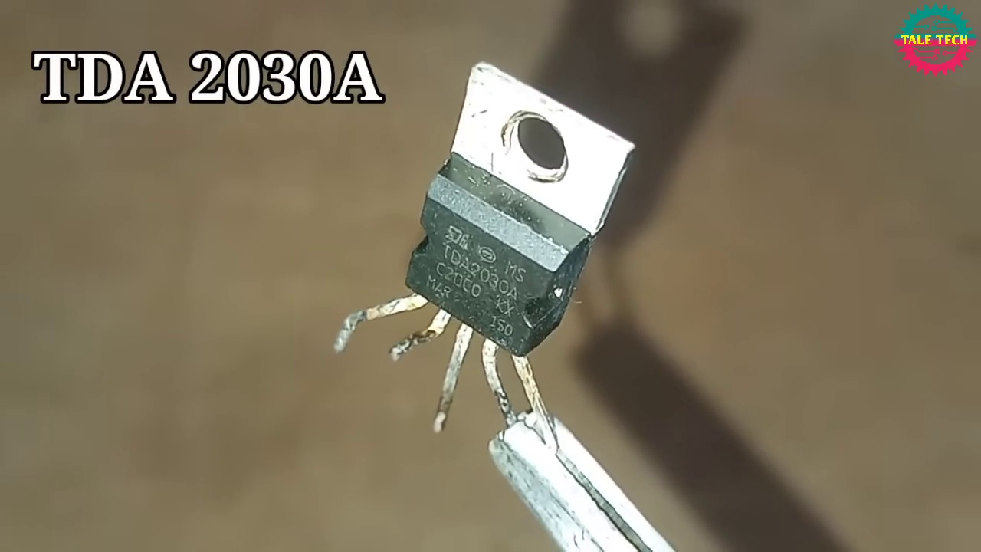 | 0:27  

Transcript
(No speech detected in this section)

Section 0: Conclusion
Time: 0:29 - 0:45

Summary
The output shows a series of images related to electronics and audio equipment, with a focus on speakers, transformers, and oscilloscopes.

Representative Frames
0:31   | 0:34   | 0:37   | 0:40   | 0:42  

Transcript
(No speech detected in this section)

