Engagement Analysis: 15cdyl2PU-E

Section 0: Thank You Messages and Subscription Requests
Time: 0:00 - 0:45

Summary
The content describes various thank you messages and subscription requests, including images of cartoon characters, whiteboards, and presentation slides.

Representative Frames
0:07  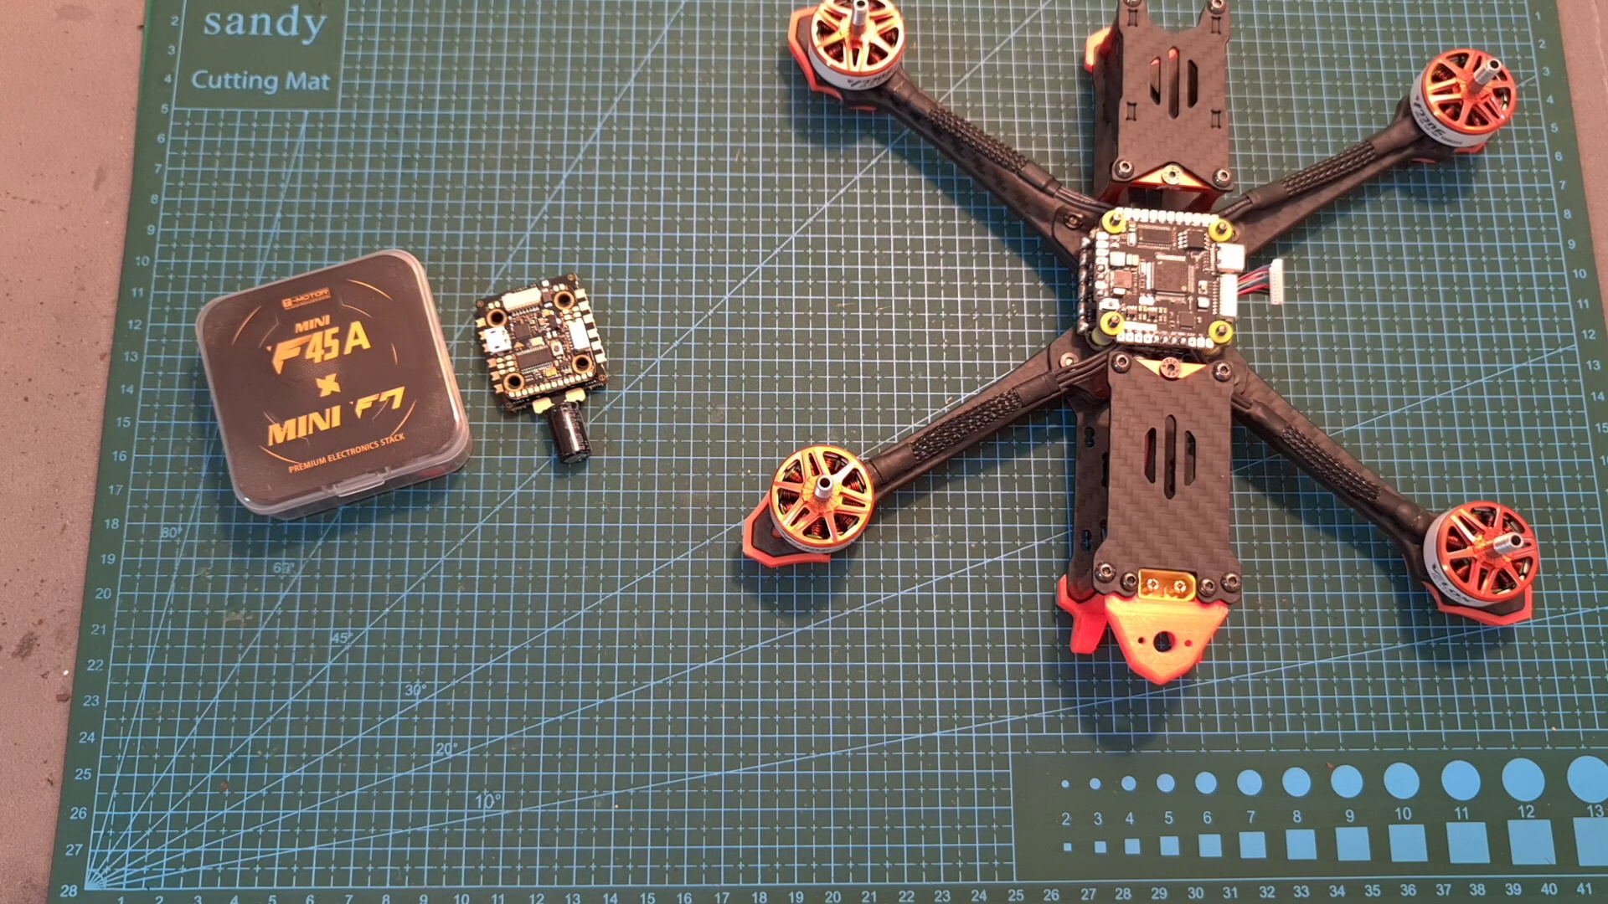 | 0:15  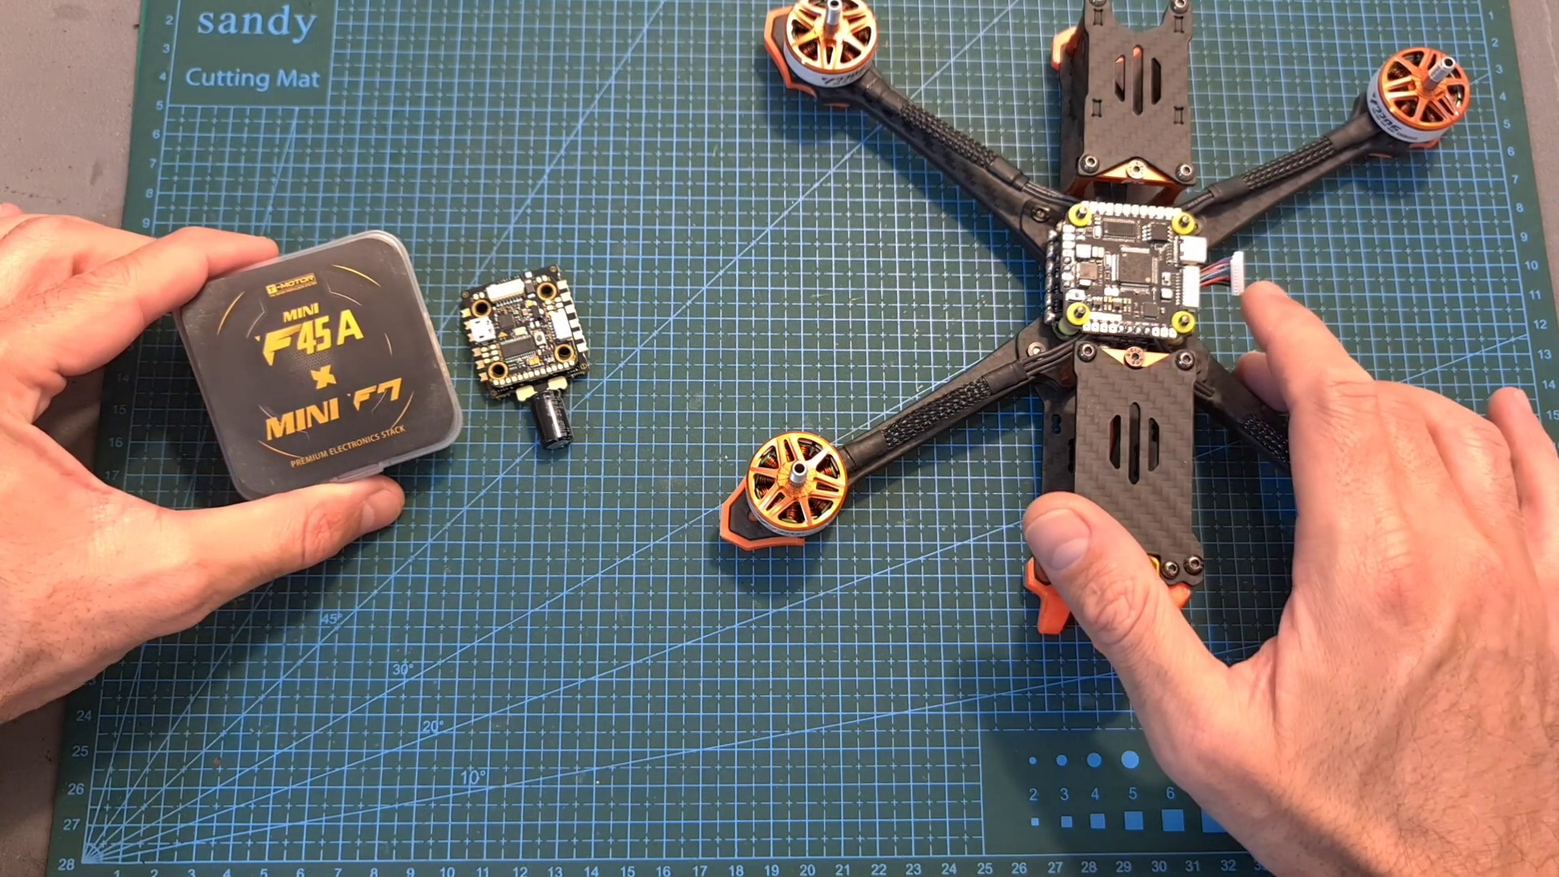 | 0:22  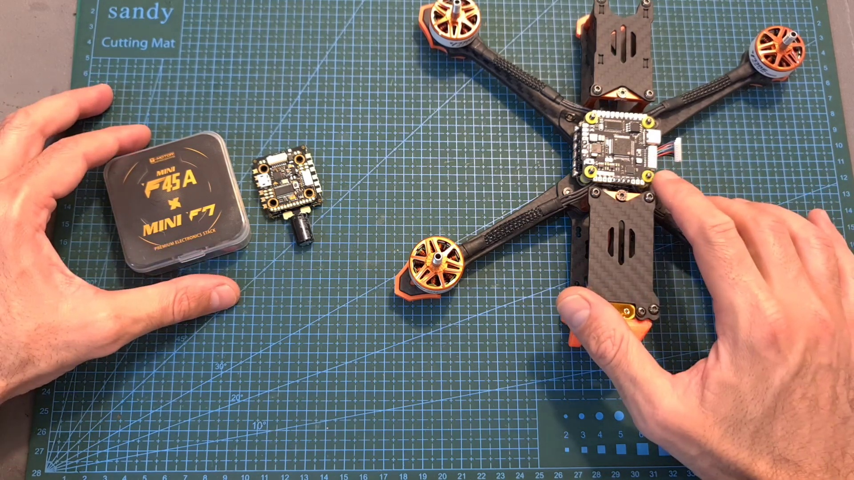 | 0:30  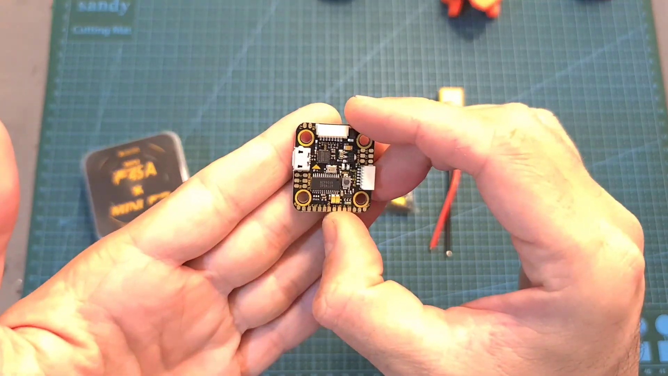 | 0:37  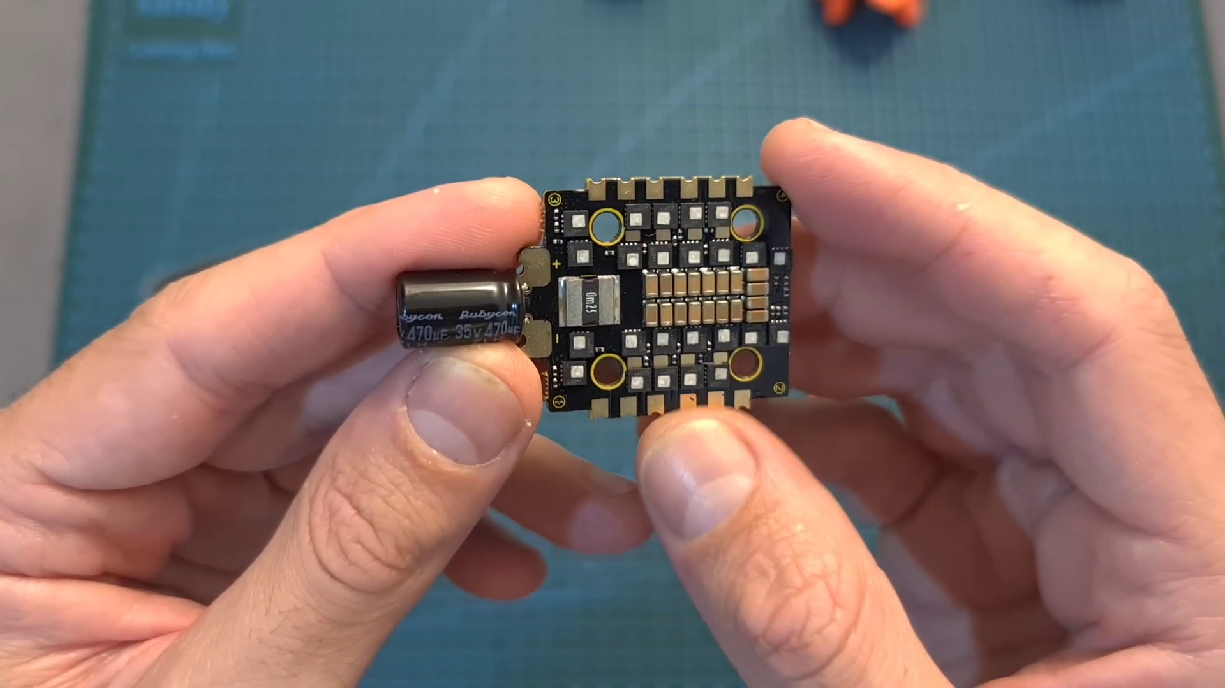

Transcript
[0:00] Hello guys and welcome back to my channel. Today I'm going to check a new DJI-friendly F7 flight
[0:10] controller and a very capable 20x20mm stack by T-Motor. In this video I'm going to go over their
[0:17] features and specs and show you how to set them up using both digital and analog systems.
[0:22] First let's start with the 20x20mm stack. In terms of packaging, inside the box you can find the
[0:29] flight controller. The 4-in-1 ESC which comes with a pre-soldered 35V 470μF capacitor. A bag with M3
[0:38] screws, nuts and silicone grammets. A high quality XT60 battery connector with pre-soldered 14G silicone

Section 0: Educational Content on Ecommerce Business
Time: 0:45 - 0:58

Summary
The content describes an educational video or presentation about starting an ecommerce business, including a whiteboard with bullet points and a thumbnail for the video.

Representative Frames
0:47  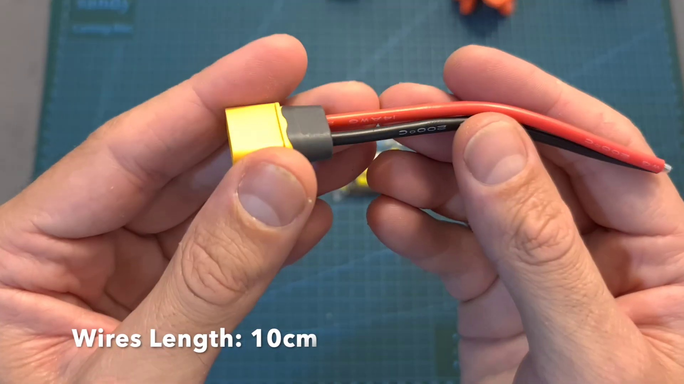 | 0:49   | 0:51  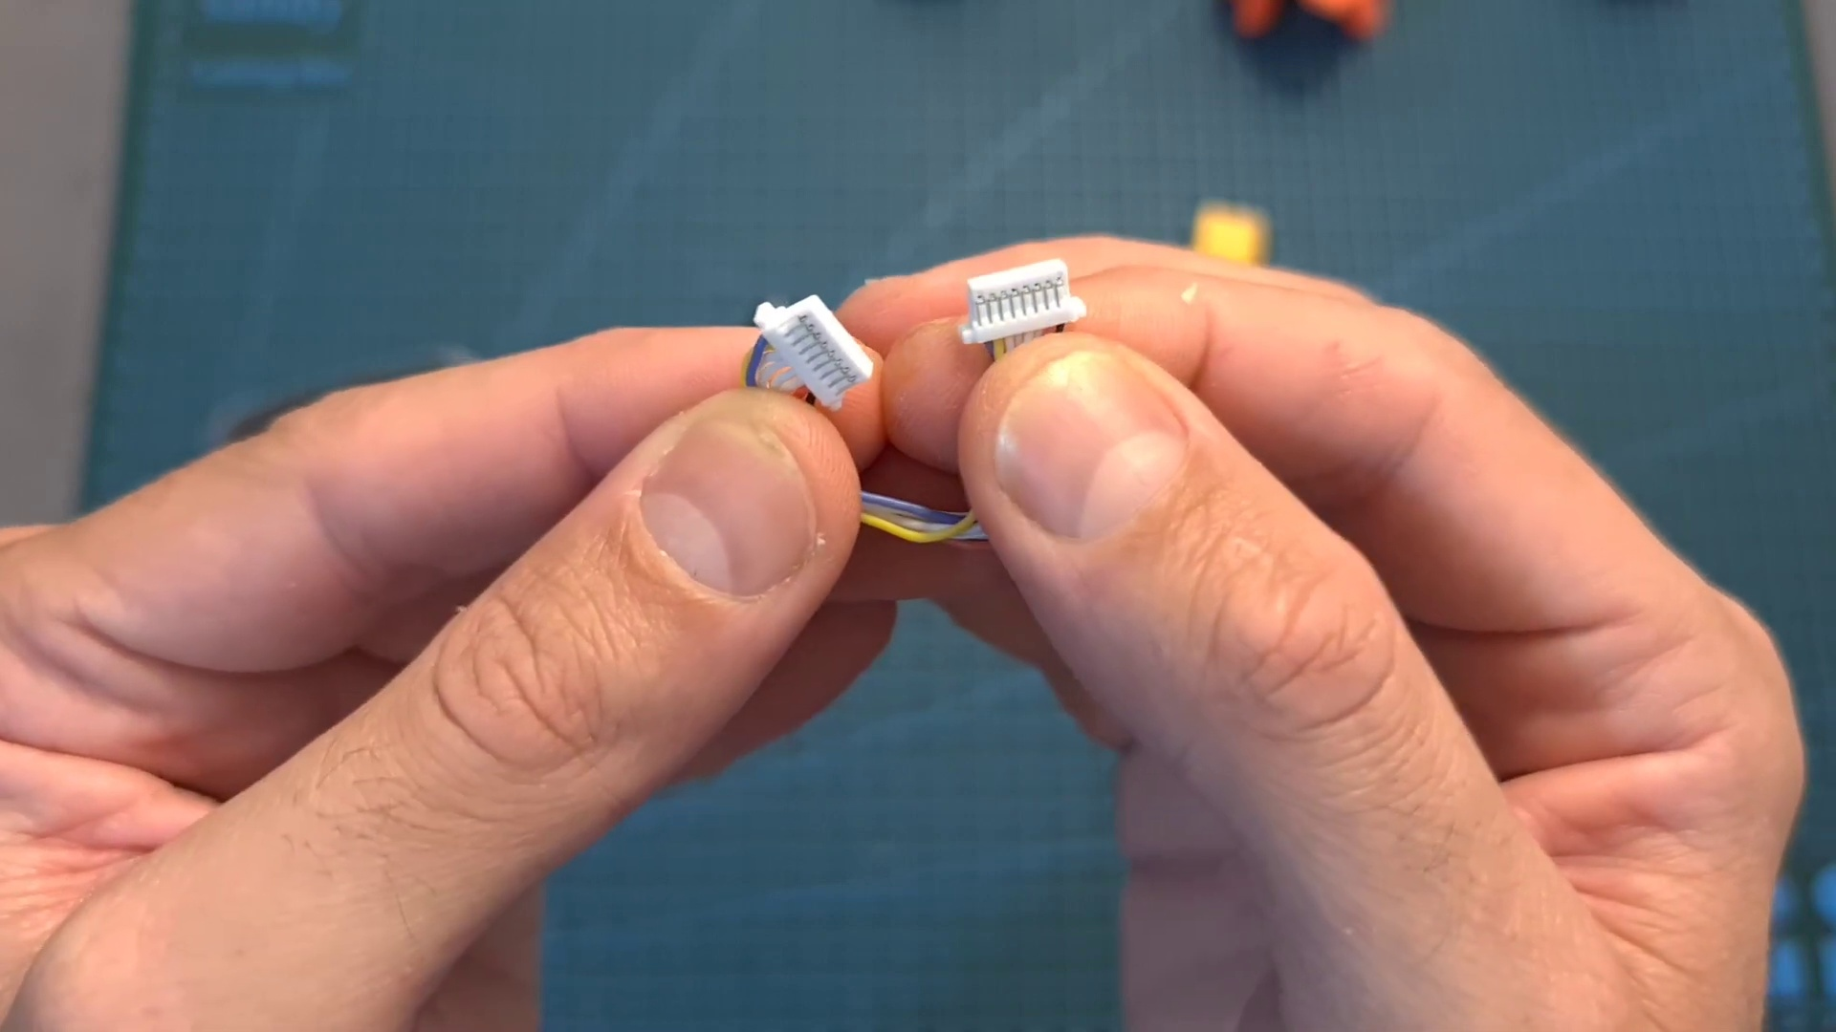 | 0:53  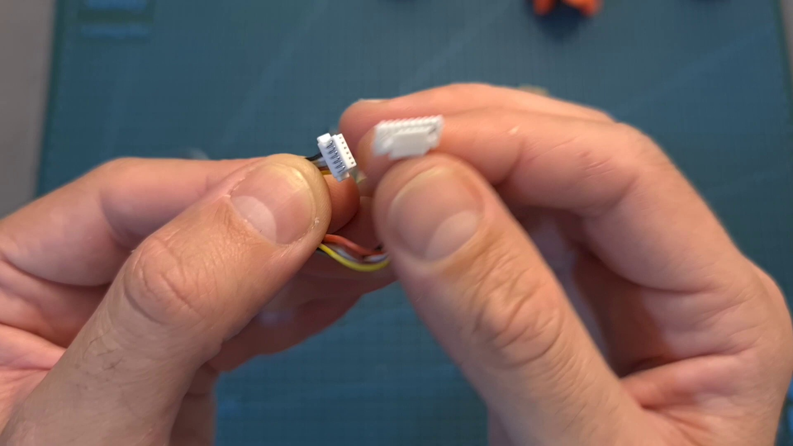 | 0:55  

Transcript
[0:46] coated wires. A harness for connecting the 4-in-1 ESC and the flight controller and a GST connector
[0:53] that will enable you to easily connect a DJI air unit. In terms of specs, the flight controller

Section 0: Cartoon Character and Thank You Message
Time: 0:58 - 1:01

Summary
The content describes a cartoon character wearing a headset on a white background, with a thank you message and subscription request.

Representative Frames
0:58  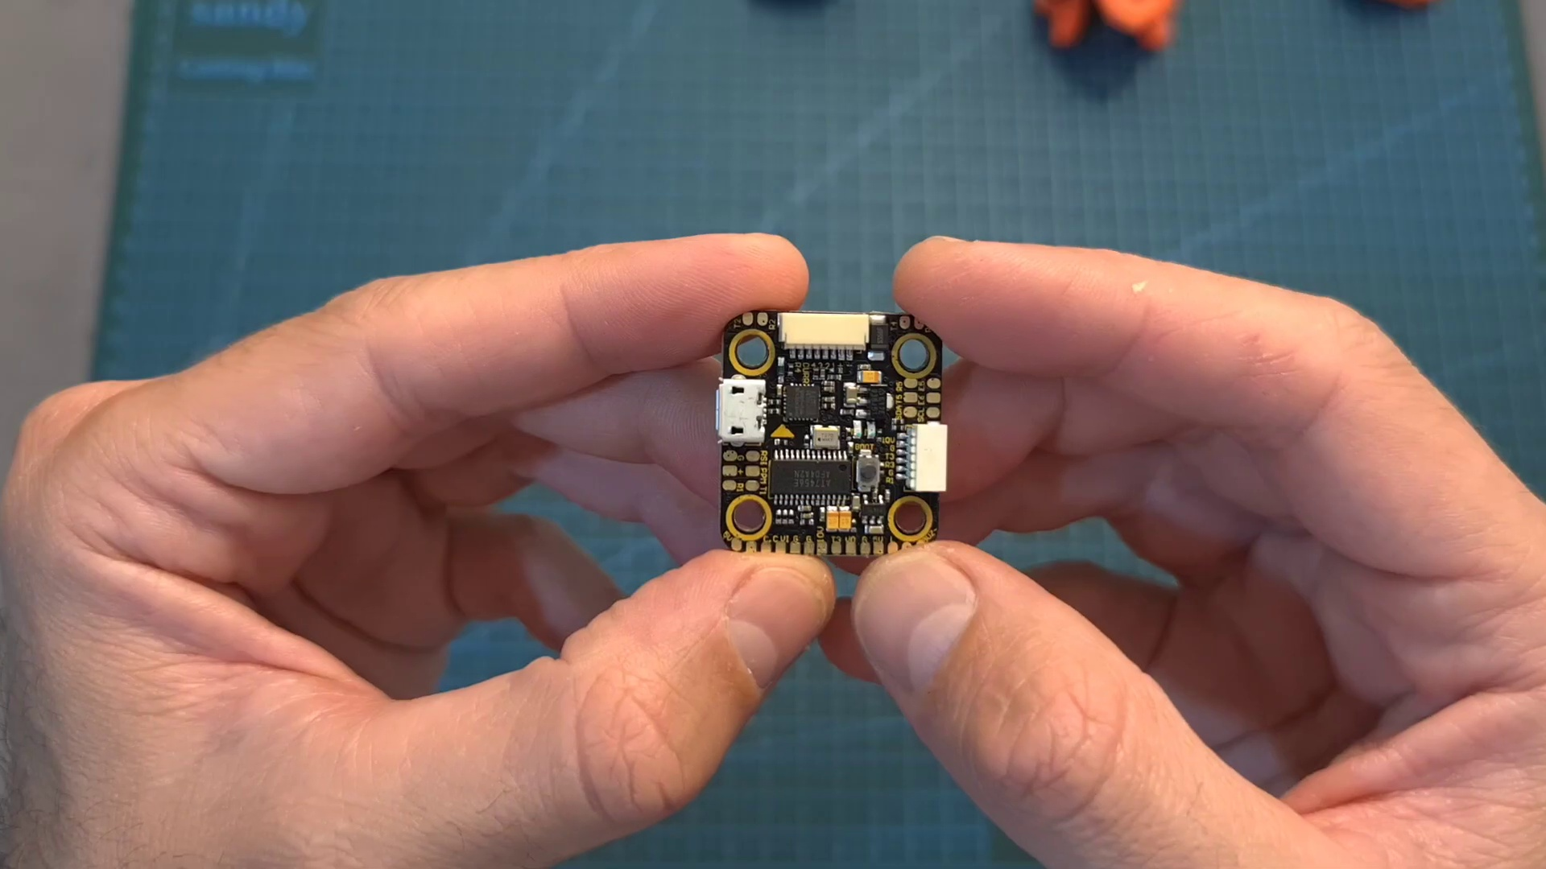 | 0:59   | 0:59   | 1:00  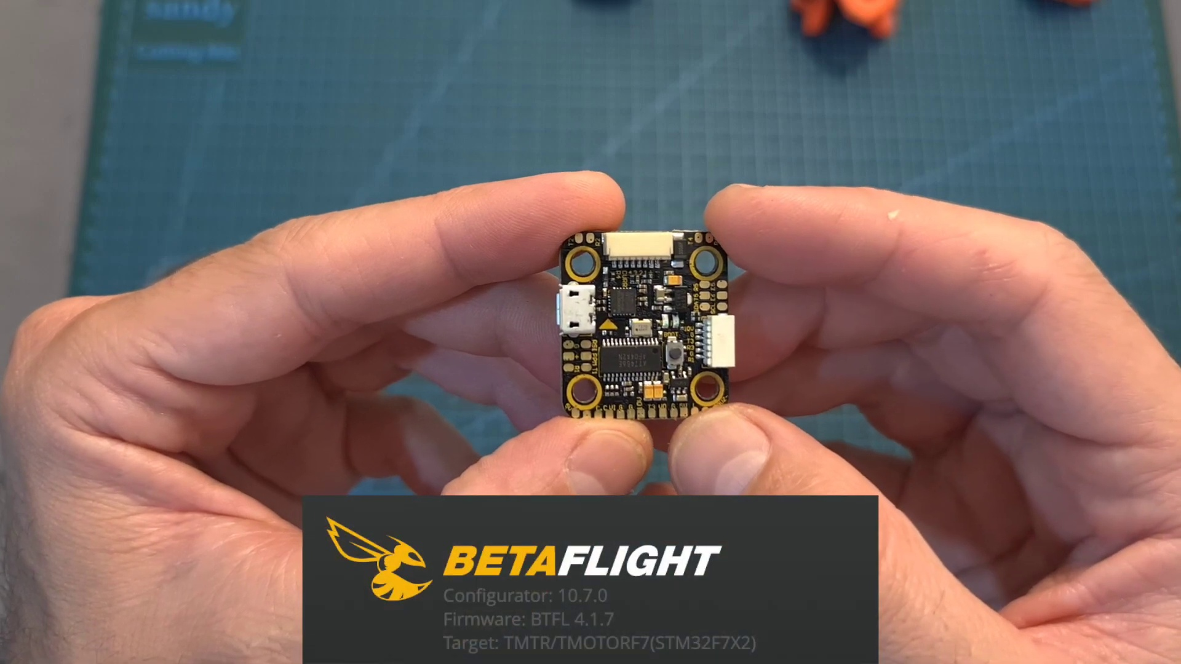 | 1:00  

Transcript
(No speech detected in this section)

Section 0: Presentation Slide with Thank You Message
Time: 1:01 - 1:05

Summary
The content describes a presentation slide with a thank you message and subscription request, including a logo or emblem on the top-right corner.

Representative Frames
1:01   | 1:02   | 1:03   | 1:03  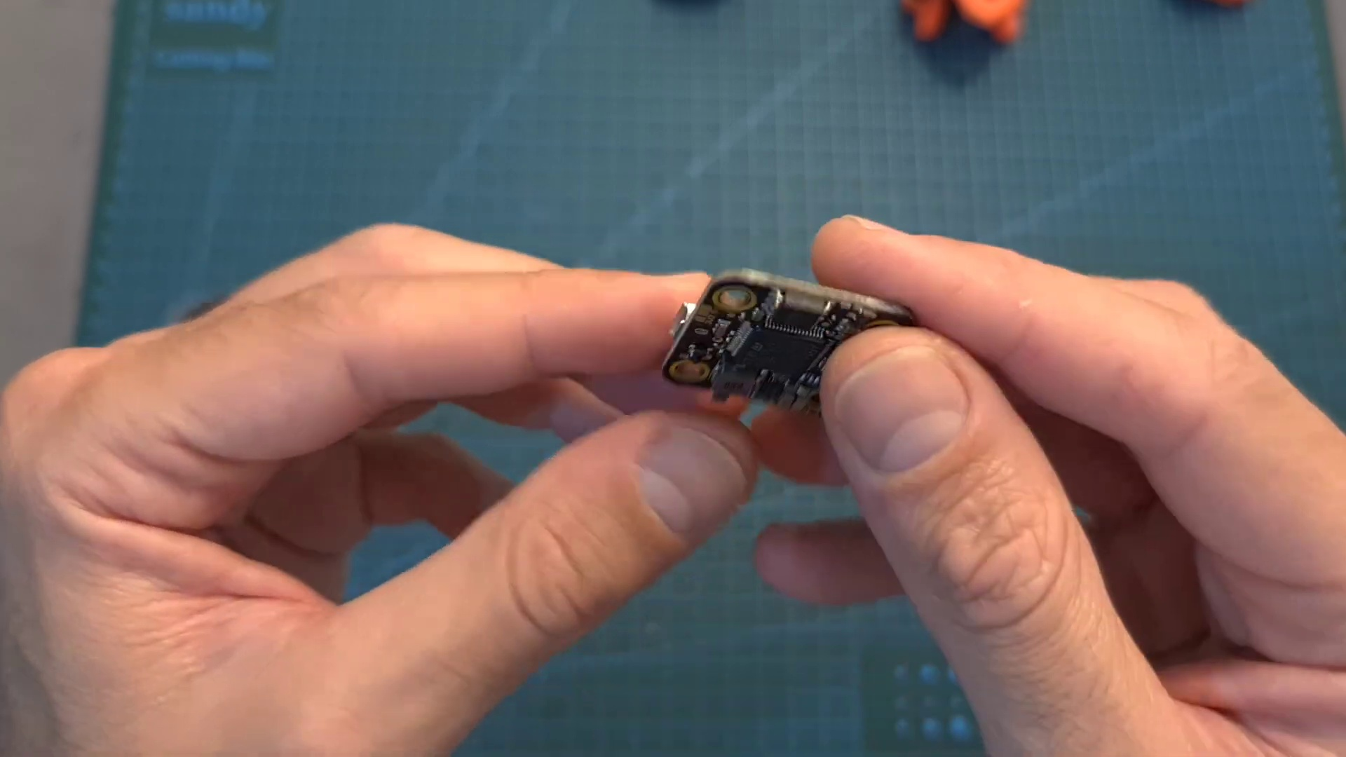 | 1:04  

Transcript
[0:59] features an F7 processor, 5 full U-out ports, in addition to a 5V BEC, a 10V BEC which is useful

Section 0: Simple Graphic Design with Thank You Message
Time: 1:05 - 1:10

Summary
The content describes a simple graphic design serving as a thank-you message, including a cartoon head wearing a headset and a call to action to subscribe.

Representative Frames
1:05   | 1:06  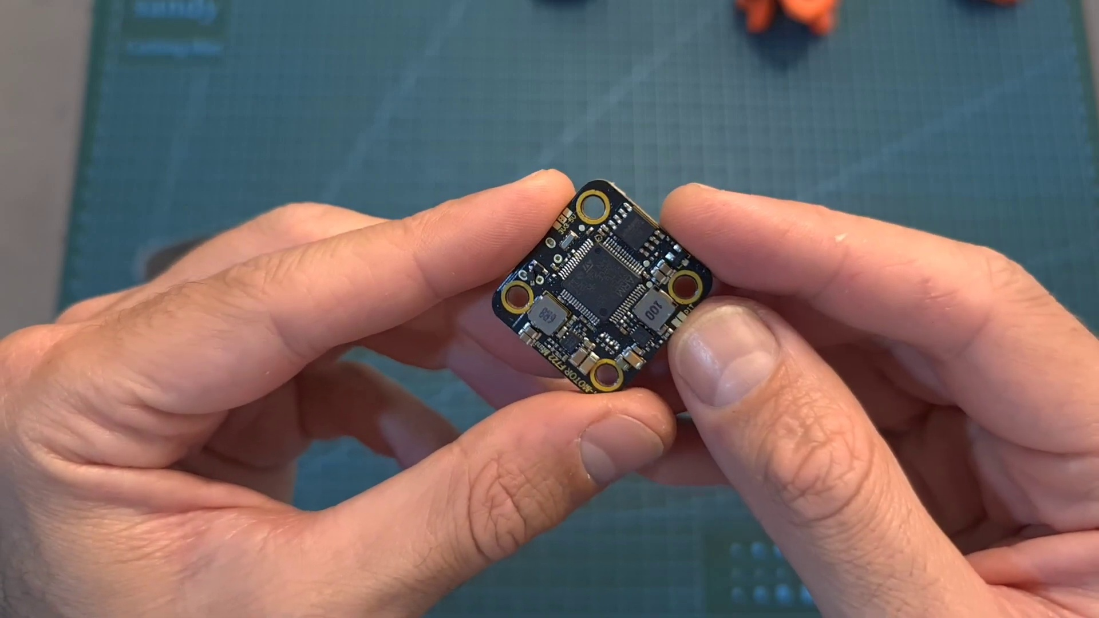 | 1:07   | 1:08   | 1:09  

Transcript
(No speech detected in this section)

