Engagement Analysis: 31ArBvYoG2Q

Section 0: Introduction to Drone Assembly
Time: 0:00 - 0:45

Summary
The content discusses drone assembly, focusing on components and tools used.

Representative Frames
0:07  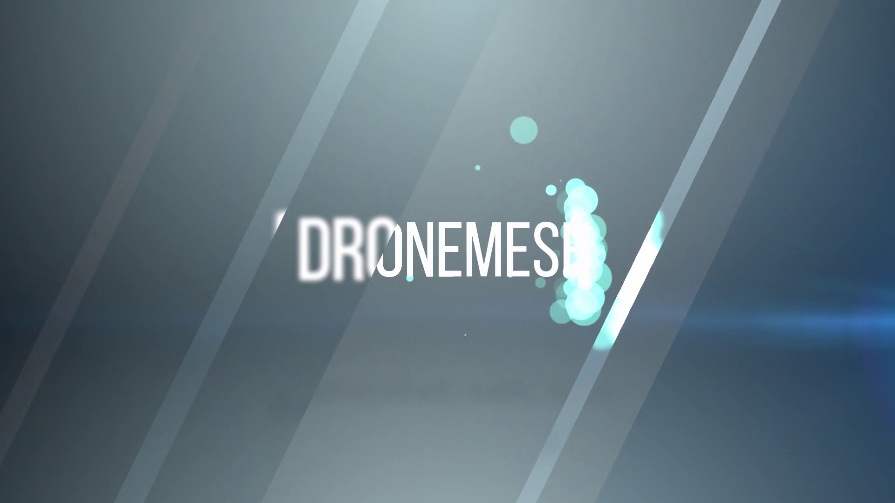 | 0:15  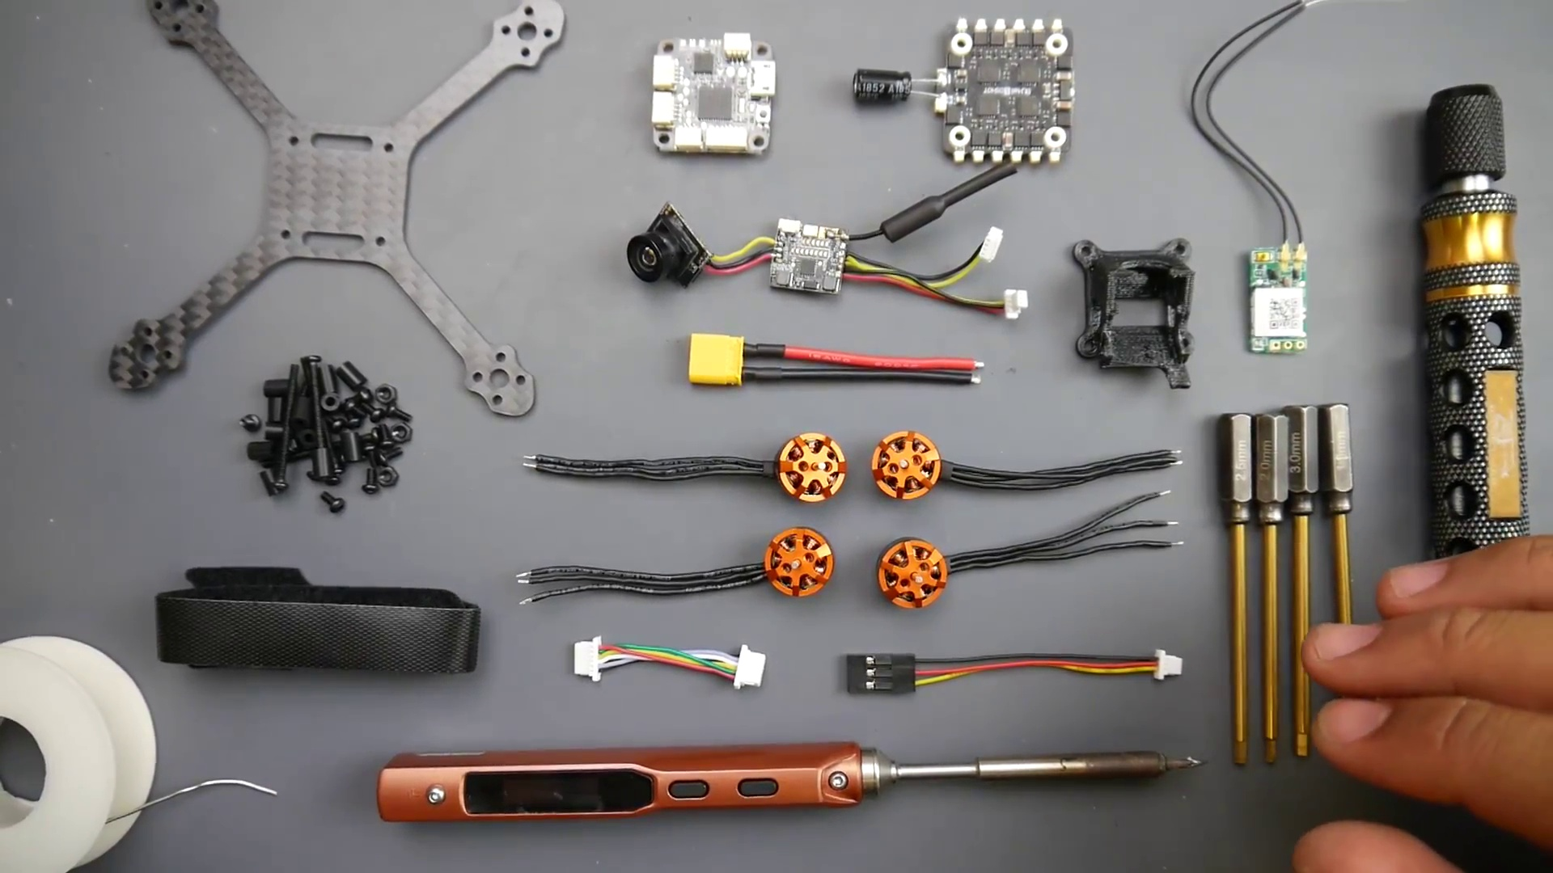 | 0:22  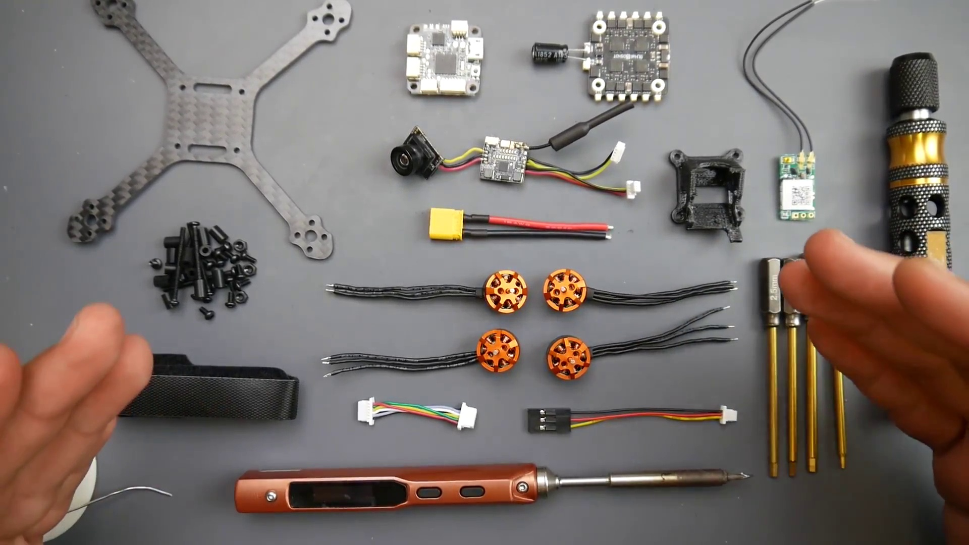 | 0:30  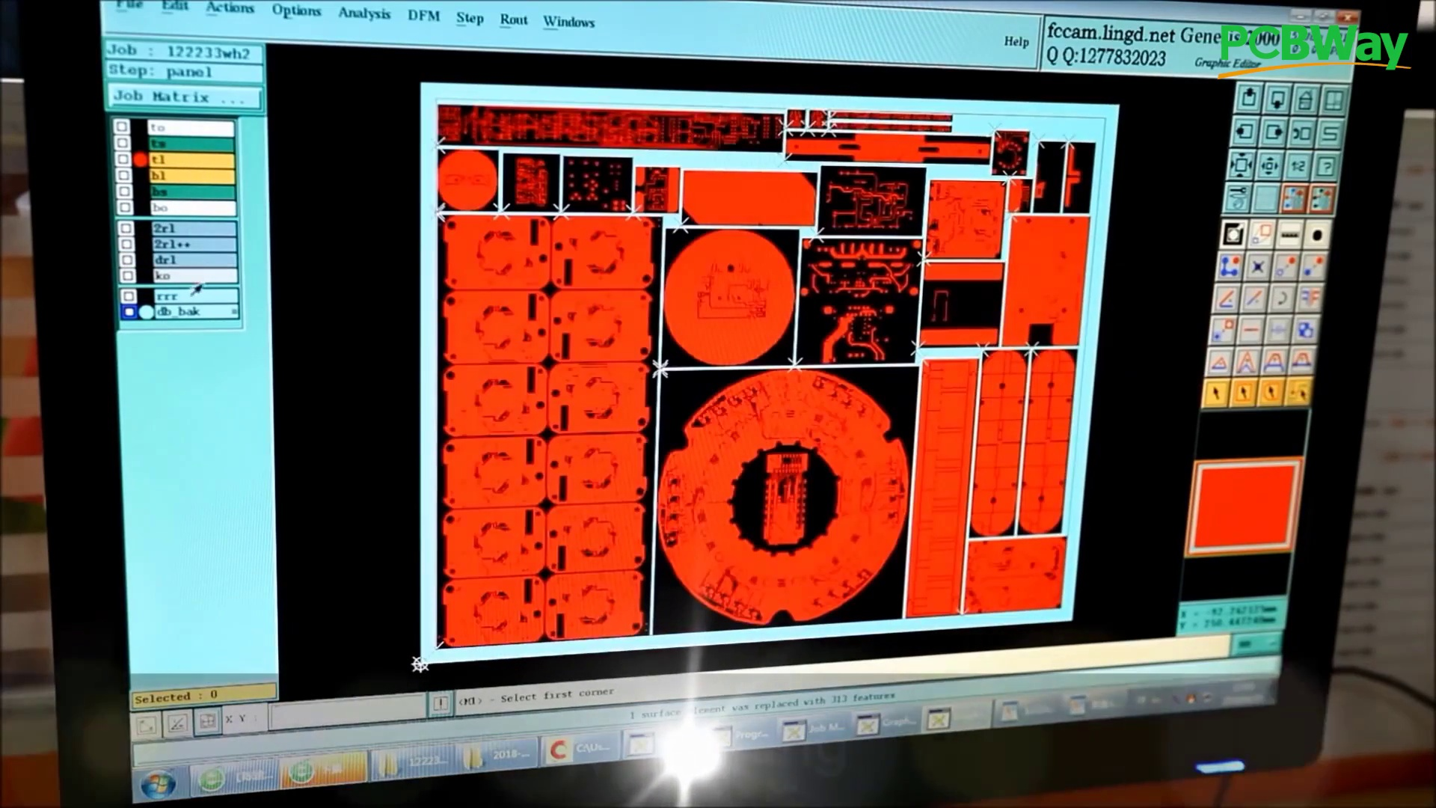 | 0:37  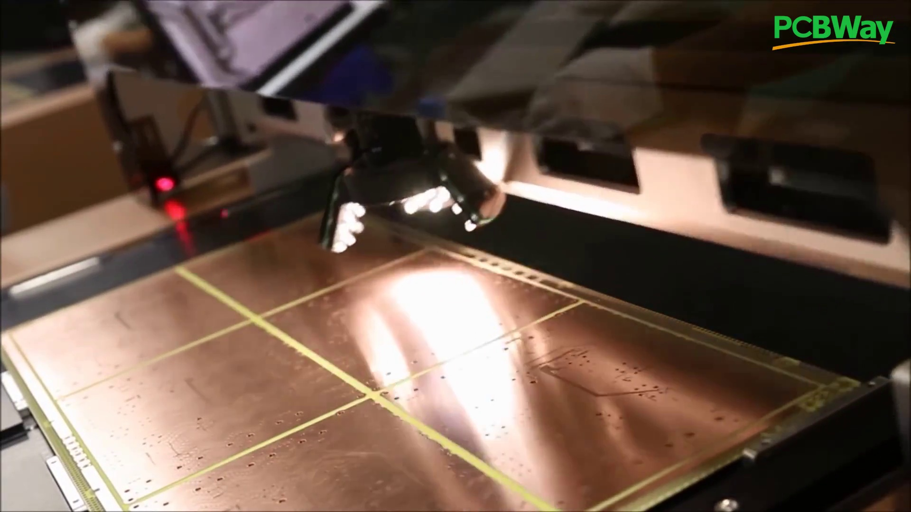

Transcript
[0:00] When I popped off, then you go gave me...
[0:03] So in this video, we're going to be building the Tyro 69 kit.
[0:15] Now, this will be a beginner's guide into how to build it, solder it, and what are good techniques to use,
[0:20] and some of the issues you might come up against and how to solve them.
[0:23] So we're going to do this together as fast, efficient, yet full of detail as possible.
[0:28] So PCBWay is one of the leading PCB manufacturers that I even use on a daily basis,
[0:33] not only to do my projects, but also some of the products that I've designed that's currently in the market,
[0:37] like the Drone Mesh VUSB, and I'm constantly using them for prototyping,
[0:42] and I'm also using their assembly services, and they also do have flashing services for specific hardware requirements.

Section 0: Component Selection and Usage
Time: 0:45 - 1:31

Summary
The content highlights the importance of selecting suitable components for drone assembly.

Representative Frames
0:53  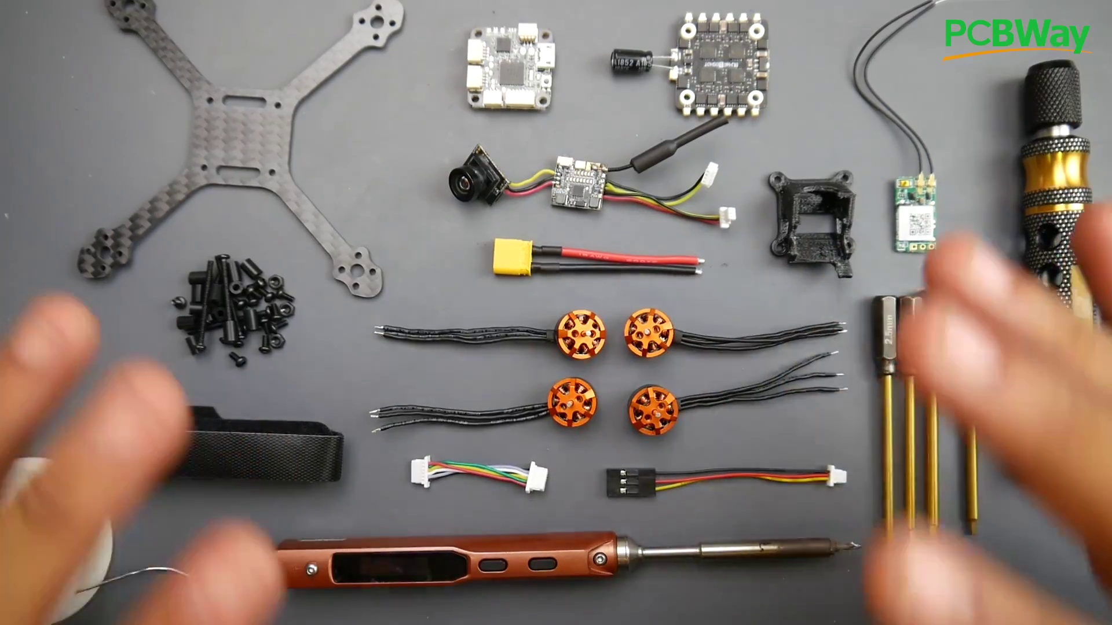 | 1:00  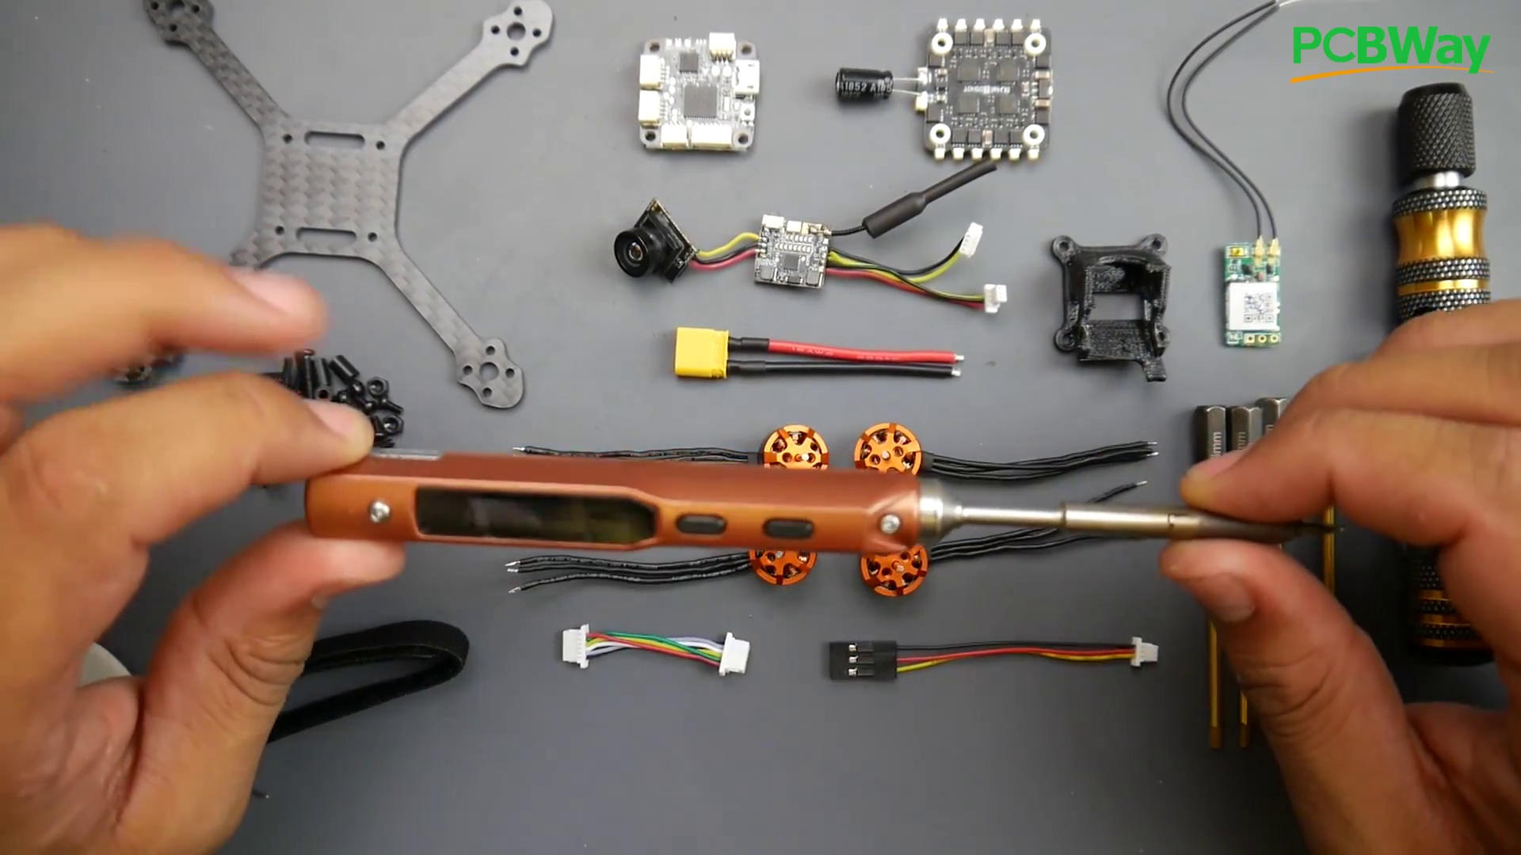 | 1:08  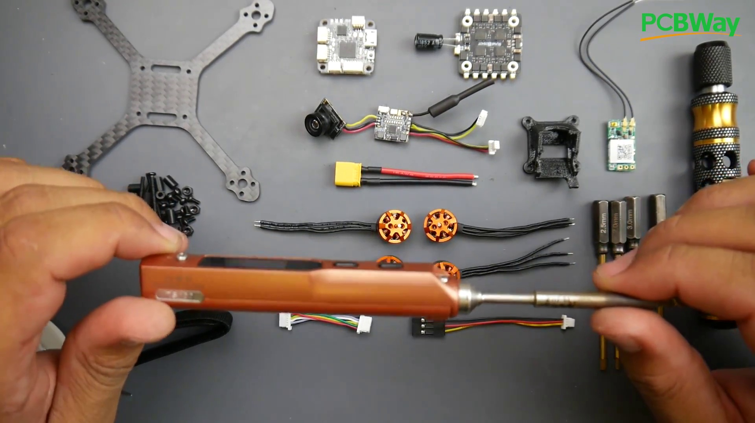 | 1:15  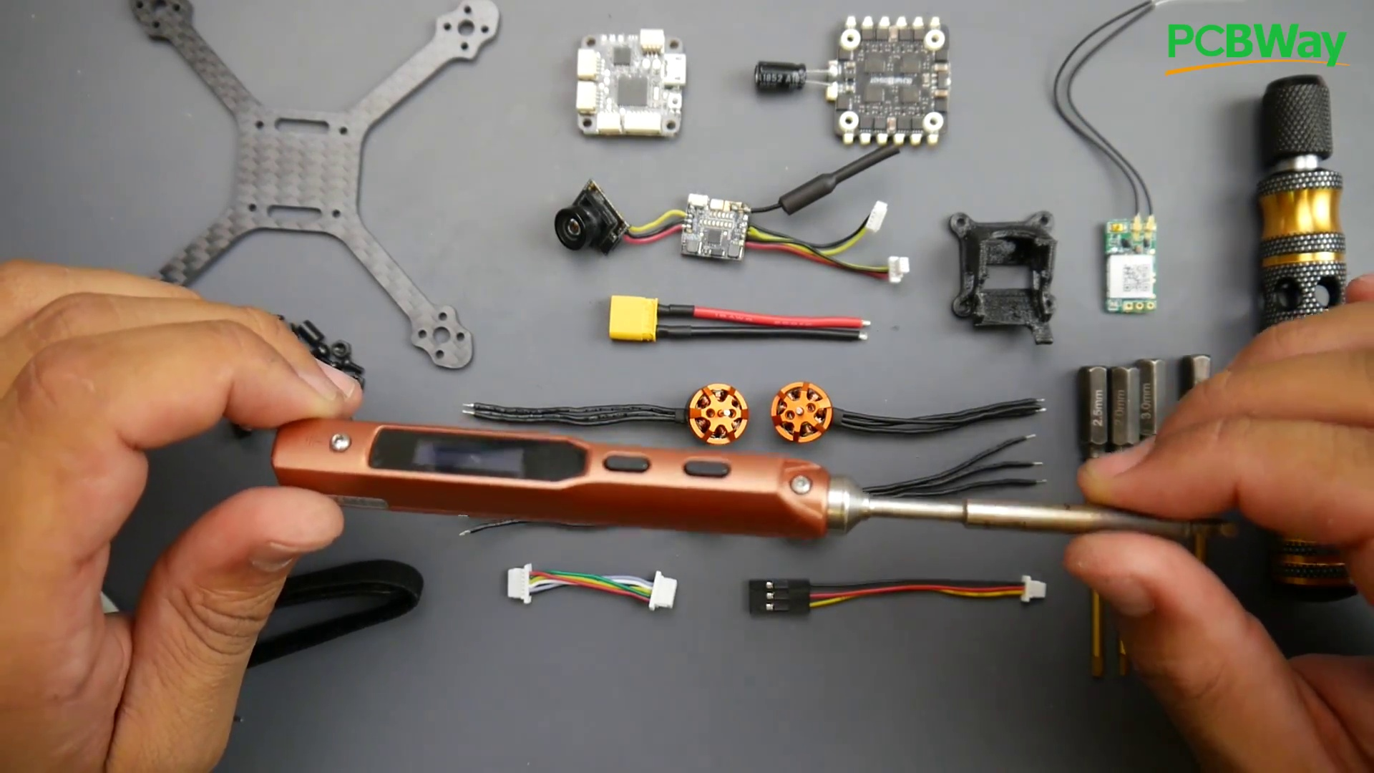 | 1:23  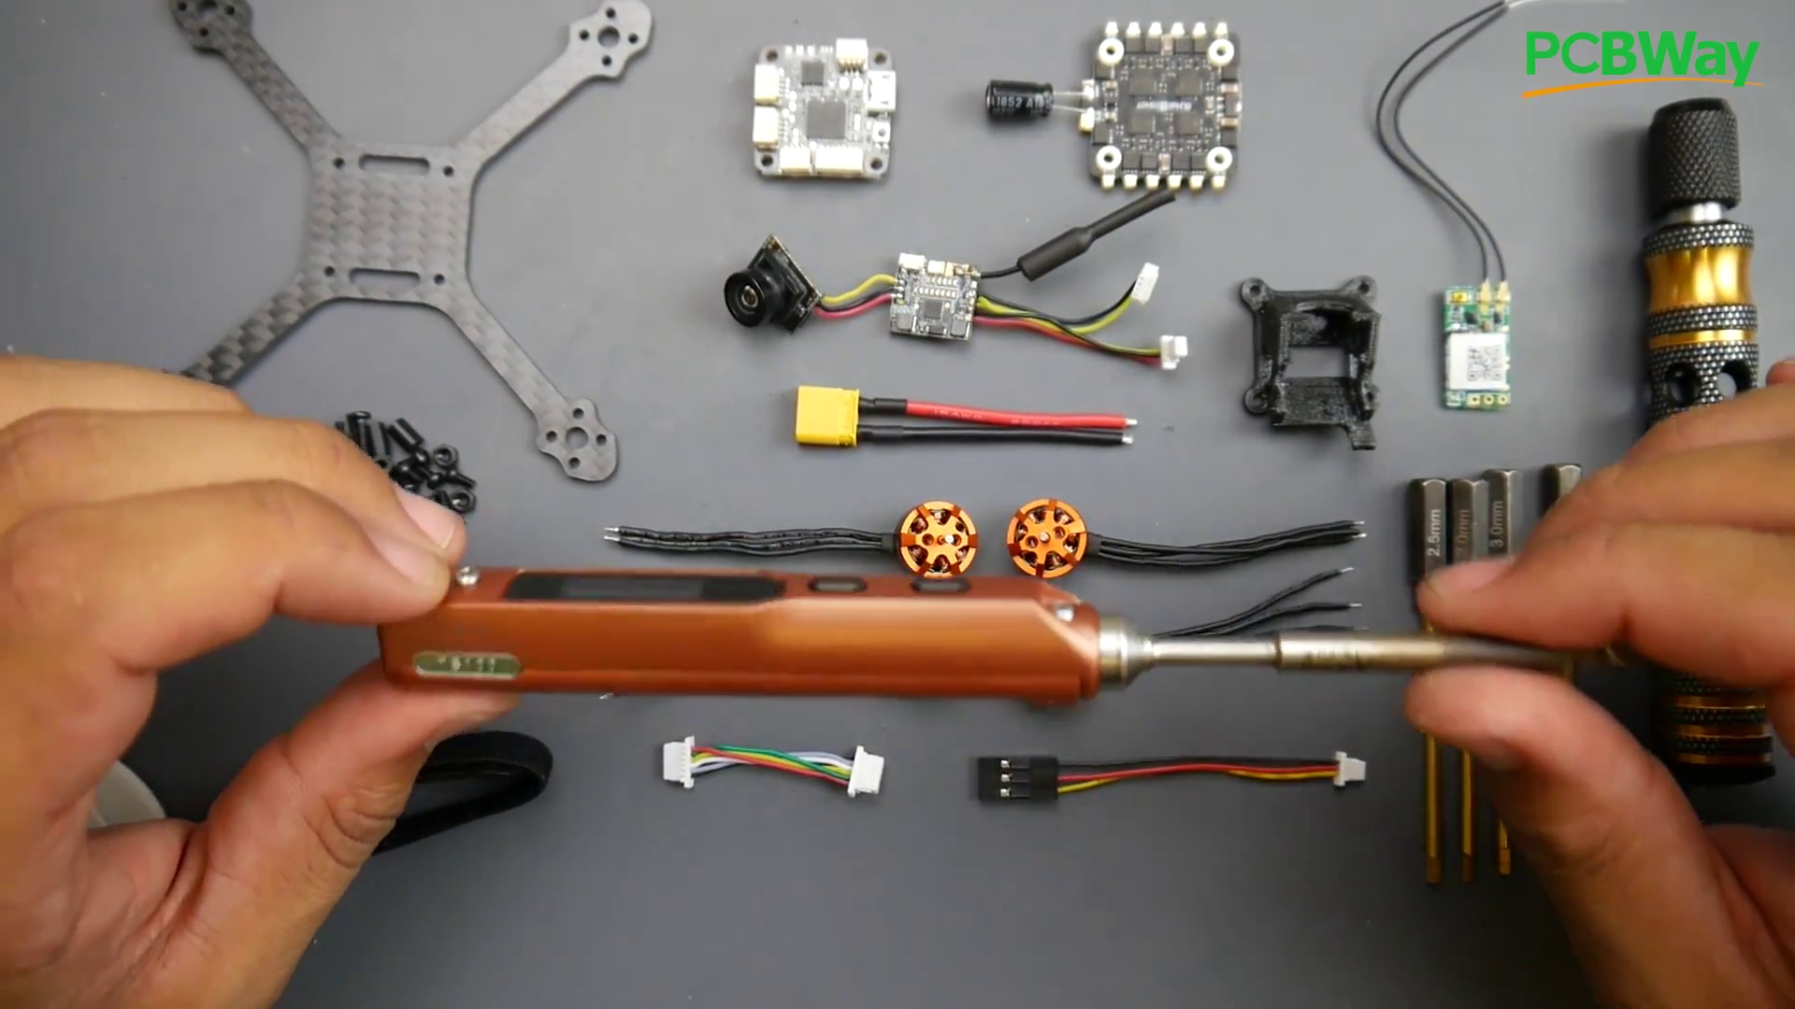

Transcript
[0:47] So it's a really great place to have your PCB manufactured or prototyped.
[0:51] All right, so let's talk about some of the tools we're going to need, because we're not going to really need much,
[0:54] and also some tools I'd highly recommend, which have dropped in price pretty insane.
[0:59] So this right here is a soldering iron. This is a portable soldering iron.
[1:02] This thing used to go for $80, $90. That's when I got mine, and right now it's like $40 or $50.
[1:08] This is the thing that I carry with me to the field always.
[1:11] I replaced big motors, big XC60, and I'd highly recommend this little tool, and it can run as your main driver.
[1:19] I've had this running as my main driver before, because it is just a well-built beast, and anybody would tell you that.
[1:25] So for this build, we're actually going to be using this to show you how good it actually is,

Section 0: Drone Assembly Process
Time: 1:31 - 2:16

Summary
The content provides an overview of the drone assembly process, including steps and precautions.

Representative Frames
1:38  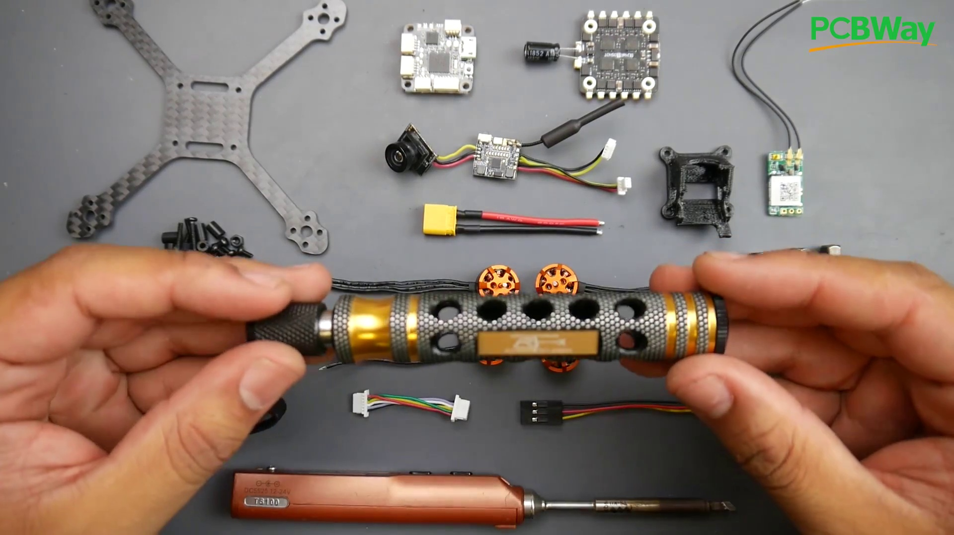 | 1:46  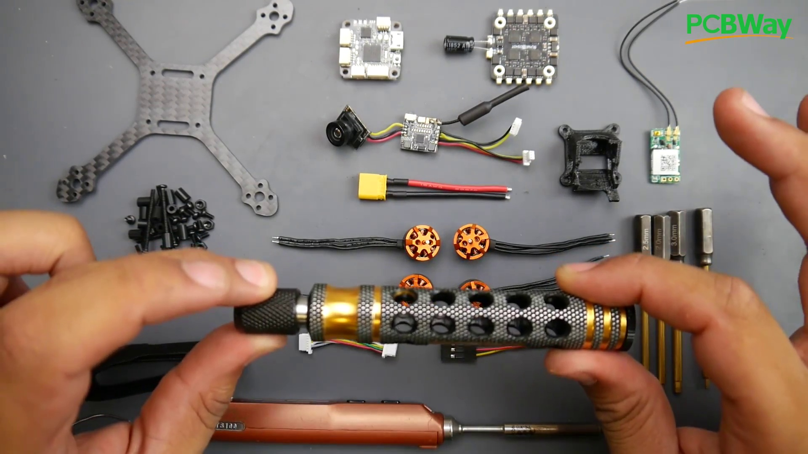 | 1:53  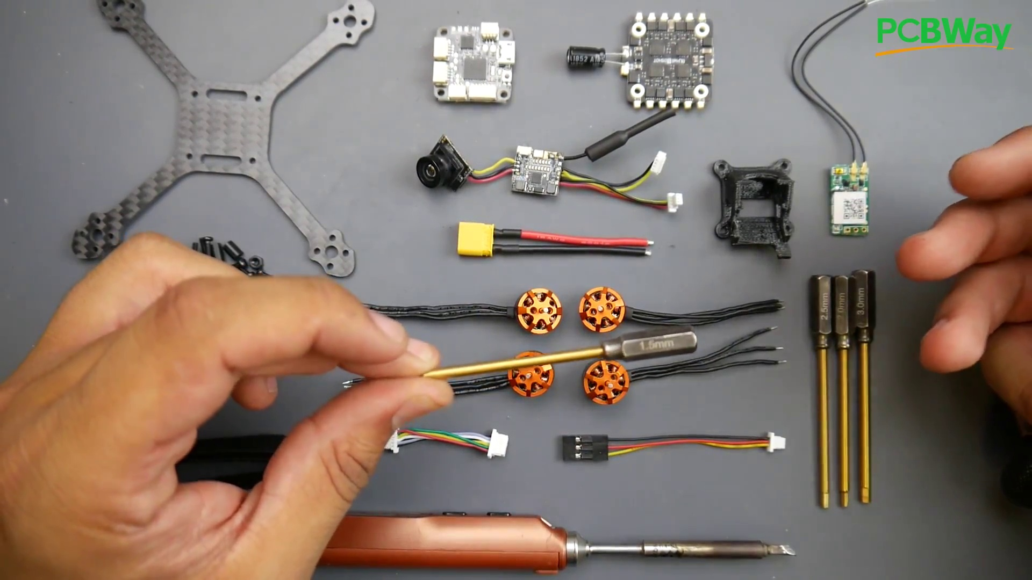 | 2:01  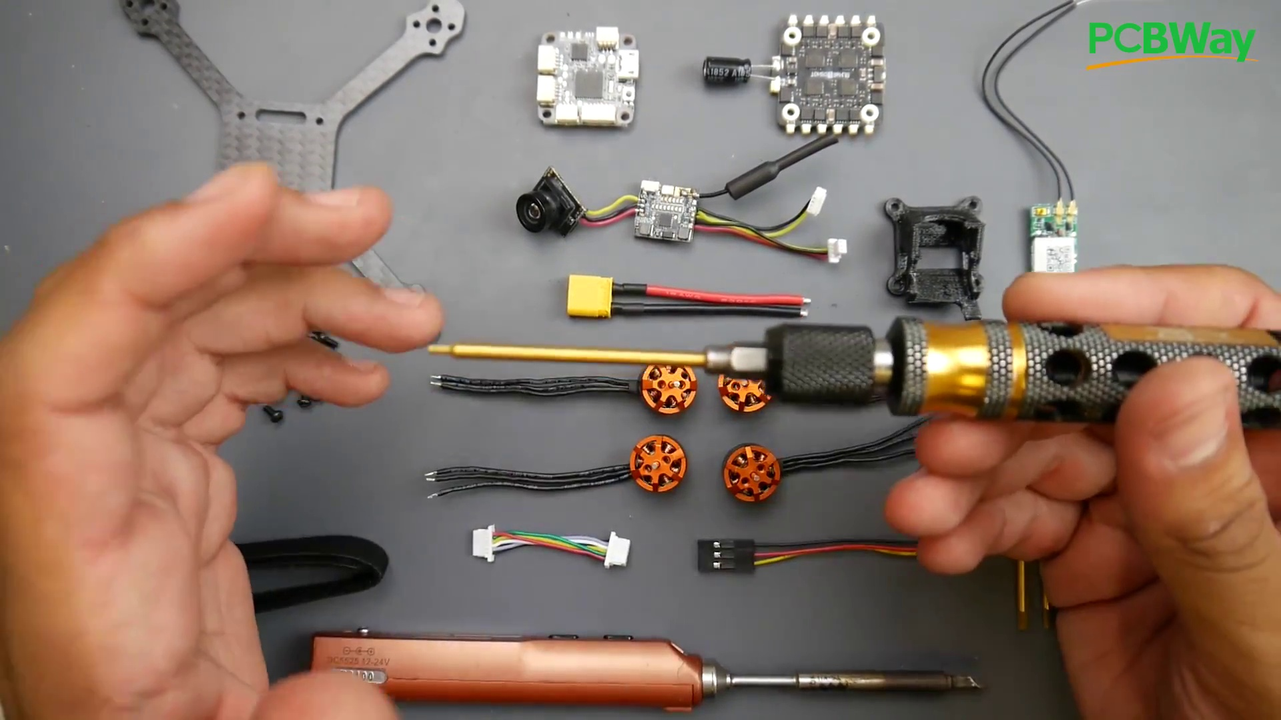 | 2:08  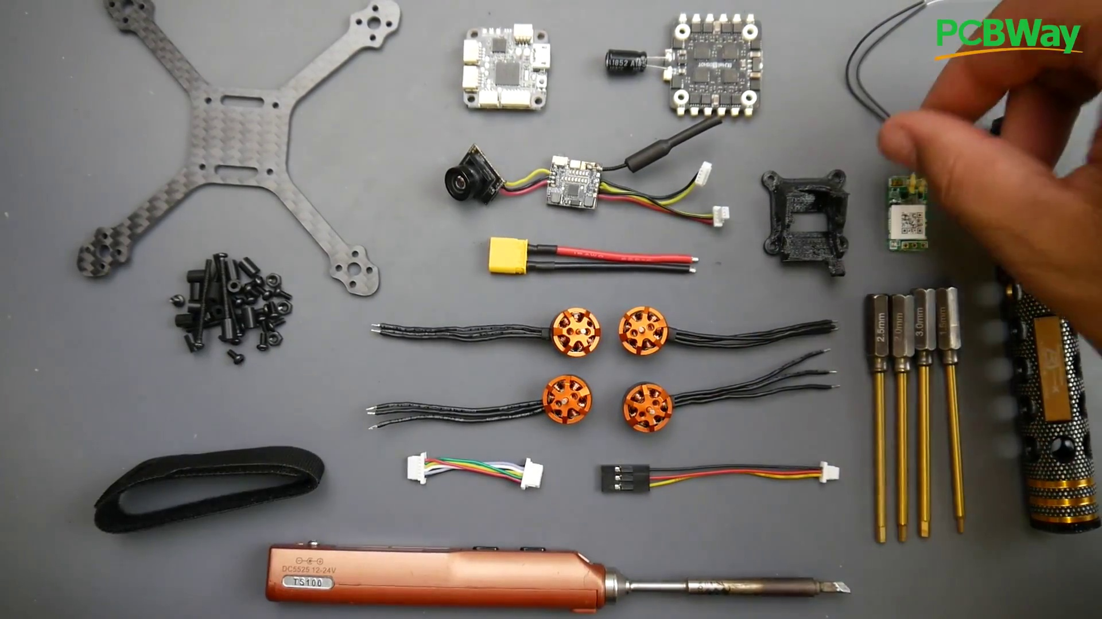

Transcript
[1:29] and we're using this flat tip that it comes with. This will be really good, especially for this small stuff right here.
[1:34] Also, something that's not included in the kit is the tools.
[1:37] I do highly recommend this tool right here. I've been using it for quite a while.
[1:40] You'll probably see it in a couple of my videos.
[1:42] If you are thinking of getting into drones, this is a must-have tool, because this is titanium-coated,
[1:47] and these are hex drivers, and every single size you're going to need, which is 1.5mm all the way up to 3mm.
[1:53] Usually, all micros are 1.5mm, and that's the only thing we're going to be using for this whole build.
[1:58] So we're just going to stick this one on and take it out, and especially in the field, this is very useful,
[2:02] because it takes less space, so you just carry those and then just put them in here.
[2:06] Next thing that we're going to need, which they don't provide, is a receiver.
[2:09] Now, I'm going to be using the XM Plus radio here.
[2:12] If you're using FlySky, then they have other receivers.

Section 0: Component Maintenance and Repair
Time: 2:16 - 3:02

Summary
The content discusses maintenance and repair procedures for drone components.

Representative Frames
2:24  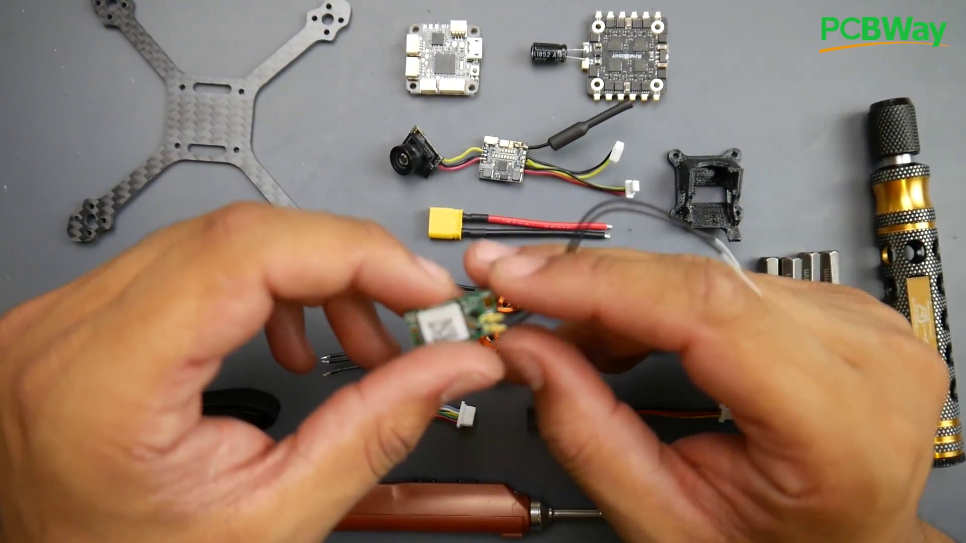 | 2:31  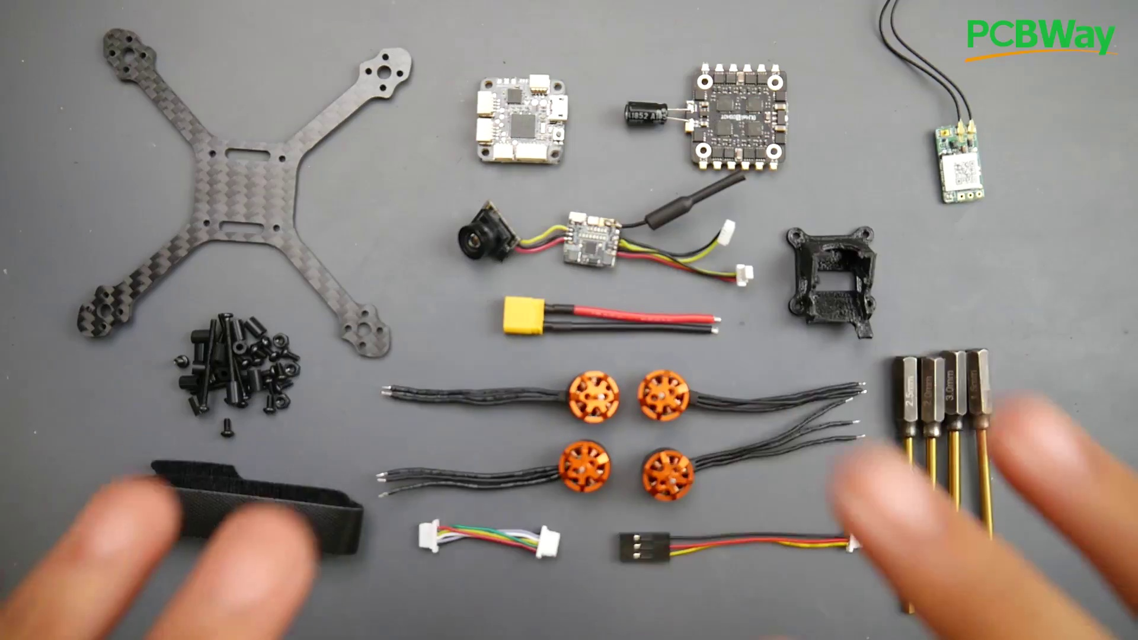 | 2:39  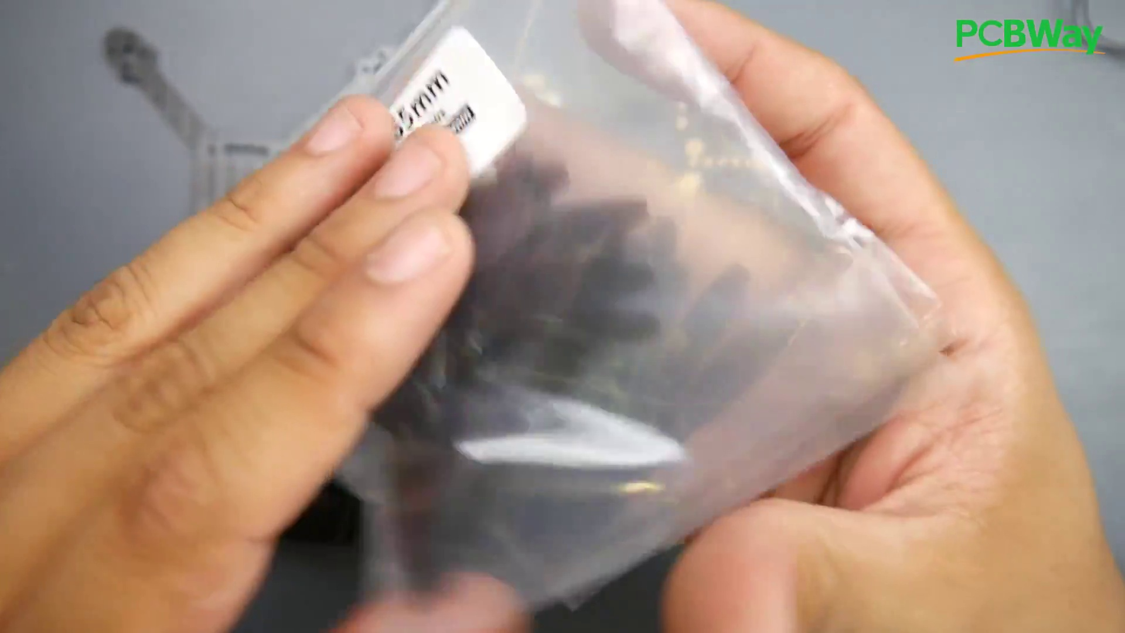 | 2:46  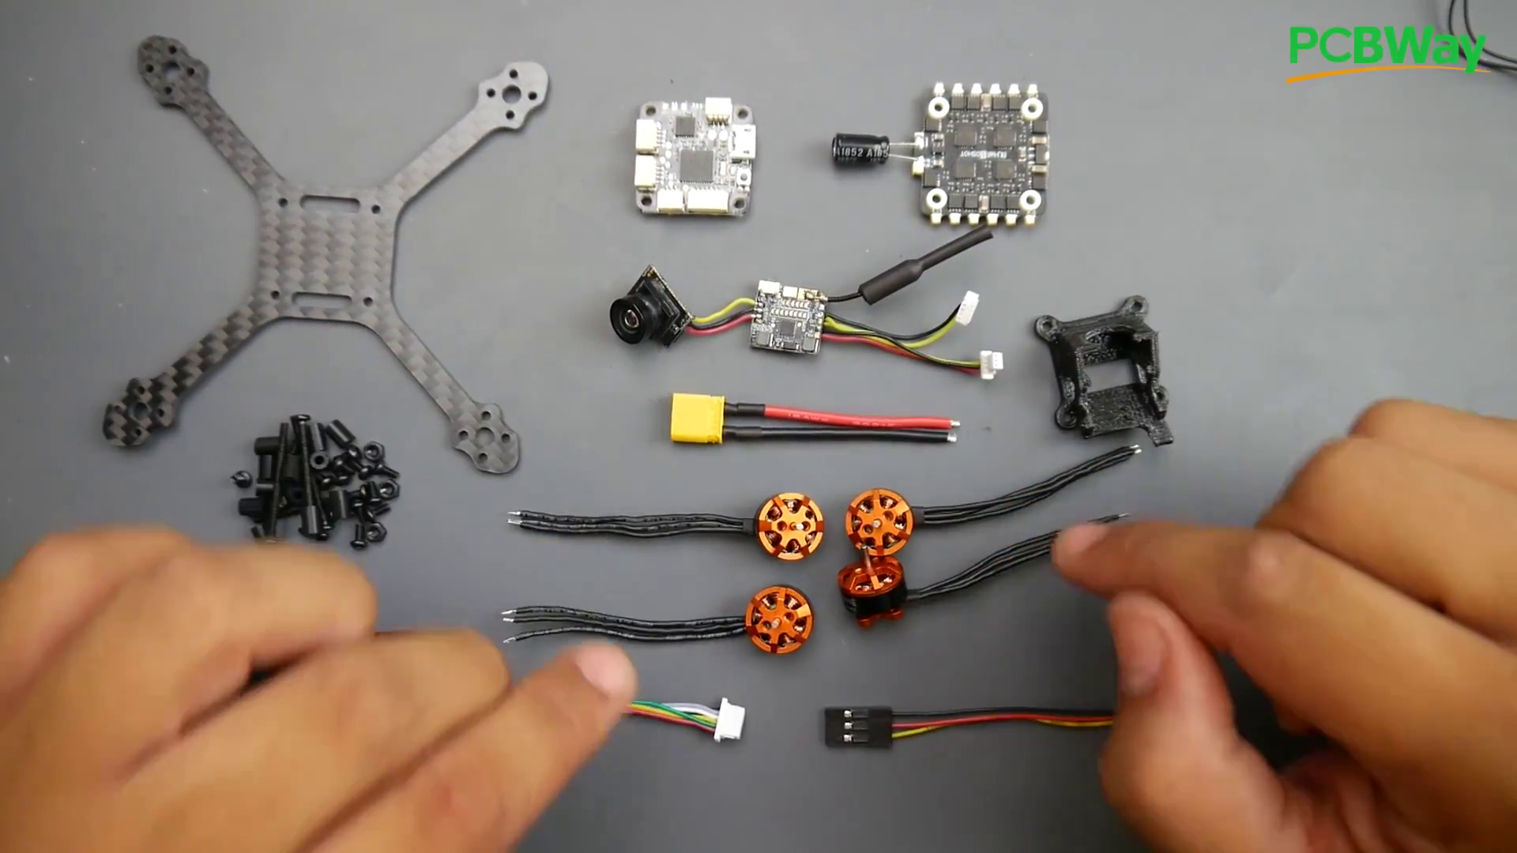 | 2:54  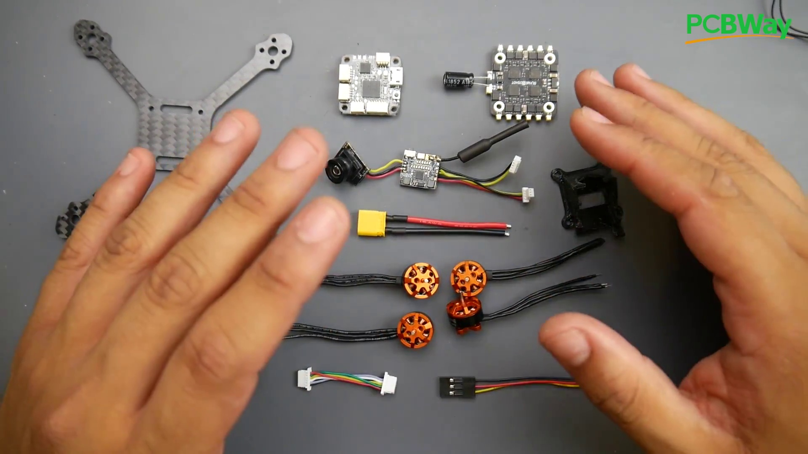

Transcript
[2:15] However, I'll have some iBus receivers, which are FlySky receivers linked down below,
[2:19] and I'll also have some FRSky receivers for the FRSky system.
[2:24] So again, I'm using XM Plus.
[2:25] They're super cheap.
[2:26] They get great distance and really great to use overall.
[2:30] All right, so now let's take a closer look at what the package actually gives you.
[2:33] It gives you a bunch of propellers, which is something you're going to need,
[2:36] and that's quite a lot, which is really nice, and they've also labeled them for you.
[2:39] So this would be the R.
[2:40] This would be the normal, and we'll get into how to place these in a bit.
[2:44] Now, they provide you with the four motors, almost cut to the exact length you'll need,
[2:48] but I'm going to show you a nice trick to keep it super clean
[2:50] and reduces your chance of actually ruining something when soldering these motors.
[2:55] So they give you the motors.
[2:56] They're 1105, 8,500 kV.
[2:59] Sorry, 1104, 8,500 kV.

Section 0: Final Assembly and Testing
Time: 3:02 - 3:47

Summary
The content covers the final assembly and testing of the drone.

Representative Frames
3:09  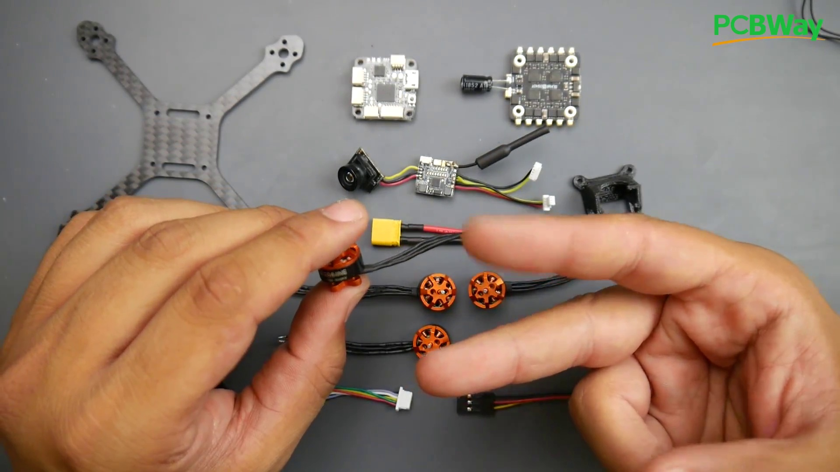 | 3:17  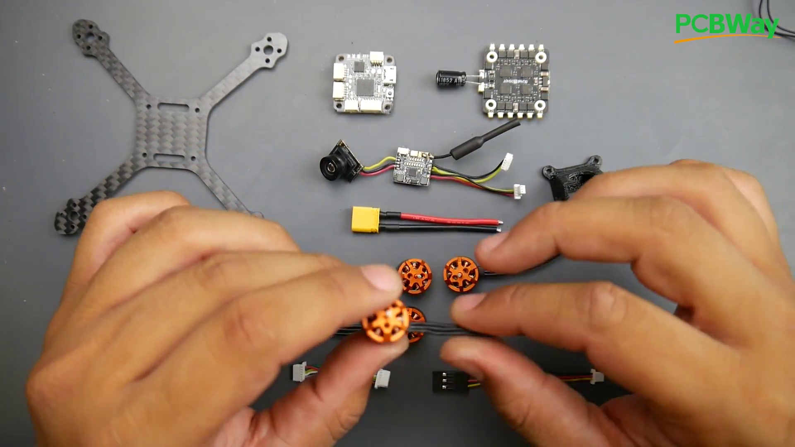 | 3:24  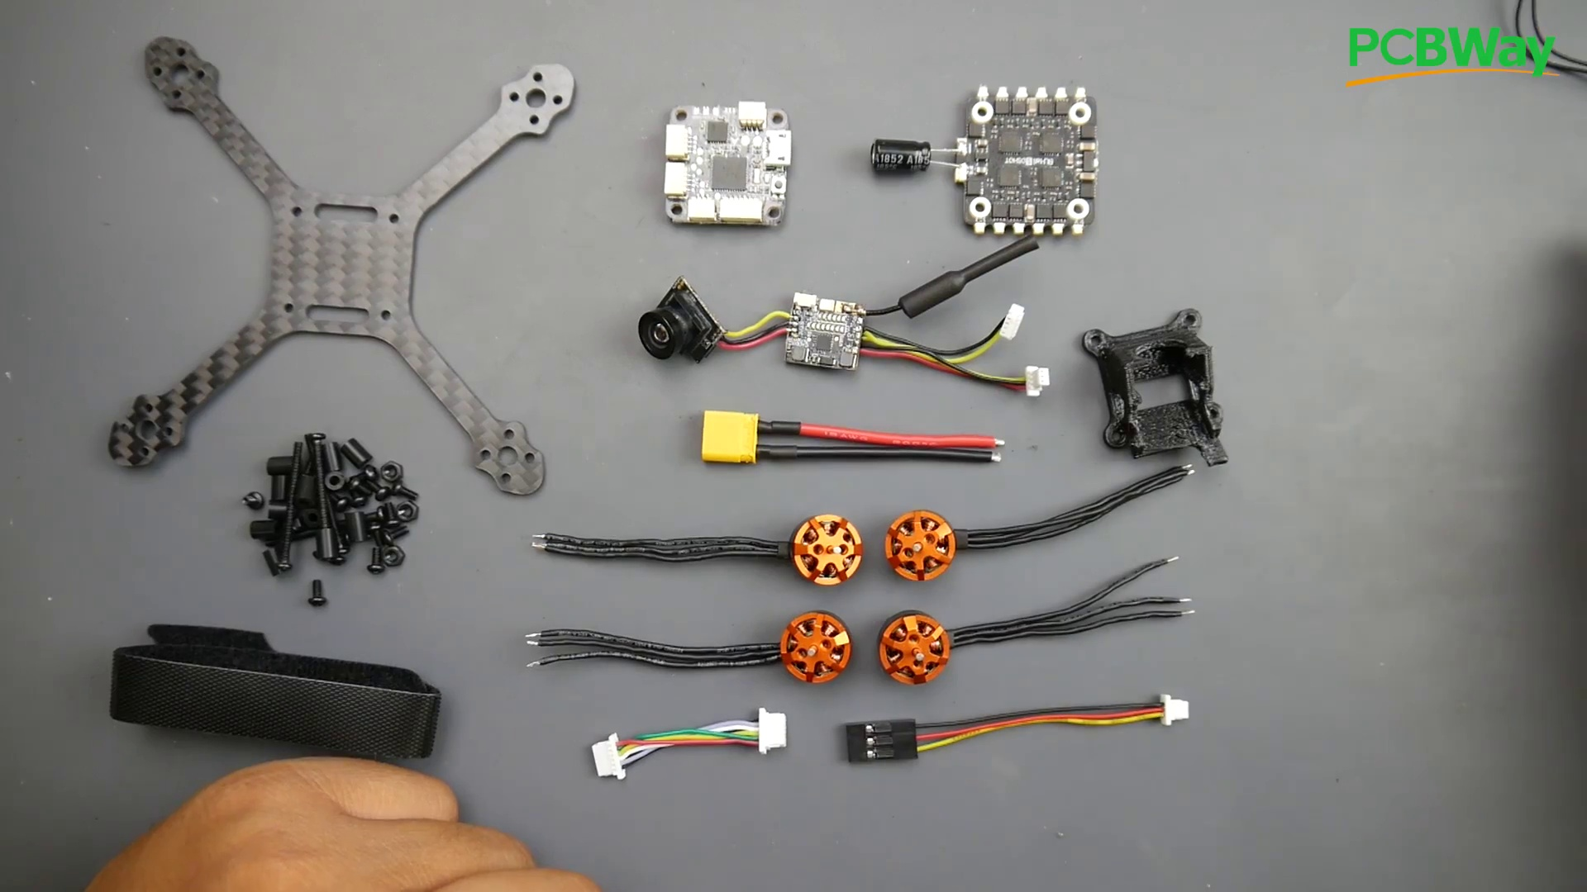 | 3:32  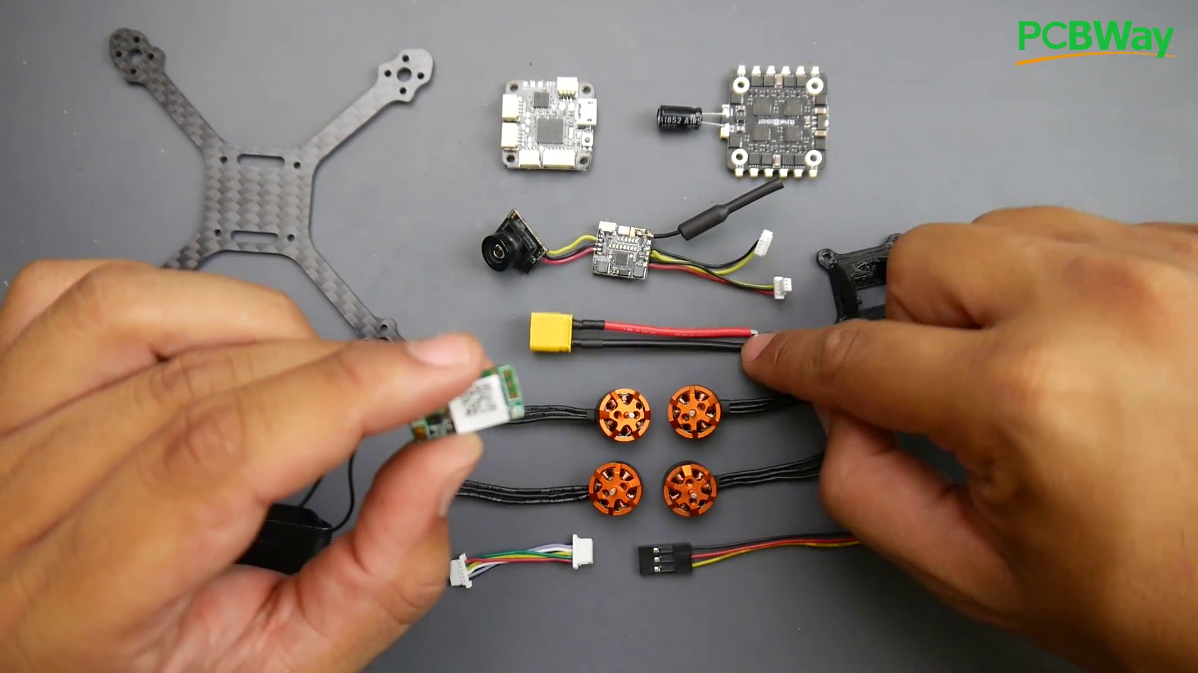 | 3:39  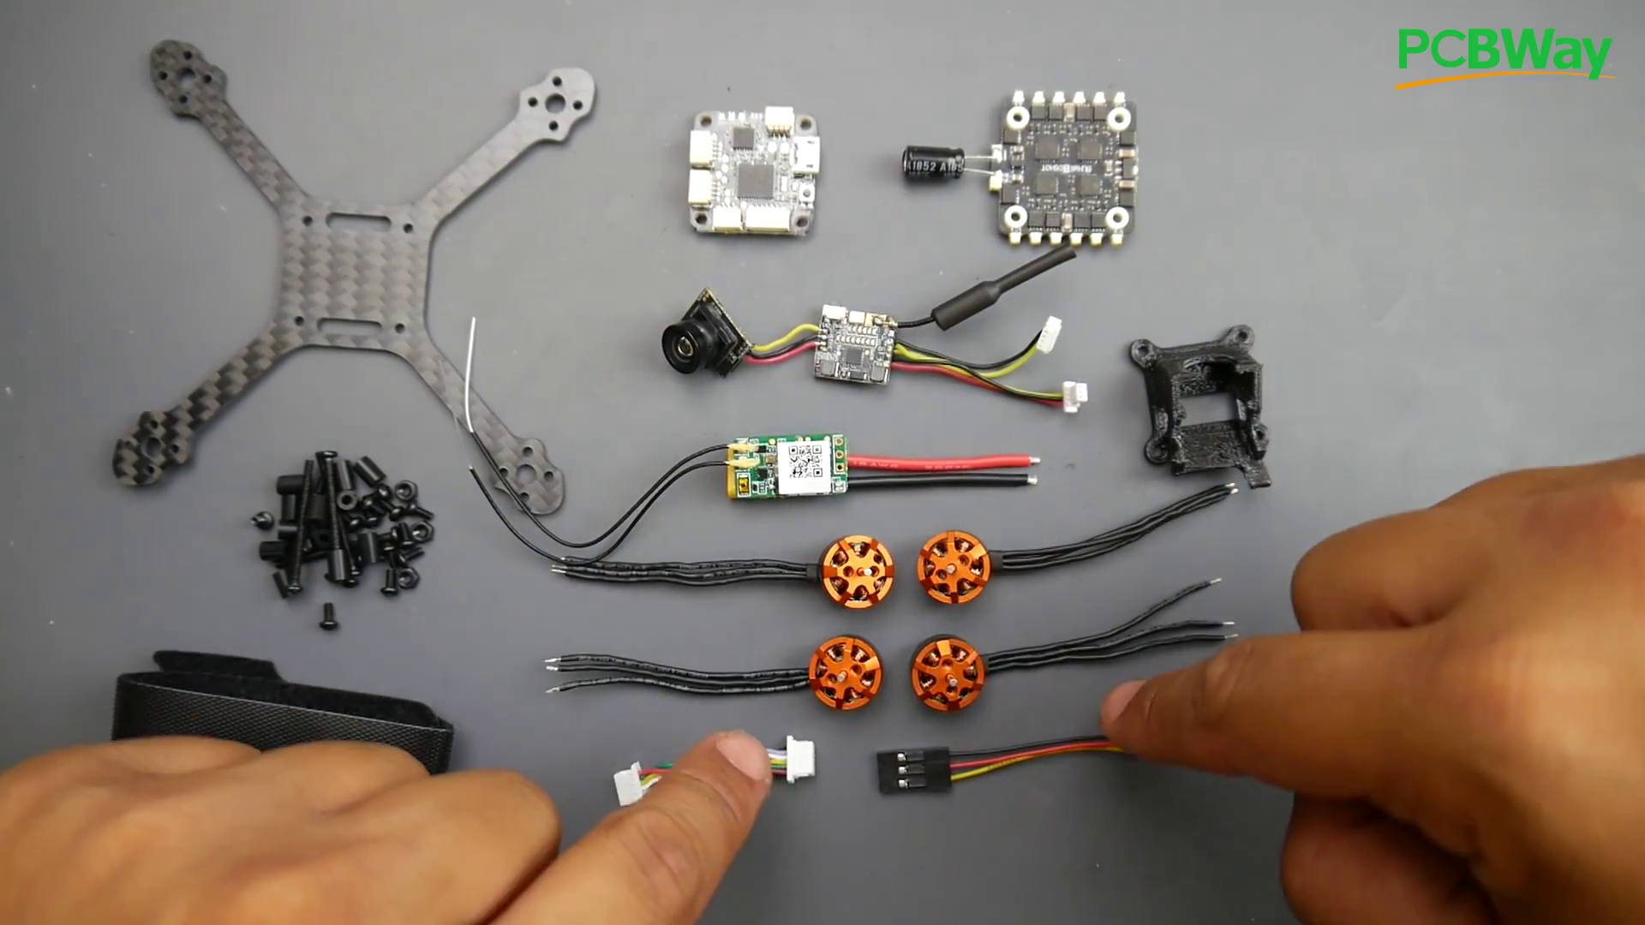

Transcript
[3:02] And the 8,500 kV is what I consider the sweet spot for these types of builds
[3:06] because you can run either a 2SHV or a 3SHV and still enjoy and get a bunch of efficiency.
[3:12] I will also have these motors tested on my benchmark in a later video
[3:15] so we can compare it to the other motors in the market.
[3:18] Now, they will give you every single connector you're going to need,
[3:20] and what's really nice about this, you're not going to have to solder much.
[3:23] All you're going to have to solder is your receiver, the XT30, and the motors, and that's about it.
[3:30] So here we have three wires, five, so with the two here, so that's five wires.
[3:34] And then here we have three times three, which is, oh, sorry, three times four, which is 12.
[3:39] So we have a total of 17 things to solder, and everything else is using connectors.
[3:44] So also something really nice with the kit is they give you the camera already pre-soldered and ready

Section 0: Conclusion and Resources
Time: 3:47 - 4:33

Summary
The content concludes with a summary of the assembly process and provides additional resources.

Representative Frames
3:55  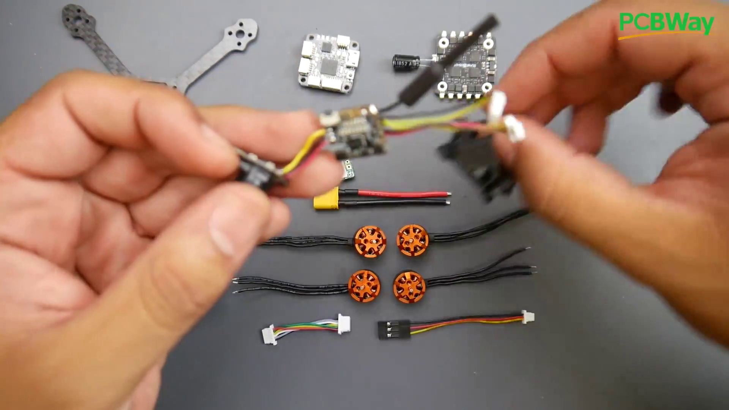 | 4:02  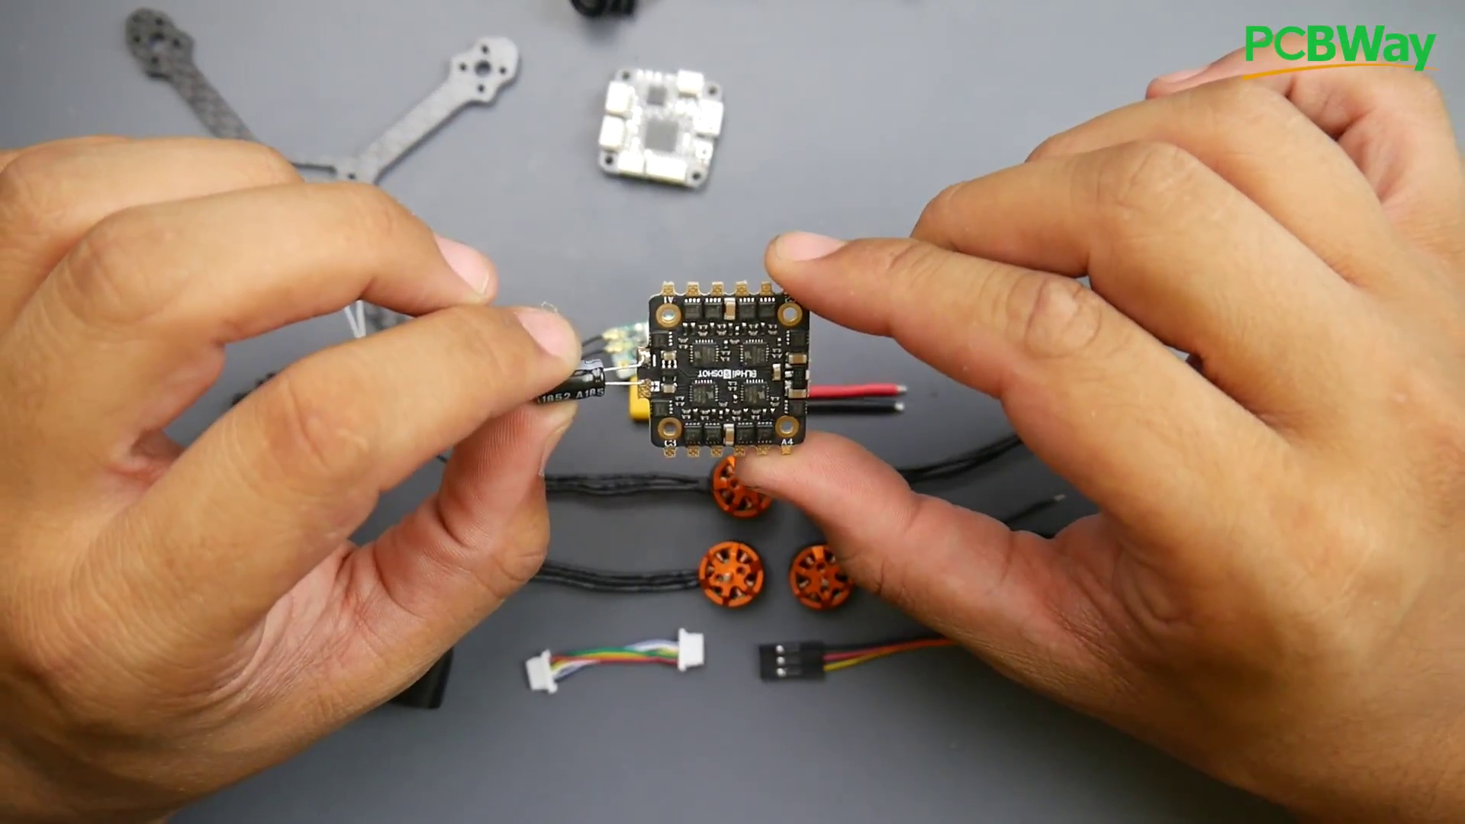 | 4:10  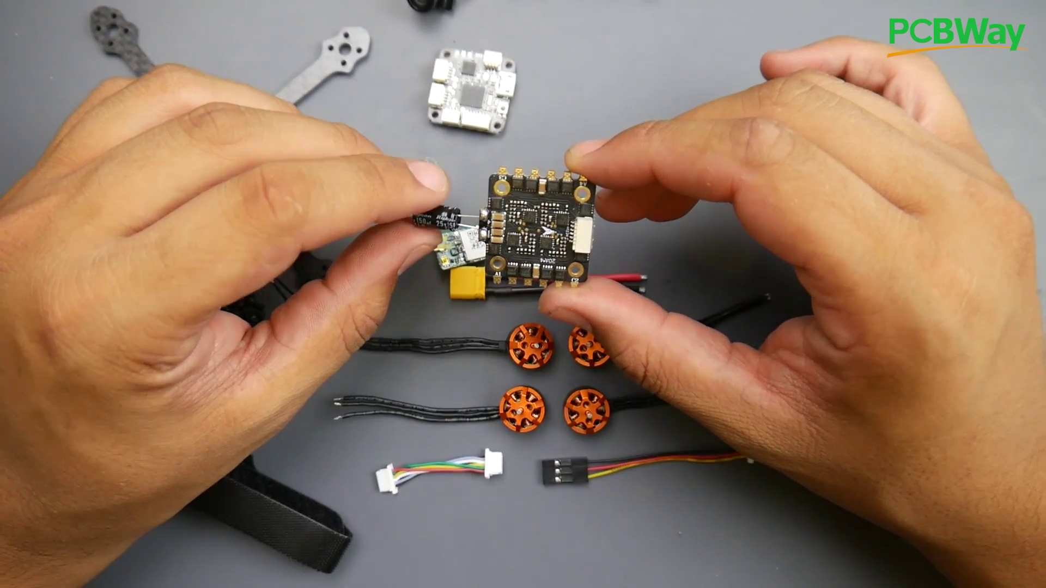 | 4:17  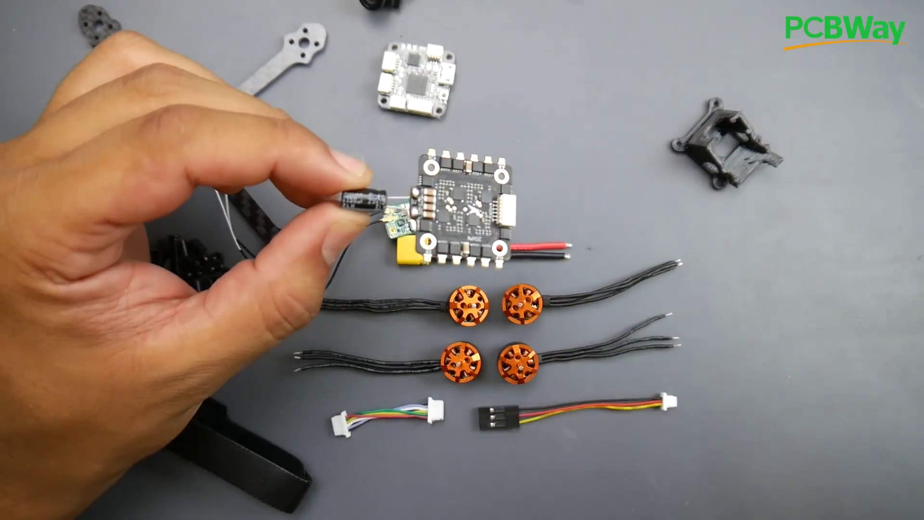 | 4:25  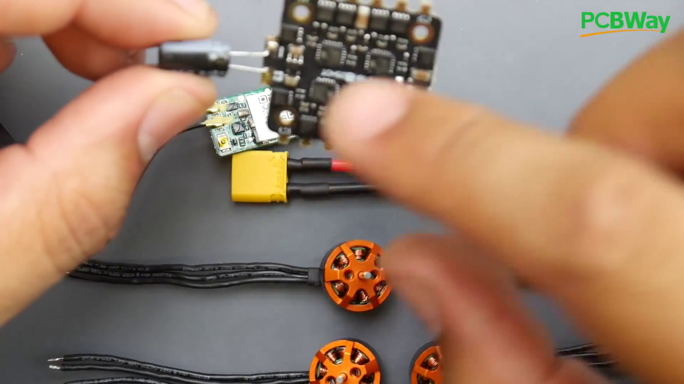

Transcript
[3:48] with just the connectors here, and I'll show you where those go.
[3:50] Those will go on the flight controller.
[3:51] All we have to do is connect them, insert it into the 3D printed part to hold it in place,
[3:55] and we'll be done with the camera in VTX, which makes our life really, really easy.
[3:59] Also, the ESC they're using is actually a pretty good ESC.
[4:03] I'm quite surprised at the ESC they're using.
[4:05] I'm pretty sure you'll probably break the thing before you ever burn this ESC.
[4:10] But then again, this is all theoretical.
[4:11] Just because the filtration is really good, especially for something of this size,
[4:15] and the fact that they even provide you with an installed 150 microfarad low ESR capacitor here.
[4:19] And it is a Rubicon, which is pretty insane.
[4:21] That's a well-known brand.
[4:23] It's a pretty good brand here.
[4:24] However, we're going to have to shorten these leads,
[4:26] or you're more than likely to actually ruin this thing if these two touch the carbon fiber frame
[4:31] because it's going to be sitting solo to the frame.

