Title - Soil Fertility Testing Market to Grow Swiftly By 2034
Video ID: -0BNev8b8CM
URL: https://www.youtube.com/watch?v=-0BNev8b8CM
Task | Subtask | Timestamp | Images
Discuss the expected growth and importance of the soil fertility testing market. | Observe the predicted market size of $2.4 billion by 2034. | 0.0 - 10.0 | 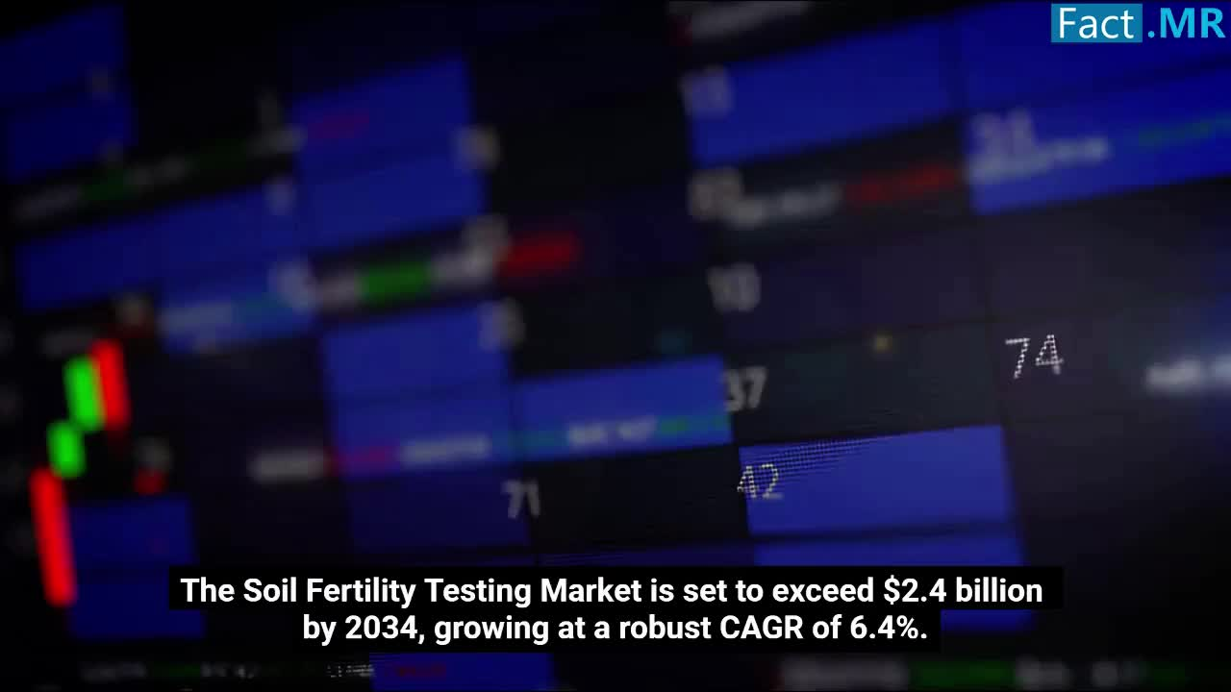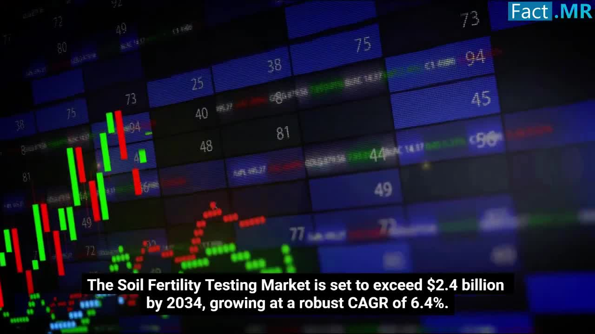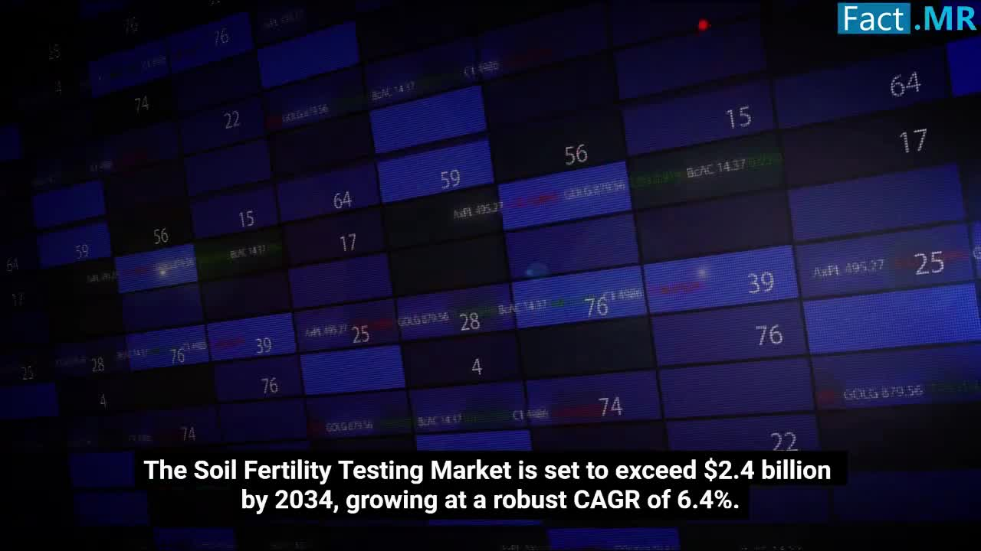
 | Highlight the role of soil testing in assessing nutrient content, pH, and organic matter. | 10.0 - 18.0 | 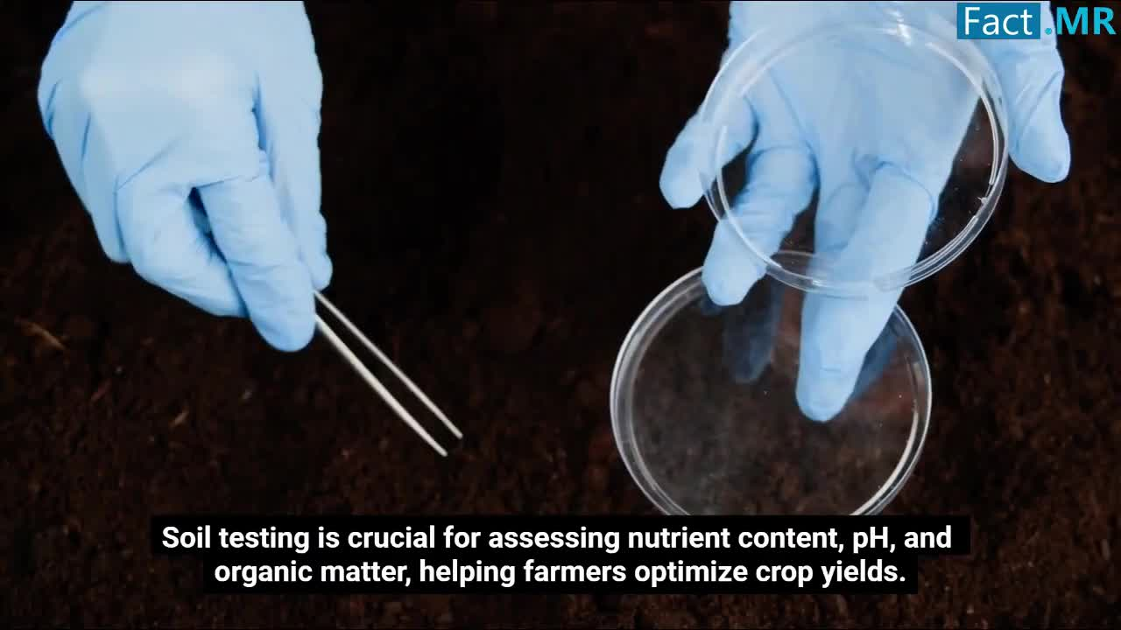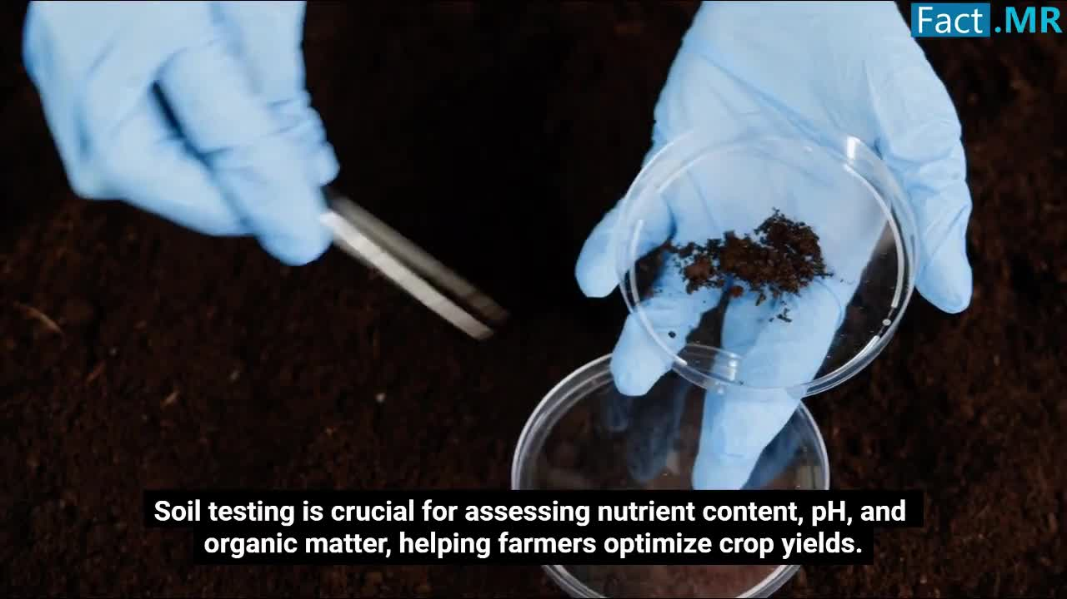
Explain the current and future applications of soil fertility testing. | Note the importance of soil fertility testing for sustainable agriculture. | 18.0 - 25.0 | 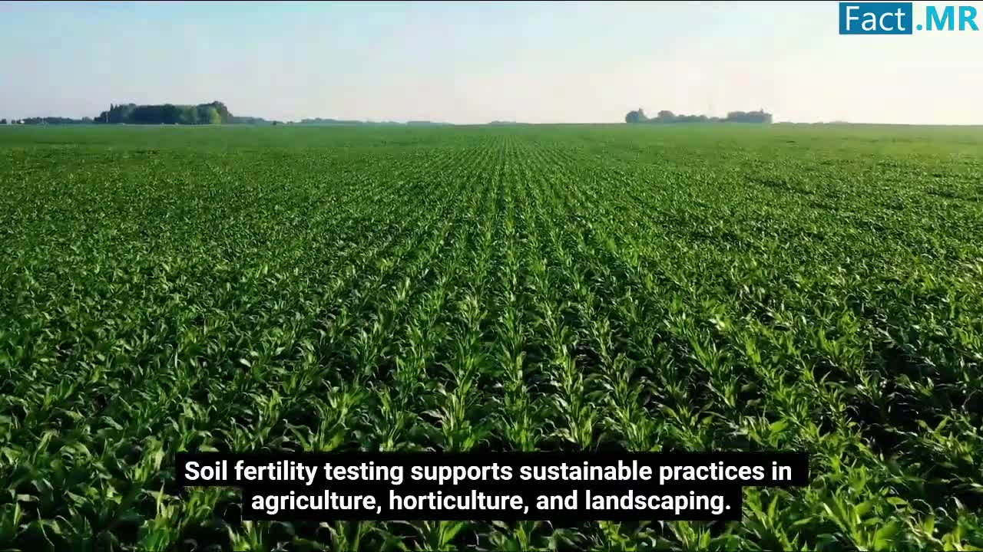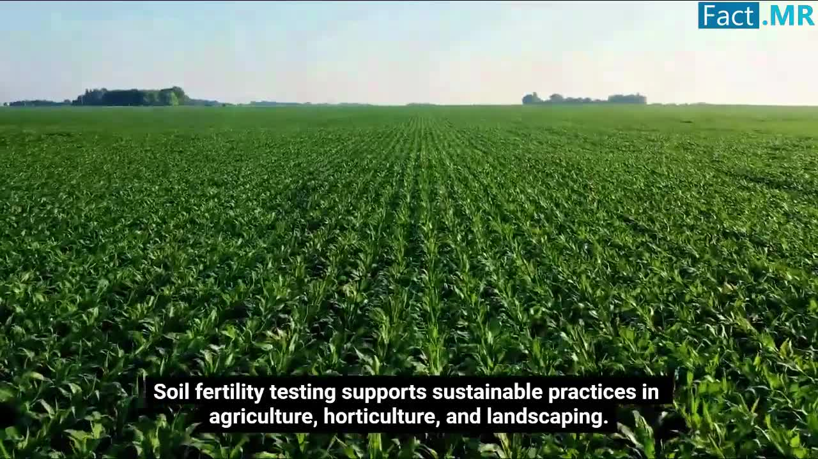
 | Observe the expected exponential growth by 2030 with the integration of AI and IoT. | 26.0 - 33.0 | 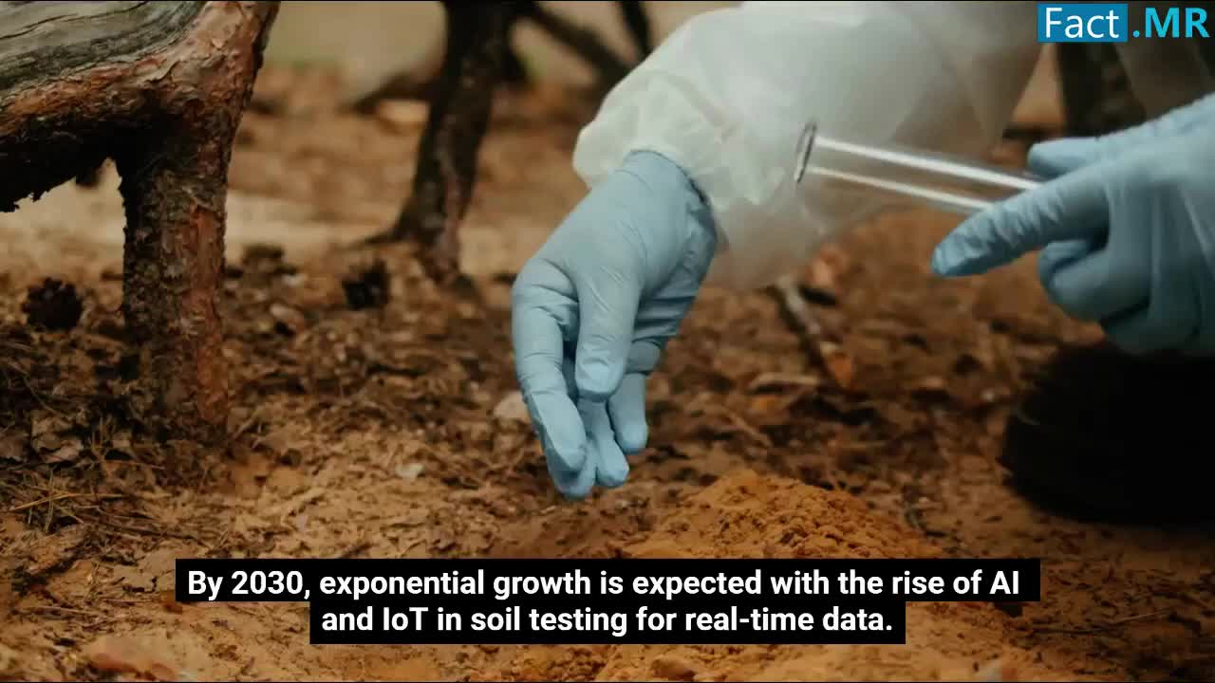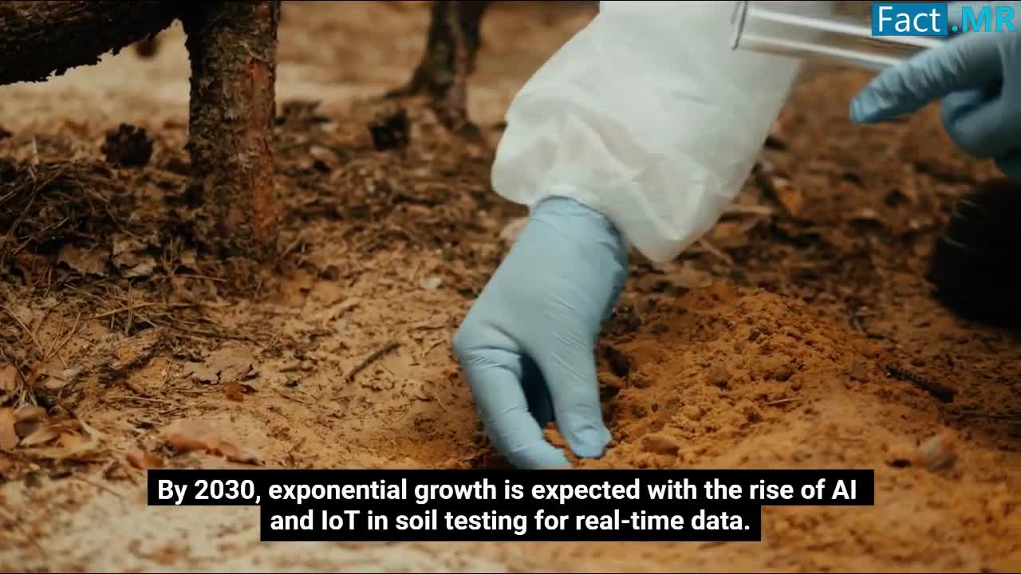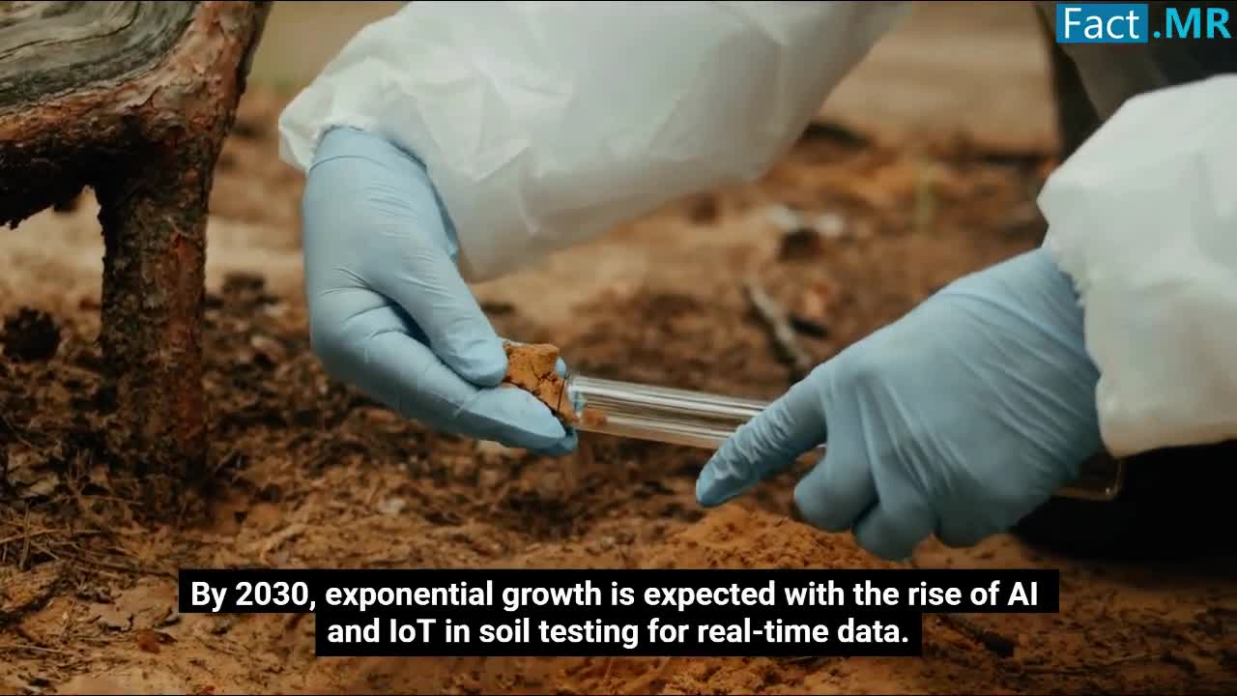
 | Mention the dominance of advanced automated solutions by 2034. | 33.0 - 41.0 | 
Identify key drivers and challenges in the soil fertility testing market. | Highlight the rise of organic markets requiring certified soil health. | 41.0 - 44.5 | 
 | Observe the impact of increasing food demand on the market. | 44.5 - 48.0 | 
 | Note the challenges of lack of standardized testing procedures. | 48.0 - 56.0 | 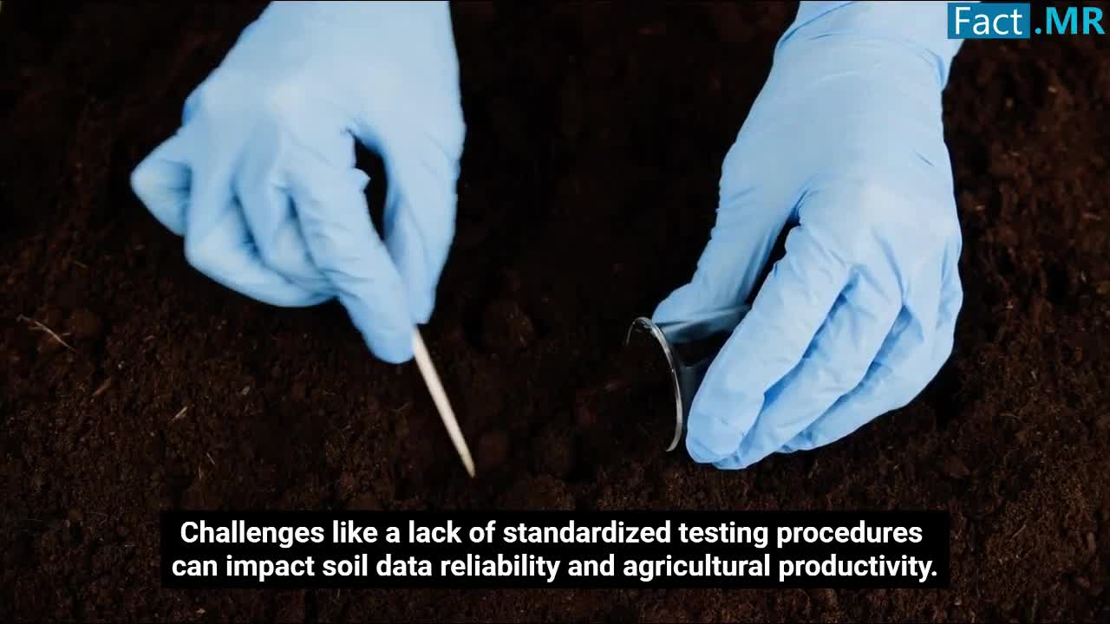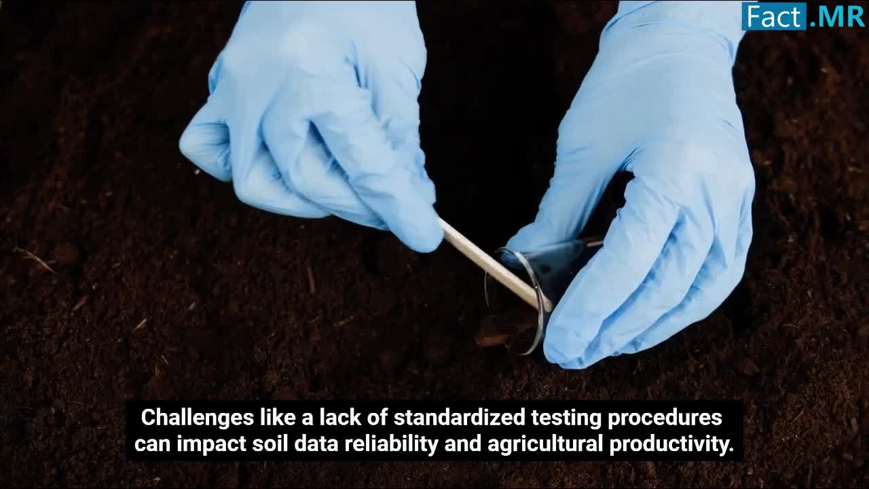
Show examples of market trends by region. | Point out the role of precision agriculture in the US. | 56.0 - 60.5 | 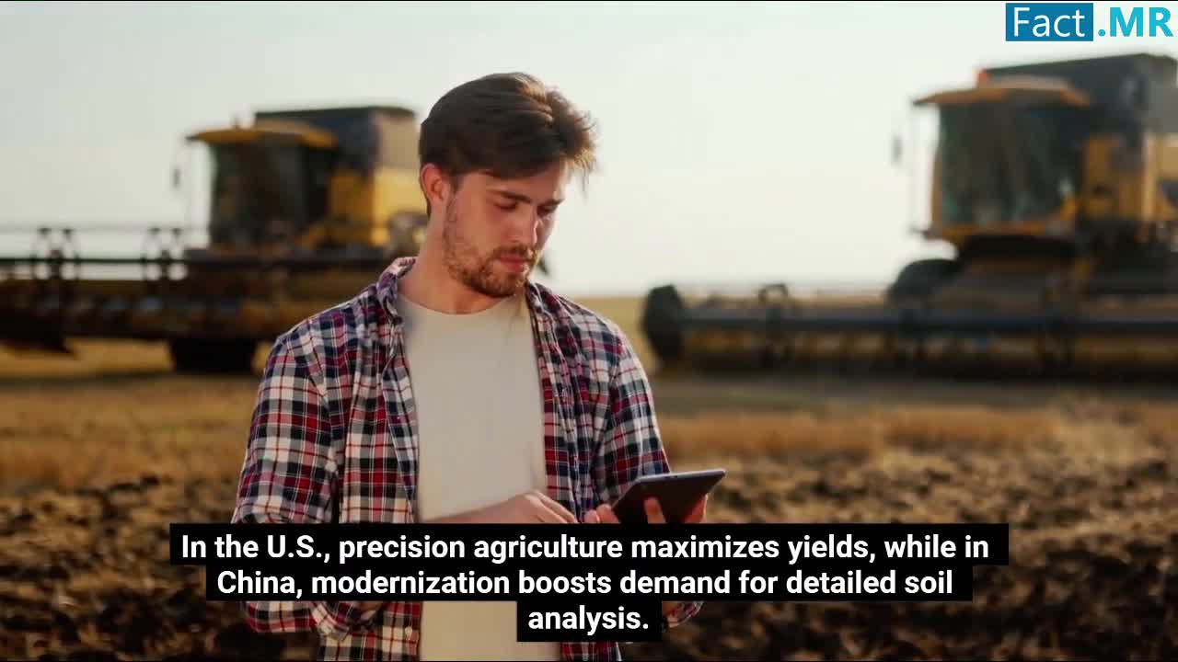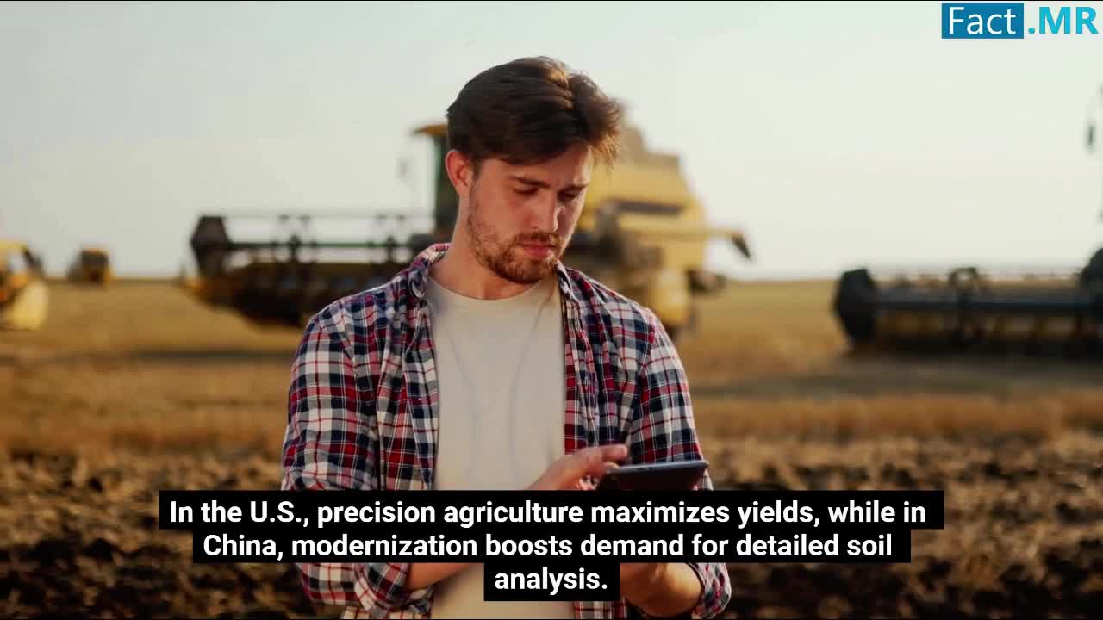
 | Observe the boost in demand for detailed soil analysis in China. | 60.5 - 65.0 | 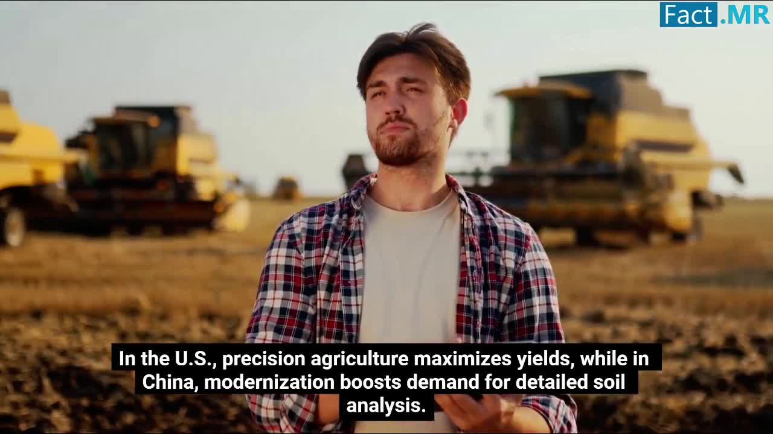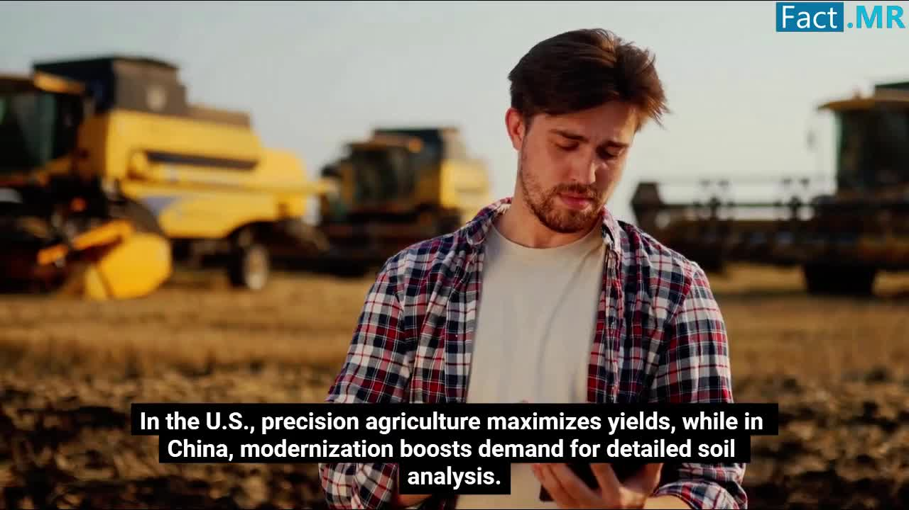
 | Highlight the significance of soil fertility testing for sustainable farming and food security. | 65.0 - 73.0 | 