Title - First Cutting Baling Tips for Pasture Management
Video ID: -3_xCNu1mtI
URL: https://www.youtube.com/watch?v=-3_xCNu1mtI
Task | Subtask | Timestamp | Images
Explain the timing of first cutting and the benefits of letting grasses go to seed. | Note the current state of the pasture as extremely tall and nearly ready for baling. | 9.34 - 15.46 | 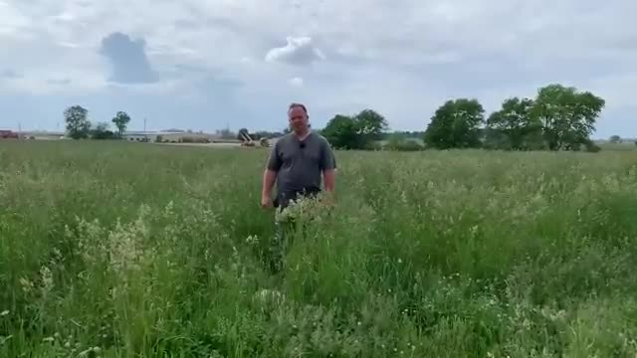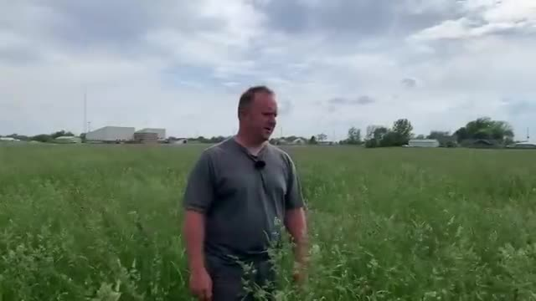
 | Outline the timing for the first cutting of pasture, indicating it's usually done before Memorial Day. | 15.46 - 24.7 | 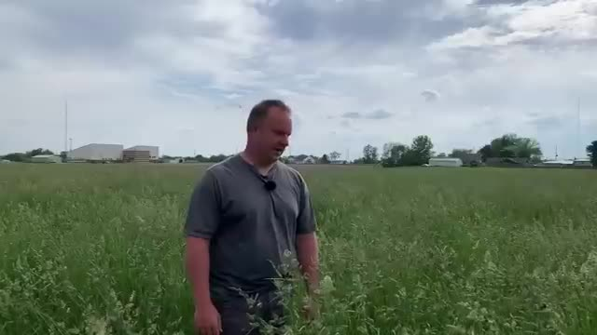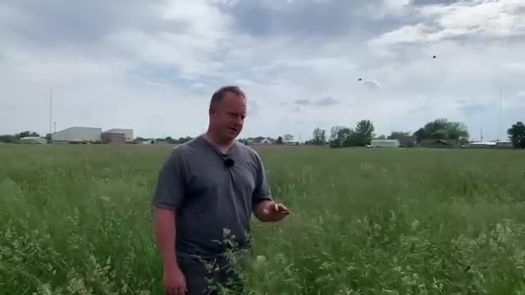
 | Highlight how stemmy the orchard grass is, which affects its quality for feeding livestock. | 36.54 - 44.22 | 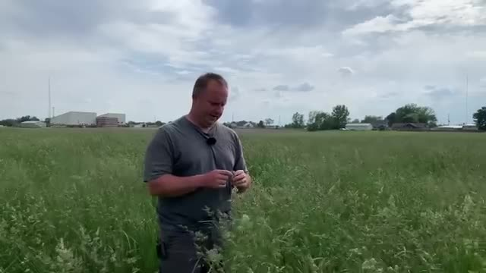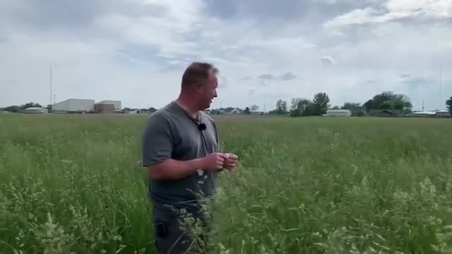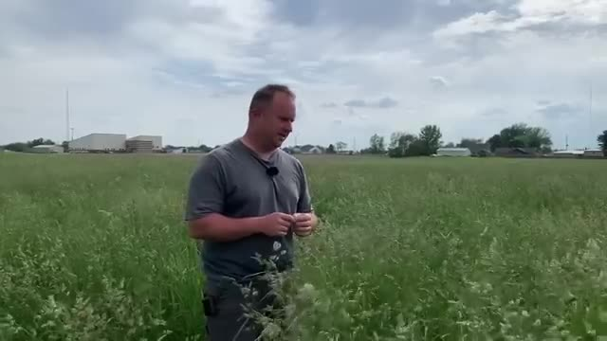
 | Explain why letting the pasture go to seed before first cutting is beneficial for reseeding. | 90.94 - 119.1 | 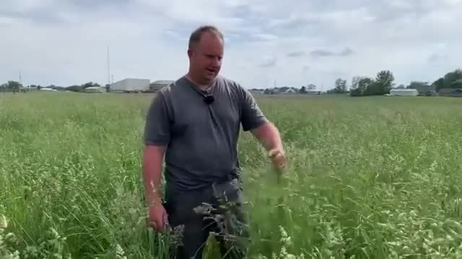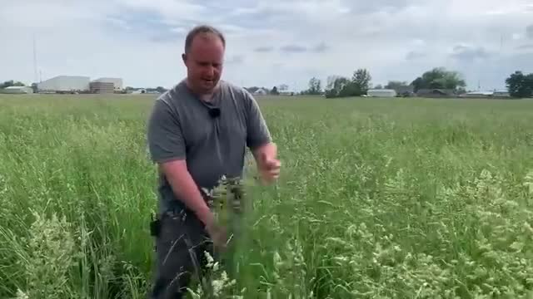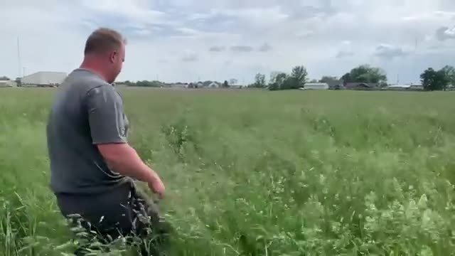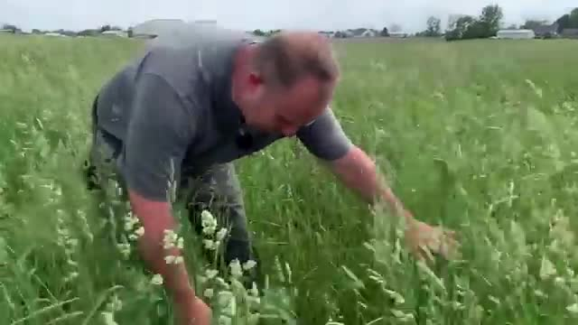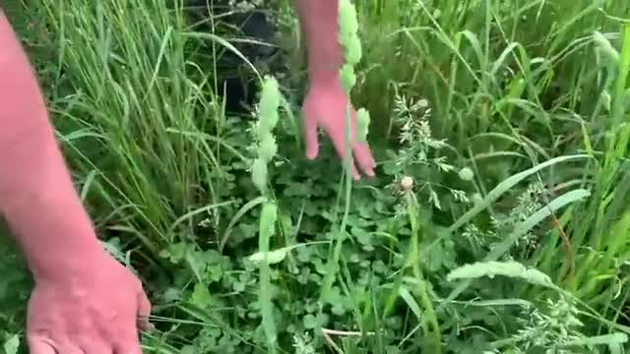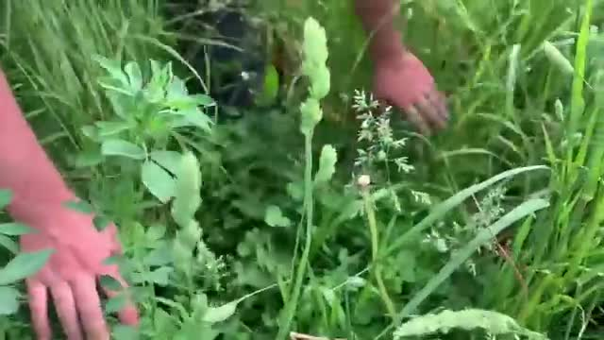
Describe the process of reseeding the pasture naturally from seed left after baling. | Point out the grass seeds on top of the clover after the plants have gone to seed. | 110.38 - 114.62 | 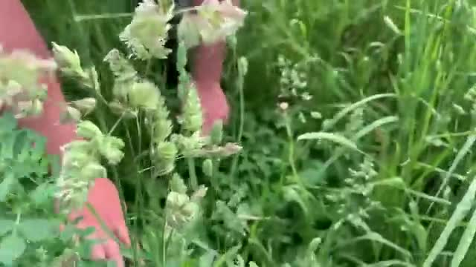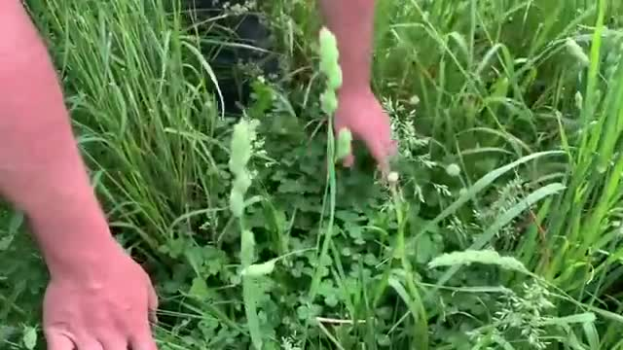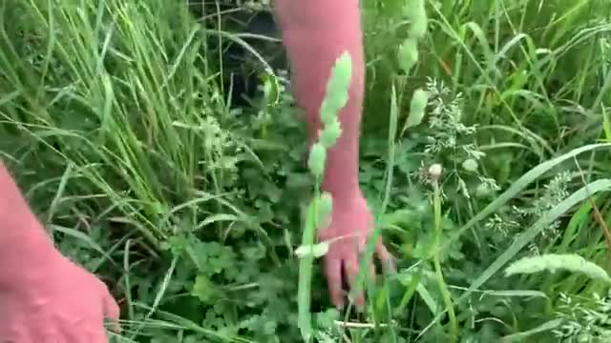
 | Emphasize the cost-saving benefit of naturally reseeding the pasture. | 119.18 - 123.42 | 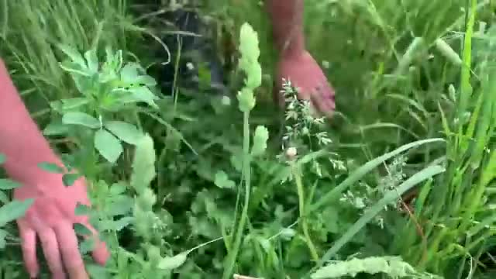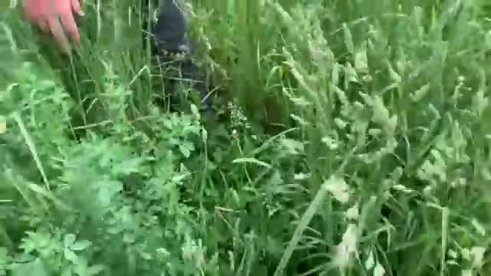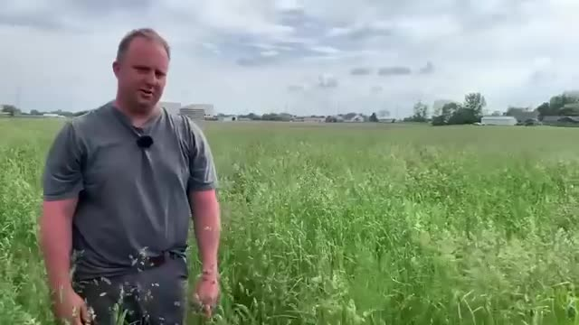
 | Explain how the reseeded pasture helps ensure better soil contact and more robust growth. | 133.9 - 141.74 | 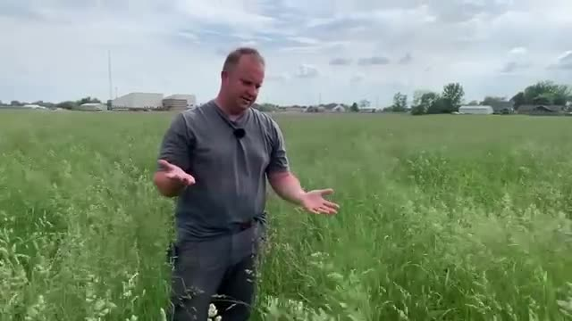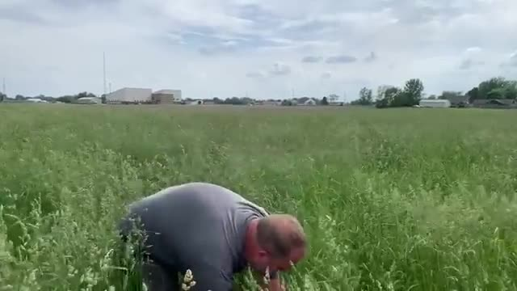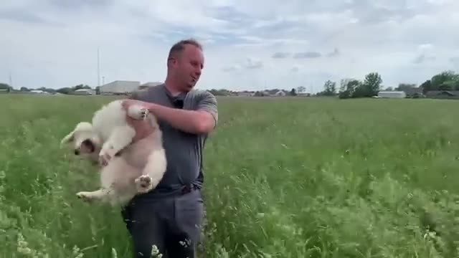
 | Recommend letting the grass go to seed before the first cutting to achieve better results. | 145.74 - 158.14 | 