Title - Giant and Tiny Pumpkins from China
Video ID: -8JUdYeWcEQ
URL: https://www.youtube.com/watch?v=-8JUdYeWcEQ
Task | Subtask | Timestamp | Images
Describe the unique pumpkin farming techniques of the Chinese. | Observe the world's largest pumpkin that no single man can carry alone. | 5.84 - 10.16 | 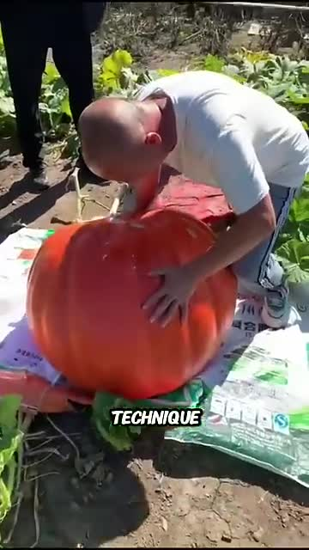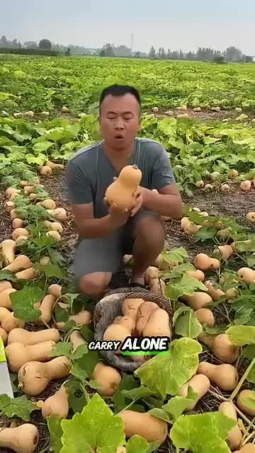
 | Note the smallest pumpkin developed by the Chinese, the size of a hand. | 10.16 - 14.32 | 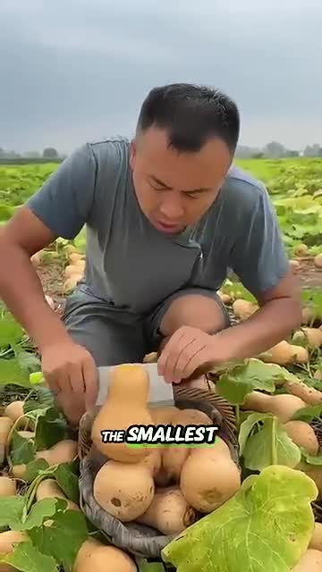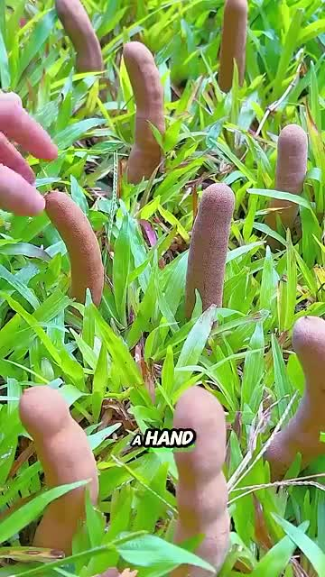
Highlight other unique products and their pricing. | Look at the tamarind fruit that looks awkward but is described as very delicious. | 14.32 - 18.48 | 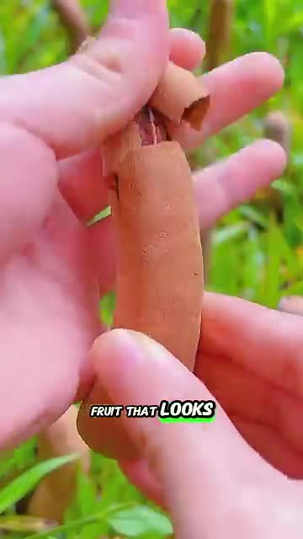
 | Mention that all these pumpkins and fruits are sold for high prices in the market. | 18.48 - 20.32 | 

