Title - Livestock Disease Control Methods Explained 2023 Edition Nyoike Live Lesson 01 09 23 Part 10
Video ID: -FehjRm_b60
URL: https://www.youtube.com/watch?v=-FehjRm_b60
Task | Subtask | Timestamp | Images
Explain the different methods of parasite and disease control in livestock. | Describe the process of deworming, including the use of drenching guns. | 113.94 - 146.94 | 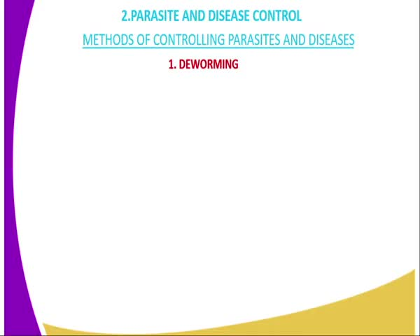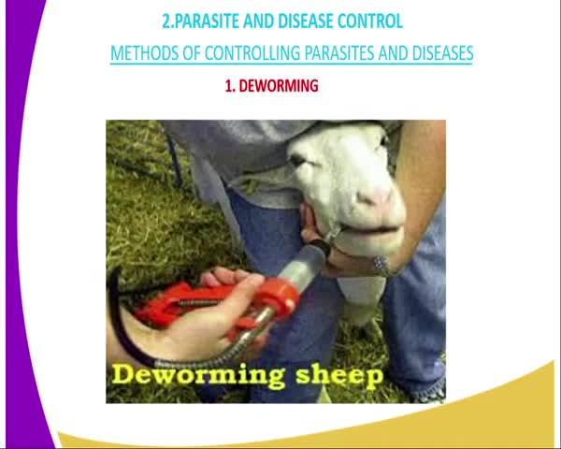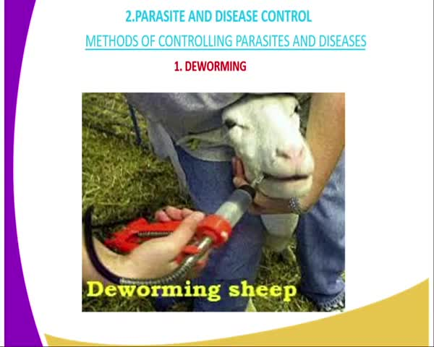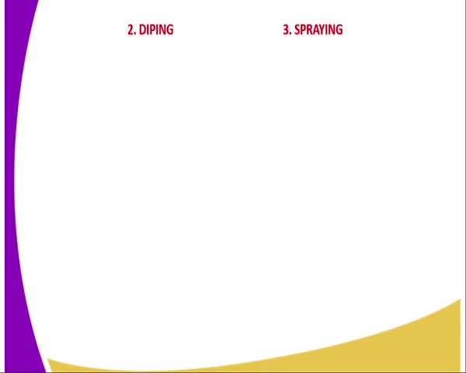
 | Explain the method of dipping for controlling external parasites. | 146.94 - 166.94 | 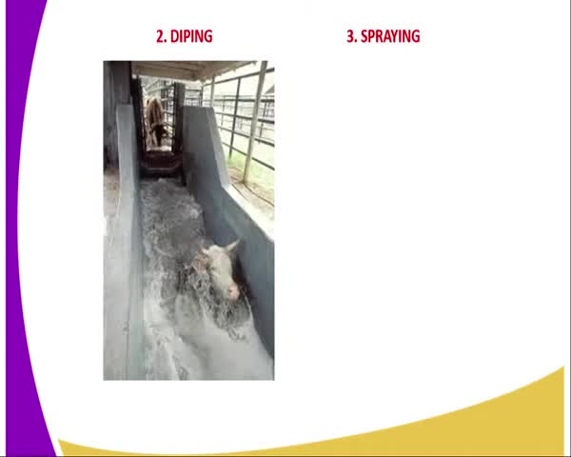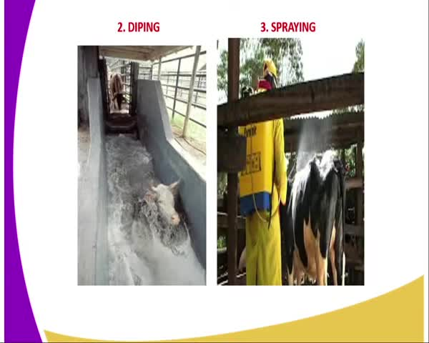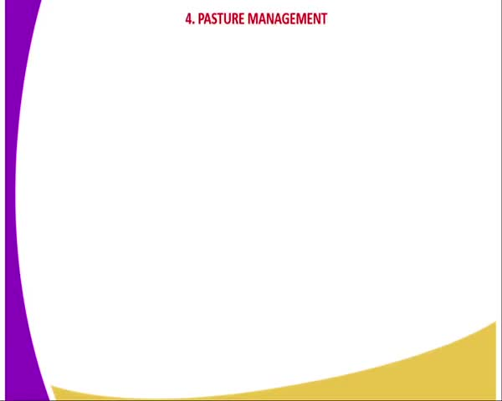
 | Describe the pasture management techniques for controlling parasites. | 166.94 - 207.94 | 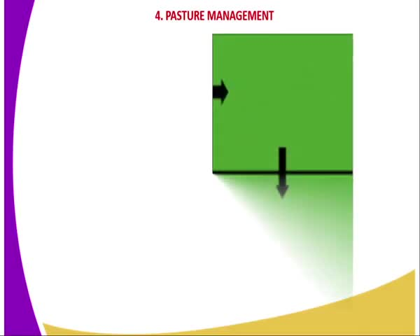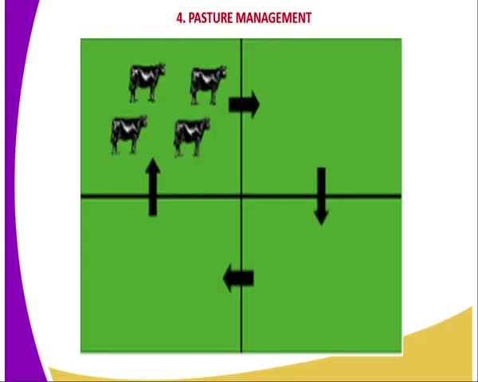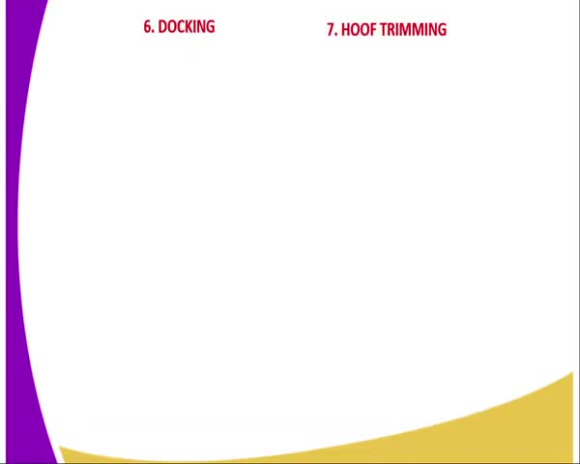
Describe other livestock management practices for disease control. | Explain the method of docking to control blue fly infestation. | 207.94 - 222.94 | 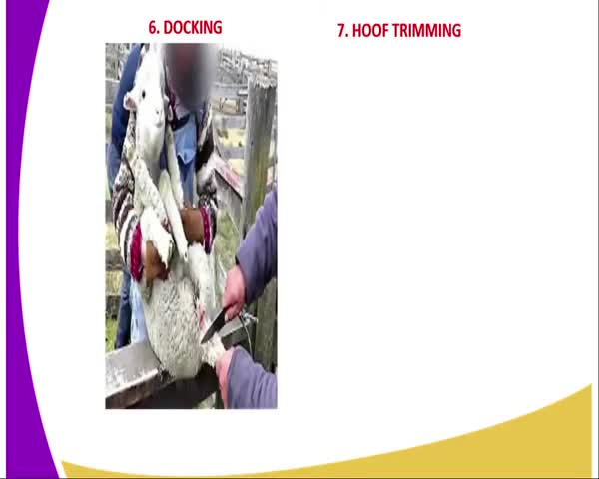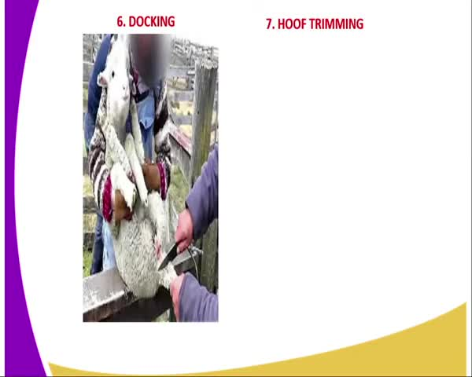
 | Describe the hoof trimming process to control hoof rot diseases. | 222.94 - 234.94 | 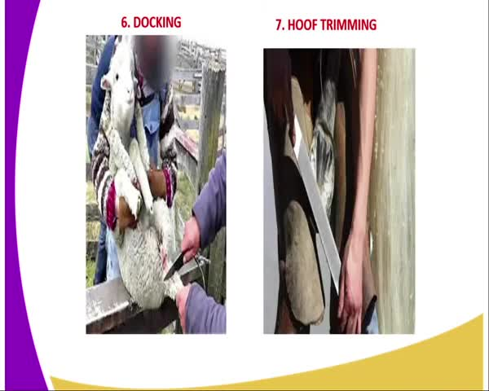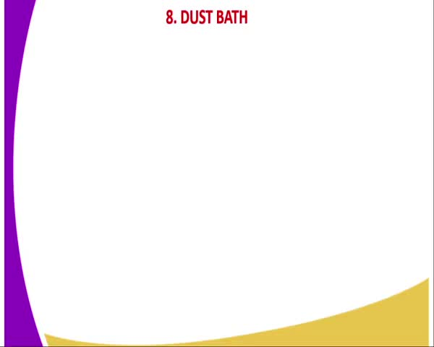
Describe the methods of vaccination used in livestock. | Explain the injection method of vaccination. | 283.94 - 294.94 | 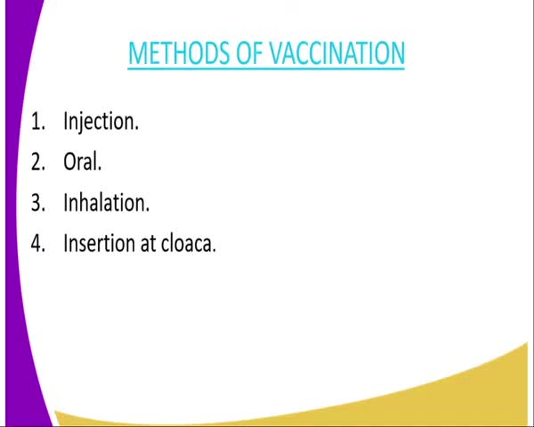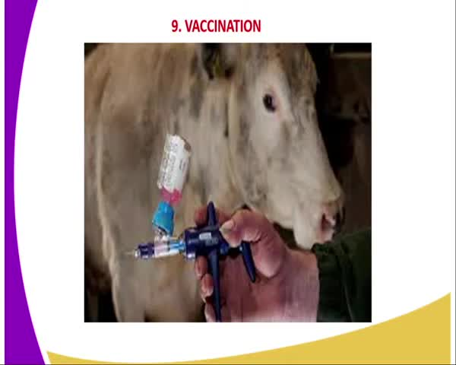
 | Describe the oral method of administering vaccines. | 294.94 - 311.94 | 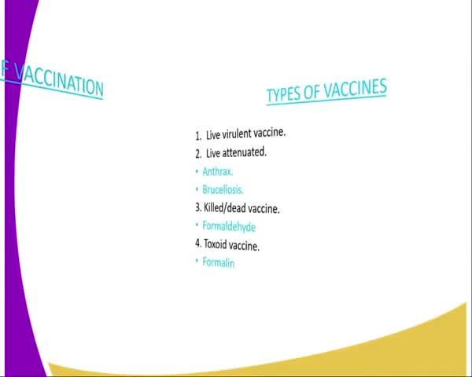
 | Explain the inhalation method of vaccination. | 311.94 - 325.94 | 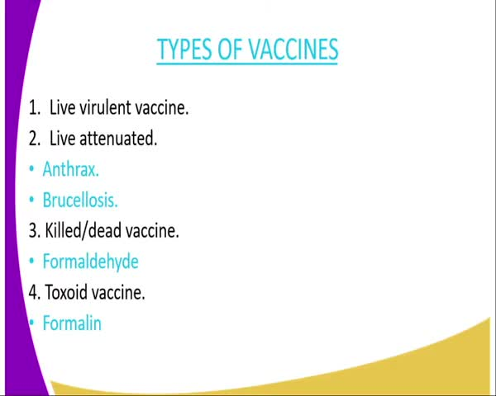
Discuss the types of vaccines and their properties. | Describe the live variant vaccine and its properties. | 311.94 - 340.94
 | Discuss the attenuated vaccine and its examples and properties. | 340.94 - 383.94
 | Explain the killed vaccine and its use. | 383.94 - 420.94 | 