Title - Green Revolution Transformation Explained Short
Video ID: -V7Vjjaeohc
URL: https://www.youtube.com/watch?v=-V7Vjjaeohc
Task | Subtask | Timestamp | Images
Explain the initial phase of the Green Revolution and the introduction of new crop varieties. | Observe the introduction of high yielding crop varieties as the starting point of the Green Revolution. | 0.0 - 7.6 | 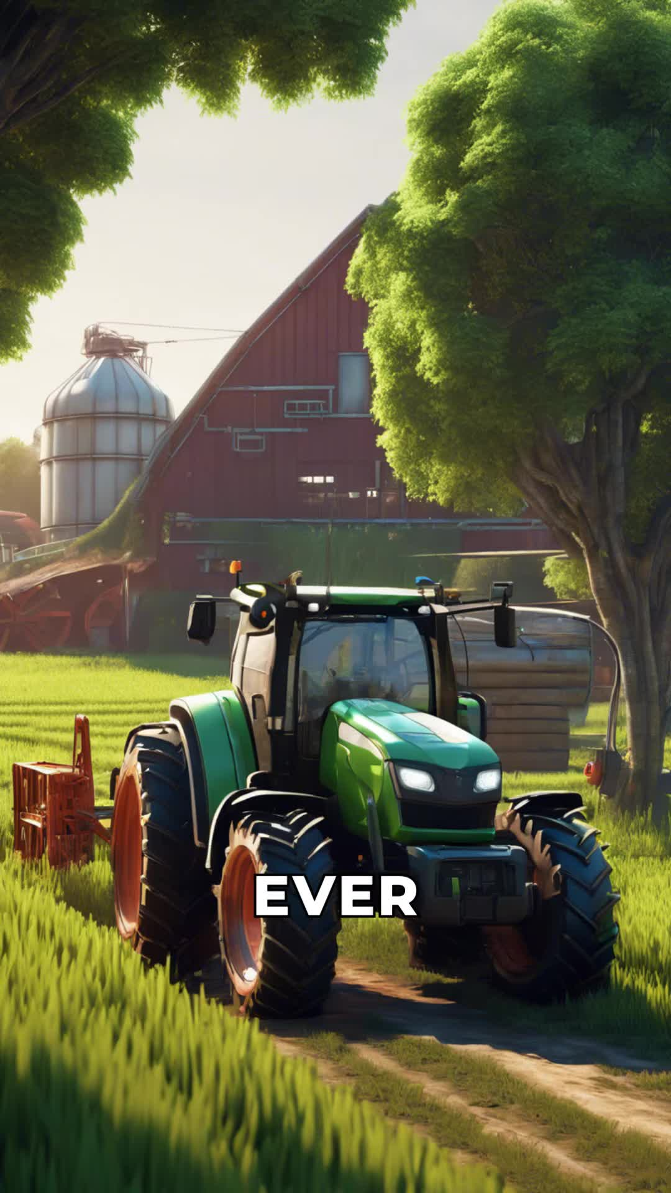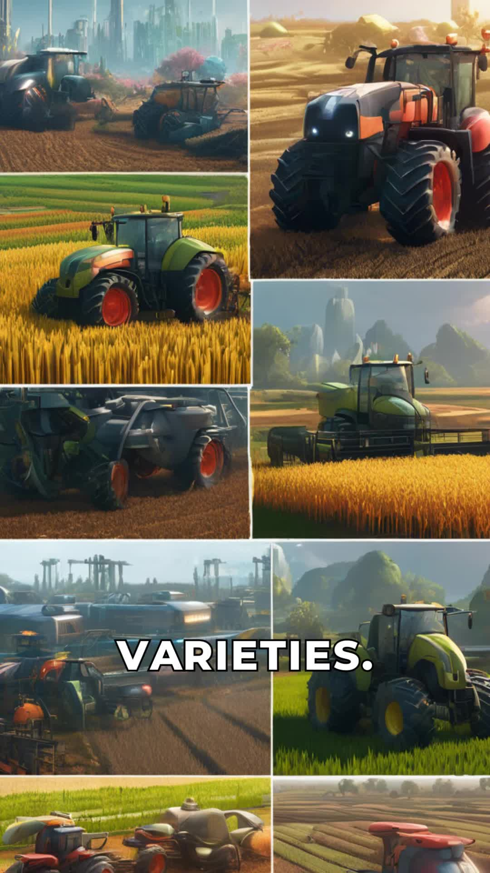
Describe the benefits of high-yielding crop varieties in terms of increased yields compared to traditional crops. | Note that these crops produced significantly higher yields than traditional ones. | 8.56 - 12.24 | 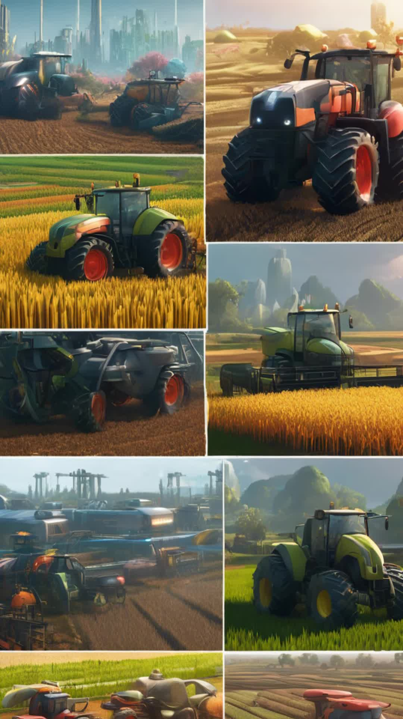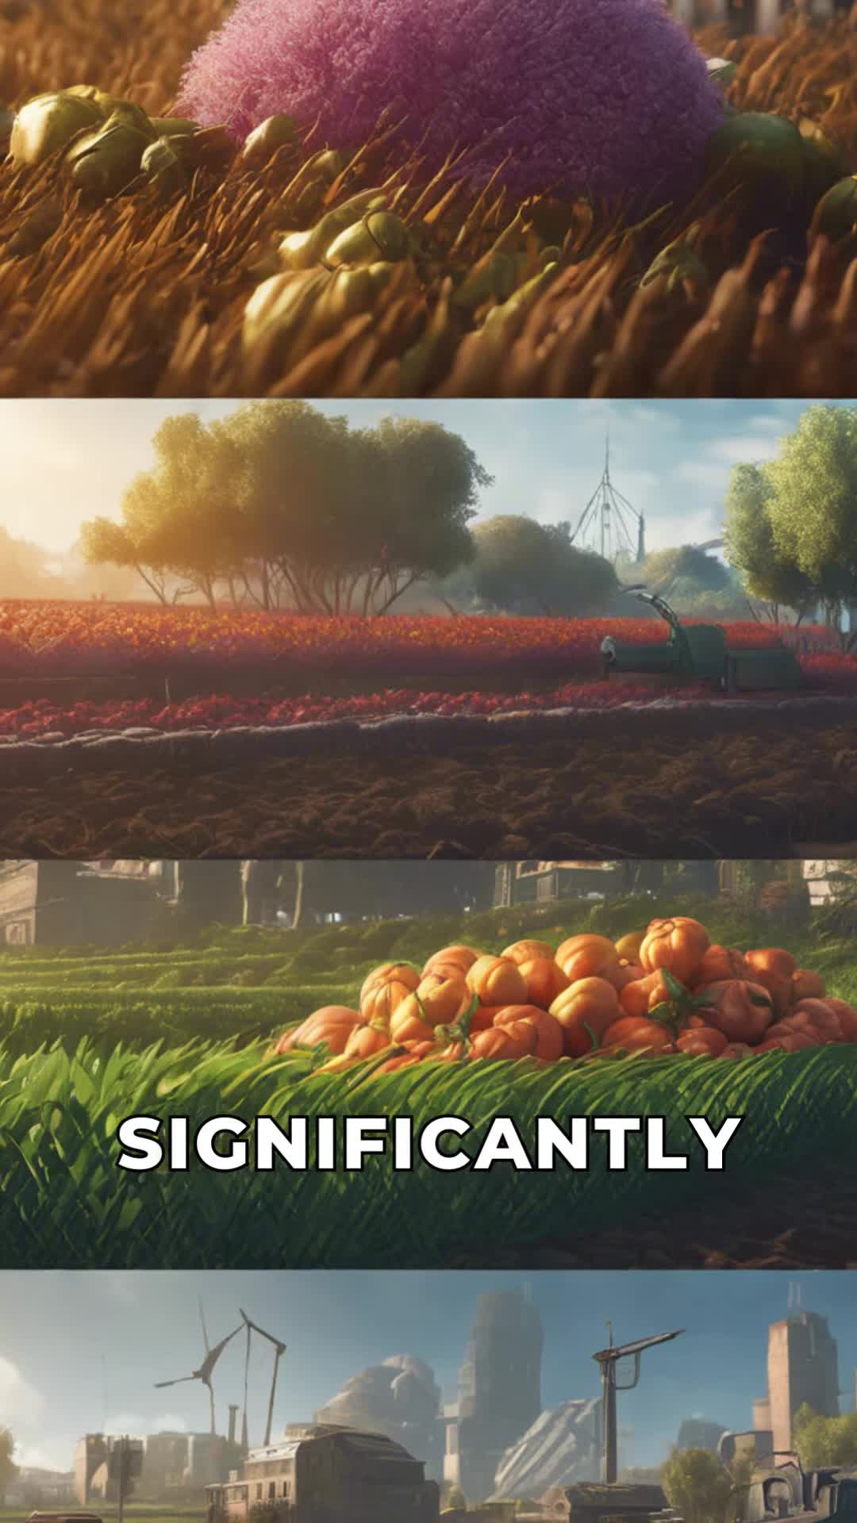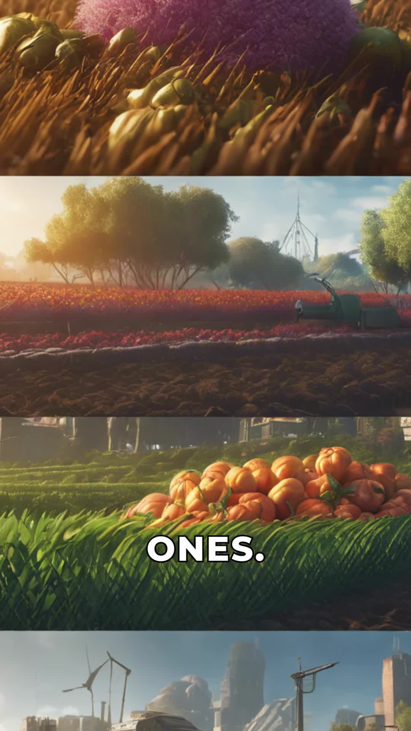
Discuss the additional measures that further increased crop growth during the Green Revolution. | Notice the use of chemical fertilizers and pesticides to boost crop growth. | 13.12 - 17.2 | 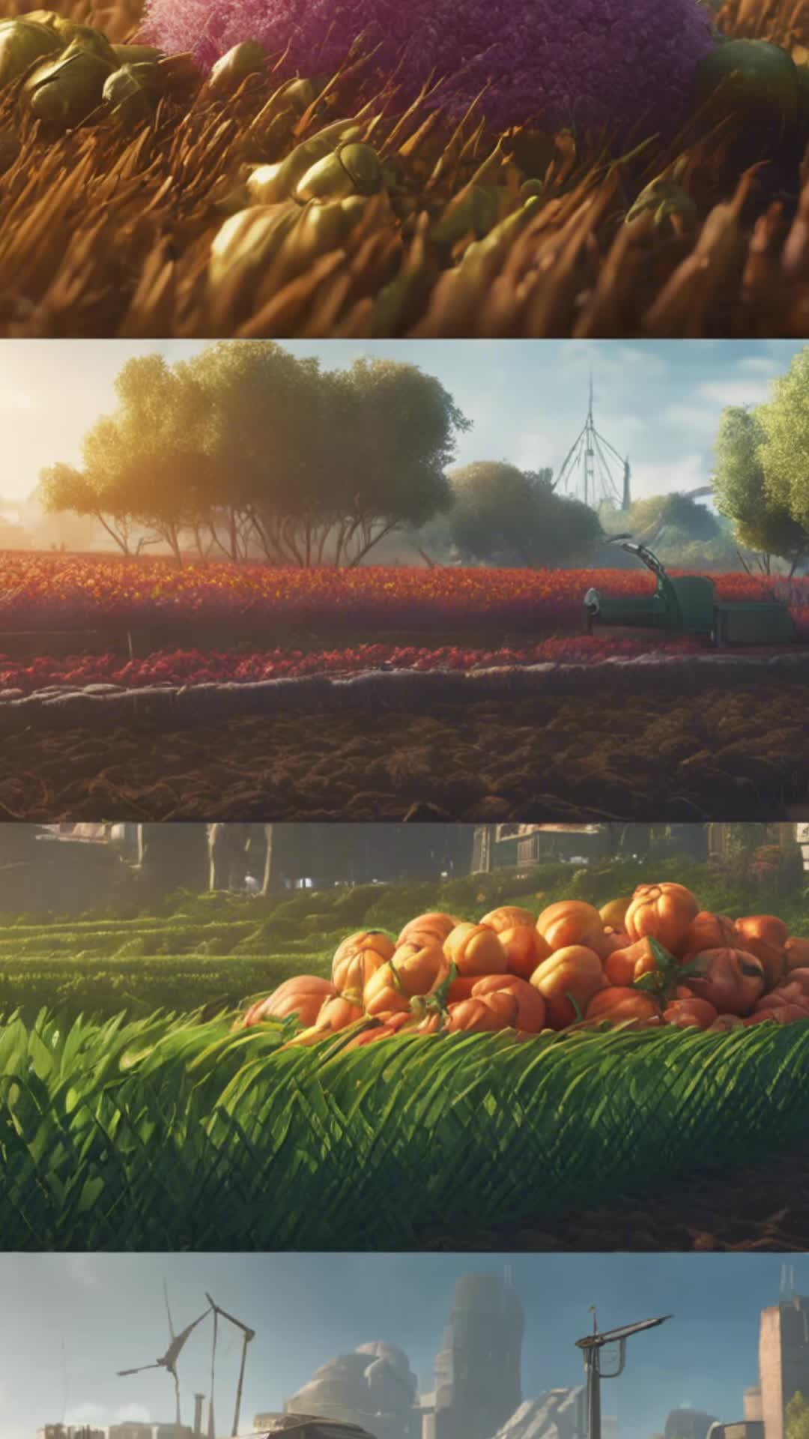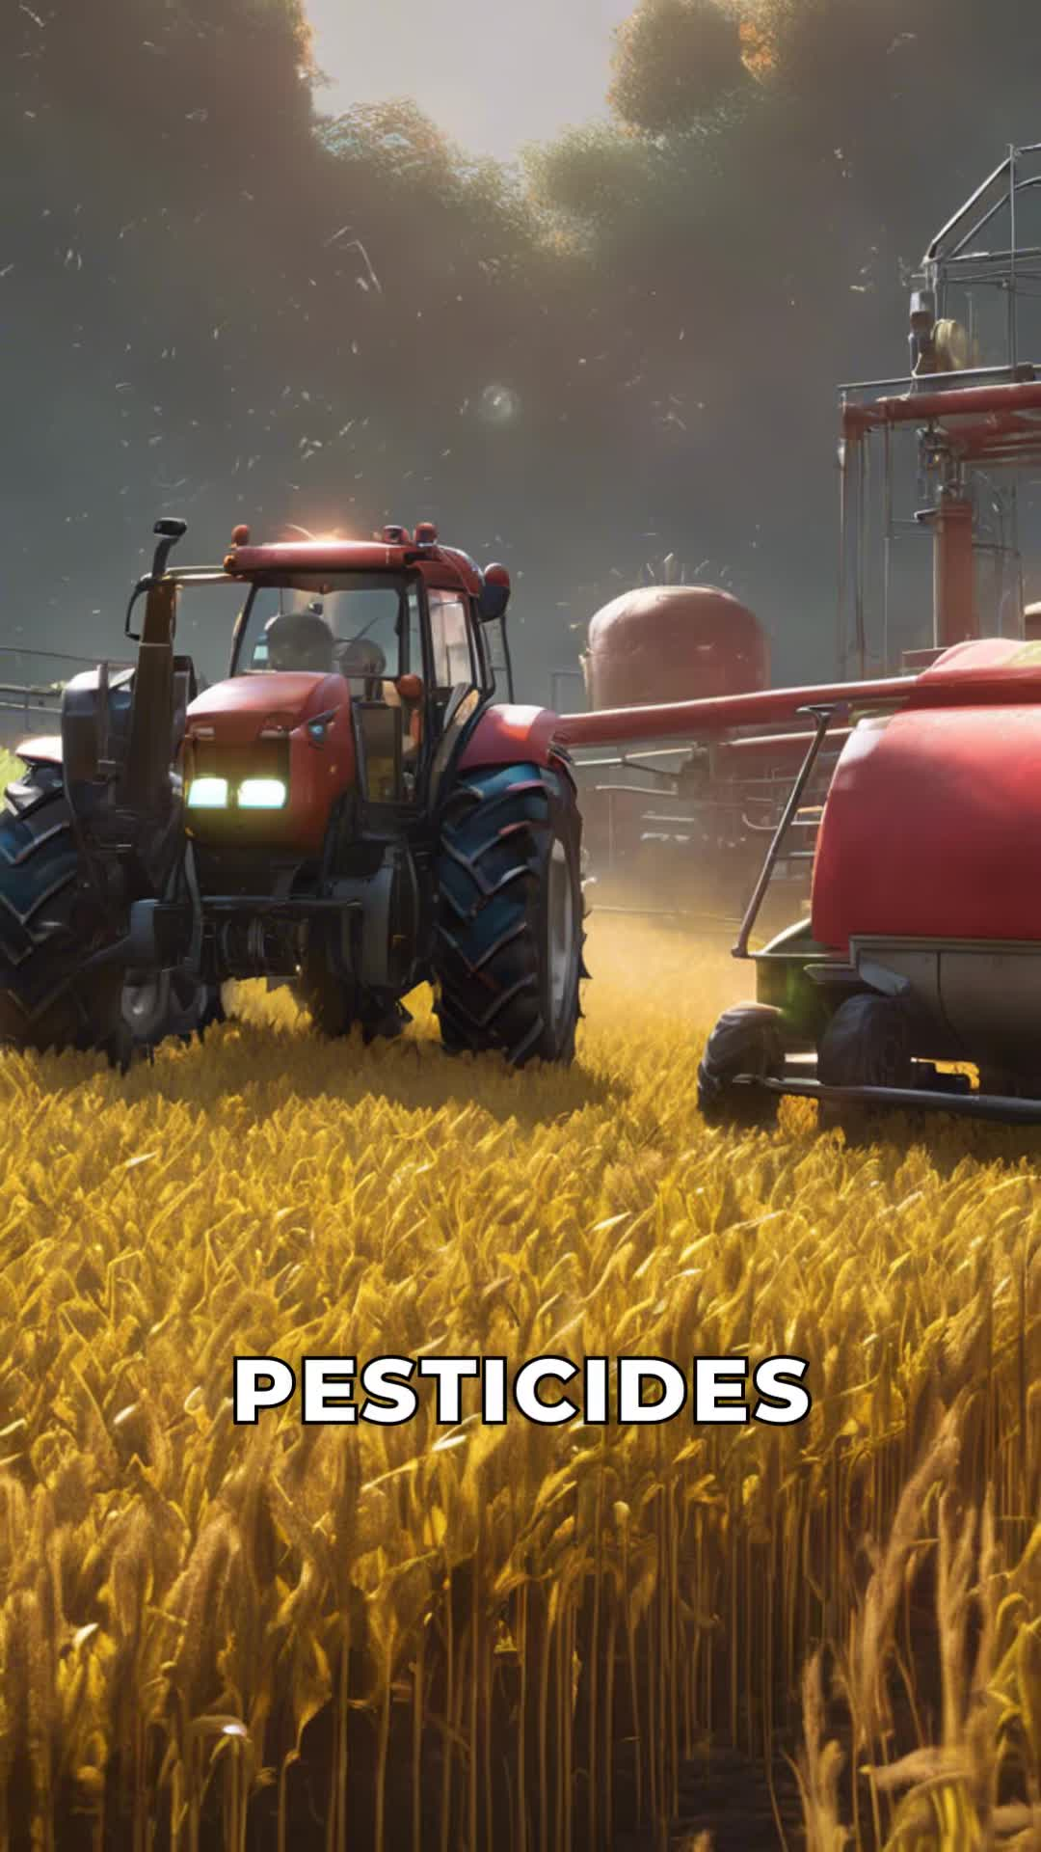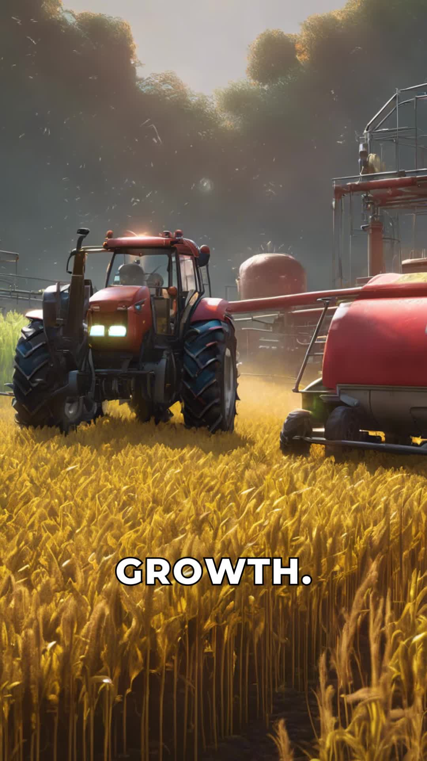
Explain the overall impact of the Green Revolution on global agriculture and food production. | Observe that this combination revolutionized agriculture, increasing food production globally. | 18.16 - 23.84 | 